Big Data Analytics (B.Tech) — Pimpri Chinchwad College of Engineering (PCCoE)
Formative Assessment 2 (FA2): Problem-based Solving using Apache Spark and Big Data Visualization
eBay-style Marketplace Analytics with Apache Spark
When, where and how well does marketplace demand get fulfilled? — Olist marketplace data as a public stand-in for eBay
Group members: [add names]
Academic year: [add]
Case study: eBay (continued from FA1)

Contents

Right-click → Update Field in Word to refresh page numbers.

Abstract
In FA1 we studied eBay's Big Data architecture: SQL warehouses (Teradata, Greenplum), Hadoop (HDFS, YARN, MapReduce) and NoSQL stores (HBase, Cassandra, MongoDB). FA2 continues that case study by applying Apache Spark to a marketplace problem: when, where and how well is buyer demand fulfilled? eBay publishes no transaction data, so we use the Olist Brazilian E-Commerce Public Dataset (nine linked tables, 2016-2018, 99,441 orders) as a public stand-in with the same seller-to-buyer model. Using PySpark in local mode we ingest the data with explicit schemas, clean it, build a denormalised table of 112,650 order lines, store it as Parquet and answer six questions with joins, aggregations, pivots, window functions, Spark SQL and an RDD comparison. Seven visualizations, four of them advanced (time series, heatmap, geospatial map, network graph), show that orders grew 8.16 times between January 2017 and August 2018 with a Black Friday peak, that three states generate 63.35% of revenue, and that late deliveries cut average review scores from 4.29 to 2.27 stars. We turn these findings into six recommendations and describe how the same code would scale on eBay's stack.

1 Introduction

1.1 From FA1 to FA2
FA1 described how eBay stores and processes data at very large scale: relational data warehouses for structured reporting, a Hadoop cluster (HDFS for storage, YARN for resource management, MapReduce for batch processing) for raw and semi-structured data, and NoSQL stores (HBase, Cassandra, MongoDB) for low-latency serving. FA2 asks what an analyst would actually do on top of such a platform. Apache Spark is the natural answer: it runs on YARN, reads from HDFS, keeps intermediate data in memory and offers one API for SQL, DataFrames, windows and low-level RDDs.

1.2 Problem statement
eBay is a marketplace that connects independent sellers to buyers. Its growth depends on knowing when demand happens, where buyers and revenue are concentrated, and how well orders are fulfilled, because late or failed fulfilment damages the ratings that buyers rely on. The problem we solve is therefore: using Apache Spark, find the time pattern, geographic pattern and fulfilment quality of marketplace demand, and turn the findings into recommendations for the platform and its sellers.

1.3 Objectives
- Select a suitable public dataset and justify it as a stand-in for eBay.
- Implement ingestion, cleaning and analysis in PySpark using both transformations and actions, and demonstrate core Spark concepts (lazy evaluation, joins, windows, Spark SQL, caching, partitioning, Parquet, RDDs).
- Present the results with at least three meaningful visualizations, including advanced ones.
- Interpret the results and give actionable recommendations, linked back to eBay's FA1 architecture.

1.4 Analytical questions
We framed six questions. Each is answered with a specific Spark technique and a matching chart; four of the charts are advanced types.
Table 1: The six analytical questions, Spark techniques and visualizations
# | Question | Spark technique | Visualization
Q1 | How did orders and revenue grow month by month? | Join, groupBy month, window lag for month-on-month growth | Time-series line charts (advanced)
Q2 | Which weekdays and hours do buyers purchase most? | Date functions, groupBy, pivot into a 7 x 24 matrix | Weekday-by-hour heatmap (advanced)
Q3 | Where are buyers and revenue concentrated? | Aggregate by zip prefix and state, join to geolocation | Geospatial map, static and interactive (advanced)
Q4 | Do late deliveries lower review scores? | datediff-style delay features, join reviews, bucketing | Bar charts (score by delay; late rate by state)
Q5 | Which seller states ship to which buyer states? | Multi-table join, groupBy (seller state, buyer state) | Network graph on geographic coordinates (advanced)
Q6 | Which product categories earn the most? | Join to translation table, global and partitioned rank windows | Horizontal bar chart

2 Dataset

2.1 Why a stand-in for eBay
eBay does not publish transaction-level data. The Olist Brazilian E-Commerce Public Dataset (Kaggle) comes from a marketplace with the same structure as eBay: independent sellers list products and buyers order them through the platform, with payments, shipping and reviews recorded per order. It is public, has about 100 thousand orders across nine linked tables (which makes joins meaningful) and contains delivery dates and review scores, which let us study fulfilment quality. The patterns we find are Brazilian patterns for 2016-2018, so they illustrate the method rather than describe eBay itself.

2.2 The nine files
Table 2: Olist source files and raw row counts
File (table) | Rows | Content
orders | 99,441 | One row per order: status, purchase, approval, delivery and estimated dates
order_items | 112,650 | One row per item: product, seller, price, freight
customers | 99,441 | Customer id (per order), unique person id, city, state, zip prefix
sellers | 3,095 | Seller id, city, state, zip prefix
products | 32,951 | Category, dimensions, weight
payments | 103,886 | Payment type and value per order
reviews | 99,224 | Review score (1-5) and comments
geolocation | 1,000,163 | Latitude and longitude points per zip prefix
category_translation | 71 | Portuguese to English category names

2.3 Data quality findings and cleaning decisions
Phase 1 of the pipeline profiles every table (row counts, null counts, duplicate keys, impossible values) and records the results. The main findings and our decisions are summarised below.
Table 3: Data quality findings and decisions
Table | Finding | Decision
orders | 625 canceled and 609 unavailable orders; 8 'delivered' orders without a delivery date; 6 orders with a delivery date but a different status; 775 orders have no item row | Kept all rows; filter valid orders per analysis; delivery fields stay null instead of being guessed
order_items | No duplicate keys, no orphans, no price at or below 0, no negative freight | Deduplicate and drop orphans if any (none found)
customers | customer_id is per order: 96,096 real people behind 99,441 ids | Trim and case-normalise city and state; zip kept as string; no rows dropped
products | 610 products without a category; 2 categories missing from the translation table; misspelled column names | Left join so no product is lost; missing category becomes 'unknown'; column names fixed
payments | 3 rows with type 'not_defined'; 9 rows with value 0 | Kept (they belong to real orders); sum per order
reviews | 789 duplicated review_id values (814 surplus rows); 547 orders with more than one review | Kept the latest review per order, giving 98,673 rows; dropped the mostly empty title column
geolocation | 42 points outside Brazil; 261,831 exact duplicate rows; 1,000,163 points for 19,015 zip prefixes | Dropped outliers, averaged latitude and longitude per zip prefix: 19,010 rows
order_lines | Derived table; 942 order lines without a review score and 2,454 without delivery fields | Row count equals order_items (112,650), so no join fan-out

2.4 Shared definitions
- Valid orders: all orders except those with status canceled or unavailable.
- GMV (gross merchandise value): the sum of item price, excluding freight, in Brazilian reais (BRL).
- Analysis window for trends: January 2017 to August 2018. Months with fewer than 100 orders (2016-09 with 4, 2016-12 with 1, 2018-09 with 16 and 2018-10 with 4) are excluded because growth percentages on such small bases are meaningless.
- Late delivery: an order delivered after its estimated delivery date; delay is the delivered date minus the estimated date in days.

3 Methodology and Spark implementation

3.1 Environment
Table 4: Software environment
Component | Version / setting
Apache Spark (PySpark) | 4.2.0, local mode with 2 cores, 1.5 GB driver memory, 8 shuffle partitions
Java | 17
Python | 3.14
Interface | JupyterLab; kernel "Python (fa2-olist)" in the project virtual environment
Plotting | matplotlib and seaborn (static), folium (interactive map), NetworkX (network graph)
Storage format | Parquet for cleaned tables

3.2 Pipeline
- Ingest. Each of the nine CSV files is read with an explicit StructType schema (identifiers and zip codes as strings, so "01037" keeps its leading zero; timestamps and decimals typed). Reviews are read with multi-line quoting because comments span lines.
- Clean and engineer features. Normalise text, fix column names, deduplicate reviews, aggregate geolocation to one point per zip prefix, and derive purchase month, weekday, hour, delivery days, delay days and a late flag.
- Denormalise. Left-join order_items to orders, customers, sellers, products and reviews into one order_lines table. Every joined table is unique on its join key, so the result has exactly 112,650 rows (asserted in the code).
- Persist. Write the cleaned tables as Parquet, so analyses read them quickly and never touch the raw CSVs again.
- Analyse. One script per question reads order_lines from Parquet, aggregates in Spark and hands only the small result (at most a few thousand rows) to pandas for plotting. Every number is saved to a metrics file that this report quotes.
Table 5: Reading a CSV with an explicit schema (p1_prepare.py)
def read(name):
return (spark.read.option("header", True)
.option("multiLine", True)
.option("quote", '"').option("escape", '"')
.schema(SCHEMAS[name]) # explicit StructType, no inference pass
.csv(common.raw_csv(name)))

SCHEMAS["olist_orders_dataset"] = StructType([
S("order_id"), S("customer_id"), S("order_status"),
S("order_purchase_timestamp", TS), S("order_approved_at", TS), ...])

Table 6: Building the denormalised order_lines table (p1_prepare.py)
# every join is a LEFT join onto a table unique on its key: no row fan-out
order_lines = (items.join(o_cols, "order_id", "left")
.join(c_cols, "customer_id", "left")
.join(s_cols, "seller_id", "left")
.join(p_cols, "product_id", "left")
.join(r_cols, "order_id", "left"))
order_lines.explain() # lazy: prints the plan, runs no job
write(order_lines, "order_lines") # action: triggers the work
assert n_items == n_lines # 112,650 == 112,650

3.3 Spark concepts used
Table 7: Spark concepts, where they are used and why
Concept | Where used | Why
Transformations vs actions | filter, select, join, groupBy build a plan; count, show, take, toPandas, write execute it | Nothing runs until an action, so Spark can optimise the whole chain
Lazy evaluation, explain(), Catalyst | explain() on order_lines before it is written | Shows the optimised physical plan (scans, projections, joins) without running a job
Joins and shuffles | Five-table join for order_lines; reviews and geolocation joins; Q5 four-table join | Combining normalised tables; joins and groupBy shuffle data across partitions, the most expensive step
groupBy / agg | All six questions (counts, distinct counts, sums, averages) | Aggregation of 112,650 lines into a few rows for plotting
pivot | Q2: hours become 24 columns of a weekday matrix | Turns long data into the matrix a heatmap needs
Window functions | lag for month-on-month growth (Q1); global rank and rank partitioned by state (Q6) | Row-level calculation using neighbouring rows without collapsing the data
Spark SQL temp views | Q1 monthly totals re-computed in SQL on a temp view | Asserted equal to the DataFrame result: both APIs share one engine
cache() | Raw tables and fact tables reused by several actions | Avoids recomputing the chain from disk on each action
Partitions and repartition | RDD demo: 2 partitions, then repartition(4) gives 4 | Partitions are the unit of parallelism; repartitioning shuffles data
Parquet | Cleaned tables written and re-read by every analysis | Columnar, compressed, schema stored with the data
RDD map / reduceByKey | Orders per state and items per category | Low-level contrast with the DataFrame API (section 3.4)

Table 8: Q1: monthly aggregation and window lag (q1_time_series.py)
w = Window.orderBy("purchase_month")
monthly = (valid.groupBy("purchase_month")
.agg(F.countDistinct("order_id").alias("orders"),
F.round(F.sum("price"), 2).alias("gmv"))
.withColumn("orders_prev", F.lag("orders").over(w))
.withColumn("orders_mom_pct",
F.round((F.col("orders") / F.col("orders_prev") - 1) * 100, 1)))

Table 9: Q2: pivot to a weekday-by-hour matrix (q2_heatmap.py)
counts = orders.groupBy("purchase_dow_num", "purchase_hour")
.agg(F.count("*").alias("orders"))
matrix = (counts.groupBy("purchase_dow_num")
.pivot("purchase_hour", list(range(24))) # listed values: no extra pass
.sum("orders").na.fill(0)
.orderBy("purchase_dow_num"))
m = matrix.toPandas() # only 7 rows x 24 columns leave Spark

3.4 RDD versus DataFrame
To contrast the two APIs we answered the same question (orders per buyer state) both ways. The DataFrame version is one declarative groupBy().count(), planned by the optimiser. The RDD version spells out map to (key, 1) pairs and reduceByKey, which combines within each partition before the shuffle. Both returned identical results (SP 41,746 orders first, then RJ 12,852, MG 11,635, RS 5,466 and PR 5,045).
A practical finding: calling df.rdd on the full joined table converts every row, with all its columns and timestamps, into Python objects, and the job took about 74 s. Selecting the single needed column before .rdd cut the RDD runtime to about 1.2 s (1.16 s measured, against 0.41 s for the DataFrame version). The lesson is that moving from the DataFrame API to RDDs is not free and should be done on as little data as possible.
Table 10: RDD map / reduceByKey (rdd_demo.py)
rdd_res = (df.select("customer_state").rdd # one column only: ~74 s -> ~1.2 s
.map(lambda r: (r.customer_state, 1))
.reduceByKey(add) # combine inside partitions first
.sortBy(lambda kv: (-kv[1], kv[0]))
.take(5)) # action: runs the job
assert [(r[0], r[1]) for r in df_res] == rdd_res # same answer as DataFrame

4 Results and analysis

4.1 Q1: How did orders and revenue grow?
We filtered valid orders, grouped by purchase month and computed distinct orders, GMV and average order value, then used lag over a window ordered by month to obtain month-on-month (MoM) growth. The same monthly totals were recomputed in Spark SQL on a temp view and matched the DataFrame result exactly. Over the window of 20 months, average order value stayed near BRL 137.37, so revenue growth came from more orders rather than bigger baskets.
Table 11: Selected months (valid orders; GMV excludes freight)
Month | Orders | GMV (BRL) | Orders MoM | GMV MoM
2017-01 | 787 | 120,098.27 | n/a (first month) | n/a
2017-10 | 4,547 | 660,179.62 | +7.6% | +6.2%
2017-11 | 7,421 | 1,003,862.14 | +63.2% | +52.1%
2017-12 | 5,618 | 742,183.79 | -24.3% | -26.1%
2018-08 | 6,421 | 848,860.10 | +3.0% | -3.3%

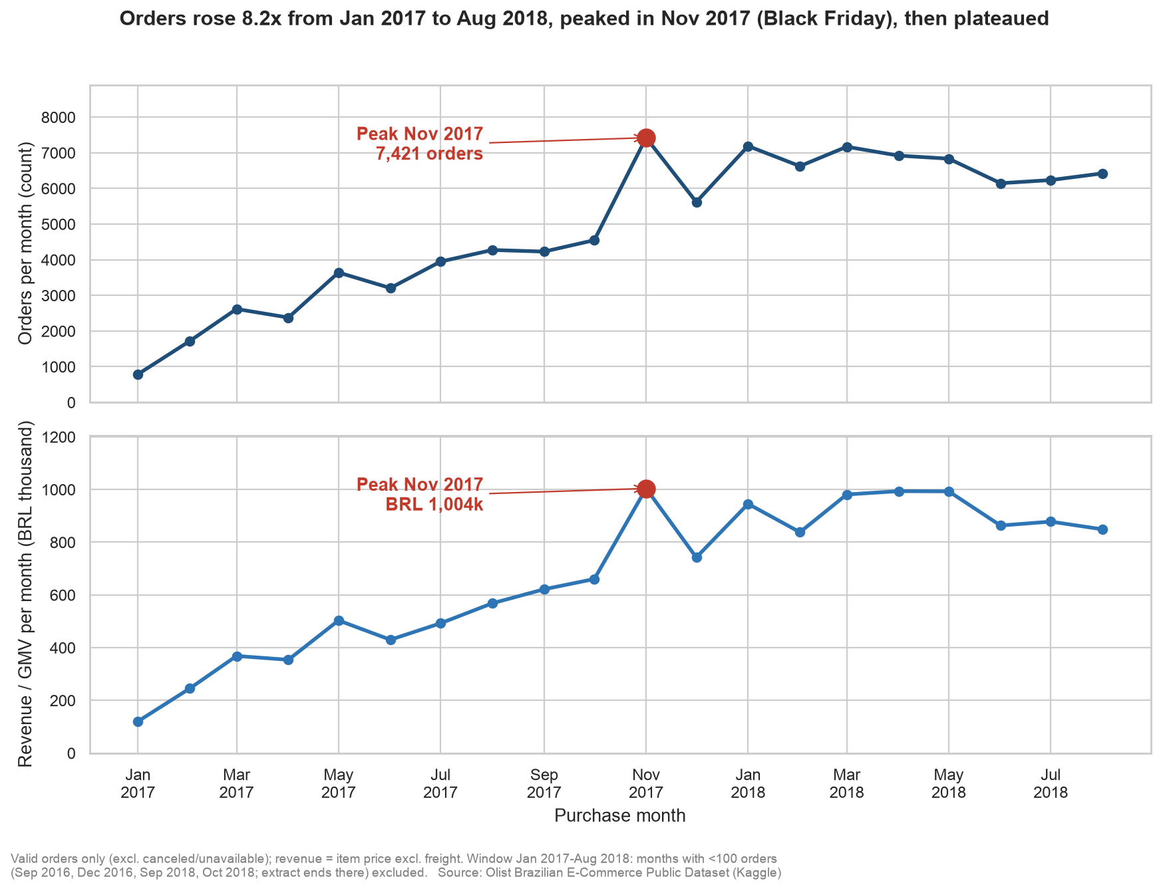
Figure 1: Orders rose 8.2x from Jan 2017 to Aug 2018, peaked in Nov 2017, then plateaued.
Monthly orders grew from 787 to 6,421, a multiple of 8.16, with an average MoM growth of 15.6% in orders and 14.2% in GMV. Comparing January-August 2018 with the same months of 2017, orders rose from 22,562 to 53,530 (+137.3%) and GMV from BRL 3,080,850.81 to BRL 7,341,037.41 (+138.3%). November 2017 was the peak, and the single busiest day was 2017-11-24 with 1,166 orders, consistent with Black Friday although the data does not prove the cause. After the peak, orders fell 24.3% in December and settled on a plateau of roughly 6,100 to 7,200 orders a month in 2018.

4.2 Q2: Which weekdays and hours do buyers purchase most?
Distinct valid orders were counted per (weekday, hour) and the hours pivoted into 24 columns, giving a 7 x 24 matrix (98,199 orders) that was passed to the heatmap.
Table 12: Orders by weekday (valid orders)
Mon | Tue | Wed | Thu | Fri | Sat | Sun
15,978 | 15,758 | 15,350 | 14,571 | 13,948 | 10,763 | 11,831

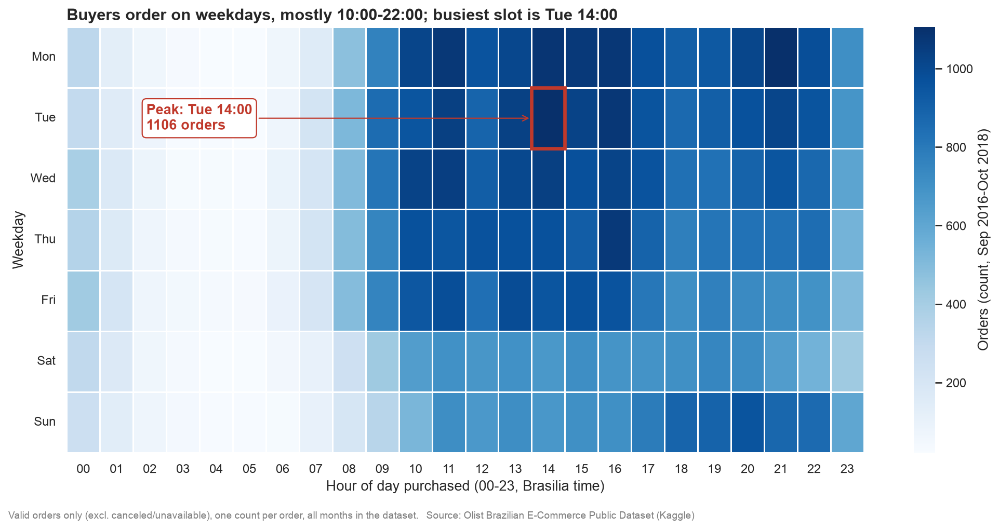
Figure 2: Buyers shop on weekdays between mid-morning and evening; nights are quiet.
Monday is the busiest weekday (16.3% of orders) and Saturday the quietest (11.0%); weekdays together carry 77.0% of orders and the weekend 23.0%, an average of 15,121 orders per weekday against 11,297 per weekend day. The 14:00-17:00 band alone holds 19.8% of orders, hours 10:00-22:00 hold 75.7%, and the quietest period, 00:00-06:00, only 4.8%. The single busiest cell is Tuesday at 14:00 with 1,106 orders, and the busiest hour overall is 16:00 with 6,594 orders.

4.3 Q3: Where are buyers and revenue concentrated?
Orders and GMV were aggregated per customer zip prefix and per state. The zip aggregates were left-joined to the averaged geolocation table (so unmatched zips could be counted rather than silently lost) and only the 14,807 mapped prefixes were handed to the plotting libraries. Of 98,199 valid orders, 274 (0.28%, from 157 zip prefixes) could not be placed on the map.
Table 13: Top five buyer states by GMV (valid orders)
State | Orders | GMV (BRL) | GMV share | GMV per customer (BRL) | Sellers
SP | 41,125 | 5,163,867.22 | 38.27% | 129.92 | 1,849
RJ | 12,697 | 1,811,623.42 | 13.43% | 148.00 | 171
MG | 11,496 | 1,573,508.20 | 11.66% | 141.32 | 244
RS | 5,415 | 742,559.78 | 5.50% | 141.90 | 129
PR | 4,982 | 676,883.06 | 5.02% | 140.32 | 349

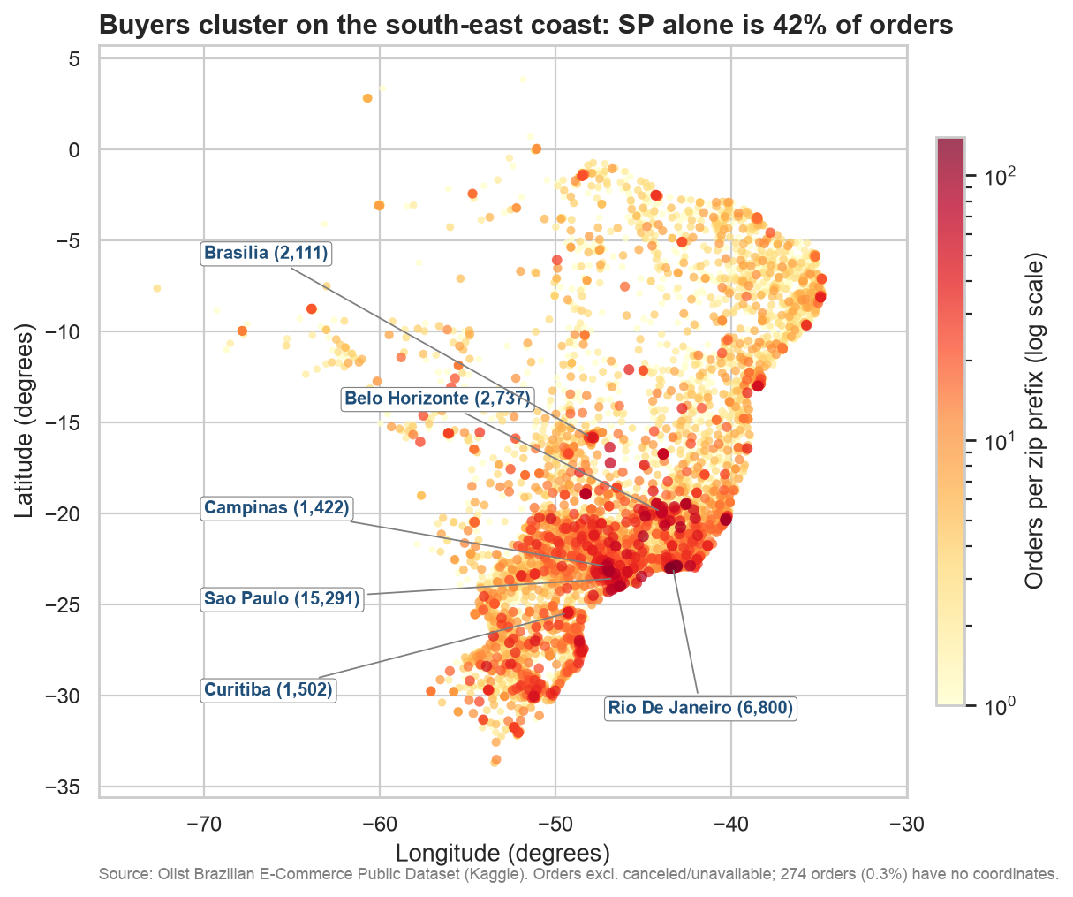
Figure 3: Orders cluster along the south-east coast, around Sao Paulo and Rio de Janeiro.
SP, RJ and MG together give 63.35% of national GMV (BRL 13,494,400.74) and 66.52% of orders. SP alone has 41,125 orders (41.88% of orders), and the city of Sao Paulo alone 15,291 orders (15.57%), ahead of Rio de Janeiro (6,800; 6.92%) and Belo Horizonte (2,737; 2.79%). Buyers in RJ spend more per customer than those in SP (BRL 148.00 against 129.92). Supply is even more concentrated than demand: 1,849 of 3,095 sellers (59.74%) are in SP. The notebook also contains an interactive folium map (figures/q3_buyer_map.html, 9,758 circle markers, 7.17 MB) with zoom and tooltips; the static figure above is the same data on a log colour scale.

4.4 Q4: Do late deliveries lower review scores?
Delivery metrics were computed at order level: delay = delivered date minus estimated date, an order is late if delay is positive, and the delivered orders were joined to the latest review per order. Of 96,470 delivered orders, 95,824 have a review.
Table 14: Review scores for on-time and late orders
Group | Orders | Average score | 1-star reviews
On time | 89,443 | 4.29 | 6.62%
Late | 6,381 | 2.27 | 53.77%

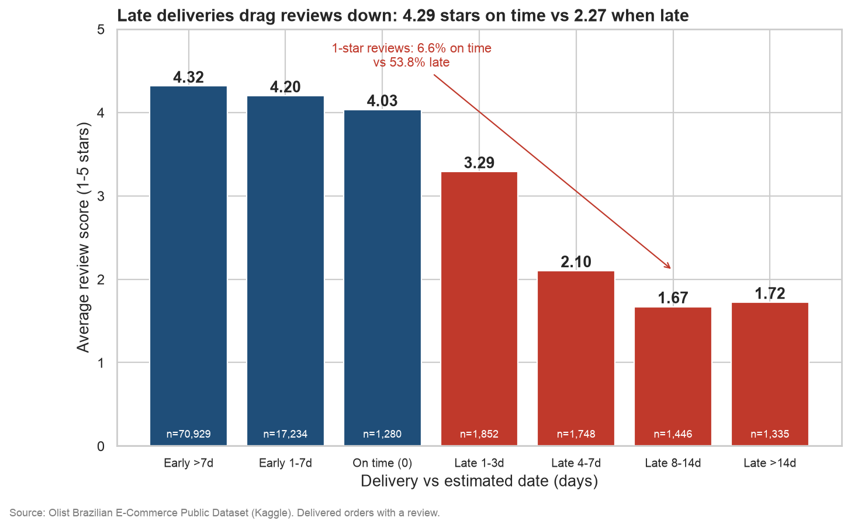
Figure 4: Late deliveries drag reviews down: 4.29 stars on time versus 2.27 when late.
Table 15: Review score by delivery delay bucket
Delay bucket | Orders | Average score | 1-star share
Early more than 7 days | 70,929 | 4.317 | 6.47%
Early 1-7 days | 17,234 | 4.201 | 7.07%
On time (0 days) | 1,280 | 4.034 | 8.52%
Late 1-3 days | 1,852 | 3.291 | 25.11%
Late 4-7 days | 1,748 | 2.103 | 58.58%
Late 8-14 days | 1,446 | 1.671 | 70.61%
Late more than 14 days | 1,335 | 1.724 | 68.99%

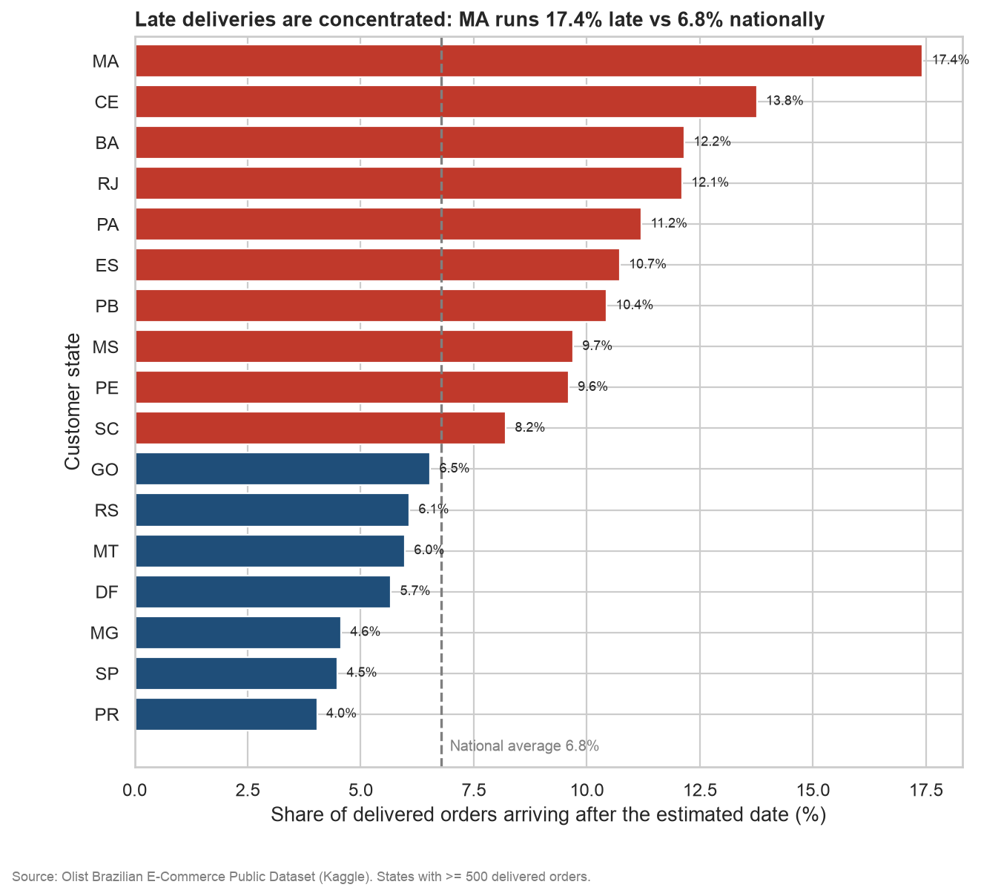
Figure 5: Late deliveries are far more common in the north-east and Rio than in the south-east core.
The national late rate is 6.77%, but it varies strongly by buyer state (among the 17 states with at least 500 delivered orders): Maranhao (MA) reaches 17.43% with 21.5 days average delivery, Ceara (CE) 13.76% and Bahia (BA) 12.16%, while SP has 4.49% (8.7 days) and PR the lowest at 4.04%. Scores fall steeply as delays grow and flatten after a week late. The overall correlation between delay in days and review score is -0.27, so this is an association: late orders may also differ in product or seller.

4.5 Q5: Which seller states ship to which buyer states?
We joined order_lines (which carries seller and buyer state) and counted orders per (seller state, buyer state) pair, together with GMV, average freight and average delivery days, giving 98,715 flows. An order with items from several seller states is counted once in each pair. The resulting edge list was drawn with NetworkX, with each state placed at the mean coordinates of its zip prefixes.
Table 16: Top five seller-to-buyer flows
Seller state | Buyer state | Orders | GMV (BRL) | Avg freight (BRL) | Avg delivery days
SP | SP | 31,293 | 3,585,867.19 | 13.20 | 7.86
SP | RJ | 8,421 | 1,099,866.81 | 20.46 | 16.03
SP | MG | 7,565 | 939,581.74 | 20.25 | 12.23
SP | RS | 3,661 | 449,317.64 | 20.70 | 15.95
SP | PR | 3,167 | 400,412.64 | 20.50 | 12.72

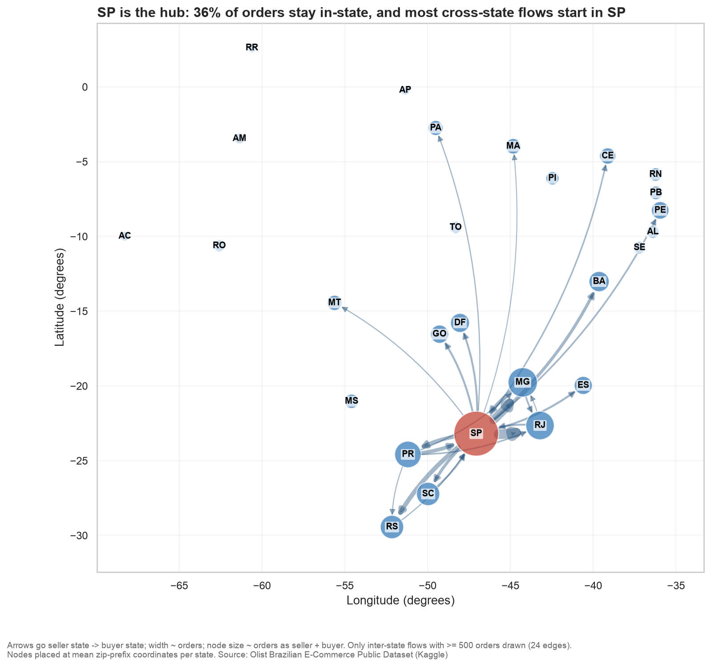
Figure 6: SP is the hub: 36% of orders stay in-state, and most cross-state flows start in SP.
Only 35.82% of flows (35,356 orders) stay inside one state; 64.18% (63,359) cross state lines. SP sellers originate 70.76% of all flows, and the ten largest flows account for 66.9% of orders. Distance costs money and time: average freight is BRL 23.69 for inter-state orders against BRL 13.45 intra-state, and SP to BA takes 19.68 days (2,380 orders) against 7.86 days for SP to SP. In the figure only inter-state flows with at least 500 orders are drawn (24 edges), of which SP-origin edges carry 73.13% of the drawn order volume.

4.6 Q6: Which product categories earn the most?
Valid order lines were grouped by English category name, ranked by GMV with a global rank window (acceptable because only 74 categories exist) and, separately, ranked within each buyer state with a partitioned window to find the leading category per state.
Table 17: Top ten categories by GMV
Rank | Category | GMV (BRL) | Share | Orders | Avg price | Avg review
1 | health_beauty | 1,255,695.13 | 9.31% | 8,800 | 130.34 | 4.15
2 | watches_gifts | 1,198,185.21 | 8.88% | 5,604 | 200.70 | 4.03
3 | bed_bath_table | 1,035,964.06 | 7.68% | 9,399 | 93.36 | 3.90
4 | sports_leisure | 979,740.92 | 7.26% | 7,673 | 114.06 | 4.12
5 | computers_accessories | 904,322.02 | 6.70% | 6,654 | 116.22 | 3.95
6 | furniture_decor | 727,465.05 | 5.39% | 6,425 | 87.67 | 3.92
7 | housewares | 626,825.80 | 4.65% | 5,847 | 90.65 | 4.07
8 | cool_stuff | 620,770.49 | 4.60% | 3,616 | 164.27 | 4.16
9 | auto | 586,585.73 | 4.35% | 3,872 | 139.53 | 4.08
10 | garden_tools | 481,009.94 | 3.56% | 3,505 | 111.14 | 4.06

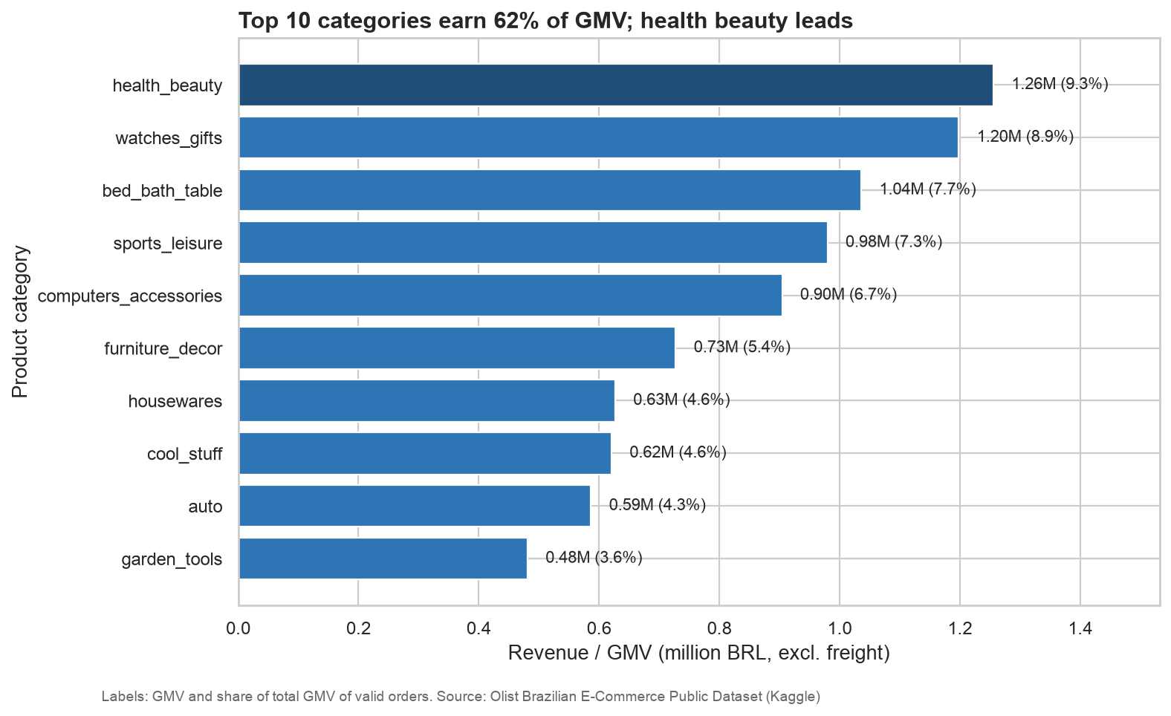
Figure 7: Ten of 74 categories earn 62.37% of all GMV.
The top 10 of 74 categories earn 62.37% of GMV, led by health_beauty (9.31%) and watches_gifts (8.88%). Volume and value differ: bed_bath_table has the most orders among the top three (9,399) but a low average price (BRL 93.36), whereas watches_gifts earns nearly as much from far fewer orders at BRL 200.70 per item. Review scores also differ (bed_bath_table 3.90, cool_stuff 4.16), and the leading category varies by state: bed_bath_table in SP and RS, watches_gifts in RJ and PR, health_beauty in MG.

5 Visualization techniques
Table 18: Charts used
Chart | Type | Why chosen | Advanced?
Monthly orders and GMV (Fig. 1) | Time-series line, two panels | Growth and a single spike are read best along a time axis; two panels avoid a dual axis | Yes
Weekday-by-hour (Fig. 2) | Heatmap | Two categorical dimensions and a count: colour shows intensity in 168 cells | Yes
Buyer map (Fig. 3, folium map) | Geospatial scatter / circle map | The question is about place; position, size and colour show concentration | Yes
Score by delay bucket (Fig. 4) | Bar chart | Compares a mean across ordered buckets; colour separates on-time from late | No
Late rate by state (Fig. 5) | Horizontal bar chart | Ranks 17 states on one measure | No
State flows (Fig. 6) | Network graph on map coordinates | Seller-to-buyer relationships are edges between states; geography keeps it readable | Yes
Top categories (Fig. 7) | Horizontal bar chart | Ranked long category names fit best on a horizontal axis | No

Design choices applied to every figure:
- Takeaway titles. Each title states the finding (for example "Late deliveries drag reviews down") instead of naming the chart.
- Annotations. Peaks and key contrasts are marked directly on the chart (the Nov 2017 peak, the 1-star shares, the largest cities) so the reader does not need the table.
- Log colour scale on the map. Orders per zip prefix range from one to thousands; a linear scale would show only Sao Paulo and Rio. A log scale keeps small clusters visible.
- Geographic node placement in the network. States sit at their mean zip-prefix coordinates rather than a force-directed layout, so the graph doubles as a map and distance is visible.
- Edge threshold. Only inter-state flows with at least 500 orders are drawn (24 edges); including all flows would hide the structure behind clutter. The table reports the full counts.
- Consistent palette and honesty. One navy and blue palette with red for the alert or peak, labelled axes with units (BRL), and a source note on each figure; bar charts start at zero.

6 Insights and recommendations

6.1 Key findings
- Q1: Growth was steep and Black Friday was the biggest spike. Monthly orders rose from 787 (Jan 2017) to 6,421 (Aug 2018), about 8.16 times. November 2017 peaked at 7,421 orders (BRL 1,003,862.14), up 63.2% on October, with a single-day peak on 2017-11-24 (1,166 orders), then fell 24.3% in December. A marketplace must provision capacity and promotions for a few extreme days, not the average month. Black Friday is a plausible cause, not proven.
- Q2: Buyers shop on weekdays, in the afternoon and evening. Monday is busiest (16.3% of orders) and Saturday quietest (11.0%); 14:00-17:00 alone holds 19.8% of orders and the single busiest slot is Tuesday 14:00 (1,106 orders). Campaigns and push notifications should land just before these windows, and heavy batch jobs belong overnight (00:00-06:00 is only 4.8% of orders).
- Q3: Demand is concentrated in a few states. SP, RJ and MG together give 63.35% of GMV; SP alone has 41.88% of orders and the city of Sao Paulo 15.57%. RJ buyers spend more per customer (BRL 148.00) than SP (BRL 129.92). Growth is mostly about deepening the south-east, while the remaining states are a smaller, harder-to-serve opportunity.
- Q4: Late delivery goes with much worse reviews. On-time orders average 4.29 stars versus 2.27 for late ones, and 53.77% of late orders get 1 star versus 6.62% on time. The national late rate is 6.77% but MA reaches 17.43% (average 21.5 days) while SP is 4.49%. Delivery promises directly shape seller ratings and repeat trust. This is correlation: late orders may also differ in product or seller, and the overall delay-versus-score correlation is only -0.27.
- Q5: SP is the supply hub, so most orders cross state lines. 64.18% of order flows are inter-state and only 35.82% stay in-state; SP sellers originate 70.76% of all flows. Average freight is BRL 23.69 inter-state versus BRL 13.45 intra-state, and SP to BA takes 19.68 days versus 7.86 for SP to SP. Distance costs buyers money and time, so geographic seller mix matters.
- Q6: A few categories earn most of the money. The top 10 of 74 categories earn 62.37% of GMV; health_beauty leads (9.31%), then watches_gifts (8.88%). Review scores differ (bed_bath_table 3.90, cool_stuff 4.16), so merchandising should focus on the top 10 while monitoring quality, since big categories are not automatically the best rated.

6.2 Connecting the findings
- Distance chain. 59.74% of sellers (1,849 of 3,095) are in SP (Q3), so most orders ship from SP (Q5). Far-away buyers wait longer (BA 19.3 days, MA 21.5, CE 21.2) and are late more often (MA 17.43%, CE 13.76%, BA 12.16%) (Q4), and late orders score about 2 stars lower.
- Supply gap. BA has only 19 sellers for 3,344 orders, so almost everything must be shipped in from elsewhere (Q3, Q5).
- Peak load meets fulfilment. The November 2017 surge (Q1) hit a network where inter-state shipping is already slow (Q5). Whether the surge itself raised lateness is not tested here.

6.3 Recommendations
Table 19: Recommendations with supporting evidence
Recommendation | Evidence (numbers) | Who acts | Expected impact
Plan capacity, stock and promotions before Black Friday | Nov 2017: 7,421 orders, +63.2% MoM, then -24.3% in Dec | Marketplace, sellers | Fewer stock-outs and slowdowns at peak; smoother December
Time campaigns and notifications to 14:00-17:00 on weekdays and Sunday evenings | 14:00-17:00 = 19.8% of orders; Mon 16.3% vs Sat 11.0% | Marketplace | Better response per message; batch jobs moved to quiet hours
Recruit sellers or open fulfilment hubs outside SP, starting with BA, CE, MA and RJ | SP sellers = 70.76% of flows; inter-state freight BRL 23.69 vs 13.45 | Marketplace, logistics | Shorter shipping, lower freight, fewer late orders
Show realistic delivery estimates and send proactive delay messages in high-late-rate states | MA 17.43%, CE 13.76%, BA 12.16% late vs SP 4.49% | Marketplace, logistics | Fewer unpleasant surprises, so fewer 1-star reviews
Track on-time delivery as a seller-quality metric | Late orders: 2.27 stars vs 4.29; 1-star 53.77% vs 6.62% | Marketplace, sellers | Ratings better reflect seller service; early warning on weak carriers
Prioritise the top-10 categories but watch their review scores | Top 10 = 62.37% of GMV; bed_bath_table 3.90 stars | Marketplace, sellers | Revenue focus without letting quality slip in large categories

7 Scaling to eBay
The analysis ran on a laptop, but each design choice maps onto the architecture we described in FA1.
- Storage and compute. At eBay scale the same PySpark code would run on a YARN cluster reading from HDFS instead of local CSVs. Only the paths and the cluster size change.
- Parquet. Columnar files let Spark read only the needed columns, which suits wide event tables far better than CSV. Partitioning the data by date would also let queries skip irrelevant files.
- Streaming. The late-delivery logic (promised date versus now) could run in Spark Structured Streaming to raise real-time delay alerts.
- Serving. Results such as per-state late rates or seller scores could be pushed to HBase or Cassandra for low-latency lookups on the website.
- Warehouse and MapReduce. The roles of Teradata or Greenplum (curated SQL reporting) and MapReduce (batch jobs) are covered by Spark SQL and DataFrames, which are shorter to write and keep intermediate data in memory.

8 Limitations
- Olist is a stand-in: Brazilian data from 2016-2018, so patterns such as the SP hub and the Black Friday spike will not transfer exactly to eBay.
- All links shown are correlations, not proven causes.
- Thin months (2016-09, 2016-12, 2018-09, 2018-10) were excluded from the Q1 trend.
- Q5 counts a multi-seller order once per seller-state and buyer-state pair, and delivery metrics cover delivered orders only.
- Spark ran in local mode on one machine; timings are informational and say nothing about cluster performance.

9 Conclusion
Using Apache Spark we turned nine raw Olist files into a clean, denormalised Parquet table of 112,650 order lines and answered six questions about marketplace demand and fulfilment. Demand grew 8.16 times in 20 months, peaks sharply around Black Friday, follows a clear weekday and afternoon rhythm and is concentrated in the south-east, while fulfilment from a single hub (SP) produces slow, late deliveries elsewhere that cost review scores. Seven visualizations, four of them advanced, made these patterns visible, and six evidence-backed recommendations follow from them. The same code and design carry over directly to eBay's YARN, HDFS and HBase stack described in FA1.

References
- Olist. Brazilian E-Commerce Public Dataset by Olist. Kaggle. https://www.kaggle.com/datasets/olistbr/brazilian-ecommerce
- Apache Spark documentation. https://spark.apache.org/docs/latest/
- PySpark API documentation. https://spark.apache.org/docs/latest/api/python/
- folium: Python data, Leaflet.js maps. https://python-visualization.github.io/folium/
- NetworkX: network analysis in Python. https://networkx.org/
- matplotlib and seaborn, Python plotting libraries. https://matplotlib.org/
- Seaborn: statistical data visualization. https://seaborn.pydata.org/
- Group report, FA1: "eBay and Big Data", Big Data Analytics (B.Tech), PCCoE.

Appendix A: Rubric coverage
Table 20: Coverage of the FA2 rubric
Criterion | Marks | Where addressed
Problem identification | 1 | Section 1 (FA1 link, problem statement, objectives, Q1-Q6); Section 2.1 (why Olist stands in for eBay); notebook introduction
Spark implementation | 3 | Section 3 (explicit schemas, pipeline, concepts table, code excerpts, RDD comparison); analysis/*.py scripts and the executed notebook
Data analysis and results | 2 | Section 2.3 (data quality) and Section 4 (Q1-Q6 results with tables); every number traced to the metrics file
Visualization techniques | 2 | Section 4 (7 figures) and Section 5 (4 advanced: time series, heatmap, geospatial map, network graph); interactive folium map in the notebook
Insights, interpretation, recommendations | 2 | Sections 6 to 8 (findings, connections, six recommendations, scaling to eBay, limitations)
Total | 10

Appendix B: How to run
- Open a terminal in the project folder and activate the virtual environment: source .venv/bin/activate.
- Start JupyterLab: jupyter lab.
- Open fa2/notebooks/fa2_olist_spark.ipynb and select the kernel "Python (fa2-olist)".
- Choose Run All. The notebook runs top to bottom in about 50 seconds on a laptop.
Table 21: Folder layout
fa2/
PLAN.md project plan
src/common.py Spark session, paths, palette, metrics helper
data/processed/*.parquet cleaned tables
analysis/ p1_prepare.py, q1_time_series.py ... q6_categories.py,
rdd_demo.py
figures/ PNG charts and q3_buyer_map.html
outputs/ metrics.json, data_quality.md, insights.md, viva_qa.md
notebooks/fa2_olist_spark.ipynb final executed notebook

Appendix C: Viva questions and answers
1. Why Spark instead of MapReduce?
MapReduce writes intermediate results to disk between every stage, while Spark keeps data in memory where it can, so multi-step analysis (joins, aggregations, iterative work) is much faster. Spark also gives DataFrames, SQL and window functions, so the code is shorter and easier to read.
2. What are transformations and actions, and what is lazy evaluation?
Transformations (filter, select, join, groupBy) only build a plan; nothing runs. Actions (count, show, collect, toPandas, write) trigger execution, and Spark optimises the whole plan first. We used explain() to show the plan before any action.
3. Why did you store data as Parquet?
Parquet is columnar and compressed, so Spark reads only the columns a query needs and keeps the schema with the data. CSV has to be parsed in full each time. Our cleaned tables (for example order_lines, 112,650 rows) are written once and re-read fast.
4. What does caching do?
cache() keeps a DataFrame in memory after it is first computed, so later actions reuse it instead of recomputing the whole chain from disk. It helps when the same table feeds several queries, like our joined order_lines table, but it is wasted if used only once.
5. RDD versus DataFrame: what did your demo show?
A DataFrame has a schema and goes through Spark's optimiser, so it is usually faster and shorter. In our demo, selecting a single column before calling .rdd cut the runtime from about 74 s to about 1.2 s, because df.rdd converts every row into Python objects, so fewer columns means far less conversion. Both approaches gave the same top-5 states (SP first with 41,746 orders).
6. What is a shuffle and which operations cause it?
A shuffle moves data across the network so that rows with the same key end up on the same partition. groupBy, joins and repartition cause it, and it is usually the most expensive step in a Spark job, so we avoid unnecessary ones.
7. Why use window functions?
They compute a value for each row using related rows without collapsing the data. We used lag to get month-over-month growth (for example November 2017 orders +63.2%) and rank to order categories by revenue.
8. Why Olist as a stand-in for eBay?
eBay does not publish transaction data, and Olist has the same marketplace model: independent sellers selling to buyers. It is public, has about 100k orders over nine linked tables (good for joins), and includes delivery dates and reviews.
9. How did you choose each advanced visualization?
We matched the chart to the question: a time-series line for growth over time (Q1), a weekday-by-hour heatmap for two-dimensional patterns (Q2), a map for geographic concentration (Q3), and a network graph for seller-state to buyer-state flows (Q5). Simple bars were enough for the late-vs-score comparison (Q4) and the top categories (Q6).
10. How would you scale this to eBay volumes?
Run the same PySpark code on a YARN cluster reading Parquet from HDFS, partition data by date, and avoid collecting large results to the driver. Use Spark Structured Streaming for real-time alerts, and serve results from HBase or Cassandra.
11. Why do late orders score 2.27 but on-time orders 4.29?
Late orders average 2.27 stars against 4.29 for on-time ones, a gap of 2.02, and 53.77% of late orders get 1 star versus 6.62%. This is a correlation: lateness probably drives dissatisfaction, but product and seller differences may also play a part, and the overall delay-vs-score correlation is only -0.27.
12. Why did you drop some months and clean the data?
Months with only a handful of orders (2016-09, 2016-12, 2018-09, 2018-10) would make growth percentages meaningless, so Q1 uses 2017-01 to 2018-08. In cleaning we kept the latest review per order to avoid duplicate rows in joins, and averaged 1,000,163 geolocation points into 19,010 zip-prefix rows.

