**Creation of Jar.**

* Created a SpringBoot project -> <https://github.com/msk4949/student-management-service>
* Project contains all project related files.
* Command to run the Jar file mvn clean install

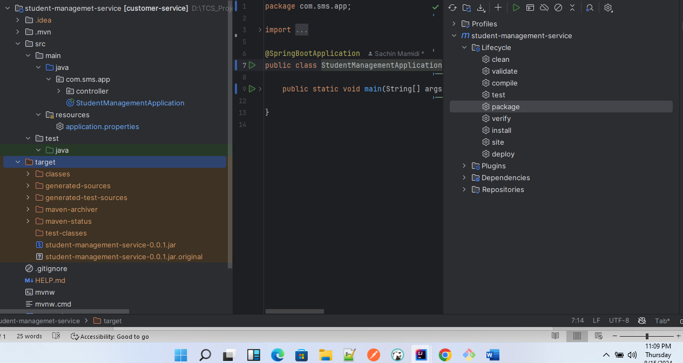

Create a docker file and build the docker image

Using below commands

**Build Docker Image**

docker build -t student-management-service-app .

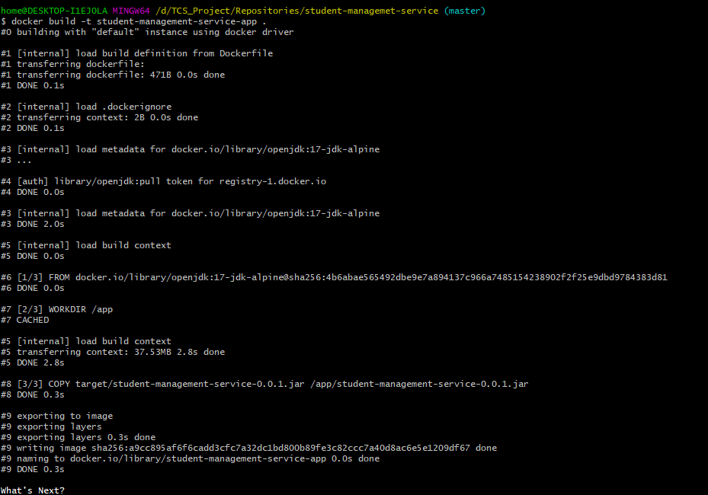

**Docker images:**

Command: docker images

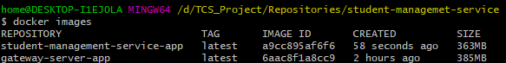

**Run the Docker Container:**

docker run -d -p 8080:8085 --name SMS student-management-service-app



**List the Container:**

Command: docker ps



**Access App Logs:**

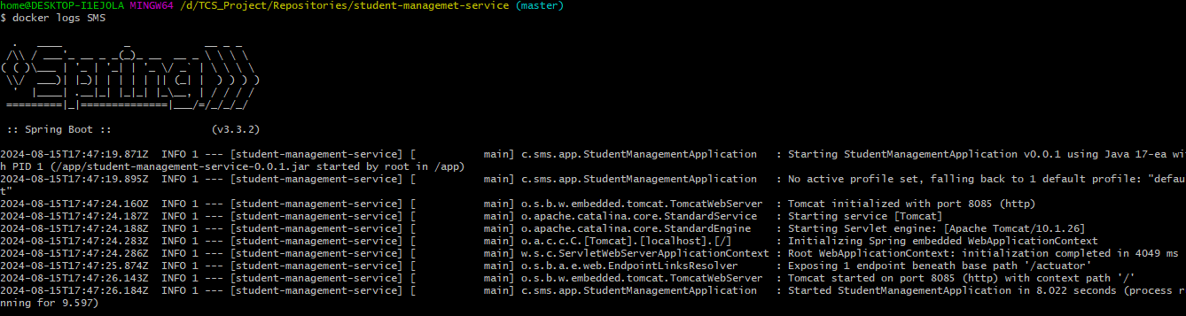

Access the application using browser

Endpoint: [localhost:8080/api/v1/student/sachin](http://localhost:8085/api/v1/student/sachin)

