Alice’s Adventures in Wonderland

# By: Lewis Carroll

*prepared by Julia Moska*



Plot page:

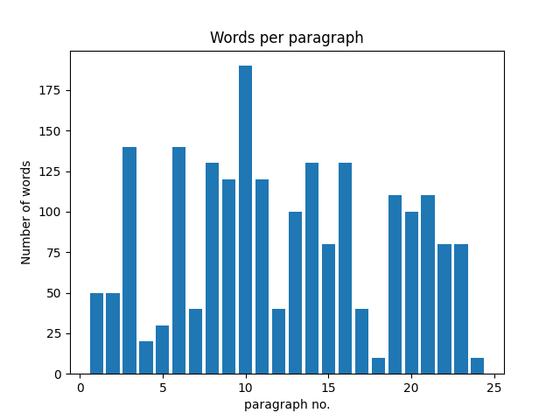

**Total Number of paragraphs: 24**

Maximum number of words: 190

*Minimum number of words: 10*

Average number of words: 85