Sii Source Code Pattern Generator

WebIDE Extension

Mateusz Skadorwa

# Table of content

1. Table of content 1

2. Protocol 1

3. About the product 2

4. Architecture of solution 3

4.1 How to read source code? 3

4.2 How to find cursor? 4

5. How to extend WebIDE 4

# Protocol

|  |  |  |
| --- | --- | --- |
| Date | Responsible for | Change |
| 20.04.2020 | Mateusz Skadorwa | Initial document |
|  |  |  |

# About the product

Sii Source Code Pattern Generator is a WebIDE Extension. It enables developers to accelerate the development due to the prepared templates of different objects like:

* Promises
* EventBus
* Functions
* Call Functions (BOPF Action)
* Cross Application Navigation
* Ajax Call

The product provides a quality of development, because the source codes are in accordance with SAP UI5 specification and JSDoc. How does it work? Extension reads the currently opened tab in WebIDE Editor, it looks for the place where your cursor stays and it puts there templates. From now, you haven’t to take care about semantic. You haven’t to look for the statements in your old projects or in community. Templates are gathered in one common place or you can explore them over shortcuts.

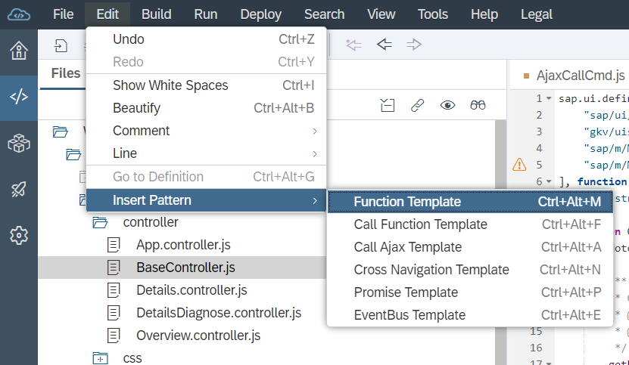

Picture 1 - Source code pattern generator. Functionality: Add Function Template

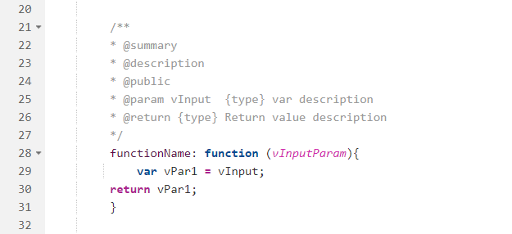

Picture 2 - Result of action ‘Add Function Template’

# Architecture of solution

Source code pattern generator uses the WebIDE SDK, which allows to create SAP WebIDE Extensions. The structure of extension looks like this:

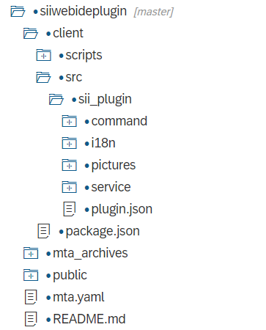

The client folder also contains a package.json file, which describes the extension and its metadata. There are two important folders (command, service) and file (plugin.json). Folder Command contains all services, which are responsible for registering commands, triggered by user interactions and can fulfill certain tasks, such as saving the content of the currently shown editor. Folder Service contains all functions, which are responsible for interfacing with command layer and provides functionality like reading data from workspace and so on.

The plugin.json file contains the plugin definition, it is built as a simple JSON object, which contains plugin class name, dependencies, services, Inherent service configurations for the plugin.

More about SAP WebIDE SDK you can find in following website: [https://sdk-sapwebide.dispatcher.hana.ondemand.com](https://sdk-sapwebide.dispatcher.hana.ondemand.com/index.html)

## How to read source code?

Module Content delivers the method to take care about the source code of currently opened tab. The method getCurrentDocument returns a promise, which give an access to tab. The method getContent returns the source code as a string.

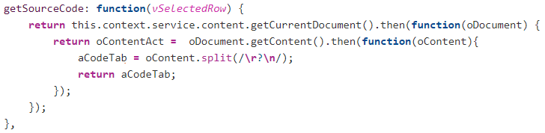

Picture 3 - how to read source code of opened tab

## How to find cursor?

Module content, which help with the content of source code, provides the methods to read the position of cursor. Method getFocusElement returns the handler to get position over the method getMarkers.

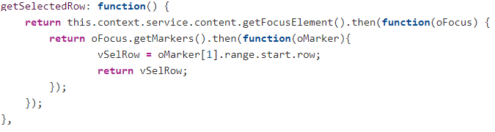

# How to extend WebIDE

In first step, the application has to be build. Then there will be created a folder, named mta_archives. When it will be available, then you have to deploy build file.

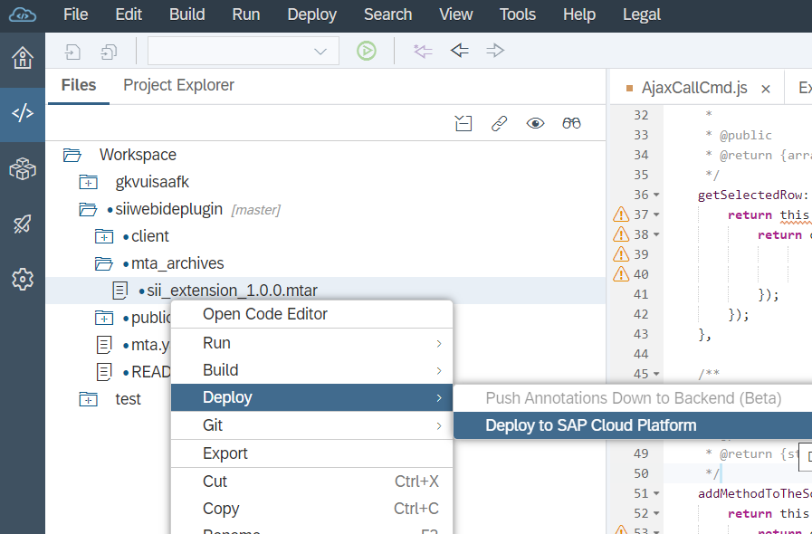

Picture 4 - Deploy an application

If it is done, you have to login into your SAP Cloud Platform Cockpit, and check what is the URL to the deployed application. You can find it, if you will chose your space, and then you have to open the Application tab. There you will see the deployed application. In the details of particular one, you will see the URL.

In next step, you need to configure new Destination in SAP Cloud Platform Cockpit. It is available under the tab Connectivity. The configuration of destination should looks like on the picture 5.

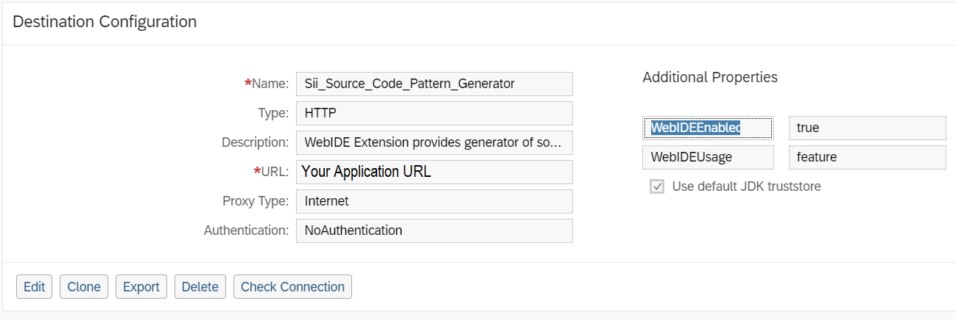

Picture 5 - Configuration of new destination

In final step, you have to enabled the extension in your WebIDE. In the Preferences tab, you have to open Extensions, and you need to look for Sii Source Code Pattern Generator and active the extension.

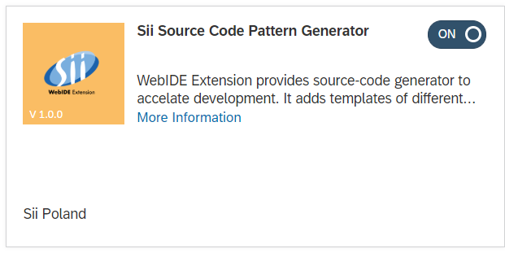

Picture 6 - Source Code Pattern Generator