Sii Whitelist of Taxpayers

SAP Fiori Application

Mateusz Skadorwa

# Table of content

1. Table of content 1

2. Protocol 1

3. About the product 2

4. Architecture of solution 2

4.1 Frontend layer 3

# Protocol

|  |  |  |
| --- | --- | --- |
| Date | Responsible for | Change |
| 08.05.2020 | Mateusz Skadorwa | Initial document |
|  |  |  |

# About the product

Sii Whitelist of Taxpayer is a Fiori Application, which help the polish customers to accelerate the business. The product helps end-users to check, if the cooperating company is registered as a VAT Tax payer. Application enables to check, if the invoice data are correctly and if the bank accounts has been correctly assigned. To prove it, we established connection with API of polish Government, which return us the most important information about selected company.

The product provides a high quality of development. It has been build as a Fiori Launchpad Component, so you can use it as a Standalone application, or you can make Cross Navigation from you existing Application.

The UX of application is in accordance with SAP Fiori Guidelines. Your users will not be surprised, because the application looks like any Fiori products.

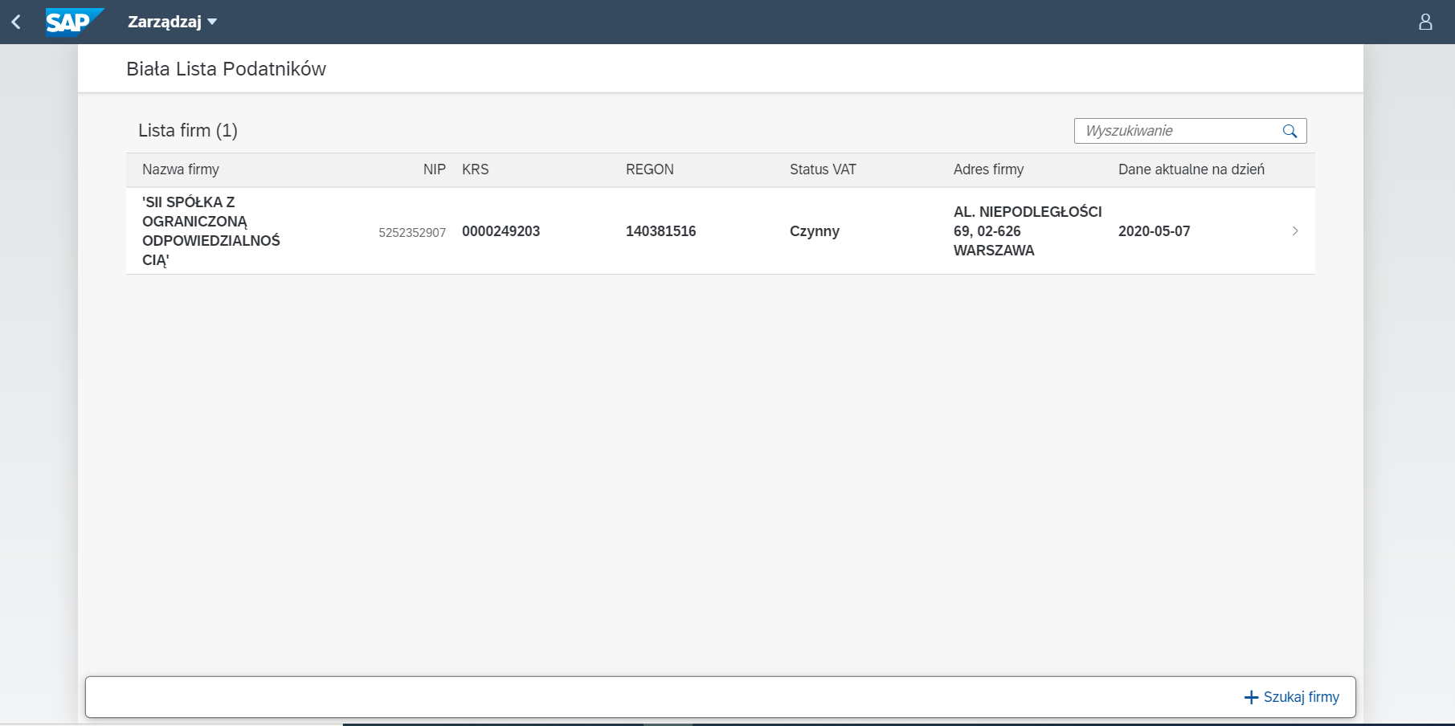

Picture 1 - Main Page of Application. List of companies

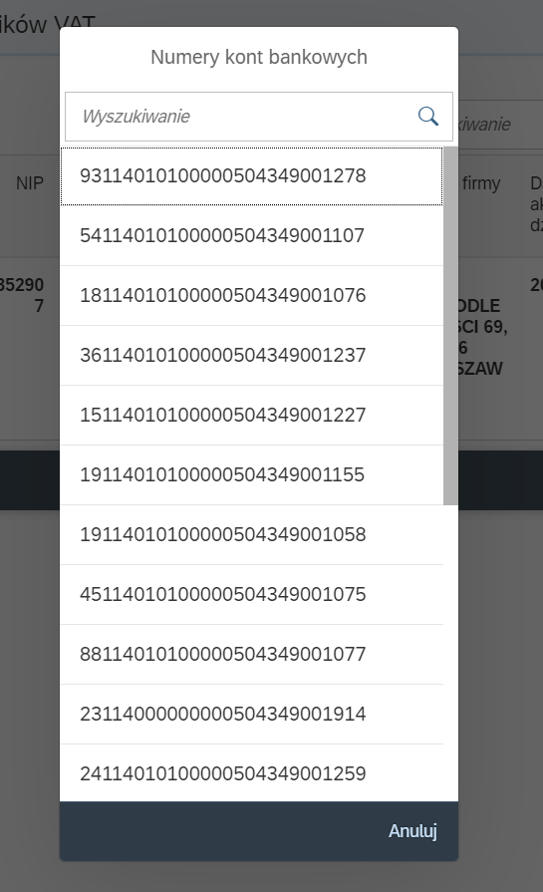

Picture 2 - List of bank accounts

# Architecture of solution

Sii Whitelist of Taxpayer is Fiori Application, which based on SAPUI5 Framework. It has been build as a Multi Target Application. For the customers the solution is offed as SaaS.

The structure of project looks as follows:

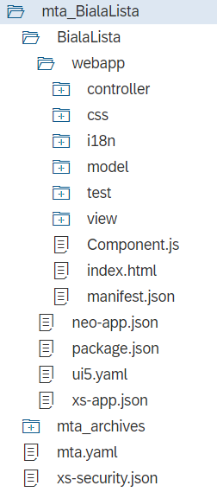

Folder BialaLista has all source codes, responsible for the UI layer and automatic testing of UI. There is no database, because the version allows only to display current data from API of polish Government.

## 4.1 Frontend layer

UI layer contain 3 view:

* Main view (ListView)
* Dialog1 (AddCompanyDialog)
* Dialog2 (AccountsDialog)

Main View displays particular information about selected company. There is navigation on the particular item, which allows to display all assigned bank accounts.