- 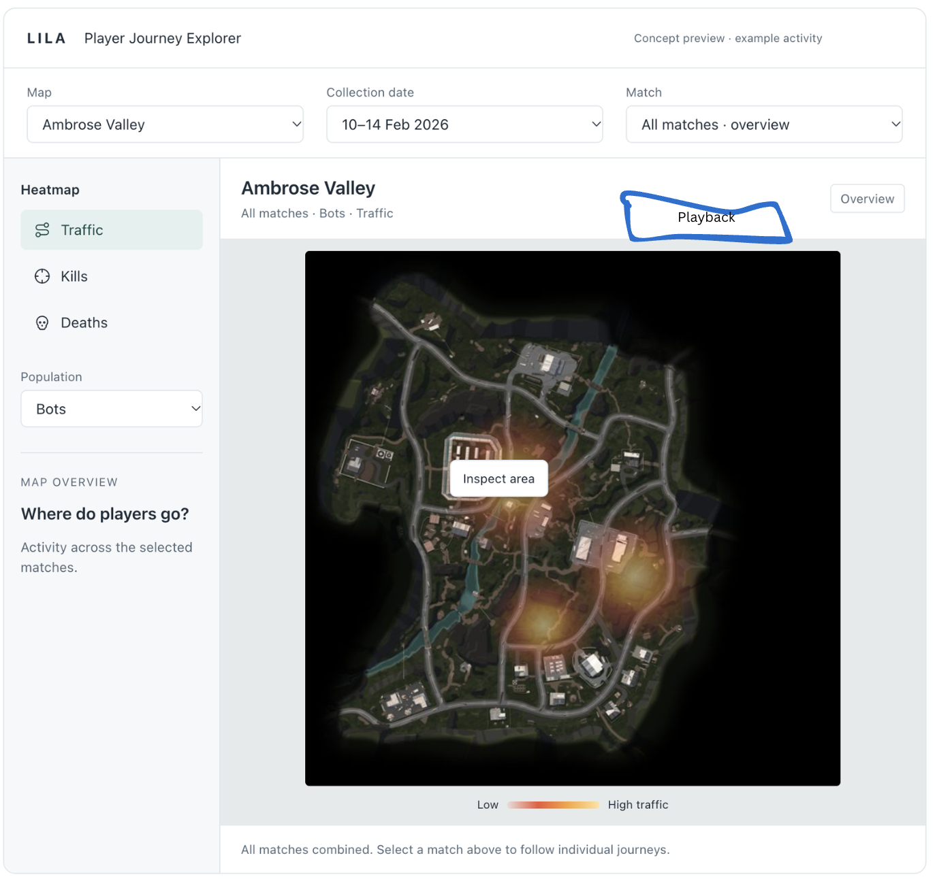
- THE OVERVIEW SCREEN PAGE:When user logs in to the portal he should be on a home screen. The home screen would be an overview screen. The map would be empty. It should be of Ambrose valley. The user can select the map from the drop down menu. The data would be selected as the first date available from our data. User should be able to select the date. Then comes selecting the match from the match drop down menu. The first match from the first date should be selected by default and the user should be able to select other matches. So by default, the user should see the overview. Like the above screen. But in the match drop-down button, there shouldn’t be a match overview option like shown in the above image. Now above the map there should be a PLAYBACK button which will toggle to match playback screen. Remove the Map overview section in the mid left. The heatmap section should be present. Remove the LILA games player explorer journey heading from the top.

