**PASSPORT: Enabling Accurate Country-Level Router Geolocation using Inaccurate Sources by David Choffnes**

**The problems this paper attempts to solve:**

* Accuracy of geolocation technologies are very poor
* The very best geolocation databases achieve more than 90% accuracy for only 46.5% of the countries explored in this paper
* Hostname parsing schemes are also another geolocation method that fails due to naming discrepancies (for example, “san” can indicate the airport code for San Diego, California, or a city such as “San Juan”).
* Constraint-based schemes based on speed of light constraints also lead to inaccuracy due to the use of an inaccurate geolocation database.
* **The main goal of this paper was to develop an online system that quickly adapts to changes in internet topologies to accurately identify the countries of internet routers.**

**Algorithm Proposed in Paper**

* The authors constructed a machine learning system that takes the following into account when determining geolocation:
  + **Traceroute data**
  + **Ground truth location labels**
  + **IP geolocation databases**
* **How the system is trained**
  + Ground truth labels are used to train an initial classifier
  + RTTs are used from traceroute data to rule out predictions that violate speed of light constraints
  + For routers that have no predicted country, geolocated routers on path and speed of light constraints are used to locate those routers.
  + This training terminates once the set of predicted router locations becomes stable (no more than 1% of router locations change from one iteration to the next)

**How this research could potentially improve our work**

* The researchers made their online predication system, user guide, and API available at <https://passport.ccs.neu.edu>
* **This allows a user to locate online routers through a traceroute measurement or by a single IP address**

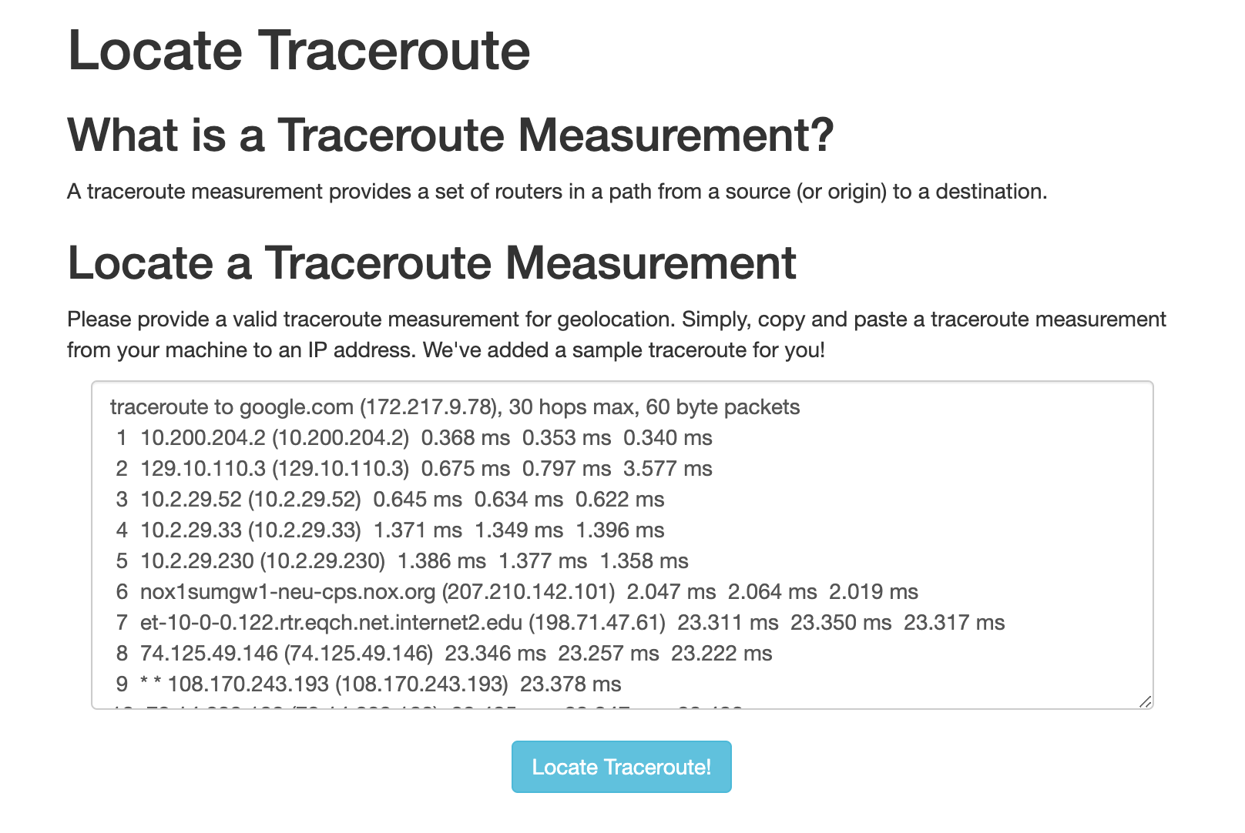

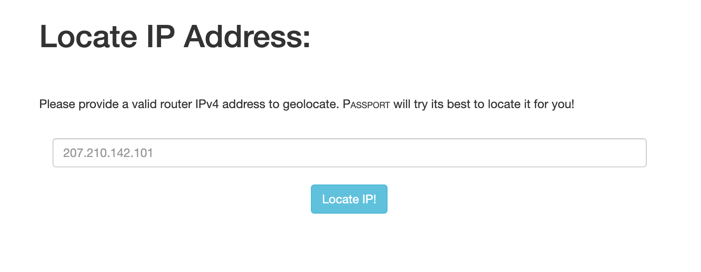

* **There is also an API that we could query to retrieve this data**

**API Pros:**

* We could potentially receive very accurate geolocations
* It was discovered in the paper that this system outperformed other geolocation sources in all continents, except Europe where Edgescape had the highest accuracy

**API Cons:**

* We will have to make many API requests which will slow down our code
* Still working on ways to see how this could efficiently be implemented