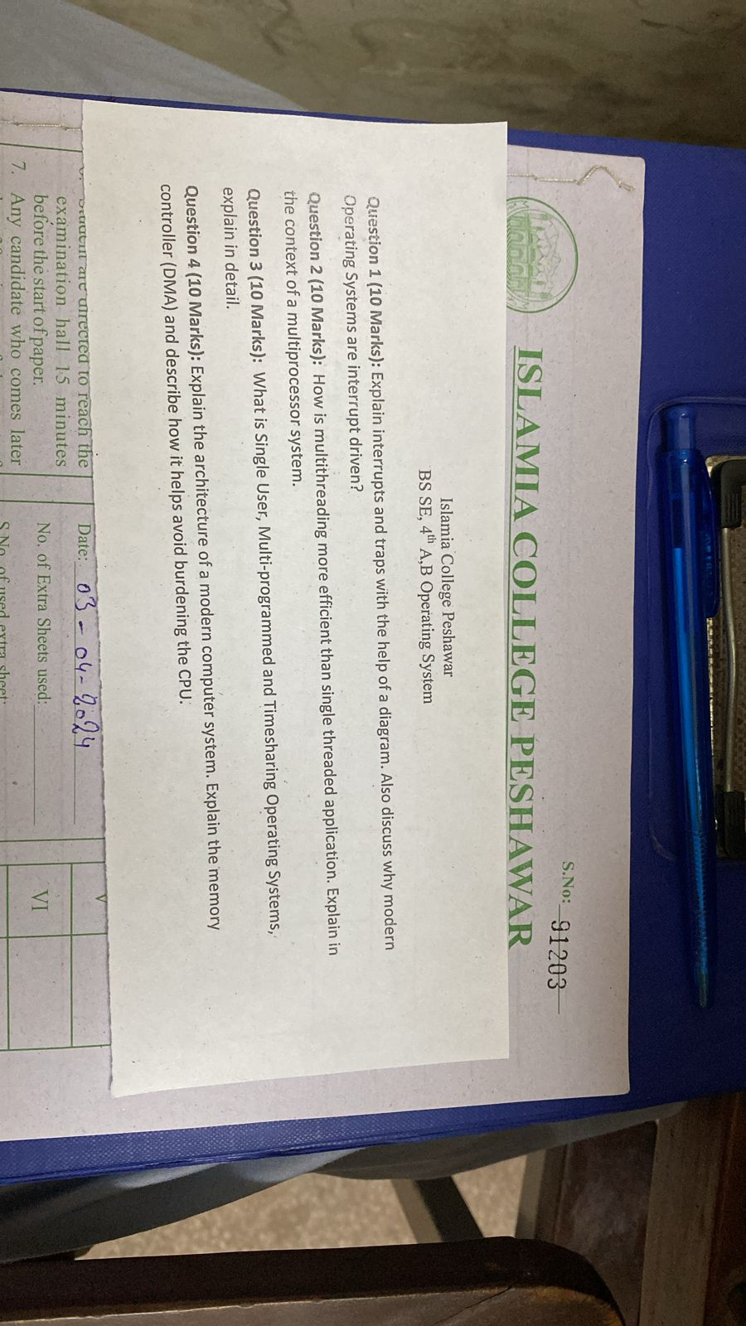**Question 1 (10 Marks): Explain interrupts and traps with the help of a diagram. Also, discuss why modern operating systems are interrupt-driven?**

**Interrupts and Traps**

* **Interrupts:** These are signals sent to the CPU to indicate an event that needs immediate attention. They can be:
  1. **Hardware Interrupts:** Triggered by external hardware devices (e.g., keyboard, mouse, printer).
  2. **Software Interrupts:** Triggered by software programs to request system services.
* **Traps (Exceptions):** These are special types of software interrupts generated by the processor when an error occurs (e.g., division by zero, invalid memory access).

**Diagram Representation of Interrupt Handling**

A basic diagram of how an interrupt is handled:

yaml

CopyEdit

Program Execution

|

v

Interrupt Occurs

|

v

Save Current State

|

v

Execute Interrupt Service Routine (ISR)

|

v

Restore Program State

|

v

Resume Execution

**Why Are Modern OS Interrupt-Driven?**

Modern operating systems are **interrupt-driven** because:

1. **Efficient CPU Utilization:** The CPU does not waste time checking devices; it gets notified when needed.
2. **Faster Response Time:** The system reacts to real-time events instantly.
3. **Multitasking Support:** Interrupts enable multiple processes to run efficiently.
4. **Device Communication:** External devices can interact with the CPU asynchronously.

**Question 2 (10 Marks): How is multithreading more efficient than single-threaded applications? Explain in the context of a multiprocessor system.**

**Multithreading vs. Single-Threading**

* **Single-Threaded Application:** Executes only one task at a time.
* **Multithreaded Application:** Can execute multiple tasks (threads) simultaneously within a single process.

**Efficiency of Multithreading in a Multiprocessor System**

1. **Parallel Execution:** In a multiprocessor system, each thread can run on a separate CPU core, reducing execution time.
2. **Resource Sharing:** Threads share the same memory space, reducing overhead compared to creating new processes.
3. **Better Responsiveness:** UI-based applications remain responsive because different threads handle UI and background tasks separately.
4. **Efficient CPU Utilization:** A single-threaded application may leave CPUs idle, whereas multithreading ensures all processors work simultaneously.

**Example:**  
A web browser with multiple tabs uses threads—one for rendering, one for network communication, etc.

**Question 3 (10 Marks): What is Single-User, Multi-Programmed, and Timesharing Operating Systems? Explain in detail.**

**Types of Operating Systems:**

1. **Single-User OS:**
   * Supports only **one user** at a time.
   * Can run only **one program** at a time.
   * Example: **MS-DOS**
2. **Multi-Programmed OS:**
   * Supports multiple programs in memory at once.
   * CPU switches between programs using scheduling.
   * Example: **Windows, Linux**
3. **Time-Sharing OS:**
   * Multiple users can interact with the system simultaneously.
   * CPU time is divided into small intervals (time slices).
   * Example: **UNIX, Linux Servers**

**Comparison Table:**

| **Feature** | **Single-User OS** | **Multi-Programmed OS** | **Time-Sharing OS** |
| --- | --- | --- | --- |
| **Users** | One user | One user | Multiple users |
| **Programs in Memory** | One | Multiple | Multiple |
| **CPU Utilization** | Low | Higher | Maximum |
| **Example** | MS-DOS | Windows, Linux | UNIX, Linux Servers |

**Question 4 (10 Marks): Explain the architecture of a modern computer system. Explain the memory controller (DMA) and describe how it helps avoid burdening the CPU.**

**Architecture of a Modern Computer System**

A modern computer system consists of the following main components:

1. **Processor (CPU):** Executes instructions.
2. **Memory (RAM, Cache):** Stores temporary data for quick access.
3. **Storage (HDD, SSD):** Stores data permanently.
4. **Input/Output Devices:** Communicate with users (keyboard, mouse, printer).
5. **System Bus:** Transfers data between components.

**What is DMA (Direct Memory Access)?**

* **Direct Memory Access (DMA)** allows devices to transfer data directly to RAM without involving the CPU.
* The **Memory Controller (DMA Controller)** manages these transfers.

**How DMA Reduces CPU Burden**

1. **Bypassing the CPU:** The CPU does not handle every data transfer, reducing its workload.
2. **Faster Data Transfers:** DMA enables fast data movement between storage and memory.
3. **Efficient Multitasking:** The CPU can continue processing other tasks while data transfer happens in the background.

**Example:**  
When copying files from a USB to a hard drive, the CPU does not process each byte; instead, the DMA controller manages the transfer.

These are the **detailed explanations** for each question. Let me know if you need further clarification! 🚀

**You said:**

Why Are Modern OS Interrupt-Driven? Modern operating systems are interrupt-driven because: Efficient CPU Utilization: The CPU does not waste time checking devices; it gets notified when needed. Faster Response Time: The system reacts to real-time events instantly. Multitasking Support: Interrupts enable multiple processes to run efficiently. Device Communication: External devices can interact with the CPU asynchronously. explain in details

**ChatGPT said:**

**Why Are Modern Operating Systems Interrupt-Driven?**

Modern operating systems (OS) are designed to be **interrupt-driven** to optimize performance, improve responsiveness, and support multitasking. This approach ensures that the CPU remains efficient and responsive by handling events as they occur, rather than constantly checking for updates (polling).

**1. Efficient CPU Utilization**

**Problem with Polling (Without Interrupts)**

Before interrupts were widely used, operating systems relied on **polling**, where the CPU continuously checks each device (keyboard, mouse, printer, etc.) to see if it needs attention. This approach has several drawbacks:

* **Wastes CPU cycles**: The CPU repeatedly checks devices even when there's no new data.
* **Inefficient**: Processing power is wasted on unnecessary checks instead of executing actual tasks.

**How Interrupts Improve Efficiency**

With an **interrupt-driven approach**, the CPU remains idle or continues executing other tasks until an event occurs. When an event (e.g., a key press or network packet arrival) happens, the device **sends an interrupt signal** to the CPU. The CPU then momentarily pauses its current task, processes the interrupt, and resumes its work.

**Example:**

* Without interrupts: The CPU continuously checks the keyboard to see if a key is pressed.
* With interrupts: The keyboard **only** sends a signal when a key is actually pressed, allowing the CPU to focus on other tasks in the meantime.

This method ensures that CPU resources are used efficiently, improving overall system performance.

**2. Faster Response Time**

**Polling vs. Interrupts in Real-Time Systems**

* **Polling-based systems** introduce delays because the CPU follows a **fixed schedule** for checking devices.
* **Interrupt-based systems** handle events **immediately** when they occur, reducing latency and improving responsiveness.

**How Interrupts Ensure Faster Response**

* As soon as a device needs CPU attention, it generates an interrupt.
* The CPU **stops its current task, handles the interrupt, and resumes the previous task**.
* This results in real-time processing without unnecessary delays.

**Example:**

* In a **real-time OS** (like those used in medical devices or industrial control systems), **interrupts are critical** to ensuring immediate response.
* In a **keyboard-driven system**, the OS **immediately** processes keystrokes instead of waiting for a fixed time interval.

Thus, modern OS can handle time-sensitive operations more efficiently.

**3. Multitasking Support**

**How Interrupts Enable Multitasking**

Modern OS need to run multiple applications simultaneously. Interrupts help achieve this by:

* **Time-sharing**: The CPU switches between different tasks using timer interrupts.
* **Process scheduling**: The OS assigns priorities to tasks and preempts them when necessary.

**Role of Timer Interrupts in Multitasking**

* The OS uses a **timer interrupt** to ensure that no single process occupies the CPU indefinitely.
* A **scheduler** assigns CPU time slices to different processes.
* When a **timer interrupt** occurs, the OS saves the current process state and switches to another process.

**Example:**

* In Windows or Linux, multiple applications (browser, media player, text editor) can run simultaneously because the OS **switches between processes** using interrupts.

Thus, multitasking would not be possible without an interrupt-driven system.

**4. Device Communication (Asynchronous Processing)**

**The Need for Efficient Device Management**

Modern systems interact with various **input/output (I/O) devices** (hard drives, network adapters, USB devices). Handling these devices **synchronously** would slow down performance.

**How Interrupts Improve Device Communication**

* Instead of the CPU actively checking devices, **devices notify the CPU** only when they need attention.
* This allows the CPU to perform other tasks while waiting for device responses.

**Example:**

* **Without interrupts:** If a printer is printing a document, the CPU would have to wait until the printing finishes before doing anything else.
* **With interrupts:** The CPU **delegates the printing task to the printer** and continues running other programs. Once printing is complete, the printer sends an **interrupt signal**, and the CPU processes the next steps.

This asynchronous communication improves the performance of modern operating systems.

**Conclusion**

Modern operating systems are interrupt-driven because interrupts **enhance CPU efficiency, responsiveness, multitasking, and device communication**. Without interrupts, systems would be slower, unresponsive, and inefficient. Interrupts **allow the CPU to focus on important tasks and handle external events only when necessary**, making modern computing smooth and powerful. 🚀

**You said:**

can you generate more sample paper relating to these 2 papers

**ChatGPT said:**

Here’s a sample **Operating System Midterm Exam Paper** based on the topics covered in the previous two papers. This will help you practice and understand the concepts better.

Os Sample Paper

**Islamia College University Peshawar**  
**BSCS 4th Semester - Operating System**  
**Midterm Examination**  
**Time: 120 min**  
**Marks: 30**

**Note: Attempt all questions.**

**Question 1 (10 Marks):**  
(a) Explain the concept of an operating system. Why is it necessary for modern computing?  
(b) List and explain any four important functions of an operating system.

**Question 2 (10 Marks):**  
(a) What are interrupts? How do they improve CPU efficiency?  
(b) Explain the difference between hardware interrupts and software interrupts. Give examples.

**Question 3 (10 Marks):**  
(a) Differentiate between single-user and multi-user operating systems. Provide examples.  
(b) How does a time-sharing system differ from a multiprogramming system?

**Question 4 (10 Marks):**  
(a) Discuss the role of the Process Control Block (PCB) in process management.  
(b) What is context switching? Why is it important in multitasking environments?

**Question 5 (10 Marks):**  
(a) Explain how memory management is handled in modern operating systems.  
(b) Differentiate between paging and segmentation in memory management.

**Question 6 (10 Marks):**  
(a) What is Direct Memory Access (DMA)? How does it help reduce CPU burden?  
(b) Discuss the advantages of using DMA in modern computing systems.

**End of Paper**

This sample paper includes questions covering **Operating System fundamentals, interrupts, process management, memory management, and Direct Memory Access (DMA).** Let me know if you need modifications or more sample questions! 🚀

**You said:**

How does a time-sharing system differ from a multiprogramming system?

**ChatGPT said:**

**Difference Between Time-Sharing and Multiprogramming Systems**

Both **time-sharing systems** and **multiprogramming systems** aim to improve CPU utilization and system efficiency, but they differ in how they manage processes.

| **Feature** | **Time-Sharing System** | **Multiprogramming System** |
| --- | --- | --- |
| **Definition** | Allows multiple users to interact with the system simultaneously. | Runs multiple programs at the same time to maximize CPU utilization. |
| **User Interaction** | Supports multiple users by allocating small time slices (time quantum) to each user process. | Focuses on executing multiple programs without user interaction. |
| **CPU Scheduling** | Uses **Round Robin** or **priority-based scheduling** to switch between users frequently. | Uses **job scheduling** to select which program runs next. |
| **Preemptive?** | Yes, uses **preemptive scheduling** to switch between processes quickly. | No strict preemption; processes run until they complete or require I/O. |
| **Response Time** | Fast response to each user due to time-slicing. | No guarantee of fast response; some processes may wait longer. |
| **Example OS** | Windows, UNIX, Linux (when multiple users access remotely). | Early batch processing systems, some embedded systems. |

**Key Difference in Simple Terms**

* **Time-Sharing** = Allows multiple users to interact with the system **at the same time** (e.g., multiple people using a remote server).
* **Multiprogramming** = Focuses on running multiple programs to keep the CPU busy, but not necessarily interactive.

Would you like more real-world examples to understand it better? 🚀

Top of Form



Search

Reason

Bottom of Form

ChatGPT can m