Welcoming the Era of Deep Neuroevolution[1]

Handout for the SZ1 class, Matyáš Skalický, 14.10.2018

# Introduction

In the upcoming seminar, I will talk about the idea of so called neuroevolution. A

## Gradient Descend (GD)

GD is an optimization algorithm that tweaks it’s parameters iteratively to minimize a given function to find the local minimum. You can imagine a climber going up a mountain that always chooses the next

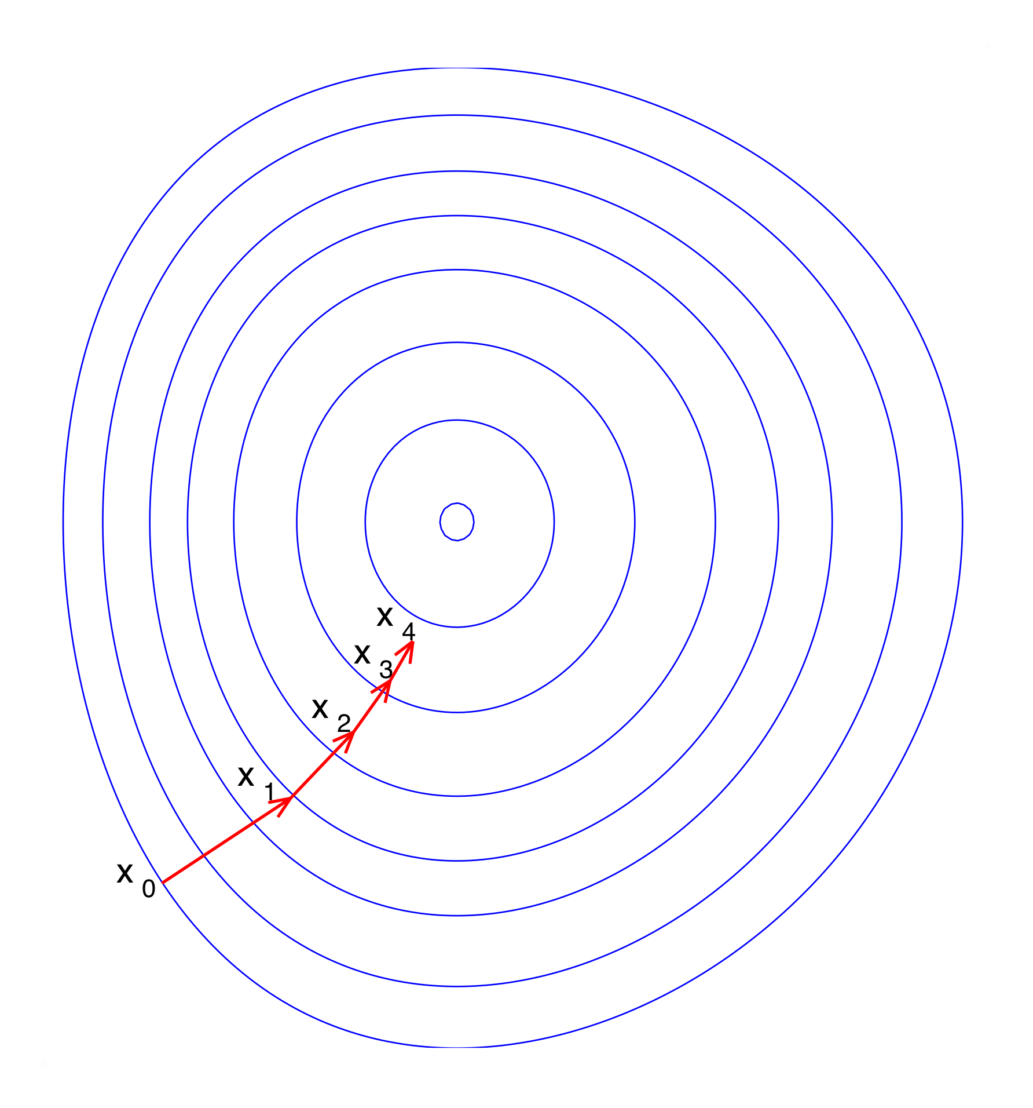

## Stochastic Gradient Descend (SGD)

# Neuroevolution