**MyTrade: Bouncing Back Bartering Via Cryptocurrency**

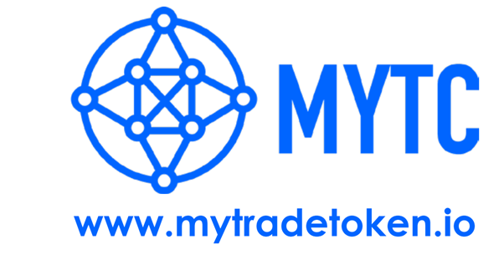

Introduction

Earlier people used to live in small groups, where communications were limited to society, news limited to radio, entertainment limited to circuses, exchange system limited to bartering and so on. A sort of contentment filled the spaces within. As the time flowed, people realized how luxuries can make a difference to lives. Sooner demands rose and corresponding to this, needs to fulfill them. Eventually market sectors made their place reaching out from small rooms to authorised shops.

But the scenario still remains the same. Most of the sectors that constitute to globalization are covered ONLY by small scale businesses. Where would I proceed to for buying daily stuffs? Or, where would I get my daily requirement products quite instantly? Easy, LOCAL MARKETS! What if we have a medium right in front of us which like an assistant divide our work? Yes, that's exactly what I said! An assistant who can make a list of all our expenses and make sure none of our hard-earned money is mishandled.

This is exactly what a Cryptocurrency market promises: a wallet with a security key securing the money. Additionally, a scope to add some amount just like a Bank provides its delegates with interest. A minute difference is, a Bank gives interest on deposited money and a Cryptocurrency wallet raises the present money by increasing Token currency value (optional).

Now, what we do with so much accounts related services when we can efficiently carry money everywhere? These services are for people like me, who like to fly freely anywhere without pondering upon the valuable assets jingling in my pockets. There were times when I left home to get some work done and most of the time I had to half-heartedly leave one or the other thing that captured my attention. Sometimes, there's a fantasy list of things that keeps on adding in a soft corner of our brain. What's fantastic about it? We can never find something we plan of (from that fantasy list) but magically they find us when we are out for something else!

To lessen the impact of such confused circumstances, markets are tempting hearts by linking themselves with a strong secondary option for candidates i.e. Cryptocurrency exchange system. And what can be better if we can exchange goods for goods, similar to the old barter system?

Entering the Crypto world with firm feet, presenting a new ray mixed with bygone barter system, MyTrade hopes to provide an easier option for traders.

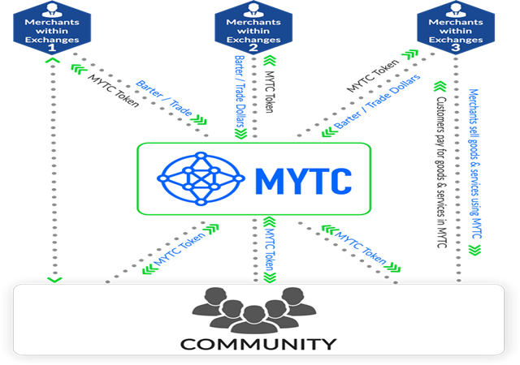

About MyTrade

MyTrade is a decentralised platform allowing traders to reach a vast range of customers and deal with them smoothly. Utilizing the Ethereum Blockchain technology, it promises a secured and modified transaction services with low trading costs. Taking barter system to a whole new level, the concept is: a seller can sell to buyer and not compulsorily buy something from the same trader. That means we are not forced to buy from the same buyer we sell our stuff to. All possible through MYTC Tokens compatible to ERC-20 wallets.

Ever wondered why some small shopkeepers keep limited stocks or only a handful items? Not much crowd move in to see what's stored following a low trading. MyTrade is here to bring customers and give a boost to their dull routines.

Conclusion

MyTrade looks forward to involve total community and expand the distribution of cost-effective trade networks. Joining hands together, they aim towards a successful growth in the future of markets. Highly influenced to raise the scopes of local/small scale markets, it builds a bridge between large and small businesses supporting each other in terms of profits and strength!