**OPTin: An Ideal Advertising Network**

**Introduction**

In today's competitive world, new ideas are produced nearly everyday. But how much it flies and gathers public depends upon the source of medium through which it is circulated. Say, for example, if a new technology is induced by Microsoft or Google, it will become a burning issue and reach thousands of ears in minutes. If the same thing is proposed by a small company, it will have to show reports and evidences about the new thought and may still not get the popularity it deserves.

Today, Marketing has touched heights and a huge credit goes to ADVERTISEMENT. Recently, I noticed one huge impact of advertisements. I went to a local bazaar (market) to check out some trendy clothing available with my friends. The market was a bunch of spacious streets aligned with stores. We got confused on which street to choose and what they have displayed. To our rescue, we found salesmen calling out customers telling the shop's name and what they have to show them! It was a nice idea to attract customers. That might cost sellers a penny, but the customer's attention makes it worthy.

A similar kind of craze is spread throughout the Online market place. Marketers pay for online advertisements, which appear on user’s screen while playing online games, surfing through sites etc. A majority of viewers become a target and the motive of ad is fulfilled. But is the motive really fulfilled? And if it would be so easy to grab attention of destined audience, then what are the further efforts made for?

Not every fisherman catches the most valued fish from the river! But each one of them has to lay out a net with strategies to increase their probability. Same goes with the marketers. A huge river full of variety of fish swim underneath, only few are valued for a particular market product. Businessmen have to locate them to sell their products and eventually make profits.

To make this job easy and to combine the matching puzzle pieces, OPTin is providing a wide network to participate in.

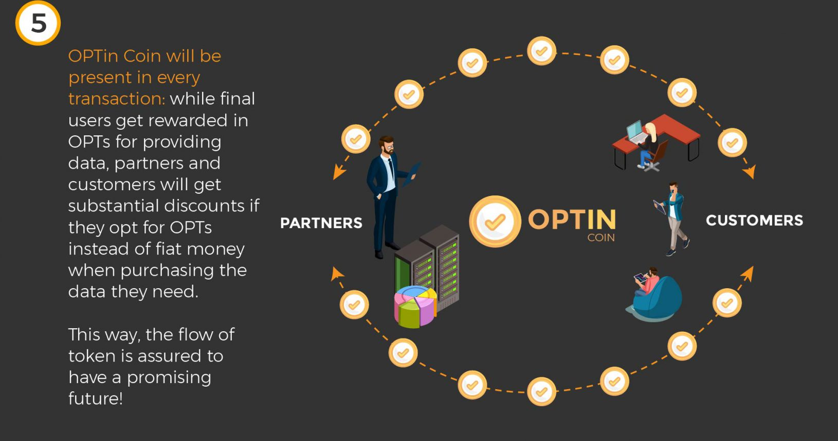

**About OPTin**

OPTin advertising network allows users to advertise in a brand new way! It provides a platform where users are free to choose industries to link their ads with. Rewards are granted to share data with advertisers. Using technologies like Datacube and Machine learning, OPTin advances in connecting direct links between advertiser and publishers.

Not that the current advertisement network is unreachable or weak, but it's kind of distorting on the grounds of honesty and trust. Data security is not provided and sometimes confidential data is at stake. Just because no one holds the right to claim as users are being misguided by abstracted information.

With an ample security of Blockchain system and encrypted database breaking over every armour, this new opportunity provides a path of growth among traders. Here, users can keep an eye on what's happening (records) and have access to all information to further make a solid view based on interests.

OPTin works primarily with OPTin Tokens (which provides certain freedom and extra benefits) and secured transactions are guaranteed by this end-to-end encrypted network.

**Conclusion**

Every change happens to be noticed, whether it affects the glass of water or the ocean, both directly or indirectly affect us. Similarly, every idea is worked upon to be noticed, it is on us what to opt-in.

OPTin provides an open platform to showcase the talented processes that needs to be seen and heard by rightful companies to share our part for a better world. Waiting for whom? Go and get the plane of dreams landed!