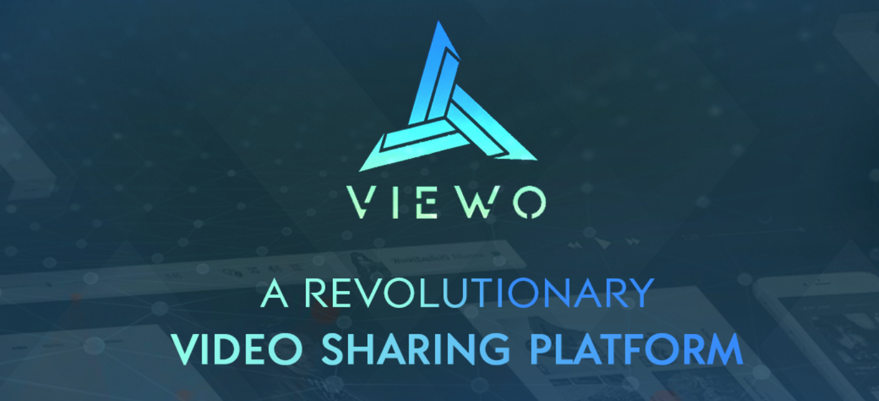**Viewo: Experience an Unusual Video-World**

**Introduction**

Photographs are insights of a perfect gathering, memorable moments, weddings, outings and many more. A picture depicts a moment captured with the special feelings it held. Ideas gathered up to transform this standstill moment into a living video! What’s more beautiful than having a wonderful packet of emotions captured as a video.

With the evolution of technology, internet supported sharing of videos via various social networking sites and statistics show that more than 5 billion videos are viewed out of which 85% people share them. What is the need? It can be to maintain the bonding between relatives, can be a professional issue or meeting a noble cause! Video sharing became a part of our lives. Even News channels sometimes rely upon video clips to process facts and information. Anyway, a photograph re-develops a feeling but a video takes you to the previous tour again.

YouTube has emerged out to be attract one largest viewer community with various sharing, commenting, choosing options available. What I do is open YouTube, hit a song and start listening having put auto-play ON. What efforts does it take? Nothing! It’s just 2 clicks away to get mesmerised, hypnotised or sometimes lost in the fantasy world and sleep.

The question is, why would then we even try on a new technology?

All of us need some sort of entertainment for passing time or to drive our minds away from stress. Music tends to calm our tensed minds and is said to renew our working system. Some choose to listen while others dance out their passion for music. Video sharing has risen to an extent that movies, daily soaps, web series are telecasted on various platforms. Many famous personalities have gained identity through video streaming! And the list goes on. In short, videos have become one important must-to-watch activity in our lives.

The world keeps moving and so should we. If the wheel invented was not taken on various trials, we would be running marathons around each day. What happens is for the sake of good. A varied lot of inventions are strategies are building up these days, all competing to set a new era of revolution through them. And why not? We are showering upon buckets of advantages. Then why not bath under its offerings. And why not shake hands together to witness a transformation occurring right in front of our eyes!

What if through this mere pass-time we are able to earn? Can’t believe what’s written? Yes! A platform where the usual video streaming, sharing, liking or criticising is possible with an unusual feature of earning side by side.

Viewo provides these facilities with some special add-ons!



**About Viewo**

Viewo is a decentralised video sharing system in which viewers too will be rewarded for their actions and contributions. Online video sharing and ratings, all possible with some associated incentives offered to users (in form of VEO Tokens). These tokens are provided to access private videos, online courses, shop what is in demand!

All these features combined in a package using Ethereum Blockchain technology, where users enjoy end-to-end encryption. ERC20 cryptocurrency wallet support and utter privacy are creating a strong pull towards giving the platform a try!

Something extraordinary? A bonus reward is guaranteed to new users as an attraction.

**Conclusion**

Viewo platform is a decent thought behind a huge revolution to take over the world of videos we see and share regularly. More than the benefits offered, it ensures a good experience to users. Also, it doesn’t seem an easy task to challenge a renowned website like YouTube with such confidence and belief!