**NordCoin Mining- A wave of change**

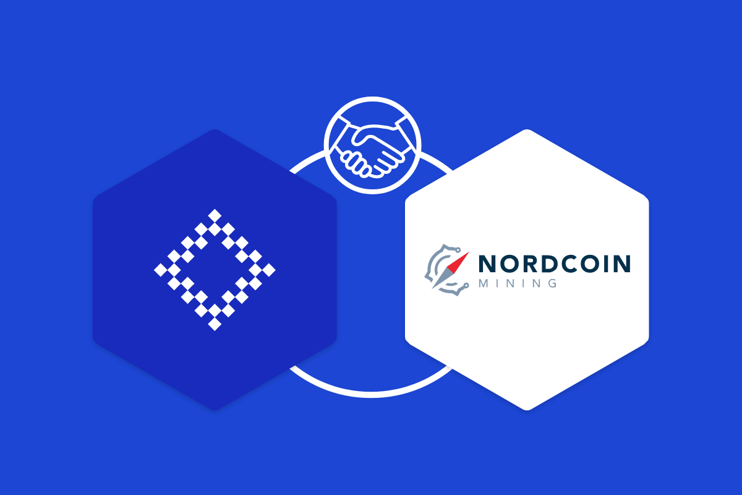

**Introduction**

Mining- in very simple words, is a process of extraction of valuable commodity like minerals to earn profit. A huge number of people are involved in the same, some for the mining equipments, some for storage purposes and some for transportation services. From there, it is exported to various countries and profit is earned.

What’s all this for? Profits? But this requires too much of physical man force! And with evolving renewable sources, we are stepping into a greener and cleaner fuel world. Carrying forward the same ideology of ‘getting work done at ease’, concept of Coin Mining came into action!

Mining of coins? Currency? Yes, read it right! A virtual place where money can be mined (extracted) and used in the real world. The money that carries quite a good value! Cryptocurrency has already made a place in markets and every developing as well as developed industries are investing in huge scales. Not only this, small scale companies too see the revolution charming. In fact, individuals find the decentralised concept so powerful that they are sharing most shares today!

Sounds romantic? With the word ‘EASY’ follows difficulty. Hardships are present to make any project successful. And so does with mining. Huge amount of electricity is used up in crypto mining farms built in a place. Added to this, they are non-mobile. This is a serious problem to the restless, moody and ready-to-change places youth. And security is at stake always. What to do to further spread the powerful fragrance of Crypto-mining to larger extents?

Is it completely safe from predator’s eyes? Is there no way a hacker can crack into the system and blow away all of the mined currency? Also, there is no centralised system coping up with every detail legally. Is it safe to mine then? That’s what we are here to answer! Blockchain technology isn’t just capturing every industrialist’s attention, but it is also providing a secured network of linking several blocks together! And that too safely away from devilish eyes of hackers!

With a door closed comes a new ray of light shining in some other direction! We just need to follow the illumination. Nordcoin mining is the ray of shine for the observed lag in Crypto mining.

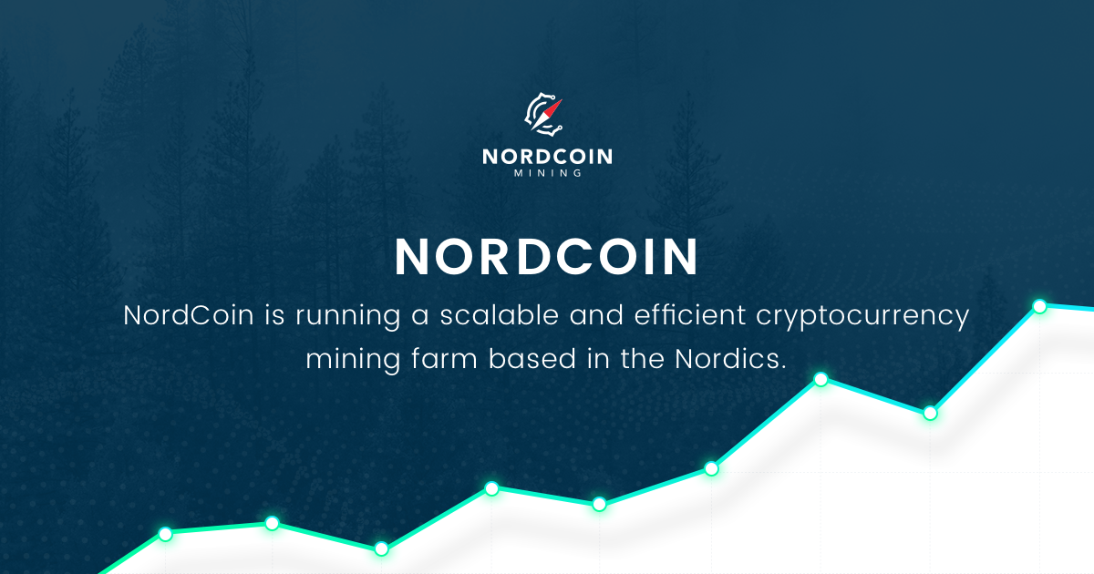

**About NordCoin Mining**

Like a warrior racing his horse through fire-filled castle, NordCoin mining is racing the fields of emerging Crypto world protecting its services from the spreading fires of security breakers. Its dynamic features support the statement above.

NordCoin mining is a decentralised crypto mining platform and is here to cut-off transportation costs, providing minors to change their location as it supports various climatic conditions! Also, it initiates in managing heat and electricity requirements to stable and available levels. Collaborating with Ethereum Blockchain network, it aims to provide best mining experience all via NRDC Tokens (compatibly ERC-20). Its mobile mining containers picked up difficulties faced by miners, crushed them all and made a perfectly designed platform to meet the required needs.

NRDC Tokens can also be used to rent hashing power (required for mining)! Heard less wonders? Can digest more?

There are exciting discounts available on the cost of electricity and service fees!

**Conclusion**

Nordcoin mining platform provides an efficient way to miners to invest and work effectively through crypto-mining network. It worked on the features that unleashed some crazy techies and land their feet on the craziness (Crypto-mining controlling the new era waves) that follows beyond! They hope to combine mobility and security of data at the same time!

In short, it offers a combo of security, cost-effective electricity with low service charges and brilliant cooling power to miners. Check out other features and bang on!