**UNIVERSAL RECOGNITION TOKEN: FAMILY TO EVERY INDIVIDUAL**

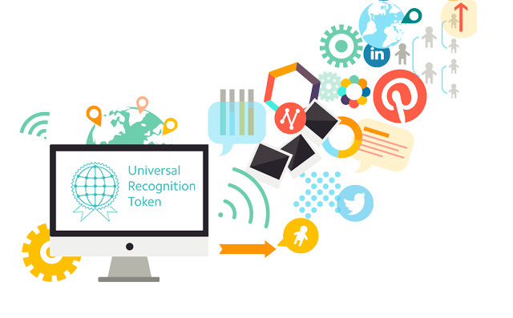

**Introduction**

A business set-up is not an easy task to begin with but it certainly does shower great profits when mixed with hardships and valued time. Eventually when a company expands its links and members, the owner needs to keep everyone bound together in a string. And therefore, a trend of organising various events to buckle up team members and show them their importance.

But not every wind blow in the same direction. Usually the gifts offered for some promotion or ceremony are same as expected always. And they might end up sitting in the cupboards for years. This lessens their excitement for working sometimes. On the other hand, company is purchasing those gifts (cards, wall clocks, merchandise etc.) on a large scale in exchange of money and not for free.

Employees sometimes get used to the gift they get and the driving force to work more lessens. And what if they are promised to get whatever they want in the take-away prize amount?

Recently, I attended an annual convention. All the deserving candidates got a 10,000 INR ($148.35) cheque signed by the authority. I found this idea very fascinating. How fantastic it would be to spend the prize money at our own terms! We daily wish to expand our assets and fulfil our dreams. Why not use our own earned money to mark our fantasy list done? If someone ask me how I will prefer my gift, I would definitely like to choose so that I’ll be 100% happy!

There is a huge chaos going right now in the business markets about what to gift an employee and the decision always ends up on either gift cards, company merchandise or some fascinating trip. And obviously it takes time and money to pre-order and schedule everything a month or two prior to the event. It is found that not everyone finds time to enjoy the trip too! Be it his destination place. Results? Money is already wasted but the time invested in scheduling bears no fruit!

Keeping this in mind, a new scheme brings with it several benefits with idea of exchanging gifts with items we prefer or can store the exchanged money. Also, adding to this glamour, blockchain technology is held responsible to every online transaction made for the exchanges. How appealing! Isn’t it?

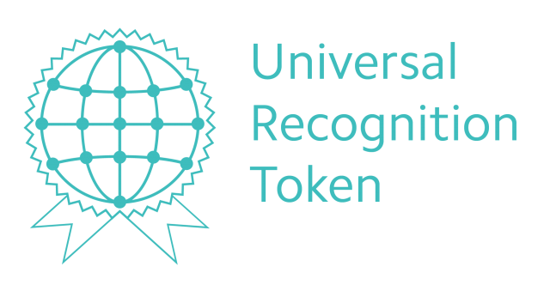The Universal Recognition Token platform is providing us with our preferable rewards and making a record of it in the firm we are working, so that the company recognises the needs accurately and plan for the events accordingly.

**About Universal Recognition Token (URT)**

A vast platform, Universal Recognition Token aims to provide its user a better opportunity to work with more enthusiasm and grab rewards they like! Basically, it is an online market where users can accept their rewards/gifts if they like or auction it in a grand group of bidders if they don’t. The deal when finalised will allow auctioneer to keep currency (in URTs) or exchange it for another reward present.

Ethereum blockchain technology is used to provide immense security through its encrypted network providing a huge distinctive market to sales and profits. URT crypto currency is available to be converted in USD and the platform accepts ETH, BTC, Fiat money for a better experience.

With the winds of change URT targets, users get an exposure to link themselves with crypto world and make benefits out of it.

**Conclusion**

Universal Recognition Token, as the name suggests, plans to bring universe together through a Crypto-currency Token where sellers (ones who are rewarded officially in companies) can choose what to keep and what to sell rather than filling up their storerooms with unnecessary goods or wait for a suitable function to pass it on!