**PHILANTHOR: CONNECT AND EARN PHILANTHROPY**

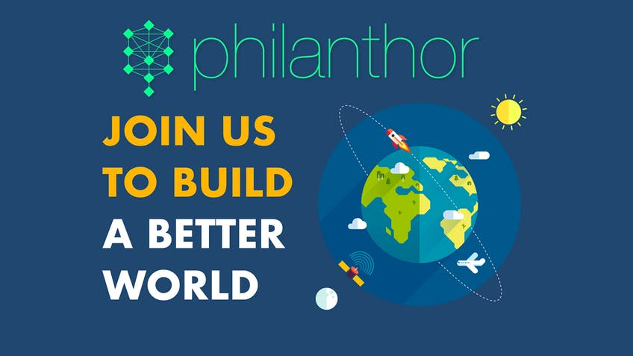

**Introduction**

Philanthropy- an act which provides happiness to some and a feeling of contentment to others. This message has been circulated in us through our elders. They teach us how we can find happiness in people we make happy.

My grandmother used to teach me how can I share my riches with others and still feel happy. I never liked sharing my toys or chocolates with others including my own brother. But one day, I had to believe that she was right. That day, my 5-year old brother brought 6 lollipops for everyone in the family and forgot to count himself (weak in mathematics). When he came to me with the last lollipop in packet, his glittery eyes couldn't see anywhere but the last lolly. But what I saw was different from expectations. He handed over it to me with a smile. My heart melted and we shared the lolly.

A quote says, "Do good and good will return". I personally believe that not always good return as it seems. Sometimes making someone happy by making efforts can find joy within us.

At present, many NGOs are working and admitting more enthusiasts who are willing to share their part and encourage a better way of living. Yes! We owe this world much more than we think, why not start with a simple cause of unity? Become a philanthropist!

But there are several problems faced by firms working every day. Funds collected are not utilised as they are supposed to be. Some money minded people have their eyes on funds and steal them to profit their own selves! How rude and absent mindedness! A transparency in the system is a must needed. In a world of attraction, people misuse this term and follow the herd in order to make profits out of nothing. Some fellows even exaggerate their causes to an extent that it looks like real issue that needs to be addressed but proves out to be fake. Similar to this, many schemes gather funds which they don't even deserve and eventually a person in need pays hard.

Ever heard about blood donation scheme? We need to donate blood and a Bonus card is issued in our name so if in future we meet a blood shortage, we need not to worry. A help is promised as a thanksgiving service.

Similarly, a platform called Philanthor is providing people to connect through genuine philanthropists and be a help to those in actual need!

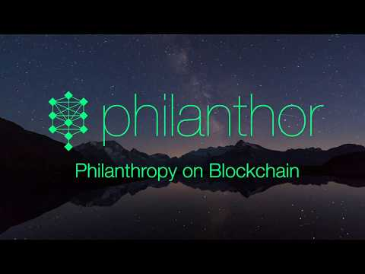

**About Philanthor**

Philanthor is a platform for various heart sizes to fit in a frame. A decentralised platform using blockchain technology provides a crystal clear view of fund transactions made through the network. A proper system that will keep records of what's been sent and to whom.

An ecosystem to uplift Humanity on a large scale, Philanthor offers its users to raise funds for a particular cause and the collected amount will be used exclusively for funding. With low trading rates and a transparent network, it aims to win user's trust at a rapid pace.

A Cryptocurrency scheme and a bonus reward becomes necessary. As a bonus, funds will be transferred as PTH Tokens which will help in the longer run (when we might be the one needing money). An advanced technique to handle fund requests is established keeping the system fraud and fault-free.

**Conclusion**

As markets are emerging, people only run behind profits and positive outcomes. To overcome the challenges and unite the world together, Philanthor offers a wide network to connect with every individual out there and understand their point of view that can make the world a better place.