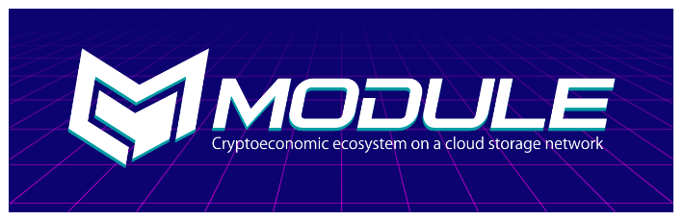**MODULE PLATFORM: More Space of Comfort**

**Introduction**

In the era of technology and advancement, we all prefer to try out new techy stuffs whenever possible. And for data storage we look up for storage devices (pen drive, hard drive etc.), cloud memory etc. If not available, we clear up the items that were once necessary. What do we need? Space! Space! Space! Space to store games, pictures, videos, projects and much more.

Few months back, I bought a smartphone having 64GB internal memory dumping my previous phone containing 32GB memory. In short, double the space, double the fun now! With these thoughts, I was head over heels. The thing happened is, I found some exciting web series and courses based on my interests.

With unlimited access to internet, I started downloading them one by one. 13 reasons why in HD resolution downloaded and a bunch of tech-based courses too downloaded. I was happy to accommodate all of them in my mobile phone. Then came the winds of Cryptocurrency in the market. I was astonished to check features of different Cryptocurrencies and various other features like e-wallet, how are they decentralised, how Blockchain network works. I came across various platforms that support Cryptocurrency and have imposed endless solutions to major problems faced by a centralised society.

That's the end! The articles I tried to save displayed "No storage available! Clear up some space" on the screen. All my excitement came to a standstill. Because of non-availability of extra storage equipments, I chose cloud space in my Google drive to fit my fascination.

This thought came to my mind, "when a door is closed, another opens to let us explore ourselves". I carried on with my searches and experiments. An earth-shaking message glowed with other notifications saying, "You can't access your account, HACKED!" My precious hours of operation got wasted and I felt damn stupid unable to put important documents saved in a pen drive!

With the idea of decentralisation combined with Blockchain model in market products, it seems easier to rely upon crypto transactions at least without fearing loss of data.

Cloud computing made a great impact in expanding user community linked to internet. Replacing cloud computing with utmost security and providing encrypted network, MODULE platform is set to target the user community to extend their "space" (in terms of memory) exponentially!

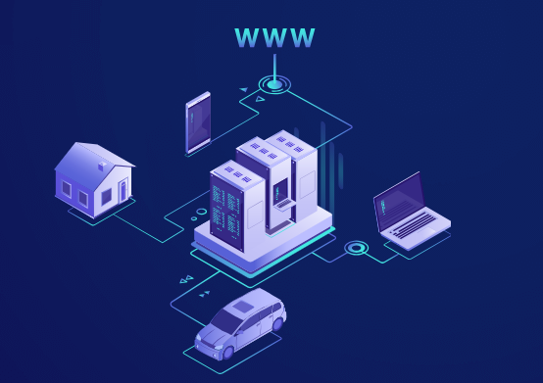

**About MODULE**

MODULE is a decentralised file storage platform that enables sharing of memory space from smartphones, pc and tablets! With an aim to use up free spaces and earn rewards in return (via MODL TOKEN compatible to ERC-20 wallets), MODULE is all set to grab user’s attention.

We can share the space we don't require or request for extra space. A total 2 billion devices are supported! Small shares of memory from 2 billion devices will sum up to a huge storage space. It will work similar to a renewable energy source (that will collect chunks of memory) and as a link for the world to join!

What is new? Features like POSTT (Proof of Space, Time and Transaction) and low energy requirements for mining purposes makes it unique.

People investing in higher proportions would earlier dominated the field but with low energy requirements, MODULE can be easily operated on smartphones inviting every interested candidate for mining. Also, with data stored in parts, no more fearing of data loss.

**Conclusion**

To bring a change and efficiently utilise unused assets, MODULE ties its link with Blockchain technology model to give rise to a powerful connection which promises to bind variety of users. Through this project, concern for emerging Cryptocurrency market will experience a rise and impart knowledge to those who are unaware of its hidden profits.