**ARAW: E-COMMERCE ECOSYSTEM IN POCKET**



**Introduction**

In the evolving era of technology, shopping is something we all prefer to do manually, specially clothing items. Brands with endless guarantees and promises are available in tons, whereas those who follow them are handful in number. Trust issues with what a product looks in picture and how it differs in reality continues.

From my personal experience, everyone tries at least once to rely on their chosen online store and has once ordered things to verify its quality. 70% of them are disappointed from the services and have opted out. I recently encountered an incident myself. There was a clothing site called ‘clothing hearts’. The outfits posted on display were very catchy and at 20% discount. The offer mesmerised me. But being at safer side, I read terms and conditions that promised a 7-day return policy. I cheerfully ordered one piece for myself. When the dress was delivered, all my joy ended up. It wasn’t stitched properly and gave a shabby look when worn. Added to this, the contact number, mail-id on the site never responded. I ended up wasting my precious pocket money for that.

Online stores have expanded to such an extent where every small-scale start-ups are provided space to get exposure. But not every start-up is rationalised to certain important terms. E-commerce websites have significantly proved to increase in value, but some unfavourable incidents stop every individual to participate further.

A common belief is spread across the market. It says, “If a company sells items at higher rates, the product is original and pure.” This has decreased the reward system of many famous brands that lie somewhere middle of high and low brands. They fear loss in sales by keeping some rewards on products. On the other hand, consumers search for discounts and rewards associated with a product. Also, consumers like me fear the fake products to be circulated among us.

Crypto currency has already entered in the industry like a boom! Many businesses are already reaching out to understand how it works and adopt it for their benefits. It has a captivating reserve to an exponentially increasing economy. Not limited to this, its highly encrypted safe network shields it from touching heights!

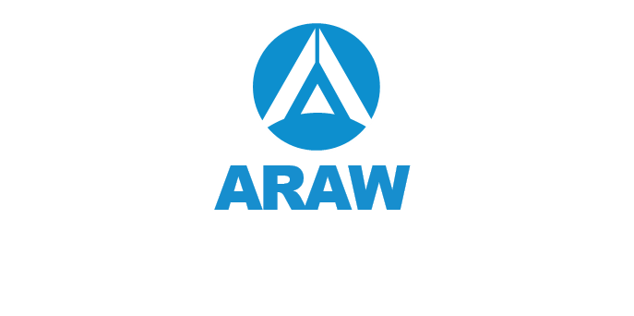What if benefits of e-commerce combine with payment industries? Everything to satisfy its customers to indulge more and more in e-commerce and experience a secured and crypted environment. Presenting ARAW platform to cut down trust issues and force inactive individuals to profit themselves.

**About Araw**

Araw is a decentralised ecosystem set to facilitate benefits of e-commerce and trading in one click. It is carefully designed e-commerce website integrated with decentralised payment gateways to ensure healthy costumer experiences. It supports ‘Unified Reward System’ that benefits both buyers and sellers! How? It brings down cost for consumers through reward system and attracts customers from all over the network for sellers.

It has efficiently utilised Ethereum blockchain technology to unite the world again! Features like customer app, Araw card (touch and pay), Araw mobile wallet, e-commerce marketplace etc. are together publishing its worth. It is a true transparent network where users can connect to various businesses and check their originality.

Exciting rewards are linked with every successful transaction through ARAW Token (easily converted to fiat money or other crypto currencies).

**Conclusion**

Araw aims to provide a platform to benefit every link (buyer or seller) and impart knowledge to people about strength of emerging Crypto world. The potential of blockchain technology is still veiled from everyone. Araw project wants to take initiative to connect everyone and take blockchain and Cryptocurrency to next level. It hopes for a progressive nation that could launch anywhere it targets!