**SIDERA: Future around your Wrist**

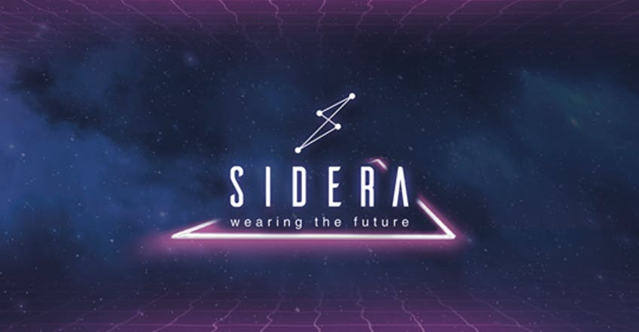

**Introduction**

The evolving blockchain technology has spread across the world. In only a few years, blockchain has made a firm stand in the crowd of many new technologies entering the techno-market. Not only is it appreciated for its security aspects, but also its widespread approach.

Adaption of blockchain is not yet entered every home but it has successfully knocked every mind. People are enthusiastically participating to know more about blockchain and cryptocurrencies. Bitcoin, being the best example, swayed away a large number of investors and attracted other traders. Cryptocurrency ecosystem gained their promotion through Bitcoin and eventually, a number of projects landed in marketing benefitting the tech-savvy community.

But it somehow lacked including the common society people. The problem faced by many investors was ‘where can they utilize this cryptocurrency’?

Talking about technology, not a decade ago, smartphones were infamous. I never played games on a smartphone. We used to spend time outside our homes. And now! Try giving a 2-year-old a smartphone and he will learn its features within seconds. That’s the power of technology! If I calculate at the same pace, in a decade or two, I’ll be working on a touch-less device to get my work done from miles away.

Technology gave humans the opportunity to explore what was earlier called impossible. It has set great examples through which people invest their time in digging deep and finding what’s unknown. Blockchain technology has set this progress to the next level. Through features like encrypted network and excellent data security, blockchain has successfully captured user’s faith and interest.

Moreover, creativity in any field has never seen downfalls. The beauty of creativity is we can explore new depths sprouting in young minds. IoT (Internet of things) is one among those creativities. After all, connecting people was never an easy task. The internet of things is a system joining links between hardware devices without requiring the presence of humans.

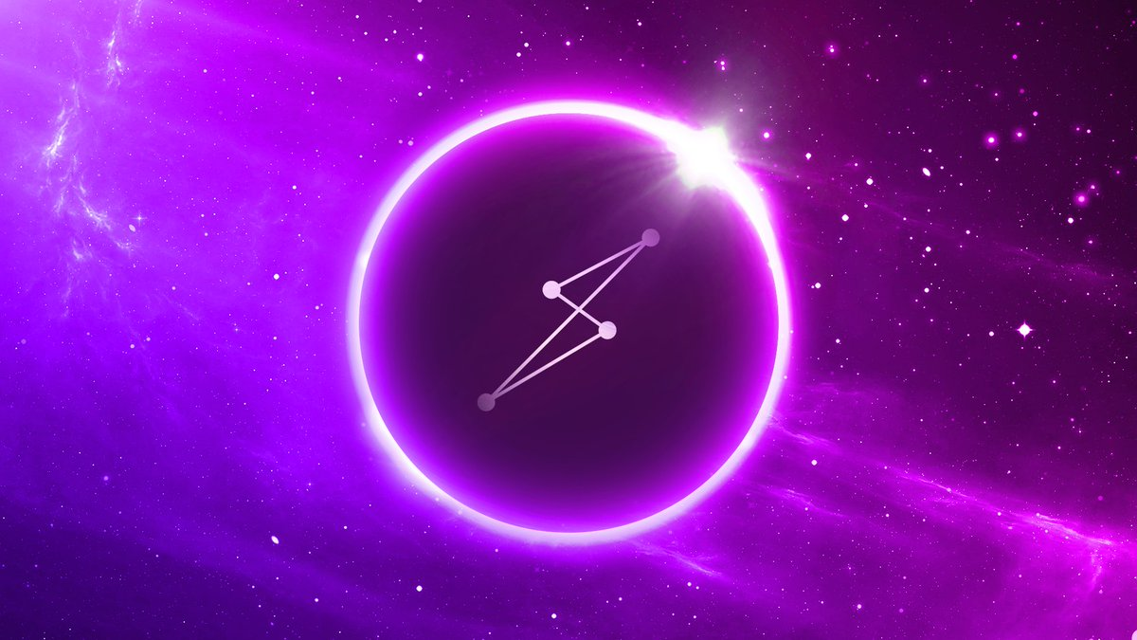A decentralized platform blending IoT with blockchain technology is now on show! Bringing idealized version of things, Sidera is set to invoke audience’s technical spirits.

**About Sidera**

Introducing a decentralized wearable device, Sidera aims to add the cryptocurrency usage medium to smartwatches and touch-less watches. As the world is growing digitalized, every step of ours is noticed and recorded. Through the wireless and touch-less approach of Sidera, it offers pure decentralization.

Isn’t it cool? How easy it sounds, managing crypto transactions through smart watches anytime and anywhere. Not only this, the smartwatch will be able to track payments, receive notification messages, trade chart views, face recognition tools, biometric and many more exciting features!

After noticing the trend of global markets and technologies, Sidera has cleverly shifted to smartwatches to promote their idea. As the public requires time to adopt new technologies and the following decade will witness replacement of smartphones to watches and touch-less screen utilities, Sidera has carefully chosen smartwatches.

Combining IoT with blockchain technology, Sidera aims to earn maximum public support. The only motive of the project is to provide an easy and pleasant way to handle crypto transactions while keeping the security intact.

**Conclusion**

Sidera platform has efficiently combined two great innovations of today’s time. Not only does it offer a way to smarten ourselves, but a comparatively lighter thing to handle things upon. A smartwatch is now capable of handling multi-secured data. We can keep an eye on transactions and send cryptocurrencies in a click. No more pains of remembering security keys for every security pass.

Although they have initiated a revolutionary movement towards smartening ourselves, the final achievement will be counted on its adaption in society. The idea is well-planned. We’ll see how it’s operated in future.