**BIXTRIM: A Multifunctional Crypto-Exchange Platform**

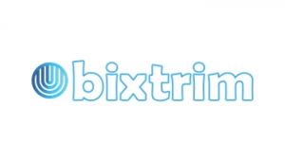

**Introduction**

Any plans on investing in trending future cryptocurrency markets but still have second thoughts against it? Or having an introverted family background not supporting profitable interests? Or lagging behind important knowledge about Crypted Web spreading across the nation? There's much more kept to what seems to be the present scenario!

Let's talk about the impression a world of Crypto currency has. Why has it become so popular in a matter of few days? Cryptocurrency is not an alien thing for people today! It has swept over the market like a huge wave engulfing every field of work. Not limited to that, it targets to achieve the position of centralised themes with eyes focussed on a decentralised view.

The cashless community has caught up an athlete's pace and proved to be very helpful to local people and to businesses as well. This made it possible to build a trustworthy relationship between a seeker and a provider dealing with anything related to their jobs. Everything can be viewed involving the history of transactions, respective date and time.

It's always a good option to search and compare at your own risk, stressing upon complex TERMS AND CONDITIONS. My own personal experience provokes me to take things seriously at any cost!

A risk factor always follows. But isn't it present in every issue we deal with? We plan out a summer holiday and prepare our bags, food and itinerary well. Then we leave out to explore the world (as we say). But what if we meet with an accident or our house gets burgled! Not all phenomena can be controlled, but that isn't a big enough reason that we opt out of enjoying vacations. A similar gamble is cryptocurrency market. We are likely to enjoy our money value rising at jet speed and can't just sit and wait for it to become stable. What would the crops be good for, if the farmers opted out to invest? Analysis, from the day Cryptocurrency came into force, shows that no major downfall is witnessed in history.

We heard about Bitcoin Cryptocurrency and how its value swiftly covered the distance from land to sky, became the fascination of endless people and their reason for contributing to crypto world. Successively, genius minds put their efforts and recorded other sufferings from day-to-day life and converted them into productive applications. This not only relieved market tension but also showcased a special power we hold. The Cryptocurrency is a replacement of WHAT WE HAVE and is highly secured by Cryptography technique. Presenting Bixtrim, taking the legacy to a new height.

**About Bixtrim**

Bixtrim is a decentralised multifunctional platform placed to provide investors to invest in a convenient and profitable way, having access to exceptional features like plastic card, crypto pawn shop. Spreading across with the theme, Invest, now or never! It provides a BXM Token wallet that can be directly linked to our digital account. Whoa! That means we can transfer money anytime we see a nightmare about lost money!

What's better than a credit facility available 24/7 in less fortunate phases? Yes! This evergreen issue was kept in mind while adding charms (features) to Bixtrim. A virtual pawn shop ready to be called your friend in need. Bixtrim also promotes 4 other cryptocurrencies namely, Bitcoin, Bitcoin Cash, Litecoin and Ethereum acceptable only in USD (US Dollar) and EUR (European Euro).

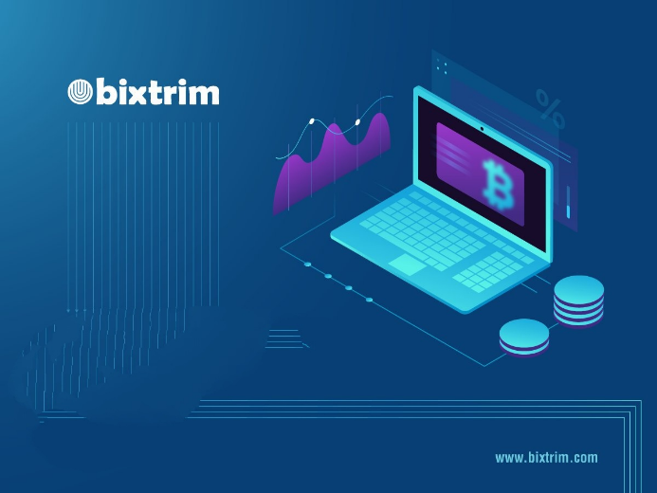

**Conclusion**

Bixtrim has a nice strategic plan which can attract potential enthusiasts to invest having laid out helpful and promising architecture. It aims to promote the upcoming Cryptocurrency business scope and to provide each head a better understanding of how things linked with super security (Blockchain model) efficiently work.