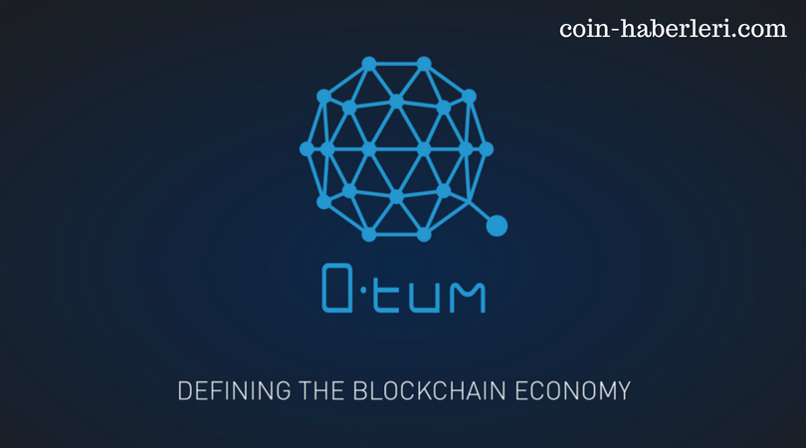**QTUM adding Quantum to Blockchain**

**Introduction**

With the Blockchain technology fusing with every market aspect, it becomes necessary for the developing as well as the developed merchants to understand the roots of Blockchain and how it works. It is a combination of two words i.e. ‘blocks’ and ‘chain’, which means several blocks linked together in a chain.

In today’s digitalized world, these blocks contain pieces of information (which, individually are useless) and make a network. For fulfilling the basic need of security, blockchain is opted widely by a range of users. They include small marketers, businessmen, website developers, and many more. Even hackers are shifting their focus to unfold the mystery of blockchain technologies.

Not limited to data security, the management level is set to “easy mode” for its users. The service is to be served to a variety of audience, therefore, blockchain technology is made easy to use and manage for the sake of gaining popularity.

China has shared a major part in many scientific advancements; blockchain technology is one among them. Its first blockchain technology project called “NEO” captured a huge market interest. It was a test project aimed to create a “smart economy”. It was an open-source blockchain and a non-profitable approach to collect public opinion.

With the similar thought of creating a “smart economy”, China developed another blockchain project, namely, QTUM (advanced of ‘quantum’). Gaining its originality from China, Qtum is like a spider’s web spread out to connect multiple blockchain features at one stop.

**What is Qtum?**

Qtum offers a platform where a better blockchain technology can be made using features of already established ones. There are a huge number of blockchain technologies that have been built one after the other solving issues of their predecessors. Qtum stands out having a different perspective towards solving those issues and provide a more reliable and successful network.

Qtum is simply merging established concepts and codes to produce an effective outcome out of them. The fight is always: what to choose between the two? Why not combine the two and utilize their features collectively? Qtum is providing us with the same opportunity ‘to use whatever we choose’!

The idea is to make maximum use of resources available and reduce the efforts of repeating things over and over again. Rather than designing a new feature and blending with older ones, we can choose to blend two designs into one.

Combining two effective blockchain technologies- Ethereum and Bitcoin, Qtum has strengthened its foundation. Other features are only adding up to raise its charm.

**What advantages Qtum have over Bitcoin?**

Due to an exceptional growth in Bitcoin value, it is known to all and hence, chosen as a standard of comparison. Except for security, Bitcoin doesn’t have other features to flaunt. Whereas Qtum is capable of running smart contracts and decentralized applications together! Here are the features explained:

• **Decentralized Applications (dApps)**

When a new web application is designed, it is uploaded to the server computer. Through the server, it is visible to everyone. The application designer and the audience are using a medium to help each other. The server is acting as their medium. This process of ‘centralizing’ is done and data is saved. Hackers retrieve this data and misuse the content or website.

To avoid these low-security protocols, Qtum provides a peer-to-peer interaction system based on decentralization. Using Bitcoin’s blockchain technology, Qtum offers security. Here, encrypted data is transferred bit by bit from one user to another, which makes the task of hacking impossible.

• **Smart Contracts**

Another advantage of Qtum over Bitcoin is reflected through smart contracts. Earlier and even nowadays, legal contracts are made public. Even then, important terms and conditions can effectively find a place to hide. This results in unseen loss and damages copyright arguments.

With Qtum’s smart contract feature, forget losses and count profits. Smart contracts are electronically generated contracts which allow transactions without third-party interference. It works on low trading costs and provides a layered security. You are allowed to make smart contracts over blockchain for your business.

* **EVM Integration**

Transactions in Qtum are done via scripting mechanism. EVM is Ethereum Virtual Machine that supports smart contracts’ execution. Smart contracts on blockchain run effectively on EVM. Transactions must be completed within seconds to avoid any discrepancy in data.

**Qtum’s mobile utility**

With the internet in our hands (via mobile phones), we have access to every piece of information available. Keeping the freedom in our hands, Qtum has provided a mobile feature through which Qtum wallet can be used to transfer or exchange money.

Mobile phones and tablets have proved to be a very crucial step in the growth of the crypto world, be it for personal or professional purposes. With new levels of development in mobile blockchain technology, its use of Bitcoin’s UTXO allows smart contracts to be executed from light wallets, everything on mobile phones.

**How to transact a Qtum?**

• Install a Qtum compatible wallet

First, you need to install a Qtum compatible wallet i.e. Qtum Official Wallet as its compatibility is still limited (was released in Sept 2017). Plus point is: it can either be downloaded on computer or on smartphones!

• Get recipient’s wallet code

There is a unique code associated with every wallet that can be shared for the purpose of sharing Qtums. For mobile devices, QR code also works.

• Enter wallet code with Qtum amount. Send it!

Enter the code or scan the QR code from the recipient’s wallet. Make sure you entered the correct details if you are transacting via the unique code. Enter the Qtum amount you want to share. Send or receive Qtum freely.

You will receive a confirmation message once the Qtum coins are transferred.

**Qtum’s pricey stats**

An advanced and beneficial technology requires decades to grow and reach out to millions of users. They first try and then adopt the project, if considered useful. It certainly takes time to attract such a crowd.

Qtum, valued from US$3.88 per Qtum coin in July 2017 rose to US$20 per Qtum coin by the end of August 2017. Further statistics are yet to be revealed.

**Qtum Resource Updations**

* Official Website
* Reddit
* Twitter
* Github
* Facebook
* Forum
* Telegram
* Slack

**Qtum’s Transparent Ecosystem**

Qtum has approached for best features and transparency is one amongst them when it comes to transparency.

The project has induced weekly community and development update sessions for encouraging users to participate and know more about Qtum platform. They talked about the ICO taking place on VEVEU- a way to earn tokens via social sharing.

**How to invest in Qtum?**

Qtum is linked to many other cryptocurrencies. If you are unable to exchange money for Qtum, you can choose any of the following currencies for trading Qtum.

• HitBTC

• Coinone

• CHBTC

• Bittrex

• Allcoin

• BTER

• Yuanbao

• Cryptopia

• COSS

• Novaexchane

• Jubi

• Liqui

• Biduobao

• BTC9

• Binance

You can always opt for purchasing BTC on Coinbase at first and then exchange it for Qtum token.

**How to earn Qtum Token?**

Since Qtum combines best features of Bitcoin and Ethereum projects, it has emerged out to be very business-friendly. Qtum can be earned through trading and sharing whereas no such mining processes are granted in Qtum.

Where people are looking forward to its growth, many are still living in their own bubble. Qtum has emerged out to be a substitute for Bitcoin. And as Bitcoin gained so much public attention, Qtum is looking forward to coming into the limelight.

Since it has been only 11 months to its discovery and release (as of September 2017), it is too early to predict its growth. By the time, we can keep an eye on its enhancement and fluctuating pace of popularity.

**Development team’s words**

Every business requires hard work and patience to bear fruitful results. Similarly, the development team will continue their efforts in promoting Qtum. They will be pursuing supporters to reach out to wide traders. After all, the growth of Qtum is dependent on adoption by traders.

**Conclusion**

Blockchain has created a rush in the business sector. With the powerful shield of security, it has the strength to remove other strategies efficiently. Carrying forward the same note, Qtum is blending two blockchain technologies into one, making the most use of the features provided by them separately. It is also viable to mobile phones easing on the hardships faced without computer systems. In all, it might be a successful approach in uniting people on crypto grounds.