KuBitX: EMERGING CRYPTOCURRENCY TRADING PLATFORM
In Ancient era, people lived simple lives and were dependent on exchange of items to meet their daily requirements. With the gradual growth in economy sectors, government proposed a well laid out plan of currency. A mode of payment which found its stability as soon as it came into force. This currency was given a value and could be exchanged to buy products.
Eventually, concept of banks were established for the purpose of serving people and secure the hard earned money in various ways. It even proposed plans on how to increase deposits(on interest basis). But techhy brains never put a full stop here. Evolutionary ideas keep coming in act to entertain our tickling bones.
I personally believe that Banks hold a major responsibility to ensure safety of our valuable assets and are no doubt wonderfully doing its job.
But nothing so helpful comes easy. Recently, I went to a Bank to open an account. I was going through the procedure and that's when I found out that there are associated charges to every transaction I make which differs Bank to Bank. A proportion of my money is going to be spent every time I use this facility. That made me disheartening and left me with no better option.


Online Emerging Markets
Being a lazy lad, I avoid strolling for items in marketplaces rather prefer ordering online goods. Endless variety and trendy items combines to generate a huge bill amount. And positively I don't find faults in quality and price for 5 years or so, securing a thumbs up for their timely services as well. But every time I loose money in transactions, it aches my heart a lil.
Having some tickling bones, I prefer to taste every spice. And thus next day, I read about Cryptocurrency trading market. With such a low trading cost, it captured my interest and I tried finding about its aspects and services. Planning to take over the market completely, KuBitX promises to provide a safe environment as well!

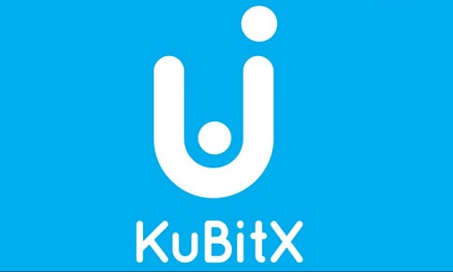

About KuBitX
Similar to online shopping, KuBitX is a user friendly Cryptocurrency trading platform destined to give digital marketing a boost. It's motive is to provide us with best experience and what's easier than to operate all its services (via mobile phones) sitting on your couch enjoying coffee!
It uses Ethereum Blockchain technology at present and is believed to invent one such technology exclusively for KuBitX. Invest and save your money ( in form of KBX TOKENS ) from the devil's eye i.e trading taxes!
KuBitX is going to issue a total of 500,000,000 KuBitcoin (KBX) and will accept only ETH currency.
Seed Round: Ongoing. Ends: 16 July, 2018.
Pre-Public Round: 16 July - 31 August, 2018
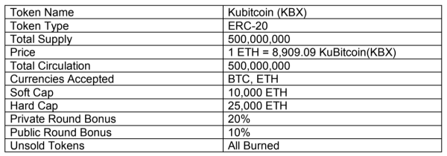
TOKEN SALE INFORMATION

CONCLUSION
KuBitX provides, both its private and professional enthusiasts, a decent and transparent platform to provide pear to pear trading experience and to revolutionalise the trending market look. Through a deeper insight into this idea we can tie the ends of dream and reality together.

