Open Packaging Network: One stop Package Providing Platform


People in ancient era evolved slowly with each day adding to their advancement. Modern era supports progress at a rapid pace where ideas are in abundance and finding dime seems a difficult task.
Internet became a revolutionary global market in itself connecting 7 continents and their ideology. If I like an item over internet and can't have a direct link to purchase it, I can easily disturb various transportation services to deliver my order at doorstep!
With this advancement, comes the responsibility of a gentle transportation of goods as well. Say, for example, I, residing in Italy, wish to buy a glassware showpiece exclusively made in Dubai. It has two main highlights to keep in mind: cost and care. If the cost is misunderstood, seller will pay. And if the care is sacrificed, the showpiece will break and I (the buyer) will get nothing out of my money. With the broken glassware, my trust is also broken. Both ways, the services are affected and I will rely on buying things available locally.
To develop a powerful connection between the buyer and seller, a strong link (in terms of packing, delivering and charging adequate rates) becomes a necessity. A third trusted member who can perform intermediate tasks at a low trading cost would be a great fit.
Packaging Industry
A vast ground of religions witnesses an even broad set of customers. Some are consistent while others are temporary. Some choose to try once while others opt to generate quick habits and keep on interacting.
Unfortunately, we aren't always lucky to find what we look for in the first place, especially stubborns like me. I was recently looking for a particular outfit for my birthday forthcoming next week. I checked out every store in every street nearby but couldn't find the perfect match! Now the stubbornness gets high on heal and I started looking online for results. I loved the second outfit in the list of thousand others. That's where I found one real smart option for getting an assured delivery on time without a single damage done!
A factor that lags for almost every product is its QUALITY. Even though other features count on stars, the moon (Quality) is left unattended.
This issue restricts many people to switch over to Online marketing. Keeping the quality a priority, Open Packaging Network works to steal a good portion of customers.
What else would a shopaholic dreams of? Shopping carefree while keeping an eye on every move of their possession (Order tracking).
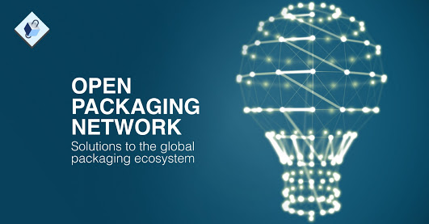
For the same purpose, Open Packaging Network is processed to deliver only best services.

Introduction
Open Packaging Network (OPN) offers its users a trustworthy platform for all packaging related services. An A-one solution to fair prices, quick payments, transparency and availability of packaging services which at times proves to be headache if taken care individually.
Its users ( buyers or sellers) have to use OPK Tokens to effectively utilize the service. The Network works on OPN Blockchain technology totally set to keep every link intact! They plan to allow Bitcoin (BTC) and Ethereum (ETH) payment variants for a better experience.


Conclusion
If a packaging service is fast and efficient, it leaves nothing to worry about. But if it comes with associated markets, what great deals it can sell is beyond imagination!
This platform provides an unbiased approach to everyone without compromising on quality or quantity. Now we can explore several options reserved for us a click away.

