CS 5351 - Assignment 3 - Results

By: Sai Kumar Manakan, UTA ID: 1001236131

Program 1: Pi calculation using Simpson’s rule

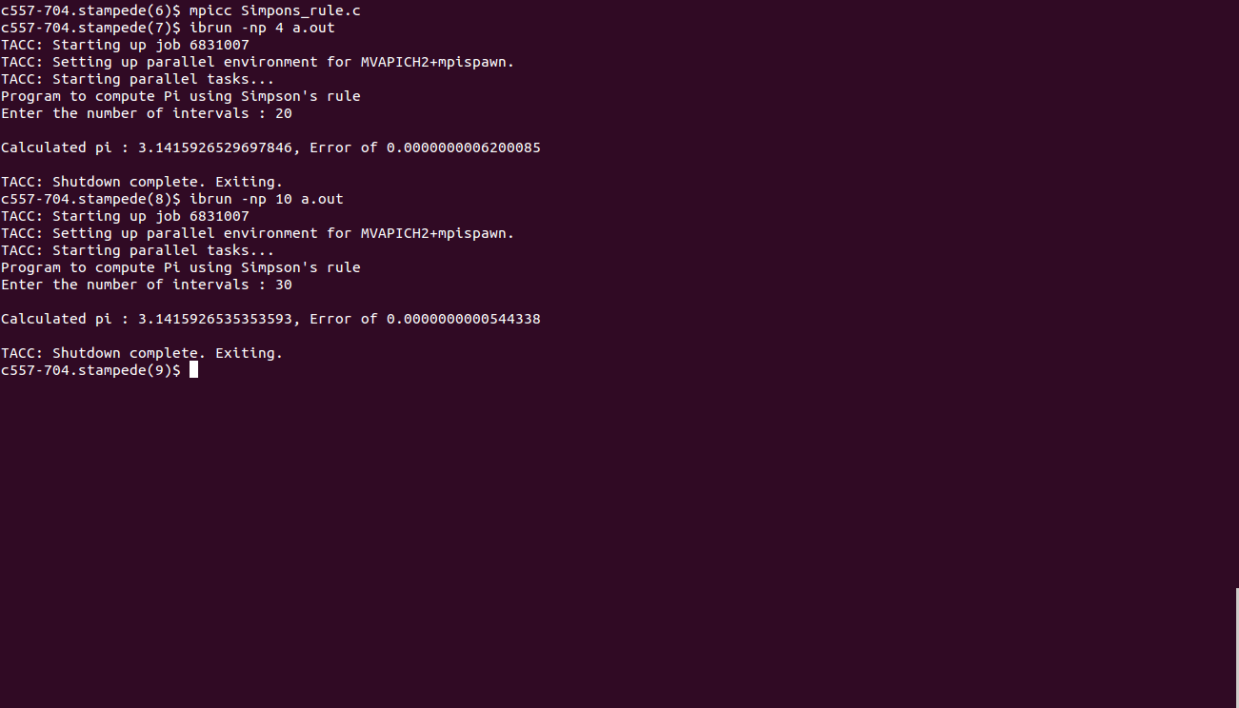

Program 2: Array shifting

