Published lncRNA prognostic signatures for lung adenocarcinoma share a modest transportable signal, but none is individually validated: a pre-registered benchmark
Running title: Benchmark of LUAD lncRNA prognostic signatures
Authors: [Author names and order to be agreed]¹*
¹ [Department, Institution, City, Country]
* Correspondence: [name, e-mail address]
Word count: abstract 316; main text 4595 (Introduction to Conclusions). Tables: 5. Figures: 6. Supplementary material: deviations log, 18 tables, 2 figures.
Highlighted text marks items to complete or verify before submission.

Abstract
Background. Hundreds of long non-coding RNA (lncRNA) prognostic signatures have been published for lung adenocarcinoma (LUAD), mostly developed in TCGA-LUAD and rarely tested, with their published coefficients, in independent patients.
Methods. In a pre-registered study (osf.io/qckvr), 15 signatures (102 genes; coefficients extracted twice, independently) were applied verbatim to TCGA-LUAD (apparent performance; 504 patients) and six independent cohorts (1,146 patients, 345 deaths), with genes matched by Ensembl identifier. A signature was evaluated where at least 80% of its genes were measurable and its authors had not used the cohort. Per signature–cohort pair we compared the C-index with 2,000 expression-matched random gene sets (H1; Holm correction within cohort), tested added value beyond stage, sex and age (H2), and compared performance across cohorts (H3). An aggregate transportability analysis was added after registration.
Results. Only 26 independent pairs were evaluable (CPTAC-3, 15; GSE81089, 8; microarray cohorts, 3), and 14 of 15 signatures were evaluable in at most two independent cohorts. The median C-index fell from 0.63 in TCGA-LUAD to 0.59 in CPTAC-3 and 0.50 in GSE81089. No pair outperformed random gene sets after correction (smallest adjusted p = 0.076). Six pairs added value beyond clinical covariates (ΔC 0.03–0.06). Twenty-three of 25 independent observations pointed in the published direction (p < 0.001), and the mean hazard ratio (HR) per standard deviation of the published score was 1.27 (95% CI 1.13–1.45). Yao 2021, the only signature evaluable in three or more cohorts, pooled to HR 1.41 (95% CI 1.30–1.52; modified interval 1.17–1.68; five cohorts, 232 deaths). Power to detect a true C-index of 0.60 was 0.48–0.64 per cohort.
Conclusions. Published LUAD lncRNA signatures share a modest prognostic signal that transports to independent cohorts, but no single signature could be shown to outperform random genes. Public cohorts measure too few lncRNAs and record too few deaths to validate individual signatures; stable gene identifiers, a stated expression scale and larger lncRNA-capable cohorts are needed.
Keywords: lung adenocarcinoma; long non-coding RNA; prognostic signature; external validation; reproducibility; pre-registration; random gene sets.

Introduction
Lung cancer remains the leading cause of cancer death worldwide, and adenocarcinoma is its most common histological type [1]. Survival differs widely between patients with the same stage, which has motivated many attempts to refine prognosis with tumour gene expression [2]. Long non-coding RNAs (lncRNAs) are attractive candidates: they are tissue-specific, frequently dysregulated in cancer and involved in proliferation, immune evasion and metabolism [3,4]. Over the past decade, hundreds of multi-lncRNA prognostic signatures have been published for lung adenocarcinoma (LUAD). Most were developed in The Cancer Genome Atlas (TCGA) LUAD cohort and reported with performance measured in the same data or in small public validation sets.
Whether these signatures carry prognostic information beyond their development data is rarely tested with the published coefficients. Three well-known problems make the question important. First, random sets of genes are often as prognostic as published signatures, because prognosis-related programmes such as proliferation are spread across much of the transcriptome [5,6]. A signature that beats chance in its development cohort may therefore not beat a random gene set of the same size. Second, external validation of a prognostic model needs enough events: at least 100, and preferably 200 or more, are recommended [7], and formal sample-size calculations often require more [8]. Public LUAD cohorts outside TCGA usually record far fewer deaths. Third, reporting guidelines ask for the information needed to apply a published model elsewhere — the exact predictors, coefficients and scale [9,10] — and this information is often incomplete.
lncRNA signatures add three problems of their own. Microarrays used for many public validation cohorts were designed mainly for protein-coding genes and measure only part of the lncRNA space [4], and RNA-seq library preparation (poly(A) selection or ribosomal RNA depletion) changes which lncRNAs are captured [11]. lncRNA names are unstable: clone-based names such as AC026355.1 have been reassigned between gene annotation releases, and Ensembl identifiers are retired or merged as annotation improves [12,13]. A gene can therefore be wrongly counted as absent, or wrongly matched to a different gene. Finally, public cohorts are reused: a cohort that the authors of a signature used for selection or validation is not independent for that signature.
We therefore carried out a pre-registered benchmark of 15 published LUAD lncRNA signatures across TCGA-LUAD and six independent cohorts. Signatures were applied exactly as published, with genes matched by Ensembl identifier and a documented identifier history, and each signature–cohort pair was checked for independence. We asked whether each signature performs better than random genes (H1), adds value beyond stage, sex and age (H2), and performs consistently across cohorts (H3), and whether the signatures as a group carry a signal that transports to independent cohorts.

Methods

Study design and registration
This is a computational validation study of public data. The protocol was registered on the Open Science Framework (osf.io/qckvr) on 6 October 2026 and updated three times before the analyses reported here: Update 1 (10 October 2026) added CPTAC-3 and the secondary direction-consistency outcome; Update 2 (12 October 2026) widened the reporting-completeness analysis to 76 papers; and Update 3 (20 October 2026) was filed after an audit found coding errors in an earlier version of the analysis code (v0.3). All code was then rebuilt from raw public data (v2). Update 3 lists the v0.3 results that had been seen, every change to data sources and data preparation with its reason, and the analyses added after registration. Hypotheses H1–H3, the scoring formula, the 80% coverage rule and the registered tests were not changed. The v2 inputs (signatures, gene mapping, cohorts, coverage) were frozen in version control before any v2 outcome analysis was run. All deviations are listed in Supplementary File 1. The study is reported following REMARK and TRIPOD+AI [9,10,14].

Signature selection and extraction
We searched PubMed on [date of search — fill in] for LUAD prognostic signatures built from lncRNAs (query in Supplementary File 1). Inclusion criteria were: a prognostic model for overall survival in LUAD, or in non-small-cell lung cancer with LUAD reported separately; the full gene list with Cox regression coefficients; and a stated risk-score formula. Reviews, models without coefficients, models based only on clinical or immune variables, non-human studies and mixed-cancer cohorts without LUAD-specific results were excluded. The search returned 404 records; 90 full texts were reviewed, and 15 signatures met all criteria (Figure 1) [15–29].
Gene names and coefficients were extracted twice by two investigators working independently. Of 102 coefficients, 86 were identical and 16 differed only because one extractor had rounded the printed value; the full-precision printed value was used. No coefficient was refitted. For each signature we also recorded the gene annotation, the expression scale stated by the authors and the cohorts the authors had used.

Cohorts
TCGA-LUAD was the apparent-performance reference, because every signature had been developed in it [2]. Six cohorts were independent: CPTAC-3 LUAD [30], GSE31210 [31], GSE50081 [32], GSE30219 [33], GSE81089 [34] and GSE72094 [35]. Eligible patients had a primary LUAD tumour, overall survival greater than zero and a known vital status. Mixed-histology cohorts were restricted to adenocarcinoma. In TCGA-LUAD, where 12 patients had more than one primary-tumour sample, the sample with the largest total read count was kept. The endpoint was overall survival, in months (days / 30.4375). Stage was coded I–IV; in GSE30219 it was derived from pT, pN and pM.

Expression data processing
TCGA-LUAD and CPTAC-3 STAR-Counts data (GENCODE v36) were obtained from the NCI Genomic Data Commons (Data Release 46.0), through TCGAbiolinks and the GDC application programming interface respectively [36], and used as log2(TPM + 1). GSE81089 transcripts per million (TPM) were computed from the deposited Cufflinks FPKM values (Ensembl 73 gene models); values coded −1 were treated as missing. The three Affymetrix HG-U133 Plus 2.0 (GPL570) cohorts were normalised from raw CEL files by RMA within each cohort [37]. Probes were mapped to Ensembl genes (release 114, primary assembly only), probes matching several genes were removed, and one probe per gene was kept by a fixed rule (_at before _s_at before _x_at, then highest mean expression), so that each gene used the same probe in all three cohorts. GSE72094 (GPL15048) was used as the submitters' normalised series matrix, with Entrez identifiers mapped to Ensembl release 114. GEO data were retrieved with GEOquery [38].

Gene identity and coverage
Each published gene name was mapped once to an Ensembl gene identifier, using the GENCODE release whose naming the paper followed (v22 for two signatures, v36 for 13) [12]. A name audit across GENCODE v22, v29, v31, v32 and v36 identified names that refer to different genes in different releases. Six gene–signature entries were resolved by documented manual mapping; three of these corrected matches to a small nucleolar RNA (two entries) and a pseudogene that had reused the clone-based names in later releases (Supplementary Table S4). Where an Ensembl identifier had been retired or merged, its official successor in the Ensembl identifier history [13] was used in a cohort only if the original identifier was not measurable there. For GSE81089, annotated with the older Ensembl 73, we checked by a rule fixed before any outcome analysis whether any older identifier led to a missing signature gene; none did.
A gene was measurable in a cohort if it had no missing values, was not constant (SD ≥ 10⁻⁶) and, for RNA-seq, had TPM > 0 in at least 10% of patients. A signature was evaluable in a cohort if at least 80% of its genes were measurable (registered rule).

Independence of cohorts
For each signature–cohort pair, two investigators recorded from the full text whether the authors had used the cohort for development, feature selection or validation. A pair was independent only if the cohort had not been used in any of these ways. All 15 signatures were developed in TCGA-LUAD. Geng 2021 used GSE31210; Yu 2024 used GSE31210, GSE50081 and GSE30219; and Yang 2022 used GSE50081 to validate a single signature gene, which we treated as use. No paper reported survival validation through an online portal that bundles these cohorts.

Risk scores
For each pair, the risk score was Σᵢ βᵢ·z(xᵢ), where βᵢ is the published coefficient of gene i and z(xᵢ) is its expression z-scored across the cohort's patients. Coefficients of genes that were not measurable were dropped, and the remaining coefficients were not rescaled. Higher scores denote higher risk.

Stage positive control
A cohort was considered able to show a prognostic effect if, in a Cox model on stage, the HR for stage III versus I exceeded 1 with p < 0.05 and the HRs increased across stages. In cohorts with fewer than 10 stage III–IV patients (GSE31210, GSE50081 and GSE30219), this criterion cannot be evaluated, and HR for stage II versus I > 1 with p < 0.05 was used instead (Update 3).

H1: comparison with random gene sets
For each independent pair, the primary measure was Harrell's C-index of the published score [39], with a 95% CI from 1,000 bootstrap resamples of patients. The score was compared with 2,000 random gene sets. In each draw, every signature gene was replaced by a measurable protein-coding or lncRNA gene from the same decile of mean expression, and the published coefficients were applied to the random genes. The two-sided p-value was (1 + #{|C_null − 0.5| ≥ |C_obs − 0.5|}) / 2,001. P-values were Holm-corrected across the signatures evaluable in each cohort [40]. A pair was Replicated if the adjusted p < 0.05 and C > 0.5, Contradicted if the adjusted p < 0.05 and C < 0.5, and otherwise Inconclusive.

H2: added value beyond clinical covariates
A Cox model with stage (four levels), sex and age was compared with the same model plus the standardised score by a likelihood-ratio test (1 df), Holm-corrected within cohort. Age entered where recorded for at least 80% of patients, which was the case in every cohort. We report the change in C-index with a 1,000-resample bootstrap CI and the adjusted HR per SD.

H3: performance across cohorts and pooling
For every signature we compared, descriptively, the C-index and the HR per SD of the standardised score in TCGA-LUAD with those in each independent cohort. We also report the C-index of the fitted Cox model, Uno's C-index truncated at 60 months [41], time-dependent AUC at 12 and 36 months (inverse-probability-of-censoring weighting) [42], and a log-rank test at the median score. The proportional-hazards assumption was tested with Schoenfeld residuals; where it was violated (p < 0.05), the difference in restricted mean survival time between patients above and below the median score is reported [43]. Pooled estimates were computed only for signatures evaluable in at least three independent cohorts, never including TCGA-LUAD, by random-effects meta-analysis (REML with the Hartung–Knapp adjustment) with leave-one-cohort-out estimates [44–46]. Because all signatures were developed in TCGA-LUAD, pooled estimates are labelled exploratory. When the cohorts agree more closely than expected by chance, the Hartung–Knapp interval can be narrower than a common-effect interval; we therefore also report, as a sensitivity analysis added after the results were seen, the modified Hartung–Knapp interval that never falls below the common-effect width [47].

Secondary analyses
Direction consistency (secondary exploratory outcome, Update 1): the sign of the log-HR per SD in each independent pair was compared with the published direction by a binomial test against 50%. To avoid counting overlapping signatures twice, signatures whose gene sets had a Jaccard index above 0.3 formed one cluster, and each cluster contributed one observation per cohort (mean log-HR). Gene-level concordance compared, for every measurable signature gene in each independent cohort, the sign of its univariable Cox coefficient with the sign of its published coefficient. Power was estimated by simulation at each independent cohort's own numbers of patients and deaths: survival times were drawn from a proportional-hazards model with a normally distributed score whose true C-index was 0.60, 0.65 or 0.70, with exponential censoring matched to the observed proportion of deaths (1,000 replicates), and power was the proportion of replicates in which C = 0.5 was rejected at α = 0.05 and at the strictest Holm step.

Aggregate transportability (added after registration)
As an analysis added after registration (declared in Update 3 and reported as not pre-registered), we averaged the log-HR per SD over all independent pairs. The 95% CI came from a patient-level cluster bootstrap with 2,000 resamples, in which one resample of patients per cohort was shared by all pairs in that cohort, preserving the correlation between pairs. A decision rule fixed in advance (δ = log 1.25) classified the result as Transportable if the lower CI bound exceeded 0, Contradicted if the upper bound was below 0, an informative null if the CI included 0 but excluded δ, and Inconclusive otherwise. As a cross-check, a multilevel meta-analysis (pairs within cohorts) with cluster-robust (CR2) small-sample inference was fitted [48,49].

Sensitivity analyses
Aggregate transportability and H1 were repeated with coverage at 100% and 70%; with scores computed on unstandardised log2 expression; with RNA-seq TPM rescaled to protein-coding and lncRNA genes; restricted to stage I–II; after excluding deaths within 3 months; in GSE31210 without the 22 cases flagged by the submitters for incomplete resection or adjuvant therapy; and, for H1, with random genes drawn from lncRNA genes only or from all measurable genes. Measurable genes were recomputed in every subset.

Reporting completeness of the literature
Five items were coded from the 76 papers among the 90 full texts reviewed for which detailed extraction records were available: a full coefficient table; whether the numeric risk cutoff was stated; whether the expression scale was stated (named unit), implied (RNA-seq without a unit) or not stated; independent external validation; and conflicts between text and tables in coefficients or sample sizes. The primary investigator coded all papers; a second investigator independently coded 10 randomly drawn papers, and a blinded second pass of the text–table item covered the remaining 66 papers (Update 2 and Update 3).

Software and reproducibility
Analyses used R [version — from session_info] with the survival, metafor, clubSandwich, GEOquery, affy, TCGAbiolinks and biomaRt packages [36,38,46,50]; package versions are recorded with renv. The pipeline is covered by more than 250 unit tests, all random draws use fixed seeds (base seed 2026), and every number reported here is written by the code to a log file. Code, gene mappings and the deviations log will be released on publication at [repository URL and release tag].

Results

Signatures and cohorts
The 15 signatures contained 4–11 genes (102 genes in total; Table 1). Five did not state the expression scale to which their coefficients apply; eight stated FPKM or RPKM. Gene identity required care: 11 published names referred to different genes in different GENCODE releases, six entries needed a documented manual mapping, and four genes were measurable in at least one cohort only through the official successor of a retired identifier. Some genes appeared in several signatures under different names; for example, MIR223HG appeared as AL034397.3 in two signatures and as MIR223HG in two others.
The seven cohorts comprised 1,650 patients and 527 deaths (Table 2). The six independent cohorts held 1,146 patients and 345 deaths, from 35 deaths in GSE31210 to 113 in GSE72094. All seven cohorts passed the stage positive control. In GSE31210, GSE50081 and GSE30219 the adapted criterion was used; in GSE30219 it rested on only three stage II patients (HR 4.45, p = 0.015).

Coverage determined what could be tested
Coverage varied more between platforms than between signatures (Figure 2). All 15 signatures were evaluable in TCGA-LUAD and CPTAC-3, eight in GSE81089, two in each GPL570 cohort and none in GSE72094. On the GPL570 arrays, Yu 2024 (8 of 9 genes) was evaluable but not independent, because its authors had used all three cohorts, which left Yao 2021 as the only independent signature there. In total, 26 independent signature–cohort pairs were evaluable: 15 in CPTAC-3, eight in GSE81089 and one in each GPL570 cohort. Seven signatures were evaluable only in CPTAC-3, seven in CPTAC-3 and GSE81089, and one (Yao 2021) in five independent cohorts.

H1: no signature outperformed random gene sets
C-indexes in the independent pairs ranged from 0.48 to 0.65 (Table 3; Supplementary Figure S1). In CPTAC-3 all 15 C-indexes exceeded 0.5 (median 0.59), but they lay within or near the range produced by random gene sets with the same coefficients (2.5–97.5th percentiles about 0.38–0.62). Five pairs had unadjusted p < 0.05 against the random-gene distribution: Yao 2021 (C = 0.65, p = 0.006), Zhang 2021 (p = 0.014), Jin 2020 (p = 0.022) and Wu 2022 (p = 0.024) in CPTAC-3, and Yu 2024 in GSE81089 (C = 0.62, p = 0.009). None remained significant after Holm correction (smallest adjusted p: Yu 2024, 0.076; Yao 2021, 0.090), so all 26 pairs were classified Inconclusive; none was Contradicted. The classification depended on the random-gene pool: with lncRNA genes only, Yu 2024 in GSE81089 was Replicated, and with all measurable genes, Yao 2021 in CPTAC-3 was Replicated; no other setting changed any classification (Table 5).

H2: added value beyond stage, sex and age
Six of 26 pairs added value beyond stage, sex and age after Holm correction: Li 2023, Wu 2022 and Yang 2022 in CPTAC-3; Yao 2021 in GSE50081 and GSE30219; and Yu 2024 in GSE81089 (Table 3; Supplementary Table S7). The gains in C-index were small (0.03–0.06), and their 95% CIs excluded zero only for Wu 2022 in CPTAC-3 (ΔC 0.044, 95% CI 0.0004 to 0.107). Among signatures evaluable in more than one independent cohort, none added value in all of them: Yao 2021 did so in two of five cohorts, and Wu 2022, Yang 2022 and Yu 2024 in one of two.

H3: attenuation from TCGA-LUAD to independent cohorts
Performance fell from TCGA-LUAD to the independent cohorts (Figures 3 and 4). The median C-index was 0.63 (range 0.61–0.71) in TCGA-LUAD, 0.59 (0.53–0.65) in CPTAC-3 and 0.50 (0.48–0.62) in GSE81089; the median HR per SD was 1.55, 1.32 and 1.11, respectively. The largest drop was for Yang 2023 (C 0.71 in TCGA-LUAD, 0.56 in CPTAC-3). Eleven of 26 independent pairs had an HR per SD whose 95% CI excluded 1, and two had point estimates below 1 (Zheng 2021 and Zhang 2025 in GSE81089). In GSE81089 the C-index and the HR disagreed in direction for two signatures with estimates close to the null (Yang 2022 and Lin 2024). The proportional-hazards assumption was violated in six independent pairs; restricted mean survival time differences agreed in direction with the HRs except for Yang 2022 in GSE81089 (Supplementary Table S8).
Yao 2021, the only signature evaluable in at least three independent cohorts, had HRs per SD of 1.28–1.48 in the five independent cohorts and 1.80 in TCGA-LUAD (Figure 5). The exploratory pooled HR was 1.41 per SD (95% CI 1.30–1.52; five cohorts, 232 deaths; I² = 0%). Because the five estimates agreed more closely than expected by chance (Q/(k − 1) = 0.19), the registered Hartung–Knapp interval was narrower than the common-effect interval (1.24–1.60); the modified Hartung–Knapp interval was 1.17–1.68. Leave-one-cohort-out estimates ranged from 1.38 to 1.44.

Direction consistency and aggregate transportability
Signature gene sets overlapped little (largest Jaccard index 0.33, between Geng 2021 and Lin 2024, which formed the only cluster), leaving 25 effective observations. Twenty-three of 25 pointed in the published direction (92%; binomial p < 0.001); nominally, 24 of 26 pairs did (Table 4). At the gene level, 78% of measurable signature genes in independent cohorts had a univariable Cox coefficient with the published sign.
The mean log-HR per SD over the 26 independent pairs was 0.243 (HR 1.27; 95% CI 1.13–1.45), classified Transportable by the pre-specified rule; the cluster-robust cross-check gave HR 1.29 (1.06–1.56). The signal differed by cohort: the mean HR per SD was 1.33 over the 15 CPTAC-3 pairs and 1.13 over the eight GSE81089 pairs. The verdict was unchanged in every sensitivity setting, with mean HRs from 1.23 (stage I–II only) to 1.30 (Figure 6; Table 5).

Power
At each cohort's own size, power to detect a true C-index of 0.60 at α = 0.05 was 0.61 in CPTAC-3, 0.48 in GSE31210, 0.64 in GSE50081, 0.53 in GSE30219 and 0.54 in GSE81089; at the strictest Holm step it fell to 0.32 in CPTAC-3 and 0.27 in GSE81089. For a true C-index of 0.65, power was 0.82–0.94, and for 0.70 at least 0.98 (Supplementary Table S9). GSE72094, with 113 deaths, had the highest power (0.91 at C = 0.60) but no evaluable signature.

Reporting completeness
Of the 76 reviewed papers, 63 (82.9%) gave a full coefficient table. All described how the risk cutoff was chosen, but only 6 (7.9%) stated its value. The expression scale was stated with a named unit in 27 (35.5%), implied by a reference to RNA-seq in 38 (50.0%) and not stated in 11 (14.5%). Independent external validation was reported in 24 (31.6%), and text and tables conflicted in 8 (10.5%). Agreement between the two coders on the 10 dual-coded papers was 100% for coefficient tables, cutoffs and external validation, 90% for text–table conflicts and 60% for the expression scale (κ = 0.43) before discussion, and 100% after the scale categories were clarified.

Discussion
In this pre-registered benchmark, published LUAD lncRNA prognostic signatures, applied exactly as published, showed a modest prognostic signal in independent cohorts: their scores pointed in the published direction in 23 of 25 independent observations, with an average HR of 1.27 per SD. Yet no single signature could be shown to perform better than random gene sets scored with the same coefficients, and only one signature could be evaluated in more than two independent cohorts. The two findings answer different questions, and both matter.
The aggregate analysis asks whether the published scores are associated with survival in the published direction outside TCGA-LUAD. On average they are, although the association is weaker than in the development data and varies by cohort, from clear in CPTAC-3 to nearly absent in GSE81089. The random-gene comparison asks a harder question: whether a signature's specific genes do better than arbitrary genes of similar expression combined with the same weights. In these cohorts, random gene sets produced C-indexes up to about 0.62 in CPTAC-3, and higher in the smaller cohorts, which is as large as most observed values. This agrees with earlier work showing that random gene sets are often associated with outcome because prognostic programmes such as proliferation are spread widely across the transcriptome [5,6]. The strong direction consistency, together with 78% sign agreement at the gene level, suggests that the published coefficients do encode real prognostic direction; the random-gene comparison suggests that much of that information is not specific to the genes chosen. The data do not show that the signatures are worthless; they show that their specific value cannot be established with the cohorts available.
The limited power of the available cohorts is central to this conclusion. With 35–55 deaths per independent cohort, power to detect a true C-index of 0.60 was about one half, and after Holm correction about one third. The two pairs closest to replication (Yu 2024 in GSE81089 and Yao 2021 in CPTAC-3) became significant under one of the two alternative random-gene pools. They are therefore candidates for testing in larger cohorts, not validated signatures. Yao 2021 was the most consistent signature: it was evaluable in five independent cohorts, all of its HRs exceeded 1, and its pooled HR was 1.41 per SD under every interval method. Even so, it did not outperform random genes after correction in any single cohort.
Platform coverage, rather than signature quality, decided which questions could be asked. Only the two RNA-seq cohorts annotated with recent gene models (TCGA-LUAD and CPTAC-3) measured all or nearly all genes of every signature. The GPL570 arrays measured all or nearly all genes of only two signatures and at most 60% of the genes of the other 13, and the GSE72094 array at most 29% of any signature's genes. GSE81089, although sequenced, was annotated with Ensembl 73, which predates many of the lncRNA gene models used by the signatures. The attenuation seen in GSE81089 may reflect differences in quantification and annotation as well as in patients. In addition, TCGA-LUAD and GSE81089 used poly(A)-selected libraries and CPTAC-3 total RNA, which capture non-polyadenylated lncRNAs differently [11]. Validating a lncRNA signature therefore needs a cohort profiled with a technology and annotation that measure its genes, which most public LUAD cohorts do not provide.
Gene identity was a recurrent hazard. Several clone-based lncRNA names now refer to different genes than they did when the signatures were published, including names reassigned to a small nucleolar RNA and to a pseudogene. Symbol-based matching would have scored the wrong genes. Conversely, the same gene appeared under different names in different signatures, which conceals overlap between signatures. Reporting Ensembl identifiers with their version, together with the annotation release used, would remove this source of error. The reporting-completeness analysis points to two further gaps that block faithful reuse: only about a third of papers named the expression scale to which their coefficients apply, and fewer than one in ten stated the numeric risk cutoff.
These results have practical implications. Developers of lncRNA signatures should report stable gene identifiers, the annotation release, the expression scale and any cutoff, and should test new signatures against random gene sets as well as against a null of no association. Validation studies should report gene coverage and event counts for each cohort, check that the cohort was not used by the signature's authors, and match genes by identifier rather than by symbol. Larger cohorts profiled by RNA-seq with current annotations, and ideally with 200 or more deaths [7,8], are needed before claims about individual signatures can be confirmed or refuted.

Strengths and limitations
Strengths of this study include pre-registration with documented updates filed before the analyses, independent double extraction of coefficients, a pipeline rebuilt from raw public data with unit tests, gene matching by Ensembl identifier with a documented identifier history, explicit checks of cohort independence, comparison against expression-matched random gene sets, and sensitivity analyses that did not change the conclusions.
Limitations should also be considered. First, only 26 independent pairs were evaluable, 15 of them in a single cohort, so the aggregate estimate is dominated by CPTAC-3; the cluster-robust cross-check, which accounts for this, gave a wider interval that still excluded no effect. Second, the aggregate transportability analysis and the modified pooling interval were not part of the original registration; the first was declared before the v2 analyses, and the second was added after the results were seen. Third, an earlier version of the analysis had been run on part of the data before the code errors were found; the results that had been seen are listed in Update 3, and the v2 analyses followed the registered rules. Fourth, all 15 signatures were developed in TCGA-LUAD, so pooled estimates are exploratory, and the signatures studied are those that reported full coefficients, which may favour better-reported studies. Fifth, calibration could not be assessed, because the original papers do not report baseline survival, and z-scoring within each cohort removes the original scale. Sixth, the stage positive control in GSE30219 rested on three stage II patients. Finally, the reporting-completeness items were coded by one investigator, with dual coding of 10 papers and a blinded second pass for one item.

Conclusions
Published LUAD lncRNA prognostic signatures share a modest prognostic signal that transports to independent cohorts, but no individual signature could be shown to outperform random gene sets, and most could be tested in only one or two independent cohorts. The bottleneck is the evidence base: public cohorts that measure lncRNAs with current annotations and record enough deaths. Stable gene identifiers, explicit expression scales and comparison with random gene sets should become standard in this literature.

Declarations
Ethics approval and consent to participate. Not applicable: the study used publicly available, de-identified data.
Data availability. All data are public: TCGA-LUAD and CPTAC-3 from the NCI Genomic Data Commons (Data Release 46.0); GSE31210, GSE50081, GSE30219, GSE81089 and GSE72094 from the Gene Expression Omnibus. Derived tables are provided as supplementary material.
Code availability. The analysis code, gene mappings, unit tests and deviations log will be released at [repository URL and release tag] on publication; the registration and its updates are at osf.io/qckvr.
Competing interests. [The authors declare no competing interests.]
Funding. [Funding sources, or "None".]
Author contributions. [CRediT roles for each author.]
Acknowledgements. [Acknowledgements.]

References
1. Bray F, Laversanne M, Sung H, Ferlay J, Siegel RL, Soerjomataram I, et al. Global cancer statistics 2022: GLOBOCAN estimates of incidence and mortality worldwide for 36 cancers in 185 countries. CA Cancer J Clin. 2024;74(3):229-263. doi:10.3322/caac.21834
2. Cancer Genome Atlas Research Network. Comprehensive molecular profiling of lung adenocarcinoma. Nature. 2014;511(7511):543-50. doi:10.1038/nature13385
3. Statello L, Guo CJ, Chen LL, Huarte M. Gene regulation by long non-coding RNAs and its biological functions. Nat Rev Mol Cell Biol. 2021;22(2):96-118. doi:10.1038/s41580-020-00315-9
4. Du Z, Fei T, Verhaak RG, Su Z, Zhang Y, Brown M, et al. Integrative genomic analyses reveal clinically relevant long noncoding RNAs in human cancer. Nat Struct Mol Biol. 2013;20(7):908-13. doi:10.1038/nsmb.2591
5. Venet D, Dumont JE, Detours V. Most random gene expression signatures are significantly associated with breast cancer outcome. PLoS Comput Biol. 2011;7(10):e1002240. doi:10.1371/journal.pcbi.1002240
6. Michiels S, Koscielny S, Hill C. Prediction of cancer outcome with microarrays: a multiple random validation strategy. Lancet. 2005;365(9458):488-92. doi:10.1016/S0140-6736(05)17866-0
7. Collins GS, Ogundimu EO, Altman DG. Sample size considerations for the external validation of a multivariable prognostic model: a resampling study. Stat Med. 2016;35(2):214-26. doi:10.1002/sim.6787
8. Riley RD, Collins GS, Ensor J, Archer L, Booth S, Mozumder SI, et al. Minimum sample size calculations for external validation of a clinical prediction model with a time-to-event outcome. Stat Med. 2022;41(7):1280-1295. doi:10.1002/sim.9275
9. McShane LM, Altman DG, Sauerbrei W, Taube SE, Gion M, Clark GM. Reporting recommendations for tumor marker prognostic studies (REMARK). J Natl Cancer Inst. 2005;97(16):1180-4. doi:10.1093/jnci/dji237
10. Collins GS, Moons KGM, Dhiman P, Riley RD, Beam AL, Van Calster B, et al. TRIPOD+AI statement: updated guidance for reporting clinical prediction models that use regression or machine learning methods. BMJ. 2024;385:e078378. doi:10.1136/bmj-2023-078378
11. Zhao W, He X, Hoadley KA, Parker JS, Hayes DN, Perou CM. Comparison of RNA-Seq by poly (A) capture, ribosomal RNA depletion, and DNA microarray for expression profiling. BMC Genomics. 2014;15(1):419. doi:10.1186/1471-2164-15-419
12. Frankish A, Diekhans M, Jungreis I, Lagarde J, Loveland JE, Mudge JM, et al. GENCODE 2021. Nucleic Acids Res. 2021;49(D1):D916-D923. doi:10.1093/nar/gkaa1087
13. Harrison PW, Amode MR, Austine-Orimoloye O, Azov AG, Barba M, Barnes I, et al. Ensembl 2024. Nucleic Acids Res. 2024;52(D1):D891-D899. doi:10.1093/nar/gkad1049
14. Altman DG, McShane LM, Sauerbrei W, Taube SE. Reporting Recommendations for Tumor Marker Prognostic Studies (REMARK): explanation and elaboration. PLoS Med. 2012;9(5):e1001216. doi:10.1371/journal.pmed.1001216
15. Yang Z, Cao S, Wang F, Du K, Hu F. Characterization and Prognosis of Biological Microenvironment in Lung Adenocarcinoma through a Disulfidptosis-Related lncRNAs Signature. Genet Res (Camb). 2023;2023:6670514. doi:10.1155/2023/6670514
16. Diao X, Guo C, Li S. Construction of a Novel Prognostic Signature in Lung Adenocarcinoma Based on Necroptosis-Related lncRNAs. Front Genet. 2022;13:833362. doi:10.3389/fgene.2022.833362
17. He C, Yin H, Zheng J, Tang J, Fu Y, Zhao X. Identification of immune-associated lncRNAs as a prognostic marker for lung adenocarcinoma. Transl Cancer Res. 2021;10(2):998-1012. doi:10.21037/tcr-20-2827
18. Jin D, Song Y, Chen Y, Zhang P. Identification of a Seven-lncRNA Immune Risk Signature and Construction of a Predictive Nomogram for Lung Adenocarcinoma. Biomed Res Int. 2020;2020:7929132. doi:10.1155/2020/7929132
19. Geng W, Lv Z, Fan J, Xu J, Mao K, Yin Z, et al. Identification of the Prognostic Significance of Somatic Mutation-Derived LncRNA Signatures of Genomic Instability in Lung Adenocarcinoma. Front Cell Dev Biol. 2021;9:657667. doi:10.3389/fcell.2021.657667
20. Zheng Z, Zhang Q, Wu W, Xue Y, Liu S, Chen Q, et al. Identification and Validation of a Ferroptosis-Related Long Non-coding RNA Signature for Predicting the Outcome of Lung Adenocarcinoma. Front Genet. 2021;12:690509. doi:10.3389/fgene.2021.690509
21. Li L, Cai Q, Wu Z, Li X, Zhou W, Lu L, et al. Bioinformatics construction and experimental validation of a cuproptosis-related lncRNA prognostic model in lung adenocarcinoma for immunotherapy response prediction. Sci Rep. 2023;13(1):2455. doi:10.1038/s41598-023-29684-9
22. Yu L, Zhou S, Hong W, Lin N, Wang Q, Liang P. Characterization of an endoplasmic reticulum stress-associated lncRNA prognostic signature and the tumor-suppressive role of RP11-295G20.2 knockdown in lung adenocarcinoma. Sci Rep. 2024;14(1):12283. doi:10.1038/s41598-024-62836-z
23. Zhang G, Liu C, Wang Y. Development of a Prognostic m6A-Related lncRNA Signature and Functional Validation of FAM83A-AS1 in Lung Adenocarcinoma. Onco Targets Ther. 2025;18:1107-1123. doi:10.2147/OTT.S538953
24. Wu J, Song D, Zhao G, Chen S, Ren H, Zhang B. Cross-talk between necroptosis-related lncRNAs to construct a novel signature and predict the immune landscape of lung adenocarcinoma patients. Front Genet. 2022;13:966896. doi:10.3389/fgene.2022.966896
25. Song J, Sun Y, Cao H, Liu Z, Xi L, Dong C, et al. A novel pyroptosis-related lncRNA signature for prognostic prediction in patients with lung adenocarcinoma. Bioengineered. 2021;12(1):5932-5949. doi:10.1080/21655979.2021.1972078
26. Yang L, Guo G, Yu X, Wen Y, Lin Y, Zhang R, et al. Mutation-Derived Long Noncoding RNA Signature Predicts Survival in Lung Adenocarcinoma. Front Oncol. 2022;12:780631. doi:10.3389/fonc.2022.780631
27. Yao J, Chen X, Liu X, Li R, Zhou X, Qu Y. Characterization of a ferroptosis and iron-metabolism related lncRNA signature in lung adenocarcinoma. Cancer Cell Int. 2021;21(1):340. doi:10.1186/s12935-021-02027-2
28. Lin C, Lin K, Li P, Yuan H, Lin X, Dai Y, et al. A genomic instability-associated lncRNA signature for predicting prognosis and biomarkers in lung adenocarcinoma. Sci Rep. 2024;14(1):14460. doi:10.1038/s41598-024-65327-3
29. Zhang Z, Yang L, Li Y, Wu Y, Li X, Wu X. Four long noncoding RNAs act as biomarkers in lung adenocarcinoma. Open Med (Wars). 2021;16(1):660-671. doi:10.1515/med-2021-0276
30. Gillette MA, Satpathy S, Cao S, Dhanasekaran SM, Vasaikar SV, Krug K, et al. Proteogenomic Characterization Reveals Therapeutic Vulnerabilities in Lung Adenocarcinoma. Cell. 2020;182(1):200-225.e35. doi:10.1016/j.cell.2020.06.013
31. Okayama H, Kohno T, Ishii Y, Shimada Y, Shiraishi K, Iwakawa R, et al. Identification of genes upregulated in ALK-positive and EGFR/KRAS/ALK-negative lung adenocarcinomas. Cancer Res. 2012;72(1):100-11. doi:10.1158/0008-5472.CAN-11-1403
32. Der SD, Sykes J, Pintilie M, Zhu CQ, Strumpf D, Liu N, et al. Validation of a histology-independent prognostic gene signature for early-stage, non-small-cell lung cancer including stage IA patients. J Thorac Oncol. 2014;9(1):59-64. doi:10.1097/JTO.0000000000000042
33. Rousseaux S, Debernardi A, Jacquiau B, Vitte AL, Vesin A, Nagy-Mignotte H, et al. Ectopic activation of germline and placental genes identifies aggressive metastasis-prone lung cancers. Sci Transl Med. 2013;5(186):186ra66. doi:10.1126/scitranslmed.3005723
34. Djureinovic D, Hallström BM, Horie M, Mattsson JSM, La Fleur L, Fagerberg L, et al. Profiling cancer testis antigens in non-small-cell lung cancer. JCI Insight. 2016;1(10):e86837. doi:10.1172/jci.insight.86837
35. Schabath MB, Welsh EA, Fulp WJ, Chen L, Teer JK, Thompson ZJ, et al. Differential association of STK11 and TP53 with KRAS mutation-associated gene expression, proliferation and immune surveillance in lung adenocarcinoma. Oncogene. 2016;35(24):3209-16. doi:10.1038/onc.2015.375
36. Colaprico A, Silva TC, Olsen C, Garofano L, Cava C, Garolini D, et al. TCGAbiolinks: an R/Bioconductor package for integrative analysis of TCGA data. Nucleic Acids Res. 2016;44(8):e71. doi:10.1093/nar/gkv1507
37. Irizarry RA, Hobbs B, Collin F, Beazer-Barclay YD, Antonellis KJ, Scherf U, et al. Exploration, normalization, and summaries of high density oligonucleotide array probe level data. Biostatistics. 2003;4(2):249-64. doi:10.1093/biostatistics/4.2.249
38. Davis S, Meltzer PS. GEOquery: a bridge between the Gene Expression Omnibus (GEO) and BioConductor. Bioinformatics. 2007;23(14):1846-7. doi:10.1093/bioinformatics/btm254
39. Harrell FE, Lee KL, Mark DB. Multivariable prognostic models: issues in developing models, evaluating assumptions and adequacy, and measuring and reducing errors. Stat Med. 1996;15(4):361-87. doi:10.1002/(SICI)1097-0258(19960229)15:4<361::AID-SIM168>3.0.CO;2-4
40. Holm S. A simple sequentially rejective multiple test procedure. Scand J Stat. 1979;6(2):65-70.
41. Uno H, Cai T, Pencina MJ, D'Agostino RB, Wei LJ. On the C-statistics for evaluating overall adequacy of risk prediction procedures with censored survival data. Stat Med. 2011;30(10):1105-17. doi:10.1002/sim.4154
42. Uno H, Cai T, Tian L, Wei LJ. Evaluating prediction rules for t-year survivors with censored regression models. J Am Stat Assoc. 2007;102(478):527-37. doi:10.1198/016214507000000149
43. Royston P, Parmar MK. Restricted mean survival time: an alternative to the hazard ratio for the design and analysis of randomized trials with a time-to-event outcome. BMC Med Res Methodol. 2013;13:152. doi:10.1186/1471-2288-13-152
44. Hartung J, Knapp G. A refined method for the meta-analysis of controlled clinical trials with binary outcome. Stat Med. 2001;20(24):3875-89. doi:10.1002/sim.1009
45. IntHout J, Ioannidis JP, Borm GF. The Hartung-Knapp-Sidik-Jonkman method for random effects meta-analysis is straightforward and considerably outperforms the standard DerSimonian-Laird method. BMC Med Res Methodol. 2014;14:25. doi:10.1186/1471-2288-14-25
46. Viechtbauer W. Conducting meta-analyses in R with the metafor package. J Stat Softw. 2010;36(3):1-48. doi:10.18637/jss.v036.i03
47. Röver C, Knapp G, Friede T. Hartung-Knapp-Sidik-Jonkman approach and its modification for random-effects meta-analysis with few studies. BMC Med Res Methodol. 2015;15:99. doi:10.1186/s12874-015-0091-1
48. Tipton E. Small sample adjustments for robust variance estimation with meta-regression. Psychol Methods. 2015;20(3):375-93. doi:10.1037/met0000011
49. Pustejovsky JE, Tipton E. Small-sample methods for cluster-robust variance estimation and hypothesis testing in fixed effects models. J Bus Econ Stat. 2018;36(4):672-83. doi:10.1080/07350015.2016.1247004
50. Therneau TM. survival: A Package for Survival Analysis in R. R package version [version — from session_info]. https://CRAN.R-project.org/package=survival

Figure legends
Figure 1. Selection of signatures. Flow of records from the PubMed search to the 15 included signatures and the 76 papers with detailed extraction records used for the reporting-completeness analysis. [Verify the counts in this figure against the screening records.]
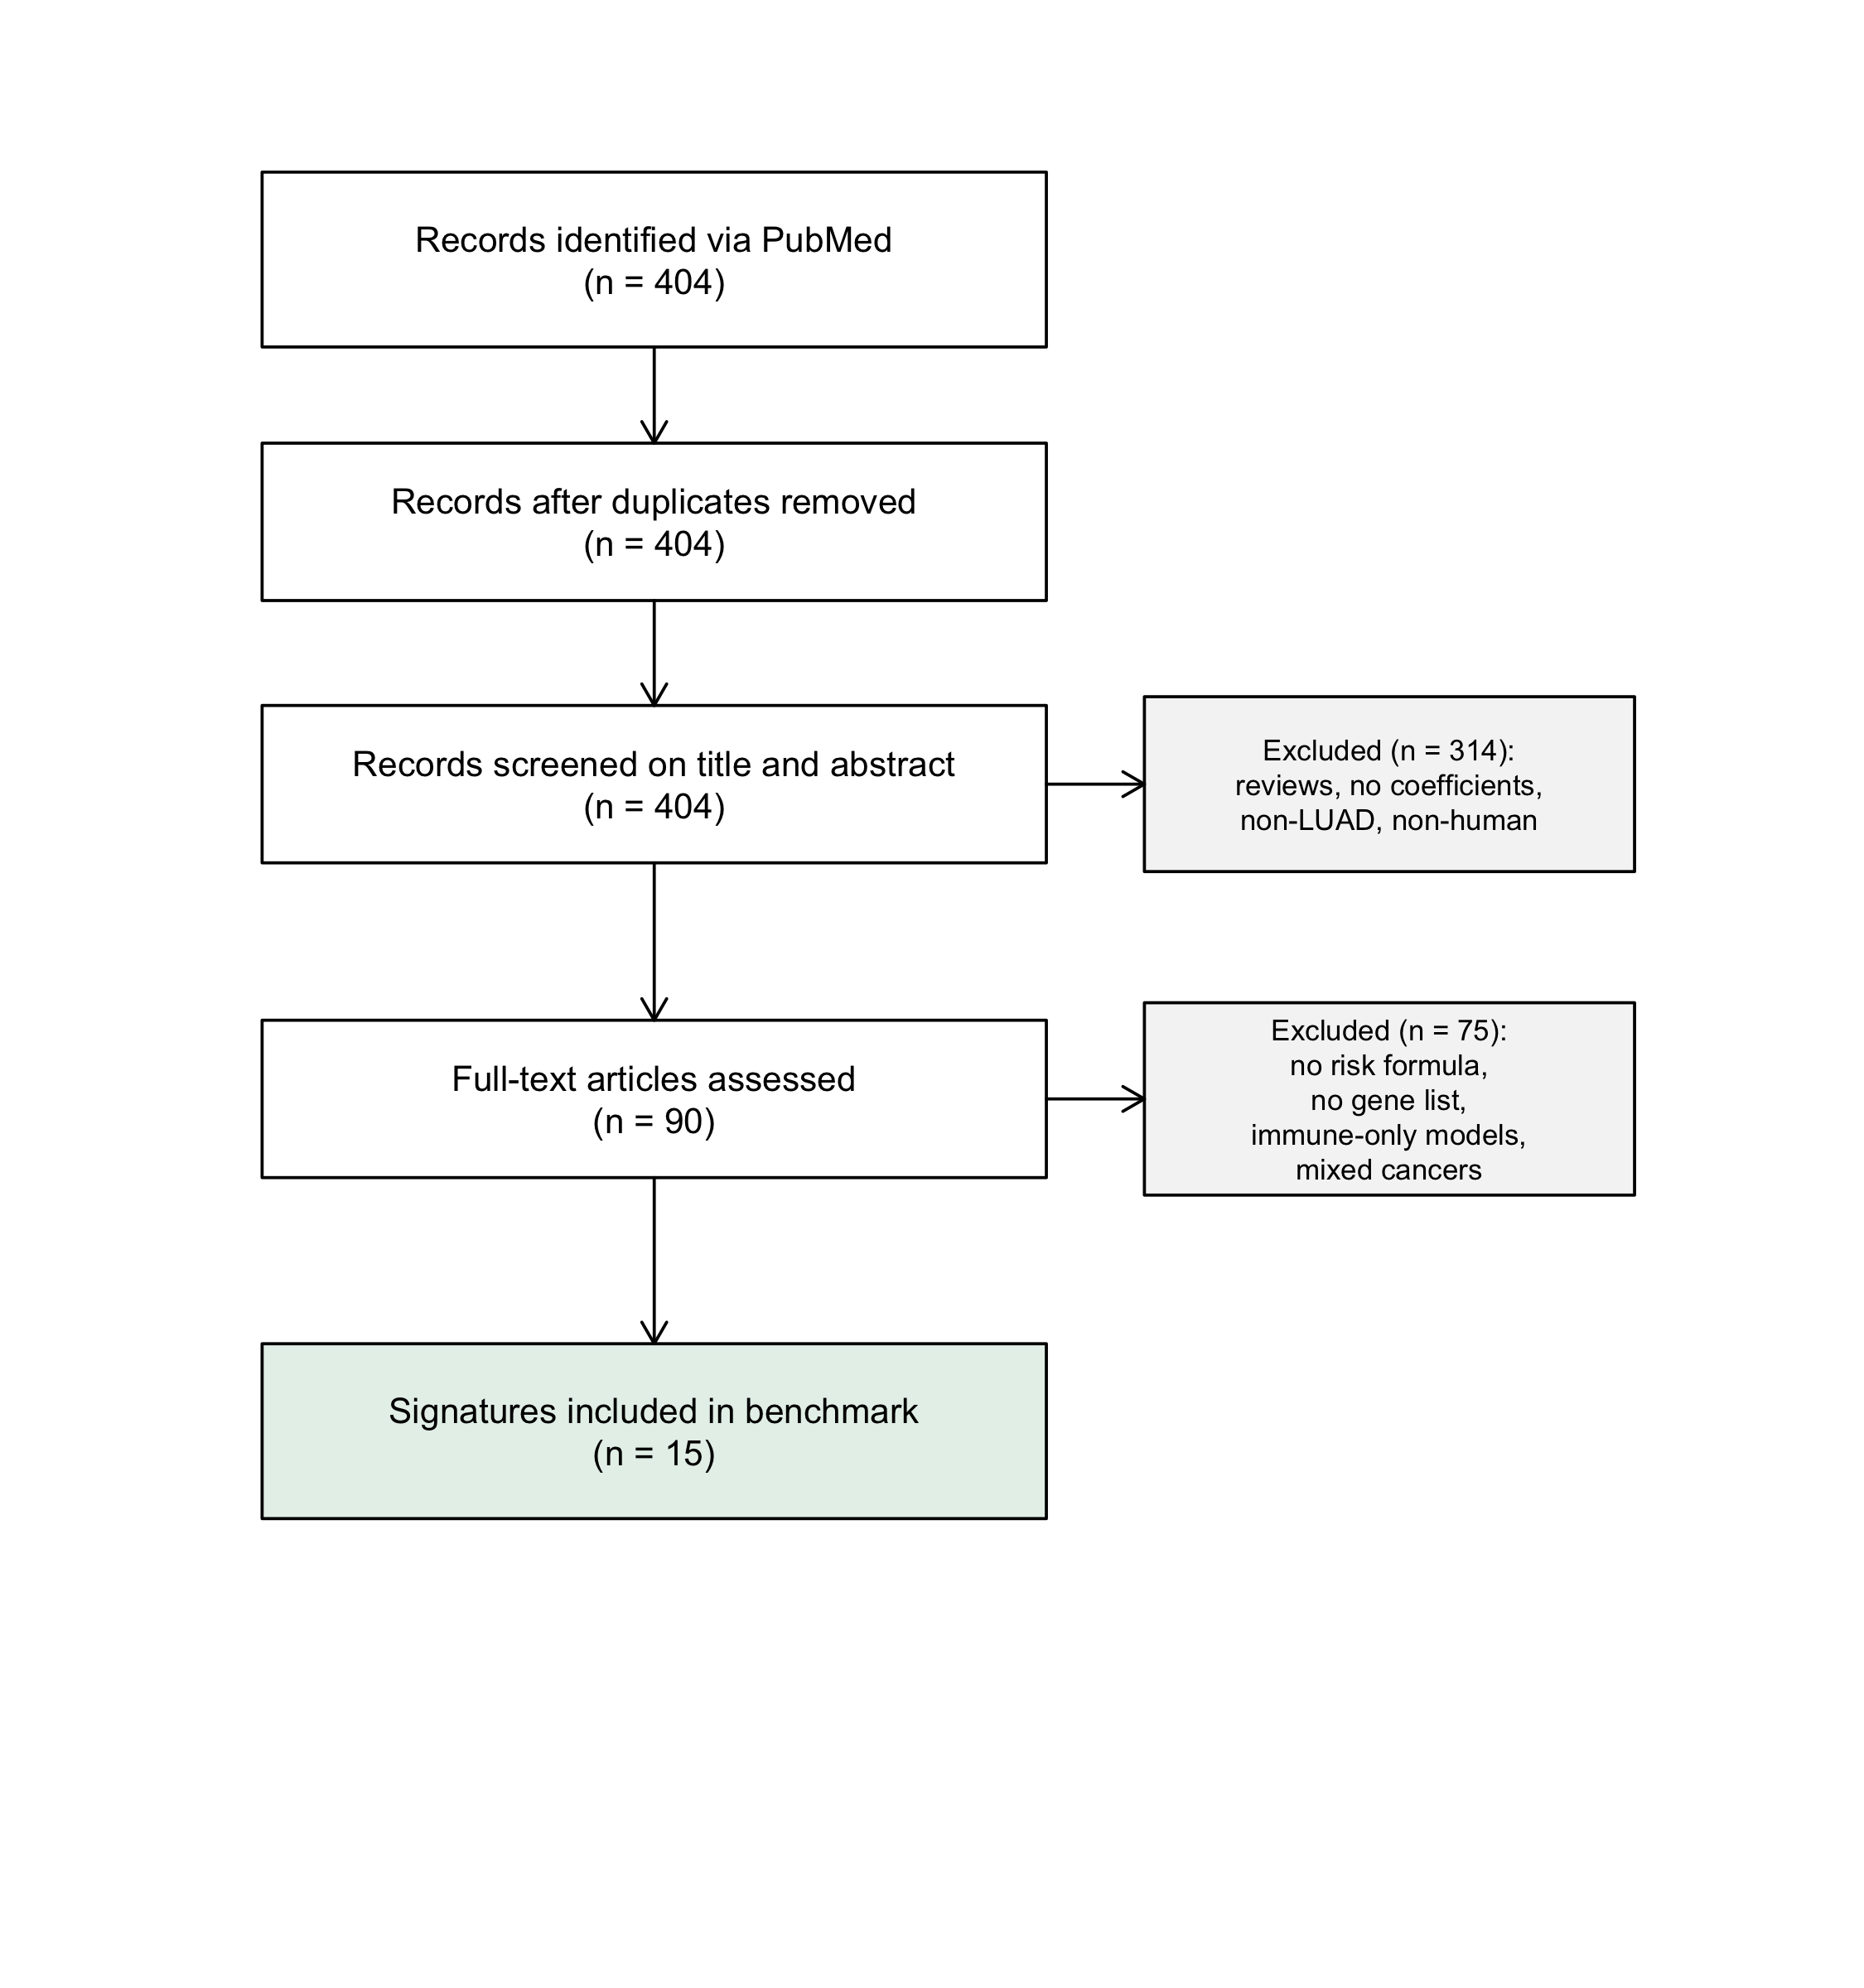
Figure 2. Signature genes measurable in each cohort. Each cell gives the number of signature genes measurable in the cohort over the number in the signature; shading shows the proportion. A black frame marks pairs that meet the registered 80% coverage rule; an asterisk marks cohorts used by the signature's authors, which are not independent. TCGA-LUAD was used to develop all 15 signatures.
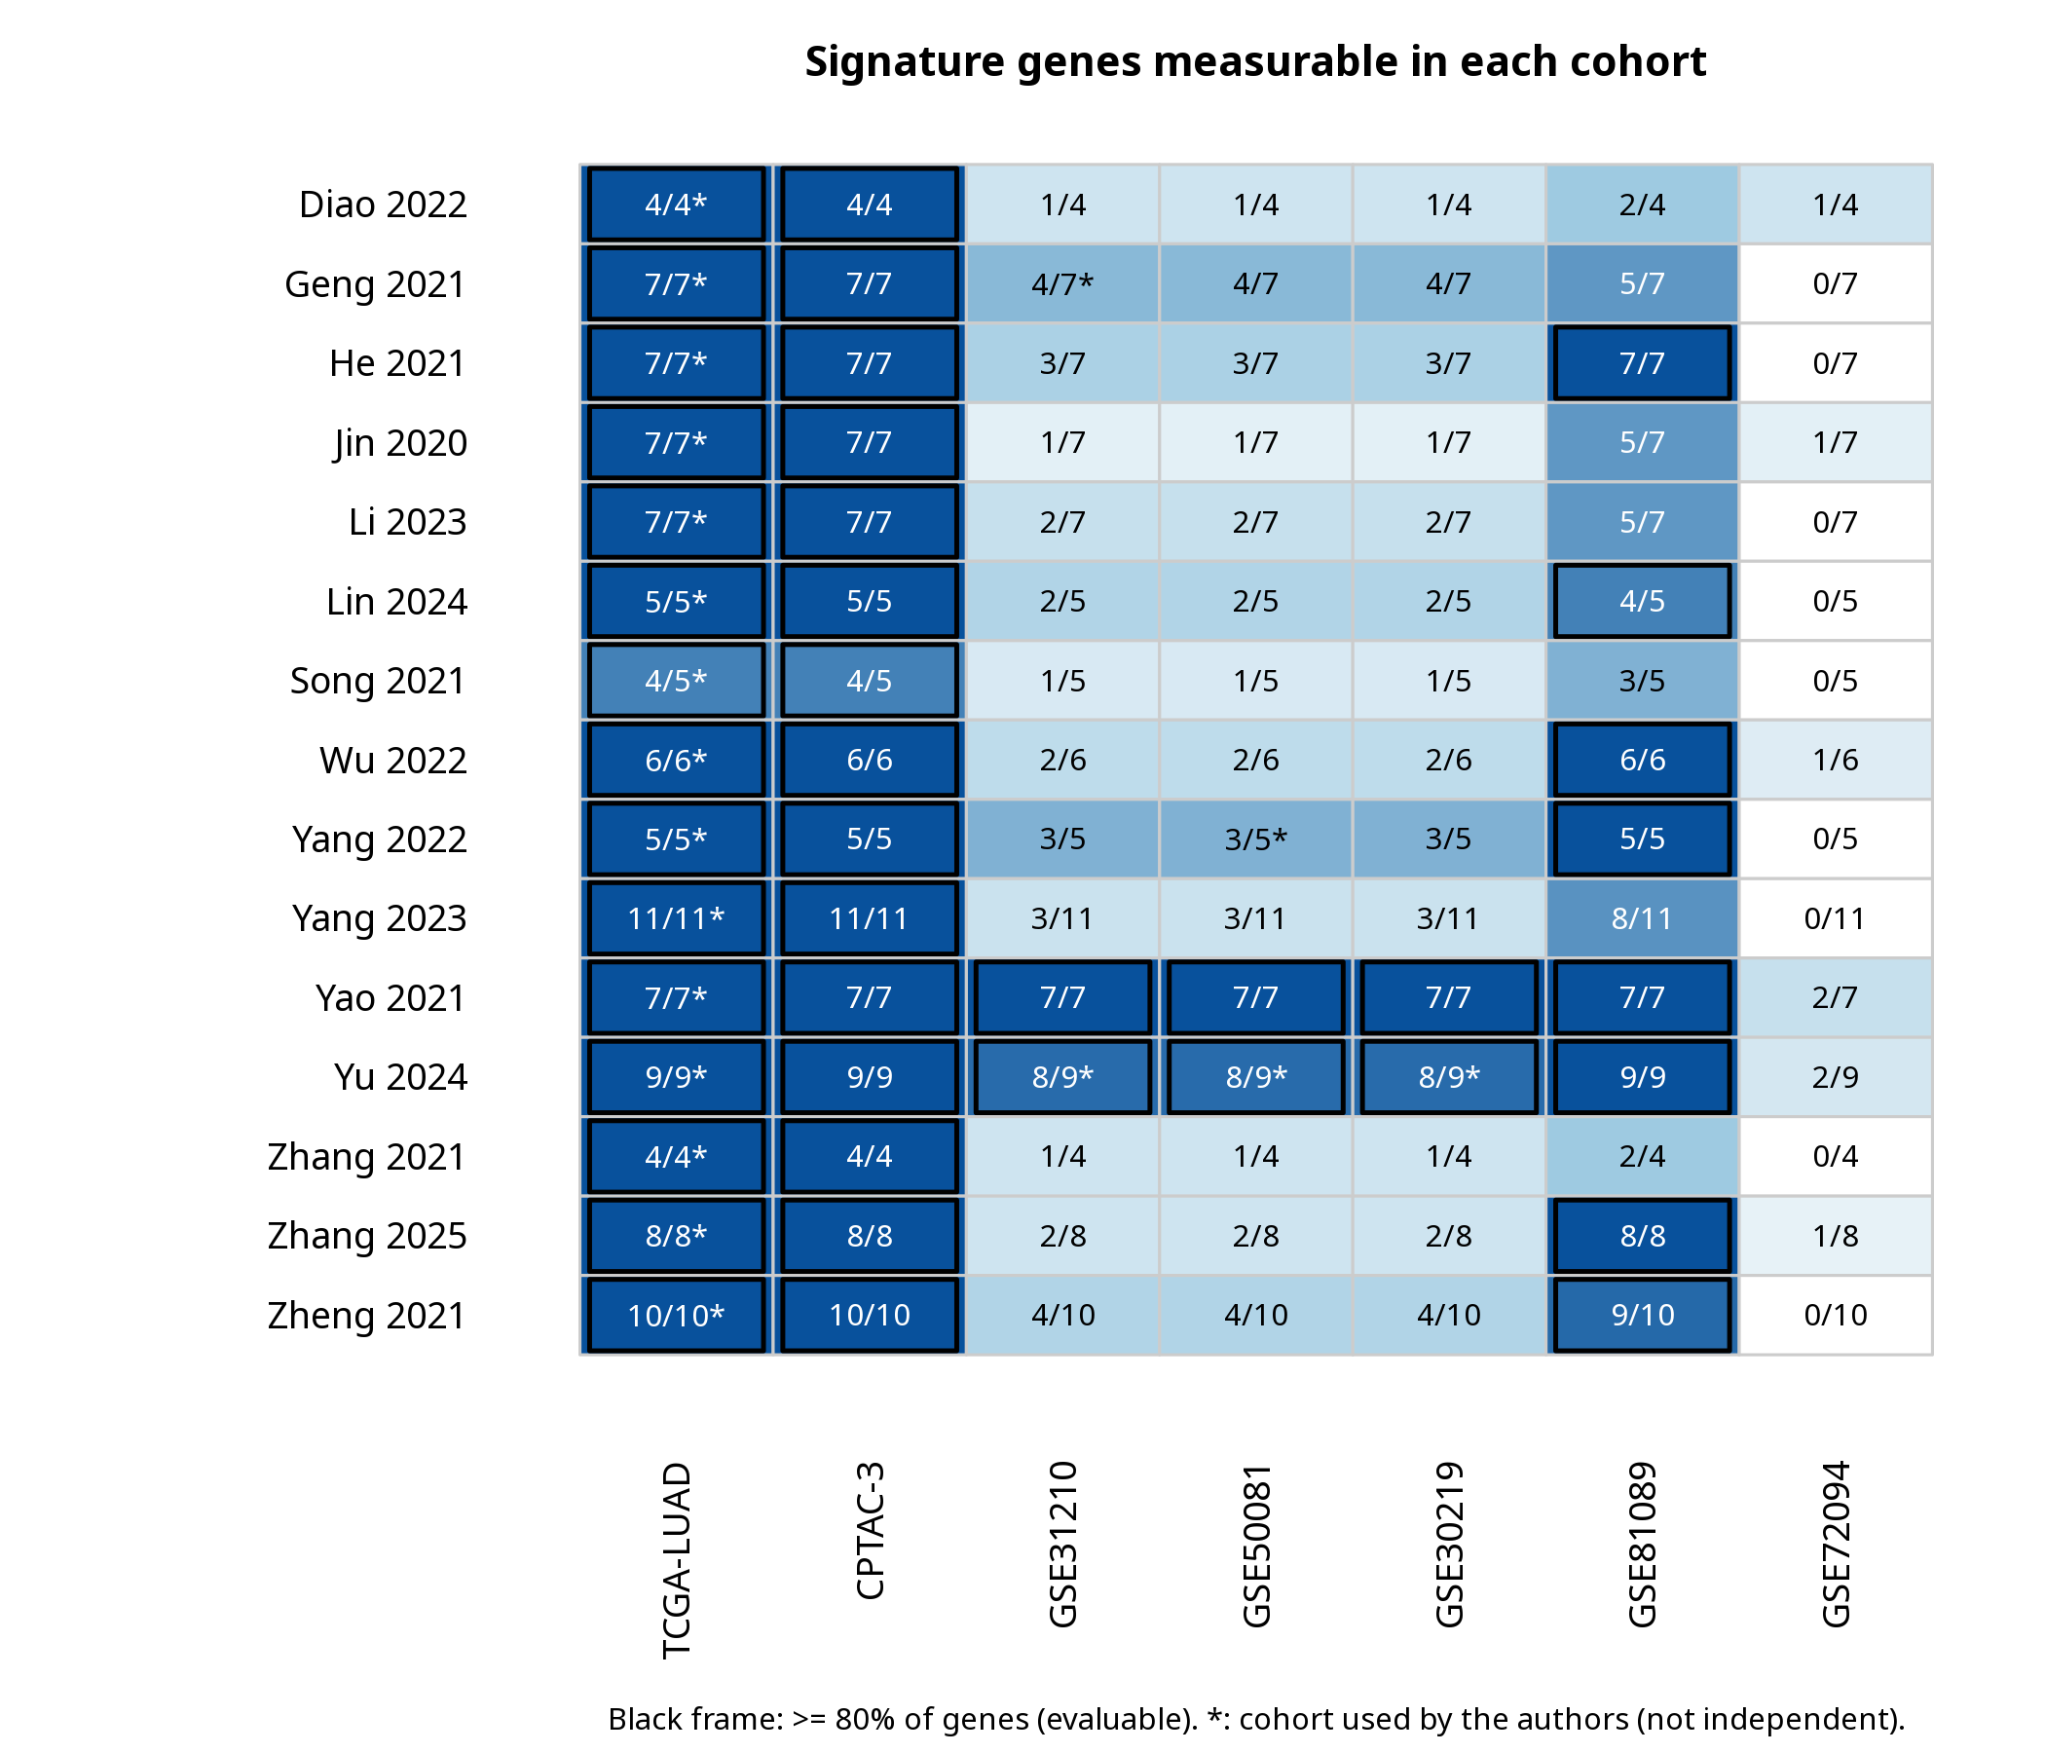
Figure 3. C-index of each published score in TCGA-LUAD (apparent performance; x-axis) and in each independent cohort (y-axis; 95% bootstrap CI). The dotted line marks equal performance and the dashed line no discrimination (C = 0.5).
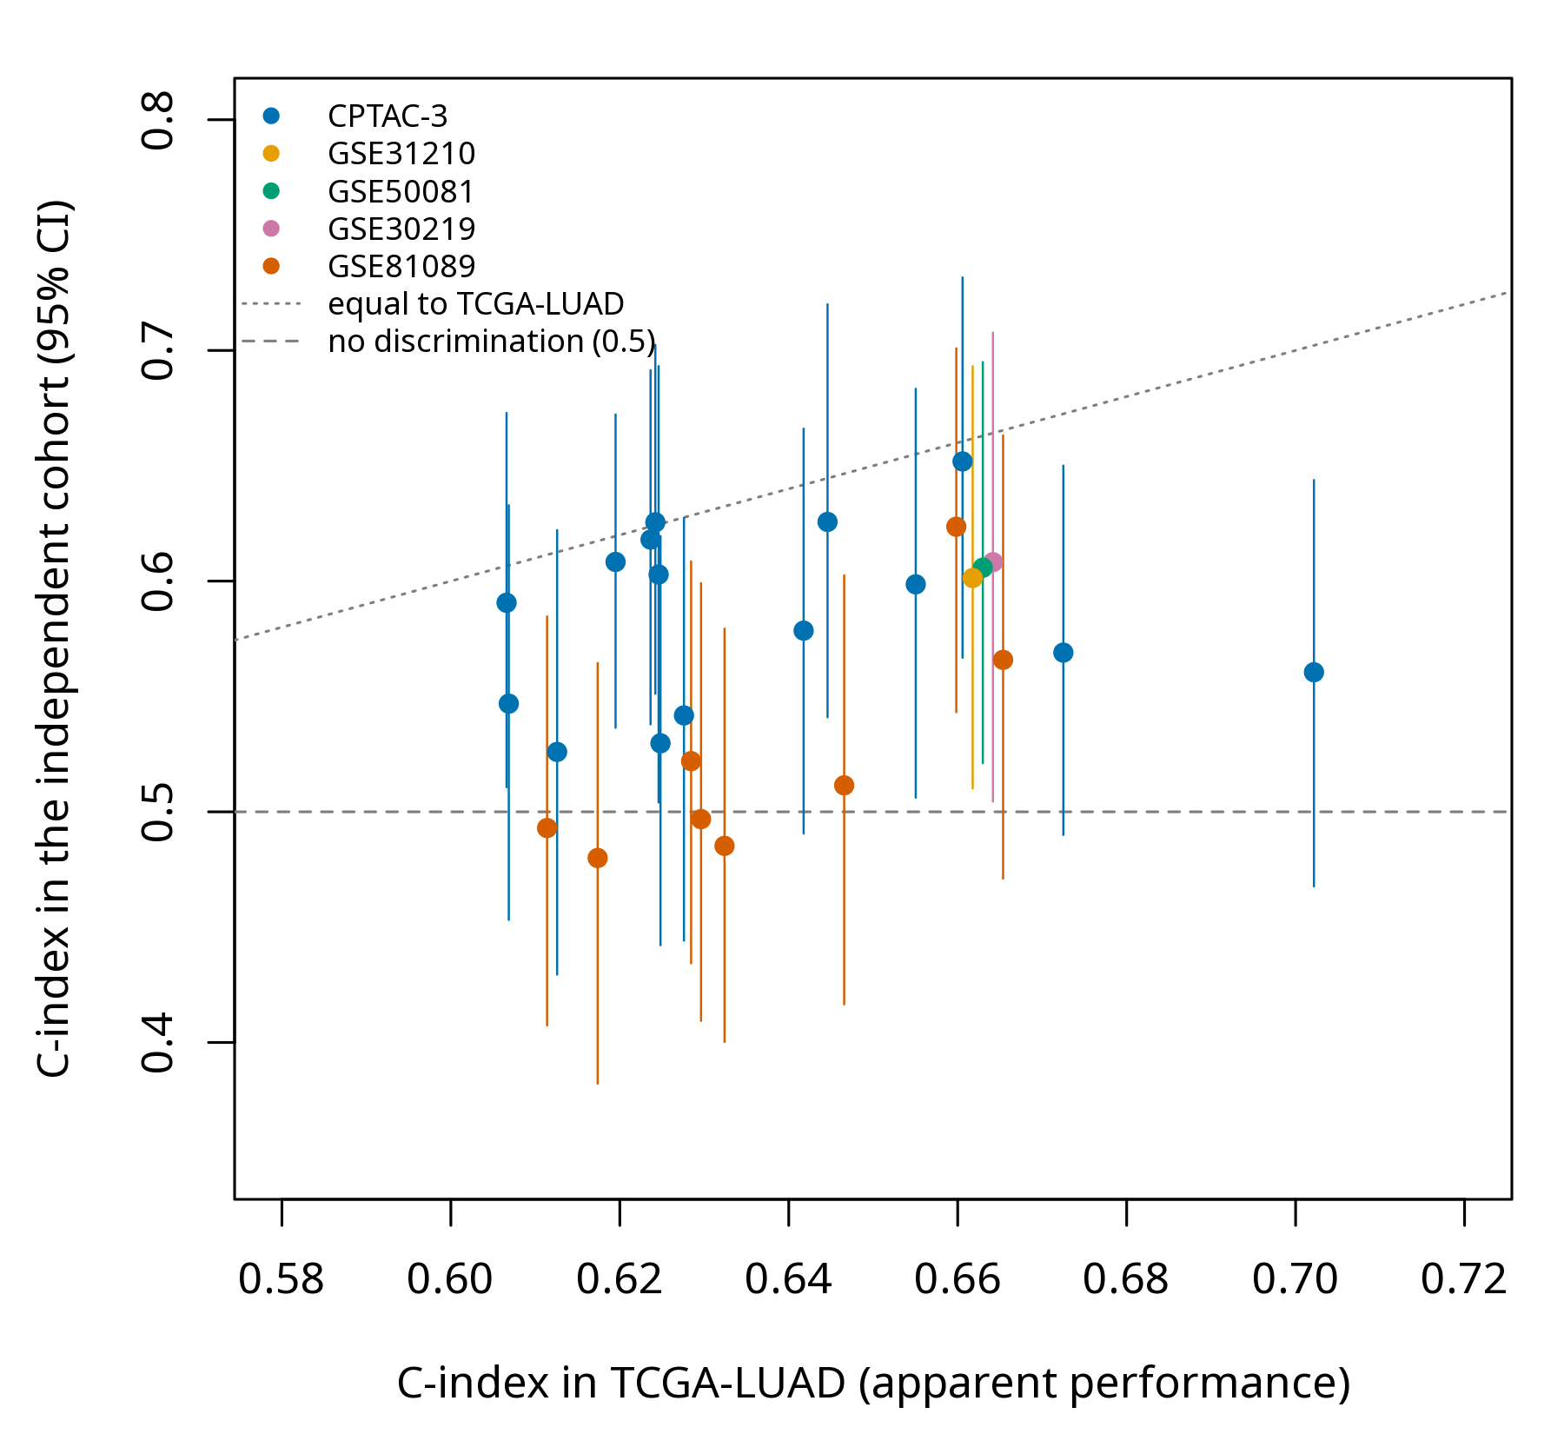
Figure 4. Hazard ratio per SD of the published risk score for each signature in TCGA-LUAD (open circles; reference only) and in each independent cohort where it was evaluable (filled squares), with 95% CIs, on a log scale.
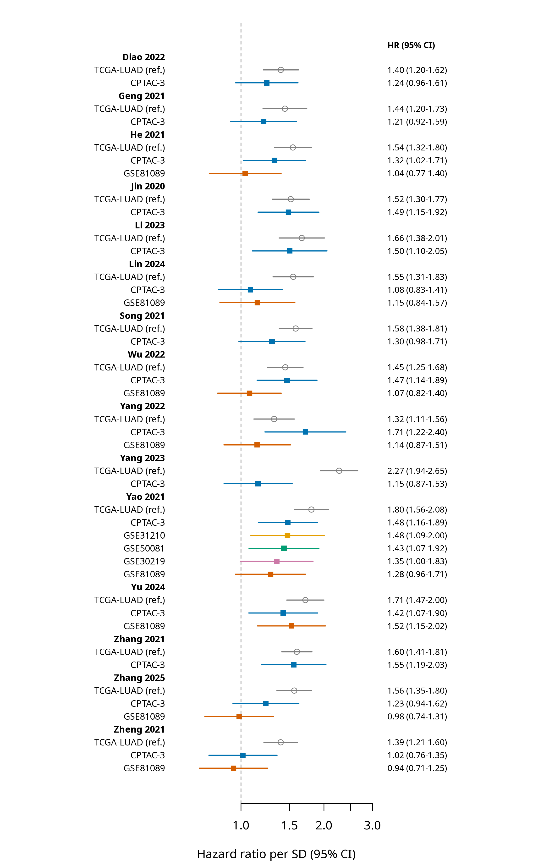
Figure 5. Yao 2021 in TCGA-LUAD (development cohort, not pooled) and in five independent cohorts. Diamonds show the exploratory pooled estimate with the registered REML Hartung–Knapp interval and with the modified Hartung–Knapp interval.
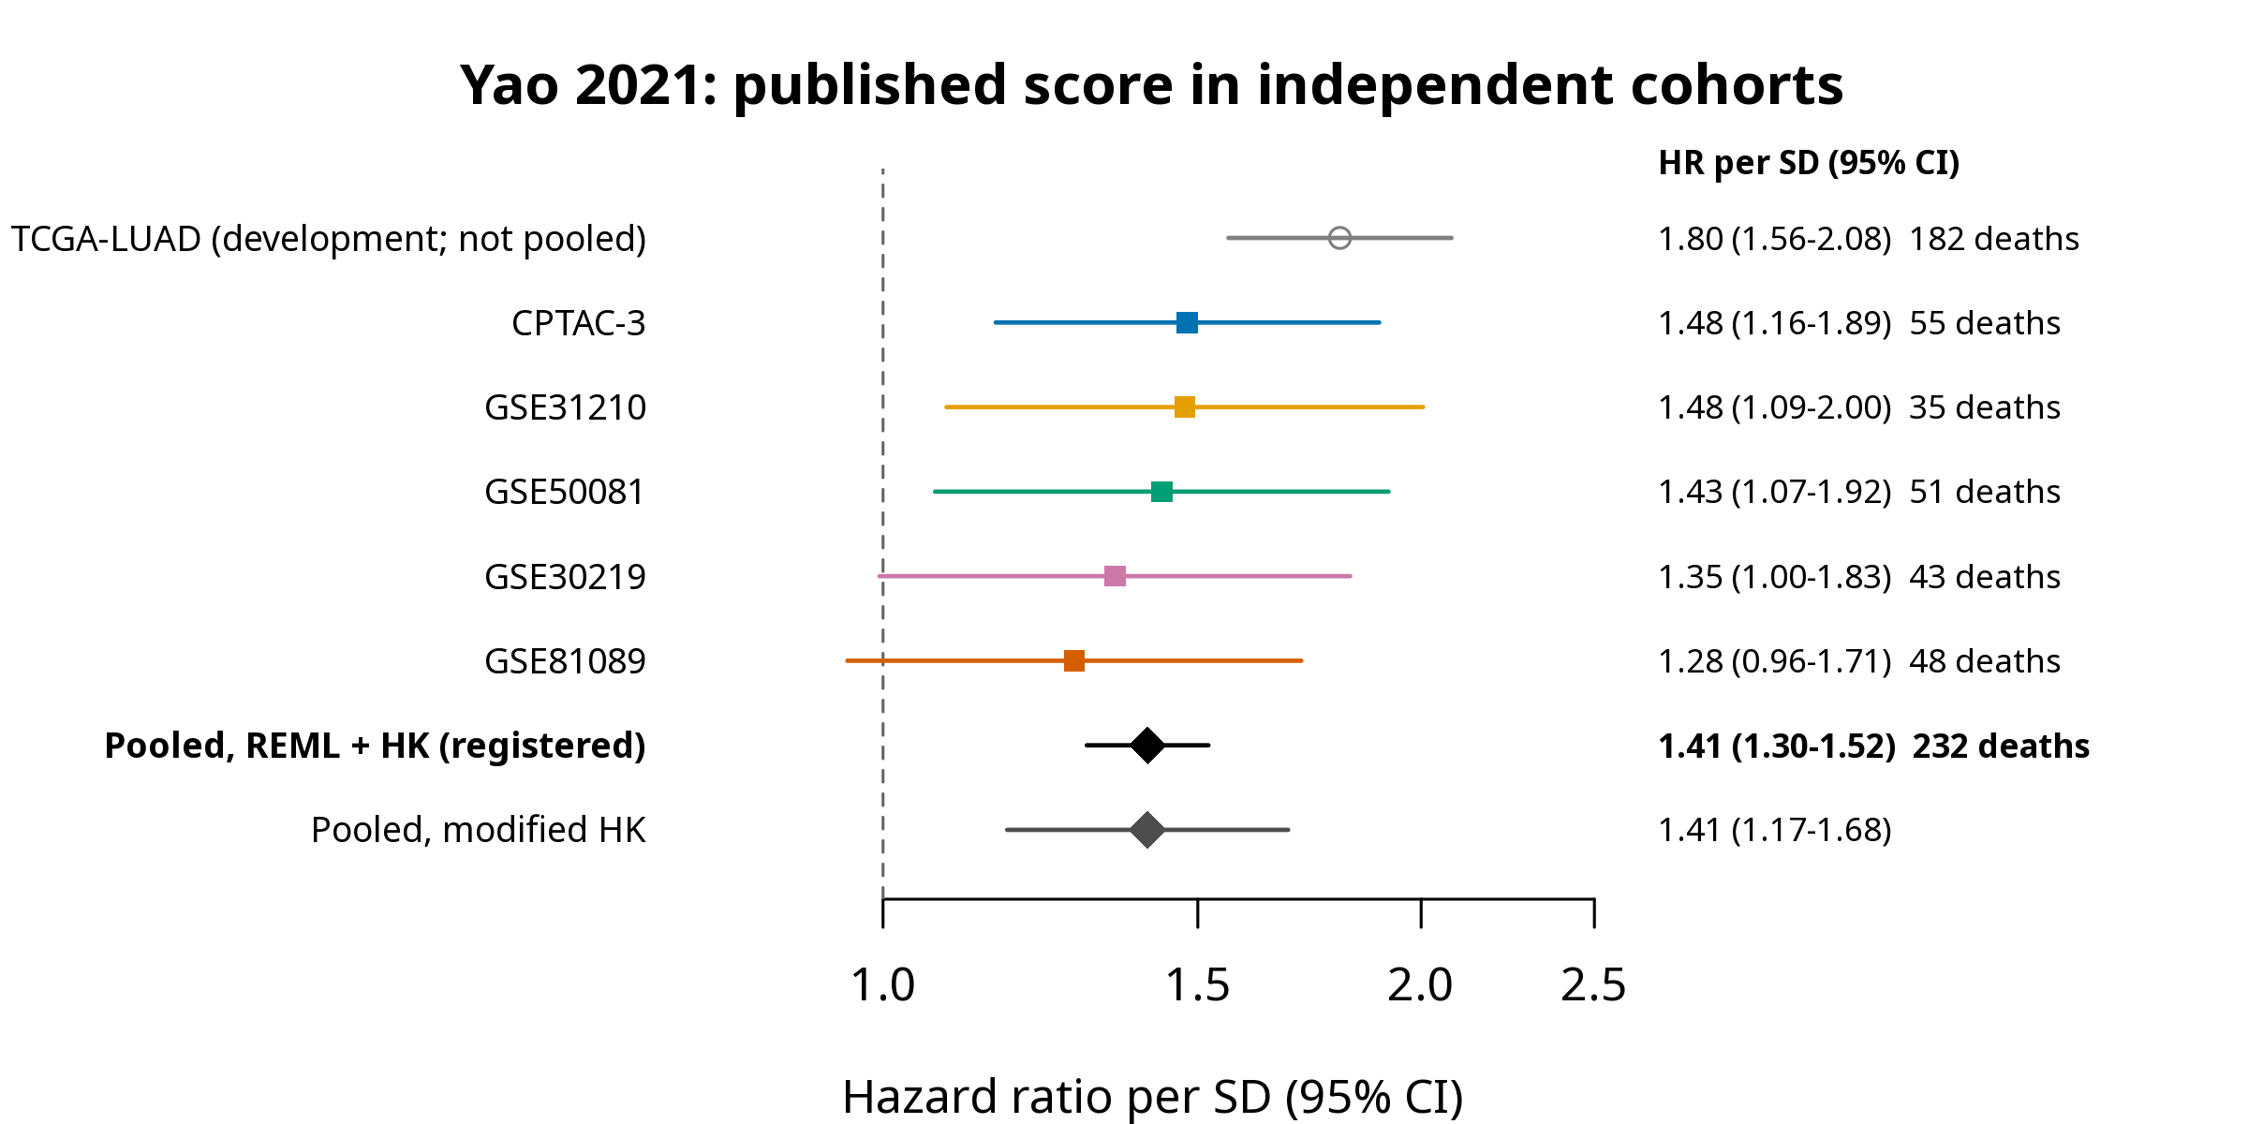
Figure 6. Aggregate transportability: mean HR per SD of the published scores over independent signature–cohort pairs, with 95% CIs from the patient-level cluster bootstrap, in the primary analysis and each sensitivity setting, and the cluster-robust multilevel cross-check. The dashed line marks HR = 1 and the dotted line the decision threshold HR = 1.25 (δ). Analysis added after registration.
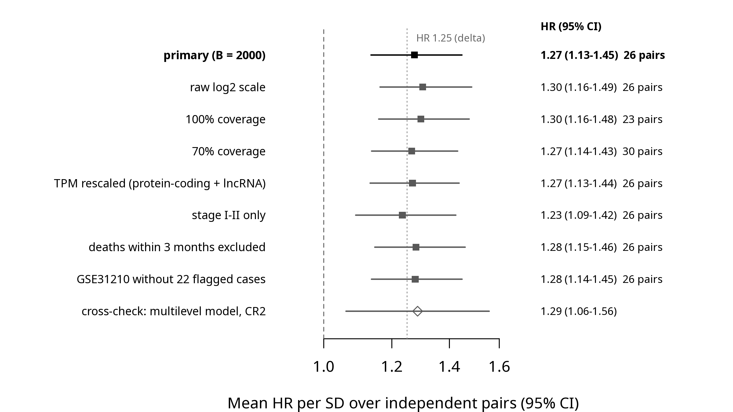
Supplementary Figure S1. Observed C-index (95% CI) of each independent pair against the range of C-indexes from 2,000 expression-matched random gene sets scored with the same coefficients (grey band, 2.5th–97.5th percentiles).
Supplementary Figure S2. Kaplan–Meier curves of overall survival for patients above and below the median published score, for the 26 independent pairs.

Supplementary material
Supplementary File 1: deviations log (v2), search strategy and the registration updates.
Supplementary tables (results/paper/tables): S1, stage positive control; S2, coverage matrix; S3, coverage by signature and cohort with missing genes; S4, gene identity, manual mappings and successor identifiers; S5, missing genes and reasons; S6, H1 comparison with random gene sets; S7, H2 added value; S8, per-pair metrics in all cohorts (C-indexes, time-dependent AUC, log-rank, proportional-hazards tests, restricted mean survival time); S9, power simulation; S10, Yao 2021 pooling intervals and leave-one-cohort-out estimates; S11, H1 sensitivity analyses; S12, direction-consistency observations; S13 and S14, gene-level concordance by pair and by gene; S15, Jaccard overlap; S16, signature clusters; S17, agreement of the two coefficient extractions; S18, independence of signature–cohort pairs.

Table 1. Characteristics of the 15 published LUAD lncRNA prognostic signatures.
Signature | Ref. | Genes | Risk / protective coefficients | Gene-name release | Expression scale stated | Cohorts used by the authors | Independent cohorts evaluable (≥ 80% of genes)
Diao 2022 | 16 | 4 | 3 / 1 | GENCODE v36 | Not specified | TCGA-LUAD | CPTAC-3
Geng 2021 | 19 | 7 | 5 / 2 | GENCODE v36 | FPKM | TCGA-LUAD, GSE31210 | CPTAC-3
He 2021 | 17 | 7 | 4 / 3 | GENCODE v36 | FPKM | TCGA-LUAD | CPTAC-3, GSE81089
Jin 2020 | 18 | 7 | 3 / 4 | GENCODE v36 | Not specified | TCGA-LUAD | CPTAC-3
Li 2023 | 21 | 7 | 3 / 4 | GENCODE v36 | FPKM | TCGA-LUAD | CPTAC-3
Lin 2024 | 28 | 5 | 4 / 1 | GENCODE v36 | HTSeq - FPKM | TCGA-LUAD | CPTAC-3, GSE81089
Song 2021 | 25 | 5 | 4 / 1 | GENCODE v36 | FPKM | TCGA-LUAD | CPTAC-3
Wu 2022 | 24 | 6 | 3 / 3 | GENCODE v36 | standardized expression levels | TCGA-LUAD | CPTAC-3, GSE81089
Yang 2022 | 26 | 5 | 3 / 2 | GENCODE v36 | FPKM | TCGA-LUAD, GSE50081 | CPTAC-3, GSE81089
Yang 2023 | 15 | 11 | 6 / 5 | GENCODE v36 | STAR-Counts | TCGA-LUAD | CPTAC-3
Yao 2021 | 27 | 7 | 3 / 4 | GENCODE v22 | Not specified | TCGA-LUAD | CPTAC-3, GSE31210, GSE50081, GSE30219, GSE81089
Yu 2024 | 22 | 9 | 4 / 5 | GENCODE v22 | FPKM | TCGA-LUAD, GSE31210, GSE50081, GSE30219 | CPTAC-3, GSE81089
Zhang 2021 | 29 | 4 | 3 / 1 | GENCODE v36 | RPKM | TCGA-LUAD | CPTAC-3
Zhang 2025 | 23 | 8 | 2 / 6 | GENCODE v36 | Not specified | TCGA-LUAD | CPTAC-3, GSE81089
Zheng 2021 | 20 | 10 | 7 / 3 | GENCODE v36 | Not specified | TCGA-LUAD | CPTAC-3, GSE81089
Risk coefficients > 0, protective < 0. Gene-name release: the GENCODE release whose gene names the paper follows, used to map names to Ensembl identifiers. Cohorts used by the authors (development, feature selection or validation) are not independent for that signature.

Table 2. Cohorts.
Cohort | Role | Platform | Patients | Deaths | Median follow-up, months | Stage I / II / III / IV / missing | Positive control | Signatures with ≥ 80% (100%) of genes; independent pairs
TCGA-LUAD | Reference (apparent performance) | RNA-seq, poly(A) (GDC STAR-Counts) | 504 | 182 | 29 | 270 / 120 / 81 / 25 / 8 | pass (HR III vs I) | 15 (14); 0
CPTAC-3 | Independent | RNA-seq, total RNA (GDC STAR-Counts) | 205 | 55 | 35.6 | 114 / 46 / 43 / 2 / 0 | pass (HR III vs I) | 15 (14); 15
GSE31210 | Independent | Affymetrix GPL570 (RMA from CEL) | 226 | 35 | 60.7 | 168 / 58 / 0 / 0 / 0 | pass (HR II vs I) | 2 (1); 1
GSE50081 | Independent | Affymetrix GPL570 (RMA from CEL) | 127 | 51 | 65.9 | 92 / 35 / 0 / 0 / 0 | pass (HR II vs I) | 2 (1); 1
GSE30219 | Independent | Affymetrix GPL570 (RMA from CEL) | 83 | 43 | 116 | 79 / 3 / 1 / 0 / 0 | pass (HR II vs I) | 2 (1); 1
GSE81089 | Independent | RNA-seq, poly(A) (Cufflinks FPKM, Ensembl 73) | 107 | 48 | 52.3 | 61 / 19 / 24 / 3 / 0 | pass (HR III vs I) | 8 (6); 8
GSE72094 | Independent | Rosetta/Merck array GPL15048 (series matrix) | 398 | 113 | 29.9 | 254 / 67 / 57 / 15 / 5 | pass (HR III vs I) | 0 (0); 0
Median follow-up by the reverse Kaplan–Meier method. Positive control: Cox model on stage; HR III vs I (registered) or, in cohorts with fewer than 10 stage III–IV patients, HR II vs I (Update 3). Independent pairs: evaluable signature–cohort pairs not used by the signature's authors.

Table 3. Results for the 26 independent signature–cohort pairs (H1, HR per SD and H2).
Signature | Cohort | Genes present | Deaths | C-index (95% CI) | Random genes, 2.5–97.5% | H1 p | H1 p (Holm) | HR per SD (95% CI) | ΔC-index beyond stage, sex, age (95% CI) | H2 p (Holm)
Diao 2022 | CPTAC-3 | 4/4 | 55 | 0.61 (0.53-0.68) | 0.38–0.59 | 0.056 | 0.60 | 1.24 (0.96-1.61) | 0.018 (-0.003 to 0.061) | 0.76
Geng 2021 | CPTAC-3 | 7/7 | 55 | 0.55 (0.46-0.64) | 0.40–0.61 | 0.41 | 1.00 | 1.21 (0.92-1.59) | 0.007 (-0.014 to 0.039) | 0.88
He 2021 | CPTAC-3 | 7/7 | 55 | 0.58 (0.50-0.66) | 0.39–0.60 | 0.15 | 1.00 | 1.32 (1.02-1.71) | 0.014 (-0.010 to 0.050) | 0.60
Jin 2020 | CPTAC-3 | 7/7 | 55 | 0.63 (0.55-0.71) | 0.38–0.60 | 0.022 | 0.29 | 1.49 (1.15-1.92) | 0.027 (-0.003 to 0.072) | 0.12
Li 2023 | CPTAC-3 | 7/7 | 55 | 0.60 (0.51-0.69) | 0.40–0.61 | 0.055 | 0.60 | 1.50 (1.10-2.05) | 0.030 (-0.010 to 0.096) | 0.021 *
Lin 2024 | CPTAC-3 | 5/5 | 55 | 0.53 (0.44-0.62) | 0.38–0.61 | 0.63 | 1.00 | 1.08 (0.83-1.41) | 0.006 (-0.013 to 0.033) | 0.88
Song 2021 | CPTAC-3 | 4/5 | 55 | 0.57 (0.48-0.65) | 0.39–0.60 | 0.23 | 1.00 | 1.30 (0.98-1.71) | 0.007 (-0.010 to 0.055) | 0.88
Wu 2022 | CPTAC-3 | 6/6 | 55 | 0.62 (0.54-0.69) | 0.41–0.61 | 0.024 | 0.29 | 1.47 (1.14-1.89) | 0.044 (0.000 to 0.107) | 0.029 *
Yang 2022 | CPTAC-3 | 5/5 | 55 | 0.59 (0.51-0.67) | 0.41–0.61 | 0.088 | 0.75 | 1.71 (1.22-2.40) | 0.029 (-0.004 to 0.068) | 0.039 *
Yang 2023 | CPTAC-3 | 11/11 | 55 | 0.56 (0.47-0.64) | 0.40–0.62 | 0.32 | 1.00 | 1.15 (0.87-1.53) | 0.003 (-0.010 to 0.051) | 0.88
Yao 2021 | CPTAC-3 | 7/7 | 55 | 0.65 (0.58-0.73) | 0.41–0.62 | 0.006 | 0.090 | 1.48 (1.16-1.89) | 0.031 (-0.001 to 0.091) | 0.12
Yu 2024 | CPTAC-3 | 9/9 | 55 | 0.60 (0.50-0.68) | 0.40–0.62 | 0.083 | 0.75 | 1.42 (1.07-1.90) | 0.015 (-0.010 to 0.078) | 0.12
Zhang 2021 | CPTAC-3 | 4/4 | 55 | 0.63 (0.54-0.71) | 0.40–0.61 | 0.014 | 0.20 | 1.55 (1.19-2.03) | 0.028 (-0.009 to 0.082) | 0.12
Zhang 2025 | CPTAC-3 | 8/8 | 55 | 0.54 (0.46-0.63) | 0.43–0.62 | 0.51 | 1.00 | 1.23 (0.94-1.62) | -0.002 (-0.017 to 0.053) | 0.67
Zheng 2021 | CPTAC-3 | 10/10 | 55 | 0.53 (0.43-0.62) | 0.38–0.60 | 0.66 | 1.00 | 1.02 (0.76-1.35) | -0.002 (-0.016 to 0.036) | 0.88
Yao 2021 | GSE31210 | 7/7 | 35 | 0.60 (0.51-0.69) | 0.34–0.67 | 0.26 | 0.26 | 1.48 (1.09-2.00) | 0.009 (-0.018 to 0.068) | 0.14
Yao 2021 | GSE50081 | 7/7 | 51 | 0.61 (0.51-0.69) | 0.38–0.61 | 0.079 | 0.079 | 1.43 (1.07-1.92) | 0.043 (-0.004 to 0.127) | 0.033 *
Yao 2021 | GSE30219 | 7/7 | 43 | 0.61 (0.50-0.71) | 0.38–0.62 | 0.10 | 0.10 | 1.35 (1.00-1.83) | 0.058 (-0.002 to 0.164) | 0.013 *
He 2021 | GSE81089 | 7/7 | 48 | 0.51 (0.42-0.61) | 0.41–0.58 | 0.80 | 1.00 | 1.04 (0.77-1.40) | 0.006 (-0.019 to 0.040) | 1.00
Lin 2024 | GSE81089 | 4/5 | 48 | 0.50 (0.40-0.59) | 0.42–0.58 | 0.94 | 1.00 | 1.15 (0.84-1.57) | -0.008 (-0.026 to 0.033) | 1.00
Wu 2022 | GSE81089 | 6/6 | 48 | 0.52 (0.44-0.61) | 0.42–0.58 | 0.60 | 1.00 | 1.07 (0.82-1.40) | -0.002 (-0.018 to 0.033) | 1.00
Yang 2022 | GSE81089 | 5/5 | 48 | 0.49 (0.40-0.58) | 0.42–0.59 | 0.87 | 1.00 | 1.14 (0.87-1.51) | -0.005 (-0.019 to 0.041) | 1.00
Yao 2021 | GSE81089 | 7/7 | 48 | 0.57 (0.47-0.67) | 0.39–0.57 | 0.18 | 1.00 | 1.28 (0.96-1.71) | 0.008 (-0.016 to 0.056) | 1.00
Yu 2024 | GSE81089 | 9/9 | 48 | 0.62 (0.55-0.70) | 0.40–0.57 | 0.009 | 0.076 | 1.52 (1.15-2.02) | 0.028 (-0.010 to 0.077) | 0.043 *
Zhang 2025 | GSE81089 | 8/8 | 48 | 0.49 (0.39-0.57) | 0.41–0.57 | 0.72 | 1.00 | 0.98 (0.74-1.31) | -0.010 (-0.029 to 0.057) | 1.00
Zheng 2021 | GSE81089 | 9/10 | 48 | 0.48 (0.39-0.57) | 0.41–0.58 | 0.64 | 1.00 | 0.94 (0.71-1.25) | -0.006 (-0.028 to 0.039) | 1.00
All 26 pairs were classified Inconclusive in H1 (no adjusted p < 0.05); none was Contradicted. H1: C-index of the published score compared with 2,000 expression-matched random gene sets scored with the same coefficients; Holm correction across the signatures evaluable in each cohort. H2: likelihood-ratio test for the standardised score added to stage, sex and age; * adds value (Holm-adjusted p < 0.05).

Table 4. Aggregate and pooled analyses.
Analysis | Estimate | Result
Aggregate transportability: mean log-HR per SD over 26 independent pairs in 5 cohorts, patient-level cluster bootstrap (2000 resamples); not pre-registered | HR 1.27 (1.13-1.45); log-HR 0.243 (0.127 to 0.370) | Transportable
Cross-check: multilevel meta-analysis (pairs within cohorts), CR2 cluster-robust CI | HR 1.29 (1.06-1.56); df 2.7 | CI above HR 1
Direction consistency (Update 1): effective: one per cluster per cohort | 23 of 25 in the published direction (92%) | binomial p < 0.001
Direction consistency (Update 1): nominal: every signature x cohort pair | 24 of 26 in the published direction (92%) | binomial p < 0.001
Yao 2021 pooled over 5 independent cohorts (CPTAC-3, GSE31210, GSE50081, GSE30219, GSE81089; 232 deaths), REML + Hartung-Knapp (registered, exploratory) | HR 1.41 (1.30-1.52); I2 0%; tau2 0.000
Yao 2021 pooled: modified Hartung-Knapp (q* = max(1, q)); not pre-registered | HR 1.41 (1.17-1.68); q = 0.19
Yao 2021 pooled: common effect | HR 1.41 (1.24-1.60)
Yao 2021 leave-one-cohort-out (REML + Hartung-Knapp) | HR 1.38 to 1.44; lowest CI bound 1.25
Gene level: share of (gene, independent cohort) pairs whose univariable Cox sign matches the published coefficient | 0.776
HR per SD of the published risk score. The aggregate transportability analysis and the modified Hartung–Knapp interval were not pre-registered. Direction consistency: one observation per cluster of overlapping signatures (Jaccard > 0.3) per cohort (effective) or one per pair (nominal).

Table 5. Sensitivity analyses.
Setting | Pairs | Mean HR per SD (95% CI) or H1 counts | Verdict or replicated pairs
A. Aggregate transportability
primary (repeated with B = 1000) | 26 | 1.27 (1.14-1.45) | Transportable
raw log2 scale | 26 | 1.30 (1.16-1.49) | Transportable
100% coverage | 23 | 1.30 (1.16-1.48) | Transportable
70% coverage | 30 | 1.27 (1.14-1.43) | Transportable
RNA-seq TPM rescaled to protein-coding + lncRNA genes | 26 | 1.27 (1.13-1.44) | Transportable
stage I-II only | 26 | 1.23 (1.09-1.42) | Transportable
deaths within 3 months excluded | 26 | 1.28 (1.15-1.46) | Transportable
GSE31210 without the 22 flagged cases | 26 | 1.28 (1.14-1.45) | Transportable
B. H1 classification (Replicated / Contradicted / Inconclusive)
primary (registered) | 26 | 0 / 0 / 26 | –
null pool: lncRNA genes only | 26 | 1 / 0 / 25 | Yu 2024 GSE81089
null pool: all measurable genes | 26 | 1 / 0 / 25 | Yao 2021 CPTAC-3
stage I-II only | 26 | 0 / 0 / 26 | –
deaths within 3 months excluded | 26 | 0 / 0 / 26 | –
GSE31210 without the 22 flagged cases | 1 | 0 / 0 / 1 | –
Primary transportability analysis with 2,000 bootstrap resamples (Table 4); sensitivity settings with 1,000. Measurable genes were recomputed in every setting.

