* Riffract Notes:
  1. Riffract Notes Overview:
     1. Take a guitar/piano, our preferred LED device (Adafruit Bluefruit ideally), and our program (Riffract) and you have an LED that will light up to notes YOU choose!
     2. Display a list of notes with prompts for choosing a color next to each one. If no color is chosen a random one is picked upon completion.
     3. When a color is picked and the program is ready, then when a note is played the color selected by the user is displayed on the LED.
  2. Static display of notes to user.
     1. 2 columns and 6 rows of all the notes, sharps and flats included.
     2. Each note has a corresponding frequency stored that the processor will use to compare to live music when determining which color to output.
     3. Next to each note name are the options for color selection in 3 boxes:
        1. RGB (255,255,255)
        2. Color Wheel/Square
        3. Hex Code (#FFFF)
  3. Processing Input
     1. Input: Notes from an instrument either via mic or Bluetooth.
     2. Output: Corresponding user-selected color value output via LEDs.
     3. Process:
        1. Determine what note is being played.
        2. Find the note with the closest frequency.
        3. Output corresponding color.
        4. Keep outputting the color until a frequency change beyond some margin is detected from the instrument.
           1. If a note change is detected, jump to step 1 and repeat.
           2. Else repeat step 4.
* Riffract Chords:
  1. Riffract Chords approaches:
     1. **Notes:** Determine the notes played in a chord and output a color for each detected note in a pattern
     2. **Chords:** Determine the chord being played and output the same color on all LED’s.
     3. **Mixing:** Determine the notes played and output a solid color that is the average RGB value of the notes detected from the given chord. Will likely just end up with super muddy colors but worth some thought.
  2. 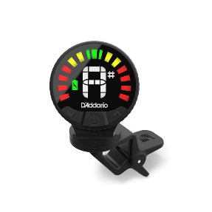Display & Processing: Largely the same as Riffract Notes with the addition of implementing one of the above approaches to determine what is done with the played chord.
* Riffract Tuner:
  1. Display: A watch-face style tuner where some margin like hand position 11:00-1:00 is perfectly in tune and everywhere else on the face is out of tune. The tuner shown to the left is likely what the page will end up looking like.
* Riffract Customs:
  1. Display:
     1. Displays some preset chord color schemes and note colors for the user to choose, made by us personally!
     2. Would be the same as Riffract Notes but without the customization option.
     3. This could serve as a reference for how to use the app, or just a cool little page for users to investigate.