Example of noisy channel that was excluded from analysis group.

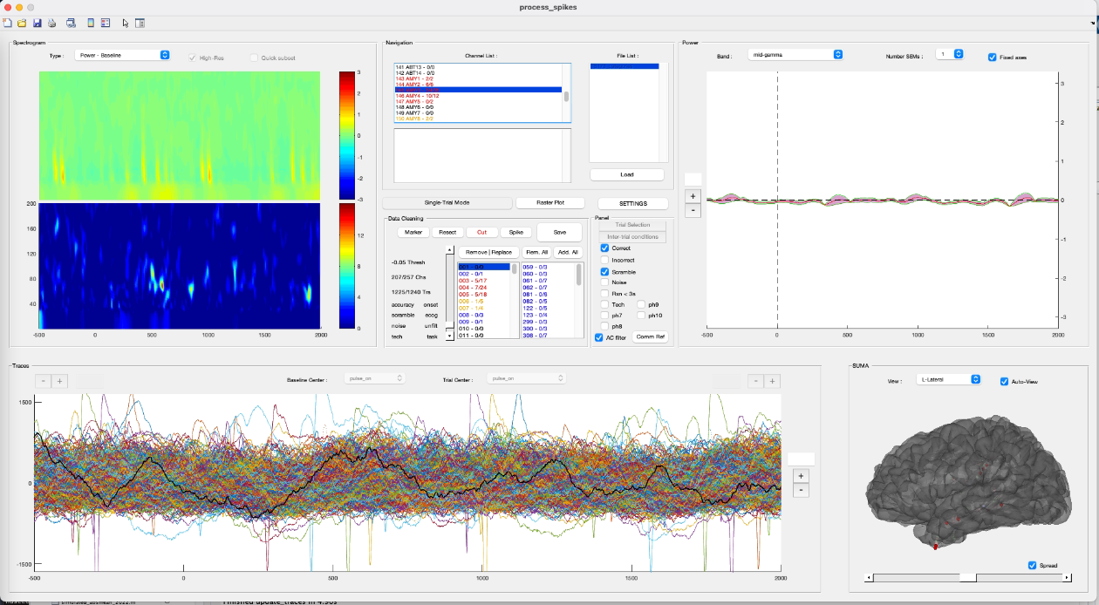

Example of clean channel that was included in analysis group

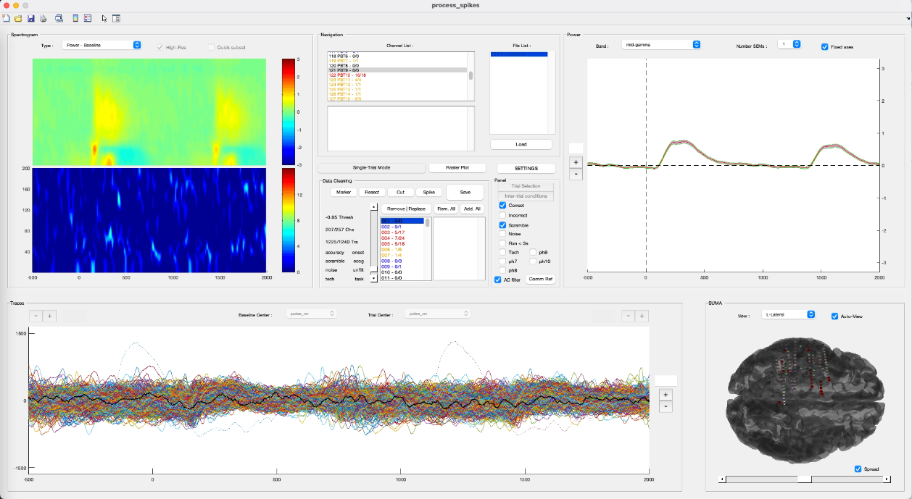

Notes:

Each screenshot shows the trail by trial activity at each electrode for a visual task. In this task, patients are presented with a series of images of different categories (faces, animals, words, scenes, control images) and are paying attention to different features of the stimuli. This gui alignes all the trials by stimulus onset of time zero (see bottom left panel showing each trial’s data). The relevant things to note are the single trial and group spectrograms showing the power in diff freq ranges. You can see this varies for the clean vs. noisy channel. Top right shows the average trace for all trials currently included for this electrode in mid-gamma. In the clean channel, can see some nice ramping of gamma after stim onset. In the middle panels, it shows which channel is currently selected up top, and then below shows each trial. You can see that some of the trials are marked in red and are excluded from the analysis. When cleaning, it’s a balance between eliminating trials vs. eliminating channels. If a channel is just noisy across all trials, it is better to remove that channel rather than remove all of the trials that it is noisy on (Because this will also remove those trials for all the rest of the channels).