Assignment 7

Task: Create a GUI Python Program that can read text files, and find instances of words within the file. It will also tell the user how many times that word is within the text document, and where within the text document it is.

Requirements:

GUI Requirements:

* Window named Lab 7 Group Project
* A menu created for “File”.
* A Close and Force Close Operation
  + Close prompts the user with a dialogue box asking if they want to quit
    - Hitting the X close button will prompt this as well
  + Force Close shuts down the application immediately
* Textbox for name of file and the word that will be searched.
  + Enter Key will move from one text box to another
* A button to accept all input and the process.
* Create a button that will save the results into a file.
  + The user can input the filename.

(GUI Screenshot here)

Program Requirements:

* There is a tracker for each instance of a word, and keeps track of the n’th word that follows it.
* Prints the results showing the search term and n’th word found.
* Shows number of total times matched

(Screenshot Here)

Use Cases:

Starting Window:

Search String with Case Sensitive True:

Search String with Case Sensitive True Results:

Search String with Case Sensitive False:

Search String with Case Sensitive False Results:

Search String with Not Found Search String:  
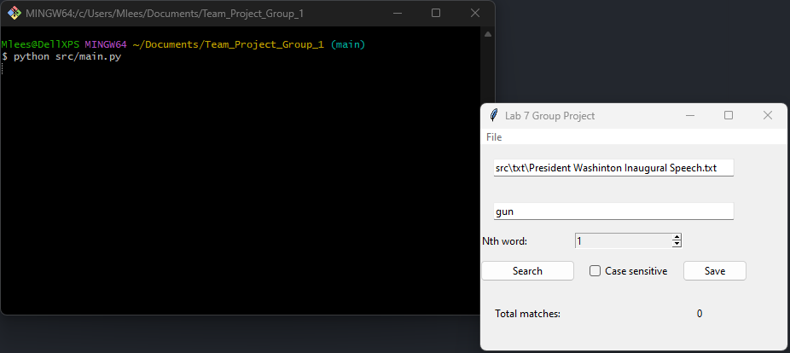

Saving Window:

