For this assignment, I focused on the topic I chose for my procedure, access token manipulation. This attack involves modifying access tokens in order to gain access to an account or system that one would not normally have access to. The Windows operating system can also be manipulated by this, since Windows uses access tokens to determine the ownership of any running processes. It is possible for a user to manipulate access tokens and make a process appear to belong to another user. When this happens, the process will also inherit the security context of the new, forged token.
After doing research and familiarizing myself with access token manipulation, I initially attempted to practice it on Windows. It is possible to use built-in Windows API functions to steal tokens from other processes. First, I ran Windows PowerShell as an administrator. I decided this would be the easiest way to attempt this for the first time, and that this method would be the safest way to experiment. Initially, I was not sure where to start and what commands or functions to utilize. I looked up tutorials on YouTube and referenced online guides. With Windows, I tried to manipulate access tokens with the “RunAs” command, but I was unsuccessful. I kept getting errors that my password was incorrect, even when it was not, meaning I could not attempt that.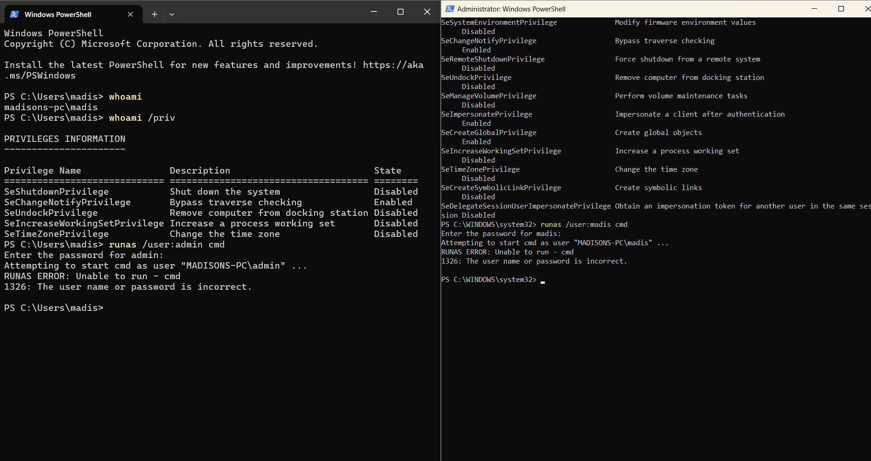
I also tried access token manipulation on Kali Linux using the Metasploit Framework, but I was not successful in that either. I was trying to execute a payload and go from there to use MeterPreter to then manipulate an access token, but that did not work out.
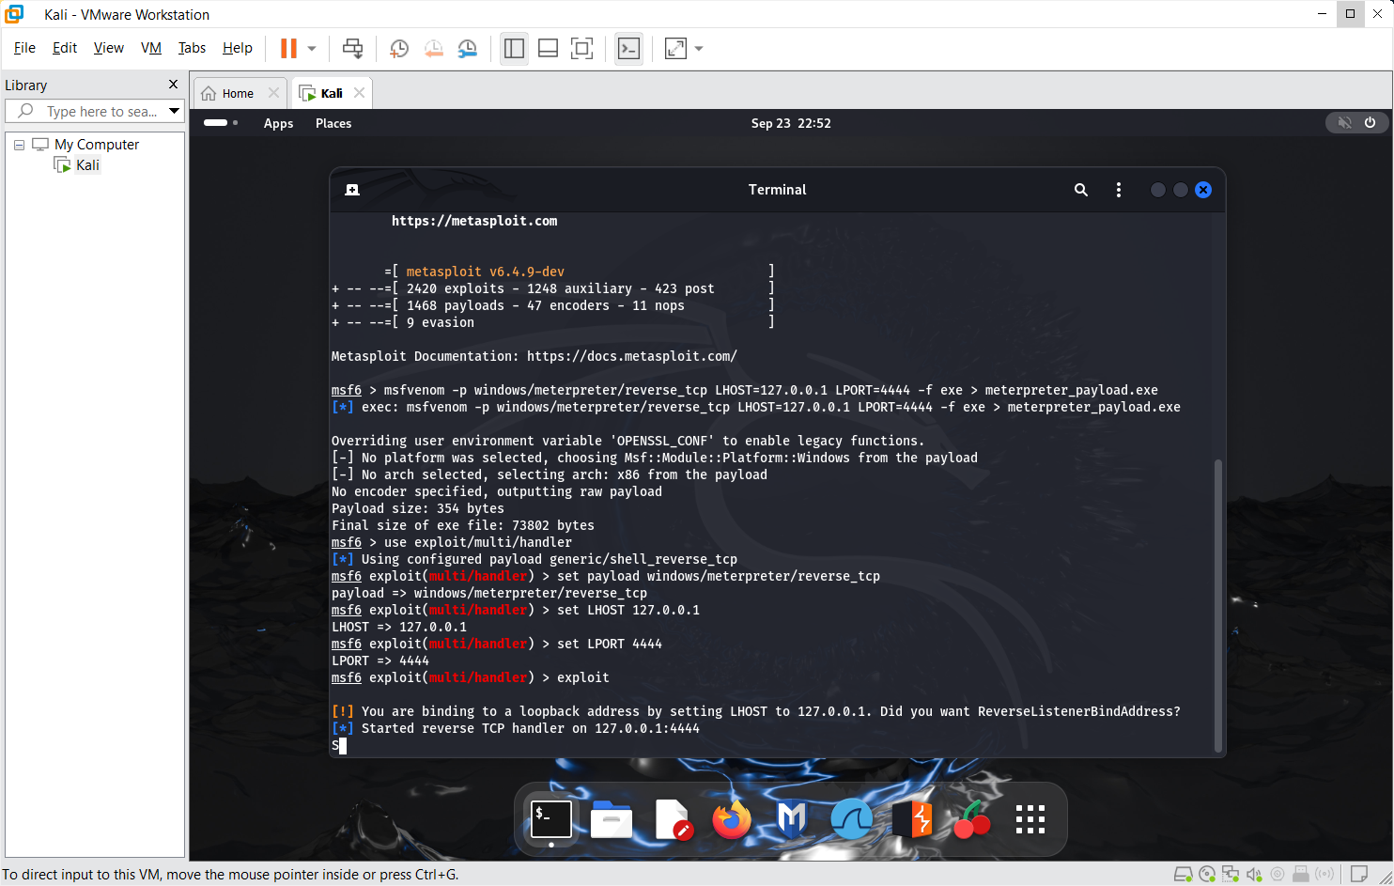
In conclusion, each attempt I made was unsuccessful. I will attempt this a couple of more times, but if I continuously cannot get this technique to run on Windows or Linux, I will have to change my topic to something that can be done.

