Quiz
- What is Jeroen Lee's email address?
Jeroen Lee’s email address is jeroen.lee@twobirds.com.
- I found less than 5 instances of Jeroen's email address. In what language(s) were the email body or email message written?
The emails were written in English and German.
- Do a search for phone numbers, what phone number did you find?
The phone number I found was 978-287-9555.

- Do a search for URLs, find and list at least 5 URLs found.
There were several URLs present, including:
  - http://sweet.tomtom.com/help
  - http://www.schneier.com/blowfish
  - http://www.apple.com/DTDs/PropertyList-1.0.dtd
  - www.xiph.org/ogg/vorbis
  - www.tomtom.com
- What is the file path for the file MapSettings.cfg?
The file path for the file MapSettings.cfg is:
/img_tomtom-1.img/USA_and_Canada/MapSettings.cfg
- Inside the file MapSettings.cfg there is an address in Newark, DE. What is the address ending in Newark, DE?
The address ending in Newark, DE is:
Glen Falls Ct 901, Newark DE
- Search online the address, describe the location you found. In the blog, include a picture.
This location is 901 Glen Falls Court, located in Newark, Delaware. It is a house in a residential area.
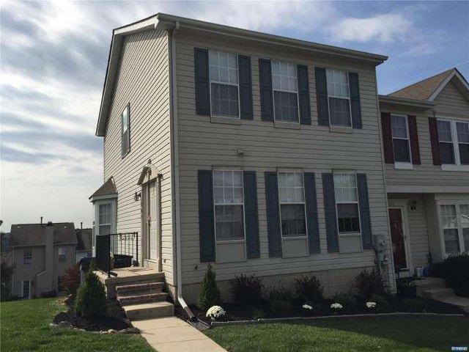
- Search for IP addresses in the tomtom.img media. List the IP address(es) found, if any...
I found the following IP addresses in the media:
  - 2.14.90.0
  - 95.95.95.95
  - 74.74.85.74
- When you searched for phone numbers, how many times or instances was the phone number found?
The phone number was found four times.

Blog/Report
This data source contains a variety of information that will be helpful in solving this case. There are also plenty of miscellaneous files The data source for this case was a GPS that was seized from one of the vehicles that was used in the crime. As such, the GPS contains information related to traveling and directions. There were many images present on the GPS, but none of them were relevant enough to serve as evidence for this case. Many of the photos were from the GPS software, TomTom. There were also images containing flags of various countries and illustrations of medical procedures. There are also images of car parts, car accidents, gas stations, and other vehicle-related scenarios. There are also pictures of different countries, including Croatia and Sweden. There were also many files that contained jumbled letters, which would not be useful in this case.
There was a configuration file, MapSettings.cfg, that contained the locations that the GPS had saved. This includes the location that the crime was committed at. Most of the locations listed on the GPS are located in Pennsylvania, but some of them are in Delaware, Maryland, and West Virginia. There are also several text documents that contain information such as IP addresses, phone numbers, and email addresses that may be relevant to the case. Since Autopsy has a function that allows the user to search for specific keywords, including IP addresses and other pieces of information, which made it easier to find the relevant information. The metadata attached to the license text files also shows that there are several different authors, implying that there are multiple perpetrators involved in this crime. Many of the authors are working with the same organization, making it possible that everyone in that organization was in on the crime.
Attached are screenshots of my findings.
