Table of contents
- Executive summary
- For each flag that you were able to pursue (either partially or fully)
  - Flag 1: Photo of employee badge
    - Relevant OSINT findings with evidence
    - Pretext and Persona used
    - AI tool’s use for planning
    - Success/failure at accomplishing the flag
      - Reason for success/failure
    - Why is this information harmful? How could threat actors use this to target the client?
  - Flag 2: Photo of staff desk/work environment
    - Relevant OSINT findings with evidence
    - Pretext and persona used
    - AI tool’s use for planning
    - Success/failure at accomplishing the flag
      - Reason for success/failure
    - Why is this information harmful? How could threat actors use this to target the client?
  - Flag 3: VPN used
    - Relevant OSINT findings with evidence
    - Pretext and persona used
    - AI tool’s use for planning
    - Success/failure at accomplishing the flag
      - Reason for success/failure
    - Why is this information harmful? How could threat actors use this to target the client?
  - Flag 4: Name of elevator service company
    - Relevant OSINT findings with evidence
    - Pretext and persona used
    - AI tool’s use for planning
    - Success/failure at accomplishing the flag
      - Reason for success/failure
    - Why is this information harmful? How could threat actors use this to target the client?
  - Flag 5: Name of parking company for employees/employers
    - Relevant OSINT findings with evidence
    - Pretext and persona used
    - AI tool’s use for planning
    - Success/failure at accomplishing the flag
      - Reason for success/failure
    - Why is this information harmful? How could threat actors use this to target the client?
  - Flag 6: Name of dumpster company
    - Relevant OSINT findings with evidence
    - Pretext and persona used
    - AI tool’s use for planning
    - Success/failure at accomplishing the flag
      - Reason for success/failure
    - Why is this information harmful? How could threat actors use this to target the client?
  - Flag 7: Name of food service company
    - Relevant OSINT findings with evidence
    - Pretext and persona used
    - AI tool’s use for planning
    - Success/failure at accomplishing the flag
      - Reason for success/failure
    - Why is this information harmful? How could threat actors use this to target the client?
  - Flag 8: Name of extermination/pest company
    - Relevant OSINT findings with evidence
    - Pretext and persona used
    - AI tool’s use for planning
    - Success/failure at accomplishing the flag
      - Reason for success/failure
    - Why is this information harmful? How could threat actors use this to target the client?
  - Flag 9: Name of trash disposal company
    - Relevant OSINT findings with evidence
    - Pretext and persona used
    - AI tool’s use for planning
    - Success/failure at accomplishing the flag
      - Reason for success/failure
    - Why is this information harmful? How could threat actors use this to target the client?
  - Flag 10: Operating system of employee workstations
    - Relevant OSINT findings with evidence
    - Pretext and persona used
    - AI tool’s use for planning
    - Success/failure at accomplishing the flag
      - Reason for success/failure
    - Why is this information harmful? How could threat actors use this to target the client?
  - Flag 11: Evidence of IT security training
    - Relevant OSINT findings with evidence
    - Pretext and persona used
    - AI tool’s use for planning
    - Success/failure at accomplishing the flag
      - Reason for success/failure
    - Why is this information harmful? How could threat actors use this to target the client?
  - Flag 12: Get hired - part 1 (submit application)
    - Relevant OSINT findings with evidence
    - Pretext and persona used
    - AI tool’s use for planning
    - AI tool’s use for live engagement
    - Psychological persuasion principle used
    - Success/failure at accomplishing the flag
      - Reason for success/failure
    - Why is this information harmful? How could threat actors use this to target the client?
  - Flag 13: Get hired - part 2 (follow up to get update on application)
    - Relevant OSINT findings with evidence
    - Pretext and persona used
    - AI tool’s use for planning
    - Psychological persuasion principle used
    - Success/failure at accomplishing the flag
      - Reason for success/failure
    - Why is this information harmful? How could threat actors use this to target the client?
  - Flag 14: Get hired - part 3 (follow up to get update on application & secure interview date)
    - Relevant OSINT Findings with Evidence
    - Pretext/Persona Used
    - AI tool’s use for planning
    - AI tool’s use in live engagement and adaptation
    - Psychological persuasion principle used
    - Success/failure at accomplishing the flag
      - Reason for success/failure
    - Why is this information harmful? How could threat actors use this to target the client?
  - Flag 15: Name of email client
    - Relevant OSINT Findings with Evidence
    - Pretext/Persona Used
    - AI tool’s use for planning
    - AI tool’s use in live engagement and adaptation
    - Psychological persuasion principle used
    - Success/failure at accomplishing the flag
      - Reason for success/failure
    - Why is this information harmful? How could threat actors use this to target the client?
  - Flag 16: Name and version of web browser
    - Relevant OSINT Findings with Evidence
    - Pretext/Persona Used
    - AI tool’s use for planning
    - AI tool’s use in live engagement and adaptation
    - Psychological persuasion principle used
    - Success/failure at accomplishing the flag
      - Reason for success/failure
    - Why is this information harmful? How could threat actors use this to target the client?
  - Flag 17: Name and version of operating system
    - Relevant OSINT Findings with Evidence
    - Pretext/Persona Used
    - AI tool’s use for planning
    - AI tool’s use in live engagement and adaptation
    - Psychological persuasion principle used
    - Success/failure at accomplishing the flag
      - Reason for success/failure
    - Why is this information harmful? How could threat actors use this to target the client?
  - Flag 18: Date and content of last IT/cybersecurity training
    - Relevant OSINT Findings with Evidence
    - Pretext/Persona Used
    - AI tool’s use for planning
    - AI tool’s use in live engagement and adaptation
    - Psychological persuasion principle used
    - Success/failure at accomplishing the flag
      - Reason for success/failure
    - Why is this information harmful? How could threat actors use this to target the client?
- Recommendations
  - Documenting good practices
  - Employee-level training and/or policy
  - Organizational-level training and/or policy
  - AI-specific training at employee and organizational level
- Appendices
  - Successful Pretexts, Personas, and Scripts
  - Flags we could not pursue
  - Glossary
  - Division of Labor

Executive summary

Our group was successful at completing all the open-source intelligence (OSINT) flags. We did not use a pretext, persona, or artificial intelligence (AI) for the OSINT flags. We also did not use live engagement to complete the OSINT flags, as all the information necessary to complete these flags was already posted to the LRS website or Recruit and Network. The availability of this information is harmful because it allows malicious actors to exploit system vulnerabilities for the computer-related flags and allows malicious actors to gain access to LRS buildings for the service-related flags. We recommend addressing this by updating company policies on what information can be posted online, and training employees in these policies.
We did use AI in creating our pretext and persona for the application, phish, and vish flags. We used ChatGPT to generate and refine our resume and to generate our cover letter for the application. Both the original and follow-up phish emails were originally written by us and then rewritten with ChatGPT. We were successful in securing an interview date, finding the email client used by LRS, and the operating system. We were able to find out that cybersecurity training sessions happen several times a year, but the employee we were speaking with hung up before we could find out the exact dates.

Flag 1: Photo of Employee Badge

Relevant OSINT Findings with Evidence:

URL: https://sites.temple.edu/recruitandnetwork/2023/01/03/%f0%9f%94%b5-dark-blue-badges-a-missed-flavor-opportunity-%f0%9f%8d%8a%f0%9f%8c%bf-by-sophia-miller/
The name of the employee who posted their badge is Sophia Miller.

Pretext and Persona Used:
This does not apply to this flag.

AI Tool’s Use for Planning:
This does not apply to this flag.

Success/Failure:
We were successful in completing this task.

Reasons for Success:
We were successful in completing this flag because an LRS employee posted a picture of her badge to Recruit and Network.

Why This Information is Harmful:
Knowing the appearance of an employee badge would allow a malicious actor to create their own fake employee badge and gain access to the building.

Flag 2: Photo of Staff/Work Desk Environment

Relevant OSINT Findings with Evidence:

Image URL: https://sites.temple.edu/recruitandnetwork/2021/02/08/%f0%9f%93%9d-confession-time-%f0%9f%93%9d-by-lisa-fernandez/
Pretext and Persona Used:
See Flag 1.

AI Tool’s Use for Planning:
See Flag 1.

Success/Failure:
We were successful at finding this flag.

Reasons for Success:
Lisa Fernandez posted an image of her LRS desk, stating how her desk may be cluttered, but she loves her job in customer relations.

Why This Information is Harmful:
This image shows the type of computer LRS uses, which can allow malicious actors to exploit vulnerabilities specific to that model. It also provides clues to the operating system that LRS uses, which again could allow a malicious actor to exploit vulnerabilities. Further, someone could read the screens on the computers or on the documents to get sensitive information to the company.

Flag 3: VPN Used

Relevant OSINT Findings with Evidence:
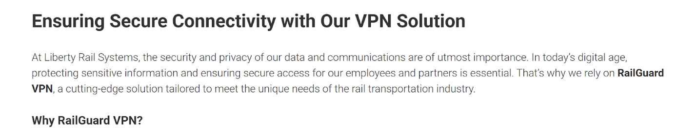The VPN used is RailGuard VPN.
Image URL: https://sites.temple.edu/libertyrailsystems/news/ensuring-secure-connectivity-with-our-vpn-solution-2/

Pretext and Persona Used:
See Flag 1.

AI Tool’s Use for Planning:
See Flag 1.

Success/Failure:
We were successful in completing this flag.

Reasons for Success:
The LRS website states this information in the news section.

Why This Information is Harmful:
This information is harmful because a malicious actor could exploit vulnerabilities specific to this VPN provider. A malicious actor could also pose as RailGuard VPN to gain sensitive information on LRS. It also allows hackers to disrupt VPN access to employees during down time. Hackers can test VPN default settings that are insecure. Hackers can used compromised credentials to access internal LRS systems

Flag 4: Name of elevator service company

Relevant OSINT Findings with Evidence:

The elevator service company is Ascend Systems LLC.
Image URL: https://sites.temple.edu/libertyrailsystems/news/liberty-rail-systems-partners-with-ascend-systems-llc-for-innovative-elevator-solution/

Pretext and Persona Used:
See Flag 1.

AI Tool’s Use for Planning:
See Flag 1.

Success/Failure:
We were successful at completing this flag.

Reasons for Success:
Liberty Rails posted an announcement “Liberty Rail Systems Partners with Ascend Systems LLC for Innovative Elevator Solution.”

Why This Information is Harmful:
It allows unauthorizes users to intrude and manipulate security features. Intruders can exploit maintenance access points. Intruders can pose as maintenance workers as they are familiar with the elevator manufacturer.

Flag 5: Name of Parking Company for Employees/Employers

Relevant OSINT Findings with Evidence:
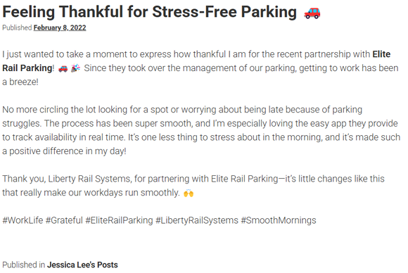
The employee parking company is Elite Rail Parking.
Image URL: https://sites.temple.edu/recruitandnetwork/2022/02/08/feeling-thankful-for-stress-free-parking-%f0%9f%9a%97/

Pretext and Persona Used:
See Flag 1.

AI Tool’s Use for Planning:
See Flag 1.

Success/Failure:
We were successful at completing this flag.

Reasons for Success:
This information was posted to an employee’s Recruit and Network page.

Why This Information is Harmful:
This information is harmful because it allows malicious actors to gain access to the employee parking lot by posing as an Elite Rail Parking employee. It may also allow malicious actors to obtain information from employees such as their license plate number.

Flag 6: Name of Dumpster Company

Relevant OSINT Findings with Evidence:
The dumpster service company is Wesley and Mack’s Dumpster Services.
Image URL: https://sites.temple.edu/libertyrailsystems/news/liberty-rail-systems-partners-with-wesley-and-macks-dumpster-services-for-sustainable-waste-management-august-14-2023/

Pretext and Persona Used:
See Flag 1.

AI Tool’s Use for Planning:
See Flag 1.

Success/Failure:
We were successful at completing this flag.

Reasons for Success:
This information was posted to the LRS website.

Why This Information is Harmful:
This information could allow a malicious actor to gain access to LRS facilities by posing as a Wesley and Mack’s Dumpster Services employee. It may also allow them to gain sensitive information as employees may throw out sensitive documents without first shredding them.

Flag 7: Name of Food Service Company

Relevant OSINT Findings with Evidence:

The food service company used is Plate Parade.
Image URL: https://sites.temple.edu/recruitandnetwork/2024/07/04/plate-parade-more-like-plate-disarray-%f0%9f%98%a9%f0%9f%8d%bd%ef%b8%8f/

Pretext and Persona Used:
See Flag 1.

AI Tool’s Use for Planning:
See Flag 1.

Success/Failure:
We were successful at accomplishing this flag.

Reasons for Success:
An LRS employee posted her opinion on Plate Parade.

Why This Information is Harmful:
This information has the potential to be harmful in different ways. An individual with malicious intentions can pose as a vendor for the food service company and be able to gain access to sensitive information from Liberty Rail Systems.

Flag 8: Name of Extermination/Pest Company

Relevant OSINT Findings with Evidence:
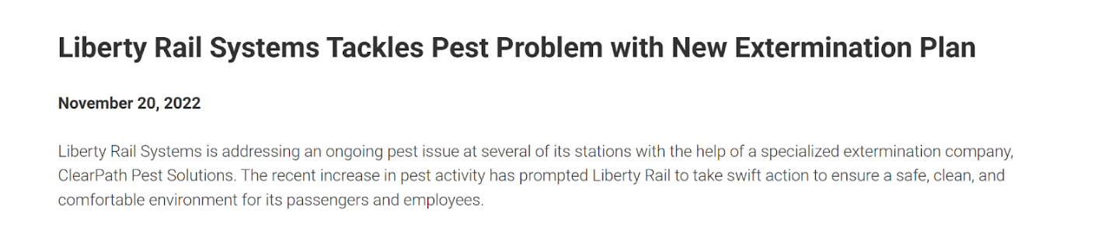
The name of the extermination/pest company is ClearPath Pest Solutions.
Image URL: https://sites.temple.edu/libertyrailsystems/news/liberty-rail-systems-tackles-pest-problem-with-new-extermination-plan/

Pretext and Persona Used:
See Flag 1.

AI Tool’s Use for Planning:
See Flag 1.

Success/Failure:
We were successful in accomplishing this flag.

Reasons for Success:
This information was posted to the LRS website.

Why This Information is Harmful:
This information is harmful because someone with malicious intent can pose as an exterminator and use that to gain access to Liberty Rail Systems, as well as gain sensitive information about this company.

Flag 9: Name of Disposal Service:

Relevant OSINT Findings with Evidence:
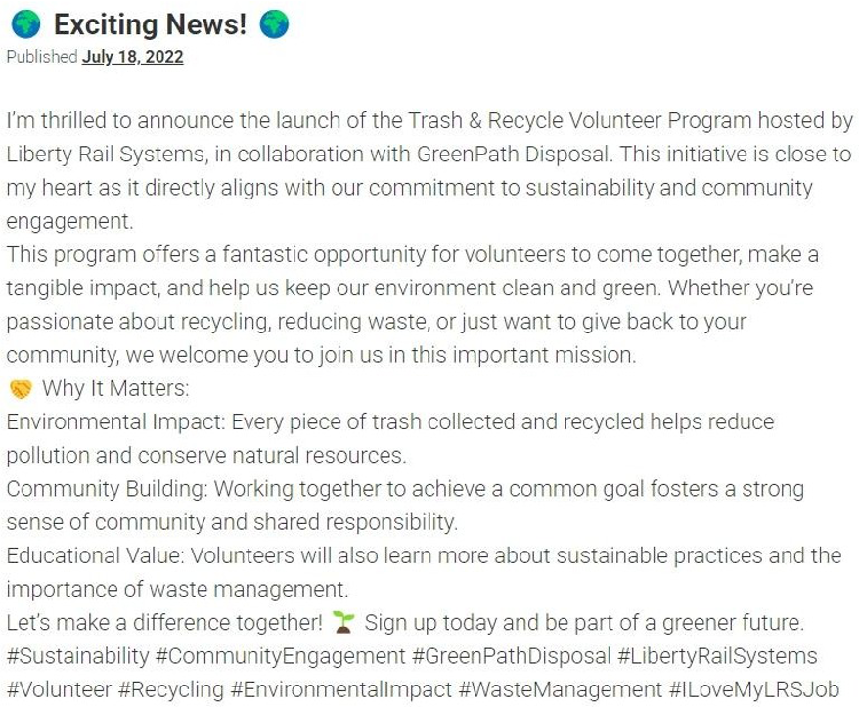
The disposal service company is GreenPath Disposal.
Image URL: https://sites.temple.edu/recruitandnetwork/2022/07/18/%f0%9f%8c%8d-exciting-news-%f0%9f%8c%8d-by-emily-zhang/

Pretext and Persona Used:
See Flag 1.

AI Tool’s Use for Planning:
See Flag 1.

Success/Failure:
We were successful at finding this flag

Reasons for Success:
The company posted their excitement to launch the Trash & Recycle Volunteer Program hosted by LRS.

Why This Information is Harmful:
There may be data leaks stemming from trash thrown out as employees may throw out sensitive documents without shredding them first. Attackers can pose as a worker for the company to get unauthorized access to LRS buildings.

Flag 10: Operating System of Employee Workstations

Relevant OSINT Findings with Evidence:

The operating system being used is Windows.
Image URL: https://sites.temple.edu/recruitandnetwork/2022/05/24/%f0%9f%92%bb-why-windows-is-the-only-choice-for-industry-leaders-insights-from-an-it-expert-%f0%9f%9a%80/

Pretext and Persona Used:
See Flag 1.

AI Tool’s Use for Planning:
See Flag 1.

Success/Failure:
We were successful at accomplishing this flag.

Reasons for Success:
An employee of Liberty Rail Systems posted about using Windows, and why Windows is the ideal operating system to use in a workplace setting.

Why This Information is Harmful:
This information is harmful because it gives individuals with malicious intent more information about the workplace. Someone can pose as an IT specialist to gain access to the Liberty Rail Systems workplace.

Flag 11: Evidence of IT Security Training

Relevant OSINT Findings with Evidence:
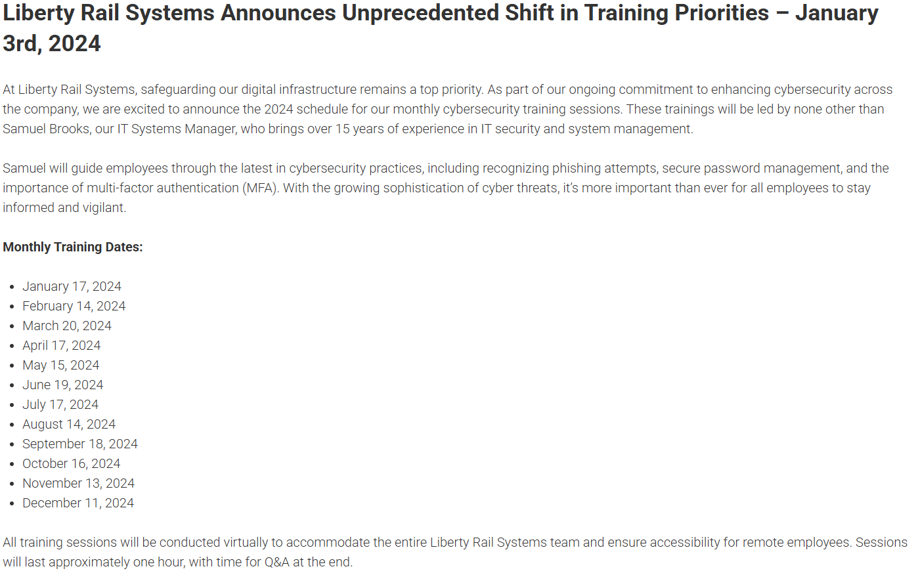
The training was done throughout 2024 and led by Samuel Brooks.
Image URL: https://sites.temple.edu/libertyrailsystems/news/liberty-rail-systems-announces-unprecedented-shift-in-training-priorities-january-3rd-2024/

Pretext and Persona Used:
See Flag 1.

AI Tool’s Use for Planning:
See Flag 1.

Success/Failure:
We were successful at accomplishing this flag.

Reasons for Success:
An employee posted details of the monthly IT training dates.

Why This Information is Harmful:
Someone who is not part of the company can pose as an employee or new hire and arrive at the training. It also lets a malicious actor know when employees are more likely to forget the training and be more likely to click on suspicious links or give away sensitive information.

Flag 12: Get Hired - Part 1 (Application)

Relevant OSINT Findings with Evidence:
The open position we decided to apply for was administrative staff. Since the director of HR, John Turner, mentioned volunteering as one of his interests on his Recruit and Network page, we added that to the personal interest section of our resume to establish commonality.
Image URL: https://sites.temple.edu/recruitandnetwork/profiles/john-turner/

Pretext and Persona Used:
The pretext we used was applying for the administrative staff position. We picked this position because out of all the open positions, the administrative staff would have the most interaction with the systems in the flags, so it would make the most sense for someone applying for that position to ask that information. The persona we used was James Anderson.

AI Tool’s Use for Planning:
We used ChatGPT to generate the resume and name. We also used Thispersondoesnotexist.com to generate a photo of James Anderson. We also used ChatGPT to improve the about me and personal interest sections of the resume.

AI Tool’s Use for Live Engagement:
This flag did not involve live engagement, so this is not relevant for this flag.

Psychological Persuasion Principles Used:
We used likeness or commonality by incorporating some of the employee interests listed on Recruit and Network into the personal interest and about me sections of our resume. We also used authority by giving our persona lot of experience in the position we are applying for.

Success/Failure:
This is a multi-part flag, so success or failure does not apply to this flag.

Why This Information is Harmful:
Getting hired by LRS would allow a malicious actor to gain access to many LRS’s systems.

Flag 13: Get Hired - Part 2 (Phishing)
Here is our phishing correspondence:
Our Initial Phish
Subject: Follow-Up on Administrative Staff Position Application
Dear John Turner,
I hope this message finds you well. My name is James Anderson, and I recently applied for the Administrative Staff position at Liberty Rail Systems. I wanted to inquire if there have been any updates regarding the status of my application and when I might expect to hear back.
I greatly appreciate your time and consideration, and I look forward to the opportunity to speak with you further.
Thank you again for your attention to this matter.
Sincerely,
James Anderson
LRS Response
Subject: Re: Follow-up on Administrative Staff Application
Dear James,
Thank you for reaching out. I’m glad to hear of your continued interest in the Administrative Staff position at Liberty Rail Systems.
To better assist you, could you let me know the exact date you submitted your application? This will help me check on its status more efficiently. If possible, please also confirm the email address you used to submit your application, as this will further expedite my review.
Once I have these details, I’ll be able to provide you with a clearer update on the next steps. I appreciate your patience, and I look forward to hearing from you soon.
Best,
HR Team at Liberty Rail Systems
Our Secondary Phish
Subject: Re Follow-up on Administrative Staff Position
Dear John Turner,
Thank you for getting back to me! I really appreciate your time in checking on my application status.
I submitted my application on March 18th using the email address james.anderson1234@gmail.com. Please let me know if you need any additional details to locate it.
I’m very excited about this opportunity and would love the chance to further discuss my qualifications. Please let me know if there is anything I can do to move forward in the process.
Best regards,
James Anderson

Relevant OSINT Findings with Evidence:
This is not relevant to this flag.

Pretext and Persona Used:
See flag 12.

AI Tool’s Use for Planning:
We made a draft of our first email and asked ChatGPT to rewrite it to be more professional. For the second email, we asked ChatGPT to generate a fake email address and to rewrite our draft response to be professional while still conversational.

Psychological Persuasion Principles Used:
We used the natural inclination to help.

Success/Failure:
See flag 12.

Why This Information is Harmful:
See flag 12.

Flag 14: Get Hired – Part 3 (Follow-Up to Get Update on Application and Secure Interview)

Relevant OSINT Findings with Evidence:
This was not relevant for this flag.

Pretext and Persona Used:
Artificial intelligence was used to prepare for this flag prior to the simulated phone call, as well as adapt to new situations during the phone call. To prepare for this situation, ChatGPT was used to help formulate potential pushback from the employees, along with mitigation techniques. The solutions generated by artificial intelligence were then used to create a script to use in the specific situations they would be relevant to.

AI Tool’s Use for Planning:
Artificial intelligence via ChatGPT was utilized to generate scripts and talking points for us to use during the vishing portion.

AI Tool’s Use in Live Engagement and Adaptation:
Artificial intelligence was used during the vishing call to generate potential scripts based on the conversation that was happening in real time.

Psychological Persuasion Principle Used:
During the vishing call, we employed several psychological persuasion principles. An example of this is authority. We claimed to be a legitimate applicant for Liberty Rail Station, and our application adds onto this to imply that James Anderson is a real person with legitimate credentials. Another principle was reciprocity. On the vishing call, we were patient and polite with the LRS employee on the phone, in the hopes that they would give us the information we wanted. We also employed a sense of urgency so that the employee would be more inclined to help us.

Success/Failure:
During this phone call, we were able to successfully schedule a follow up interview date with the HR department.

Reasons for Success:
Based on the response of the HR representative spoken to, it is our understanding that it is company policy to aid in scheduling an interview if a verifiable applicant requests aid.

Why This Information is Harmful:
This information is harmful because it involves a malicious actor impersonating an applicant. This allows the perpetrator to gain the trust of the person they are speaking to on the phone and other members of the company. If this flag is successfully captured, the malicious actor will be able to gain physical access to the company’s premises. This can then allow them to implant malware on company devices and gather more information about the company.

Flag 15: Name of Email Client

Relevant OSINT Findings with Evidence:
See Flag 14.

Pretext and Persona Used:
See Flag 14.

AI Tool’s Use for Planning:
See Flag 14.

AI Tool’s Use in Live Engagement and Adaptation:
See Flag 14.

Psychological Persuasion Principle Used:
See Flag 14.

Success/Failure:
Successfully identified the email client as Microsoft Outlook.

Reasons for Success:
For this information, the individual could not confirm that their email client by name, they were able to recognize and confirm it when it was described visually as “a Microsoft icon with a circle.” By this we were able to confirm the email client in use.

Why This Information is Harmful:
This information is harmful because it lets the malicious actor know how the company sends and receives emails. This enables spear-phishing, where the malicious actor can create email payloads that exploit vulnerabilities, impersonate the company and its members, and pass by spam filters. This can lead to the perpetrator gathering more information from not only the company, but its affiliated companies, clients, and employees as well.

Flag 16: Name and Version of Web Browser

Relevant OSINT Findings with Evidence:
See Flag 14.

Pretext/Persona Used:
See Flag 14.

AI Tool’s Use for Planning:
See Flag 14.

AI Tool’s Use in Live Engagement and Adaptation:
See Flag 14.

Psychological Persuasion Principle Used:
See Flag 14.

Success/Failure:
Failed to identify a specific browser name and version used by the organization.

Reasons for Success:
We were only able to gather information about the browser used by individual employees; we did not obtain a consistent or official browser name and version used organization wide.

Why This Information is Harmful:
This information is harmful because it allows a malicious actor to use relevant browser-based exploits or redirect the user to other websites that can target that specific browser and allow for the perpetrator to gather information from company devices, including log-in credentials. Additionally, if the browser version is outdated, company devices will be vulnerable to more exploits.

Flag 17: Name and Version of Operating System

Relevant OSINT Findings with Evidence:
See Flag 14.

Pretext/Persona Used:
See Flag 14.

AI Tool’s Use for Planning:
See Flag 14.

AI Tool’s Use in Live Engagement and Adaptation:
See Flag 14.

Psychological Persuasion Principle Used:
See Flag 14.

Success/Failure:
We were able to gather information on a specific employee’s machine. An HR representative told us he specifically uses an HP laptop running windows. We weren't able to gather information on the standard machines used.

Reasons for Success:
The employee in question provided the information during a casual conversation about the difficulty in the use of select machine operating systems.

Why This Information is Harmful:
This information is harmful because it allows the malicious actor to create and utilize payloads specifically for that operating system and version. This can also help the attacker avoid antivirus tools by implementing payloads that can remain undetected on that specific platform.

Flag 18: Date and Content of Last IT/Cybersecurity Training

Relevant OSINT Findings with Evidence:
See Flag 14.

Pretext/Persona Used:
See Flag 14.

AI Tool’s Use for Planning:
See Flag 14.

AI Tool’s Use in Live Engagement and Adaptation:
See Flag 14.

Psychological Persuasion Principle Used:
See Flag 14.

Success/Failure:
Confirmation employees receive cybersecurity training multiple times a year. No specific information on the training (dates or name of training exercises) was provided.

Reasons for Success:
This information was revealed during a casual conversation discussing the annoyance of cyber training on the job.

Why This Information is Harmful:
This information is harmful because it tells the malicious actor how prepared the company and its employees are for potential attacks. If the training is outdated, it lets the attacker know that the company and its employees are likely more susceptible to possible attacks. If the training was recently completed, it tells the attacker that this company and its employees are more up to date on hacking or phishing techniques. Whether the training was recent or happened long ago, it gives the malicious attacker more information and can help them create the perfect approach to gathering information, including creating pretexts. If the attacker knows what the employees were trained on, they know which approaches to avoid, and will likely find an approach they were not trained on.

Recommendations

Documenting Good Practices:
Jessica, the receptionist we spoke to, did give some initial pushback on the email client flag by asking how it was relevant.

Employee-Level Training and/or Policy:
We recommend employees be more conscious of what LRS information they post online. We also recommend employees be more careful not to reveal LRS information over the phone.

Organizational-Level Training and/or Policy:
We recommend updating and training employees on what is and is not safe to post online. This is because we were able to complete several of the OSINT flags with information posted directly to the LRS website, and the remainder of flags were completed using posts that employees made on Recruit and Network. Some things that are not safe to post include names of vendors LRS currently works with, details regarding the operating system of LRS devices, information regarding IT cybersecurity training, and photos of LRS offices or employee badges. We also recommend training employees on what information is and is not safe to reveal in phone calls and how to deflect requests for sensitive information.

AI-Specific Training at Employee and Organizational Level:
We recommend running applications and outside emails through AI detection software such as GPTZero.

Appendices

Successful Pretext, Persona, and Scripts
We were able to successfully gather information about Liberty Rail Systems by developing a persona and relevant pretext for that persona. The persona we developed was for a man named James Anderson, who had several years of experience with working in an office. The pretext for James was that he was applying for the role of an administrative assistant at Liberty Rail Systems. The persona and pretext were used together to convince LRS that a real person was interested in working for their company, so that their guard would be down and we could extract information from the employees.

Flags We Could Not Pursue:
There were no flags that we could not pursue at all. We were able to fully pursue all OSINT, phishing, and web-based flags. We were able to fully pursue two vishing flags and partially pursue the other three flags during the vishing call.

Glossary:
AI – Artificial intelligence. A computer application created to perform tasks and output responses that would normally require human intelligence to complete. This includes generative software, such as ChatGPT.
ChatGPT – An open-source software of artificial intelligence that generates output based on user input.
Flag – Pieces of information we were attempting to gather using generative AI and social engineering.
OSINT – Open-source intelligence. The collection of personal information of a potential victim using open resources, such as public websites and social media.
Payload – The portion of the attack that does the damage, such as stealing data or installing malware
Persona – False identity created by an attacker to trick someone into trusting them to obtain information
Phishing – When a malicious actor attempts to trick someone else into giving out personal information online, normally by sending a malicious link to the victim disguised as something else.
Pretext – The story an attacker creates to try and trick their victim into giving them the information they want
Social engineering – When attackers use human emotions and traits, such as empathy, trust, or urgency, to gather information.
Spear-phishing – A more targeted version of phishing where the attacker targets a specific victim and creates a message specifically for them.

Division of Labor:
Louis: executive summary, flag 1, why it’s harmful flag 2, flag 3, why it’s harmful flag 5, flag 9, why it’s harmful flag 11, flag 12, flag 13, organization level recommendations, good practices, employee recommendations, AI specific recommendations
Brianna: flag 2, Flag 3 why is this information harmful, Flag 4, flag 6
Madison: Flag 5, Flag 7, Flag 8, Flag 10, Flag 11, Flag 14 (Persona/Pretext used, How AI was Used for Planning), WHY This Information is Harmful [Flags 14-18], Flags We Could Not Pursue, Glossary, Successful Pretext/Persona/Script, AI’s use (Flags 14-18), Psychological Persuasion Principles (Flags 14-18)
Arwin: Flag 15, Flag 16 Success/Failure and Reasons for Success/Failure
Ben: Flag 14, Flag 17, Flag 18

