Penetration Test Report

Prepared for Temple University

Prepared by Madison Sleppy

April 30, 2026

Table of Contents
Revision history 3
Client information 4
Contacts 4
Project details 5
InfoSec Team 6
Executive Summary 7
Background 7
Approach 7
Scope 7
Tools Used 7
Recommendations 8
Tactical Recommendations 8
Strategic Recommendations 8
Technical Report 9
Enumeration and Reconnaissance 9
Discovered credentials 9
Targets 10
Scanning and Identifying Vulnerabilities 11
Penetration Testing Attack 11
Web Based Attack 11
Enterprise Attack 12
Specialized Attack 12
Penetration Testing Tasks 12
Vulnerabilities 12
Findings overview 12
Description 12
Remediation 12
Conclusion 13

Revision history
Date/Time | Version | Description
02/04/2026  9:00 PM | 1.0 | Initial draft …. Milestone 1
03/01/2026  10:00 PM | 2.0 | Milestone 2
04/08/2026  8:00 PM | 3.0 | Milestone 3
04/30/2026  2:00 PM | 4.0 | Final Draft …. Milestone 4

Client information




Contact
- Temple University
- Name: John Fry
- Phone: 215-204-7405
- Email: president@temple.edu
- Role: President

Project details
Temple University is a public university located in Philadelphia, Pennsylvania. It was founded by Russel Conwell in 1884 and has gone on to be a critically acclaimed research university, known for its STEM programs. As of 2025, approximately 30,005 students attend the university, with roughly 3,519 faculty members being employed. The university offers several technological resources, including Microsoft 365, Microsoft OneDrive, Adobe Express, and Adobe Creative Cloud. In addition, the university provides support for cloud computing services. The university utilizes websites such as Canvas, Zoom, and select Google services. Temple University also has an internal network that is overseen by the university’s Information Technology Services.
The scope of this project includes devices owned by Temple University, along with Microsoft applications and Windows operating systems. Personal devices of faculty and students are excluded from the scope. External, internal, and web application tests will be conducted. This testing is part of an educational exercise, which is part of the cybersecurity major capstone course CIS-4696: Ethical Hacking and Intrusion Forensics.
All of this testing is non-intrusive.

InfoSec Team
This security team is aiming to learn more about vulnerabilities while helping companies partake in safer cybersecurity practices.
Name | Bio
Madison Sleppy | Penetration Tester

Executive Summary

Background
This penetration test was conducted to evaluate the security posture of Temple University. The assessment aimed to identify vulnerabilities across network infrastructure, internal systems, and web applications that can be exploited by attackers. These findings indicate that an attacker has the potential to gain full control of the target environment and access sensitive data with minimal opposition.

Approach
The approach was taken from a “black box” perspective, with zero starting knowledge of the network and operations. Our approach used these high-level steps:
- Enumeration and Reconnaissance of network systems and services
- Identification of vulnerabilities through scanning and analysis
- Exploitation of identified vulnerabilities to validate risks and impacts

Scope
The test was restricted to the following scope:
- Any computer system or equipment within the private network
- Any business-owned mobile device operating within the private network
- The public website
- Any device with a Windows operating system

Tools Used
We used the following tools in our penetration test:
- Kali Linux
- Linux Terminal
- Windows
- Windows PowerShell
We were able to penetrate and take control of a number of systems through various technical and non-technical means. The results indicate a high-risk security posture, as multiple vulnerabilities were successfully exploited to gain unauthorized access, escalate privileges, and compromise other systems.

Key Findings
- CRITICAL: Domain Compromise (Zerologon)
A critical vulnerability allowed full administrative control of the domain device, resulting in a completely compromised network.
- HIGH: Credential Harvesting and Reuse
NTLMv2 hashes were captured and cracked, allowing unauthorized access to internal systems.
- HIGH: Web Application IDOR
The web application allowed unauthorized access to restricted resources through modifying URL parameters without properly validating them beforehand.

On the web application, it was possible to both access and download resources without properly authorizing the user beforehand. This was possible through manipulating the object reference identification in the URL. The web application is vulnerable to the following exploits:
- Insecure Direct Object Reference (IDOR)
- Improper access control validation

Recommendations
Based on our findings, we recommend the following:

Tactical Recommendations
After analyzing specific results, here are our tactical recommendations for the IT department and management:
- Immediately patch the Zerologon vulnerability and update all affected systems
- Disable insecure services, including FTP and Telnet
- Reset all compromised credentials and enforce strong password policies
- Implement and enforce multifactor authentication (MFA) for all users
- Apply proper access control checks within the web application

Strategic Recommendations
After analyzing all results, here are our strategic recommendations for management:
- Establish and enforce formal vulnerability management programs
- Implement consistent penetration testing and security assessments
- Provide security awareness training to lower the likelihood of phishing and social engineering attacks succeeding
- Strengthen network segmentation to limit lateral movement
- Implement secure configuration standards for systems and services

Technical Report

Enumeration and Reconnaissance
Reconnaissance was performed early in the test to identify the network’s infrastructure, active hosts, and exposed services. Public domain information was gathered, including DNS records and their associated IP addresses. Network scanning identified several active hosts within the targeted subnet. Many open ports were discovered, including FTP (21), SSH (22), Telnet (23), SMTP (25), and HTTPS (443). The system hosting ports 21, 22, 23, and 25 was noted as a higher risk due to the amount of accessible services. Ports 21 and 23 were noted to be insecure protocols, since they transmit data in plaintext; which allows for potential credential interception. These findings provided multiple possible entry points that could be exploited.
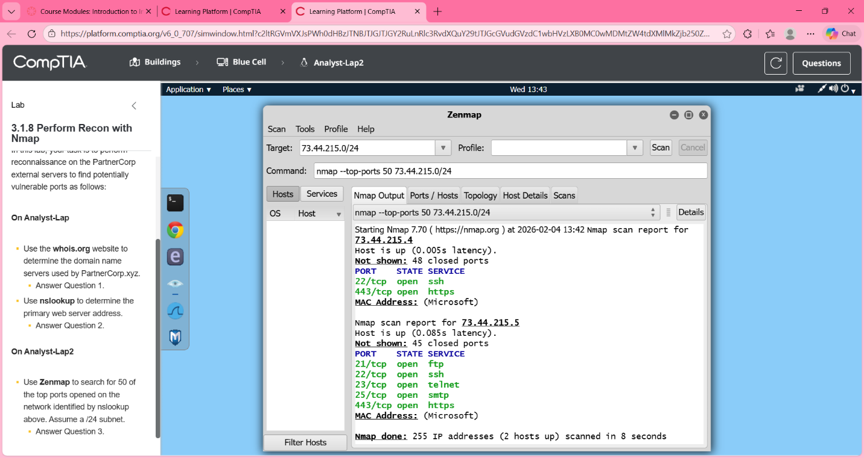
Figure 1: Network scan identifying open ports and active hosts

Discovered credentials
Name | Note | Type
User Account | NTLMv2 hash: captured and cracked | Credentials
Administrator | Privileged access obtained | Credentials

Targets
Name | Kind
Domain Controller | Internal System
Web Application | Web Server
Internal Network Hosts | Network Devices

Scanning and Identifying Vulnerabilities
Vulnerability scanning and service enumeration were conducted in order to identify weaknesses in the target environment. Multiple hosts were analyzed to determine their running services, operating systems, and potential vulnerabilities within the systems. This assessment revealed the presence of not only misconfigured services, but outdated systems. A domain controller was identified as a vulnerability to a known authentication bypass vulnerability, Zerologon, which was successfully exploited. In addition, network services such as LDAP and SMB were analyzed. These findings revealed more opportunities for enumeration and exploitation. Overall, these findings were indicative of weak authentication mechanisms and security configurations.
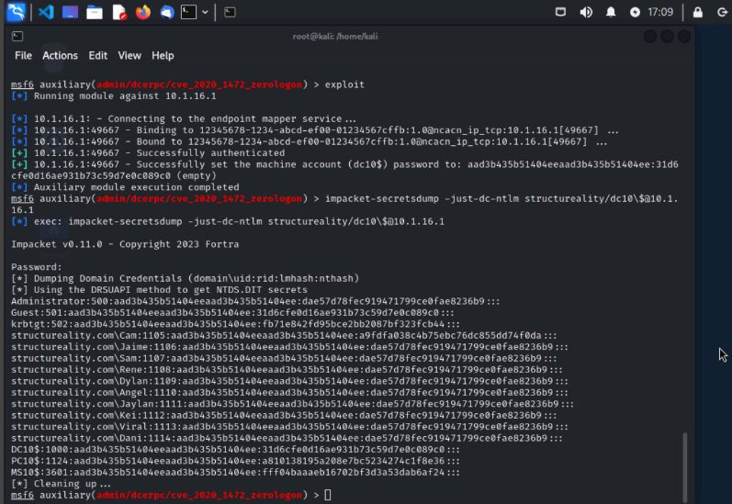
Figure 2: Successful Zerologon exploit, resulting in authentication bypassing and extraction of domain credentials
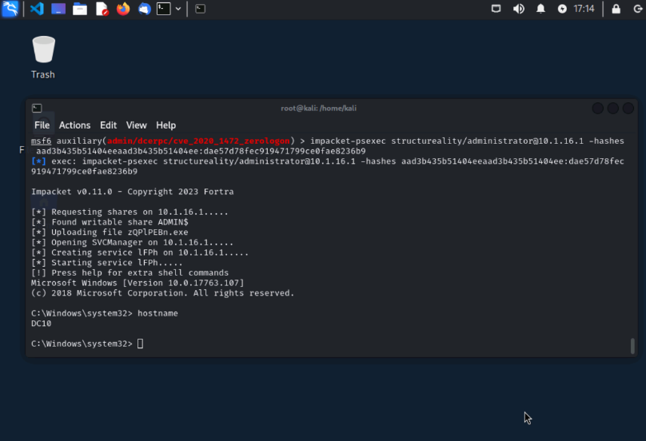
Figure 3: Remote command execution on the domain controller with administrative privileges
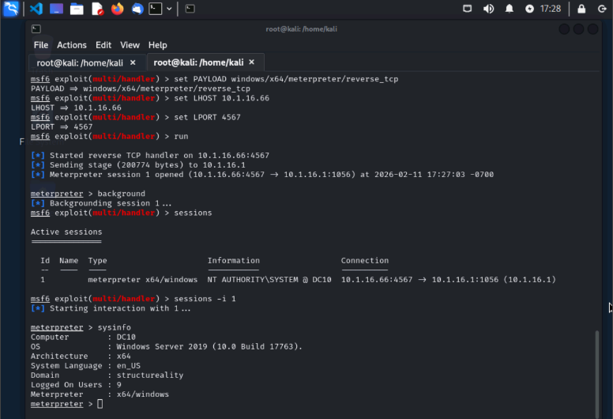
Figure 4: Meterpreter session established with system-level privileges on the compromised host

Penetration Testing Attack
After vulnerabilities were identified, exploitation activities were attempted to validate risks and determine the level of access an attacker could achieve on the system. The exploitation of identified vulnerabilities resulted in a successful compromise of the system, privilege escalation, and remote command execution.
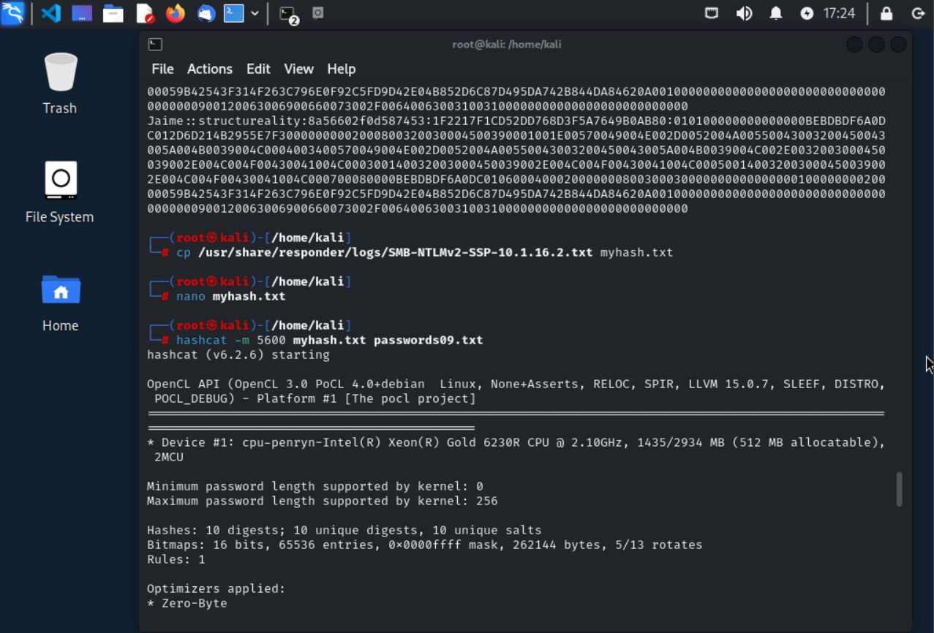
Figure 5: Successful Zerologon exploitation resulting in authentication bypass and the extraction of credentials
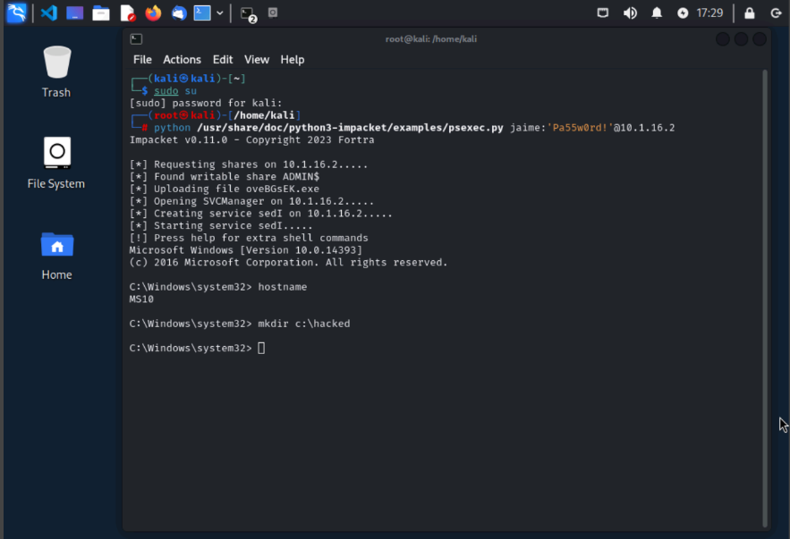
Figure 6: Administrative level access obtained on domain controller after a successful exploitation

Web Based Attack
The web application was then tested for access control vulnerabilities. An insecure direct object reference (IDOR) vulnerability was discovered, allowing for unauthorized access to restricted resources. By modifying the URL parameters, it was possible to access product files without proper authorization or purchasing the item beforehand. The website’s directory listing was exposed, which allowed an enumeration of available resources. This vulnerability demonstrated a lack of server-side validation, as well as an improper enforcement of access controls.


Figure 7: Direct access to an internal resource through URL manipulation
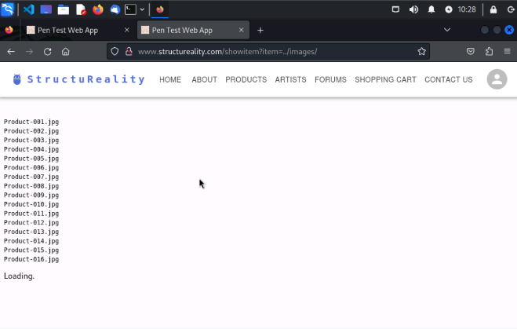
Figure 8: Directory listing exposed through manipulating the request parameters, allowing unauthorized access to internal files

Enterprise Attack
Internal network communication was tested, which revealed that insecure services could be leveraged in order to establish a connection between systems. Remote communication channels were successfully established, which demonstrated the ability to transfer data and execute commands across systems. These findings indicate that insufficient network restrictions and monitoring could potentially allow an attacker to move within the network and maintain persistence.
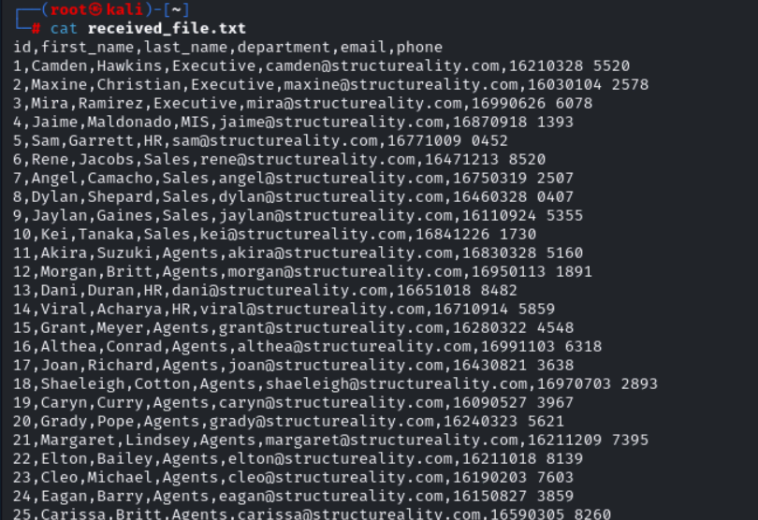

Figure 9: Successful exfiltration of sensitive employee information from the targeted system

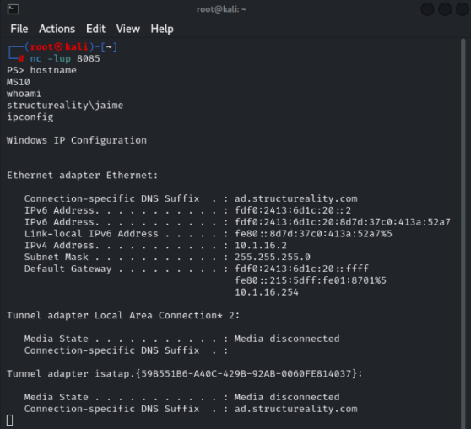

Figure 10: Remote command execution demonstrating access to the compromised system and the retrieval of sensitive system information

Specialized Attack
A phishing-based attack was conducted in order to evaluate the organization’s exposure to credential theft. A malicious link was sent to a targeted user, which modified the system’s proxy settings to route traffic through a proxy being controlled by the attacker. When the user attempted to authenticate their account in a web application, their credentials were intercepted using a proxy tool. The capture request contained both the user’s work email and password, which was displayed in plaintext. This demonstrates that users are susceptible to social engineering attacks, and that their credentials can be intercepted while in transit. The successful capture of credentials emphasizes the necessity of user awareness and stronger authentication mechanisms.
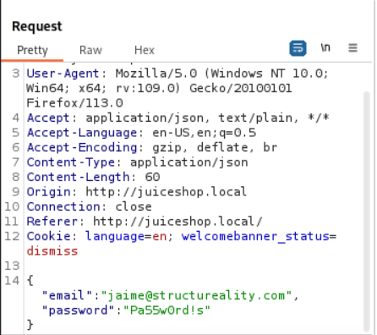

Figure 11: Intercepted HTTP request that captured user credentials in plaintext through malicious proxy configuration

Penetration Testing Tasks
An internal network assessment was conducted in order to evaluate the risks associated with unauthorized access to the internal network. By connecting to the network, it was possible to scan and enumerate internal systems. Network scanning identified multiple active hosts, open ports, and running services across the subnet. This demonstrated that if an attacker has internal access, they can gain visibility into the network and identify potential targets for exploitation. These results emphasize the risk of insufficient network access controls. Unauthorized devices that are connected to the network could perform reconnaissance activities and even identify vulnerabilities without detection. Additional scans confirmed a consistent visibility of multiple hosts and services, which indicates limited internal network segmentation.

Vulnerabilities

Findings overview
This table should contain the final tally all the findings from the report
Critical | 1
High | 2
Medium | 2
Low | 0

The below should be repeated for each finding in the above table

Description
Zerologon Vulnerability
Category: Authentication/Privilege Escalation
Severity: Critical
CVSS Score: 10.0

The domain controller was vulnerable to the Zerologon exploit, allowing authentication bypass and full administrative access to the target network.

Remediation
Apply Microsoft security patches and enforce secure Netlogon communication.

Description
Credential Harvesting via Responder
Category: Credential Access
Severity: High
CVSS Score: 8.5

NTLMv2 hashes were captured and cracked, allowing unauthorized access to systems and accounts.

Remediation
Disable LLMNR and NetBIOS, enforce strong password requirements, and implement multifactor authentication.

Description
Insecure Direct Object Reference (IDOR)
Category: Web Application Security
Severity: High
CVSS Score: 8.0

Users were able to access restricted resources by modifying URL parameters without authorization or purchasing beforehand.

Remediation
Implement server-side access control validation.

Description
Exposure of Insecure Services
Category: Network Security
Severity: Medium
CVSS Score: 6.5

FTP and Telnet services were exposed, increasing the risk of credential interception.

Remediation
Disable Telnet, and replace FTP with more secure alternatives.

Description
Weak Password Policies
Category: Authentication
Severity: Medium
CVSS Score: 6.0

Enforce strong password requirements, and account lockout policies.

Remediation
Implement server-side access control validation.

Conclusion
This penetration test identified several vulnerabilities that can potentially pose a significant risk to the organization’s security. Critical findings, including the Zerologon vulnerability and the successful credential harvesting, demonstrate that attackers have the potential to gain full control of the network and access sensitive information. The presence of insecure services and web application vulnerabilities further increases the likelihood of the network and system being exploited. These weaknesses indicate that there are gaps in system configuration, access controls, and user awareness. By addressing the identified vulnerabilities and implementing the recommended remediation strategies, the organization can drastically improve its security posture and reduce the risk of future vulnerabilities.

Appendices

Appendix A: Network Scanning and Results
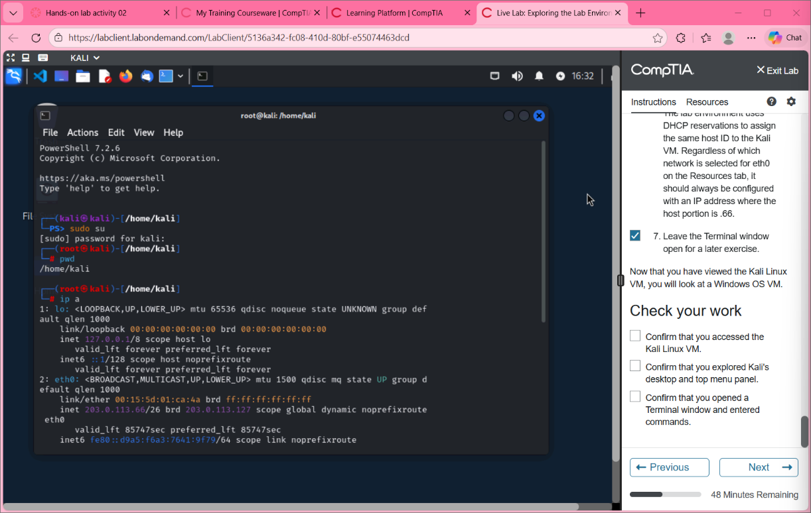
Figure A1: Network interface configuration on testing system
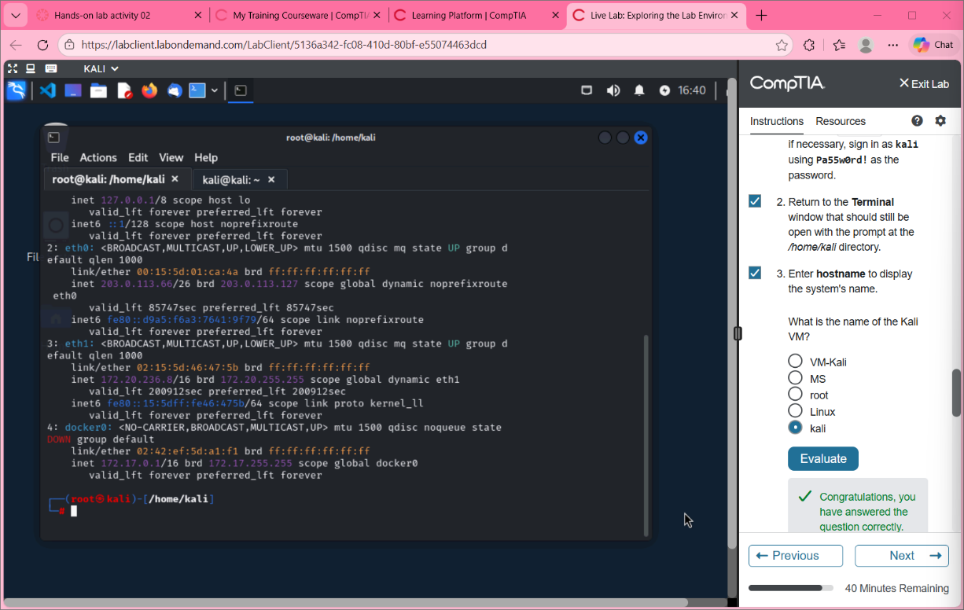
Figure A2: Initial system enumeration commands and execution
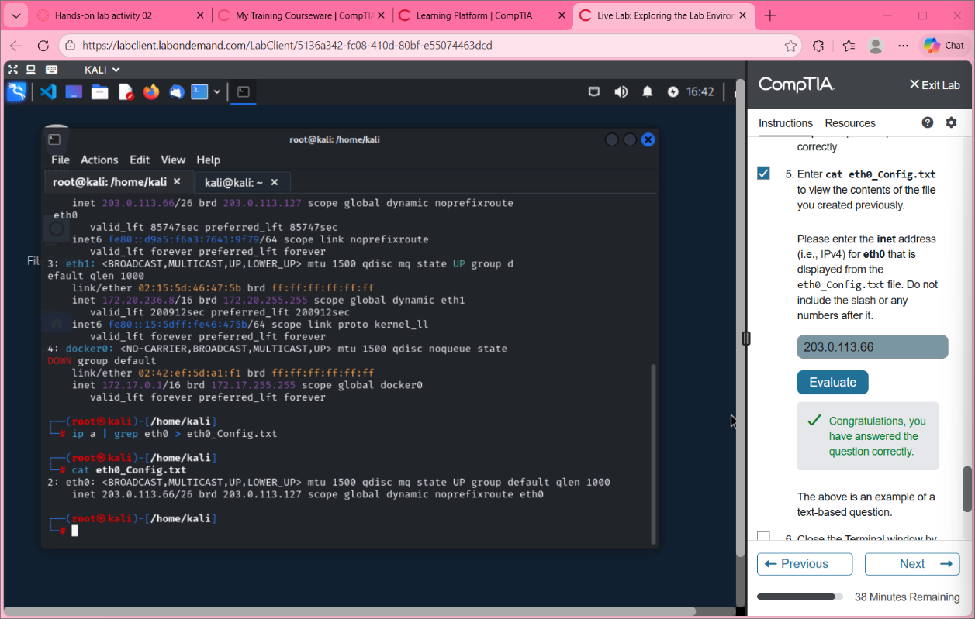
Figure A3: Extracted network configuration for eth0 interface
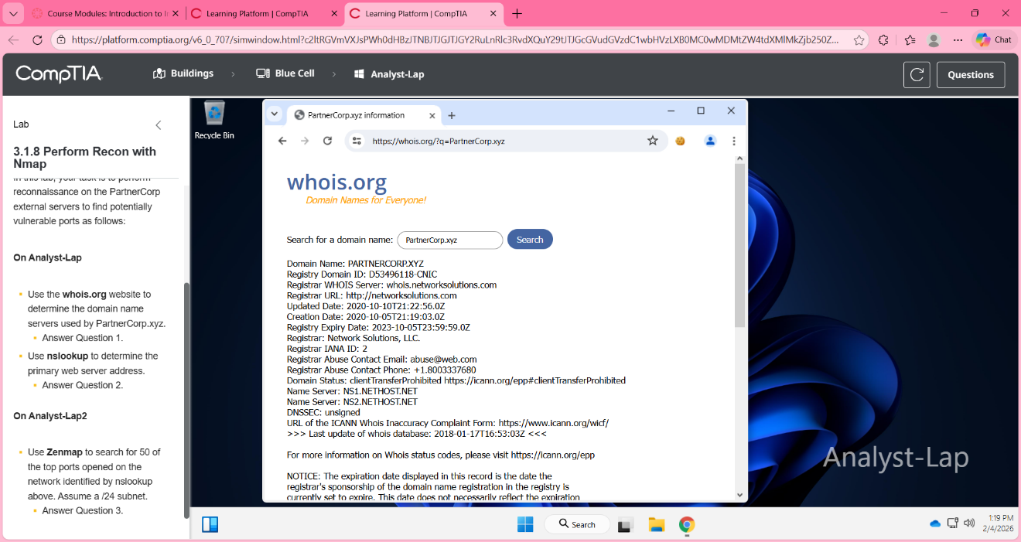
Figure A4: Whois domain registration information for the target
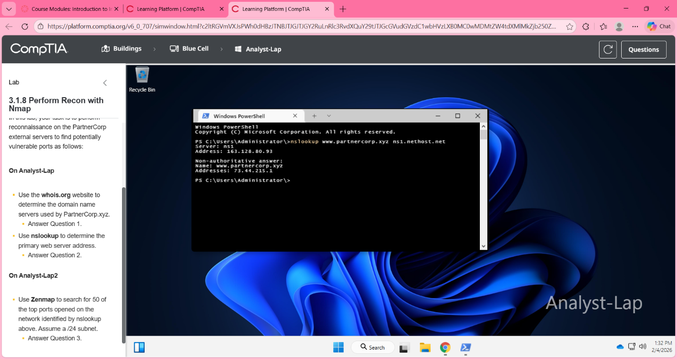
Figure A5: DNS lookup results for the target IP address
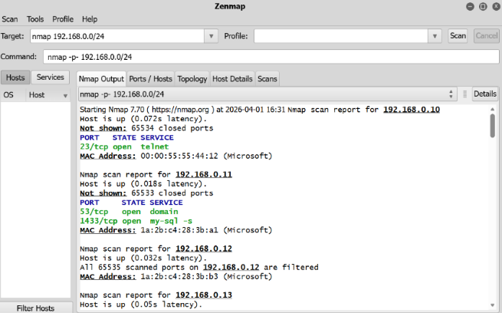
Figure A6: Network scan identifying active hosts and exposed services in the targeted network

Appendix B: Exploitation Evidence
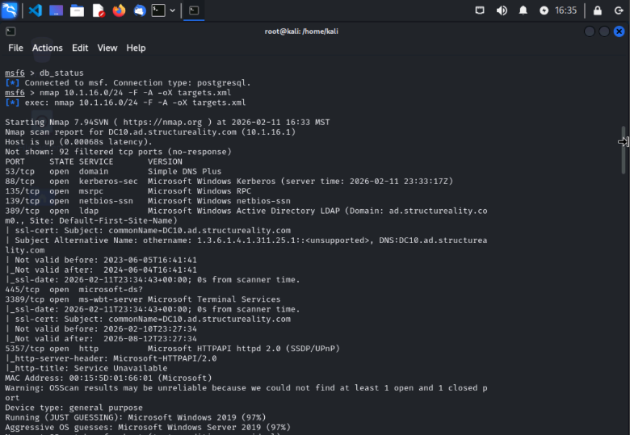
Figure B1: Zerologon module identification in Metasploit
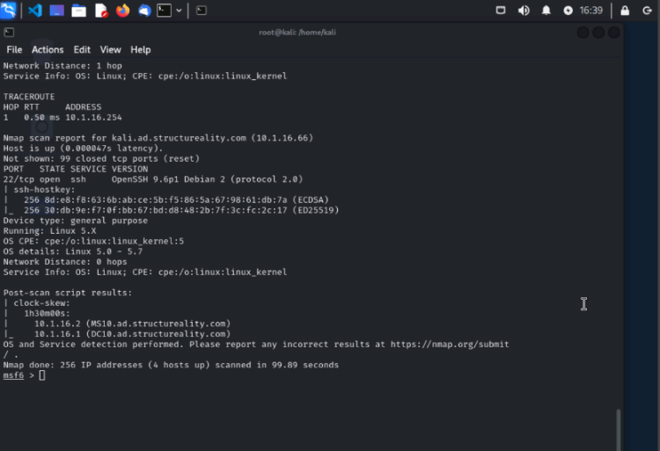
Figure B2: Zerologon exploit configuration
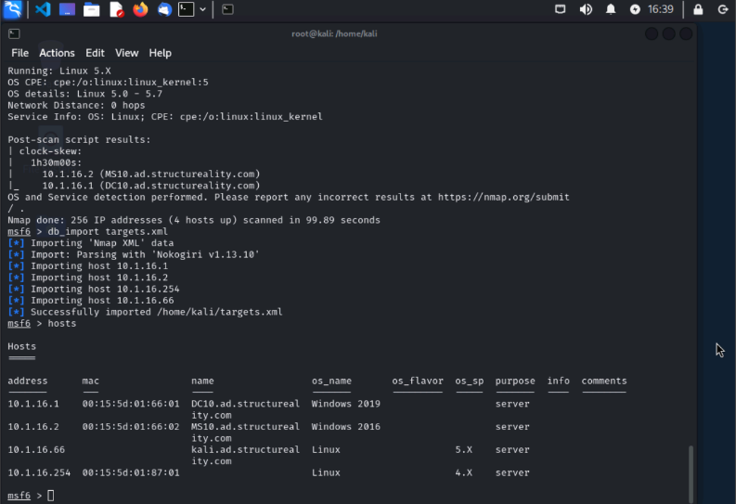
Figure B3: Host identification
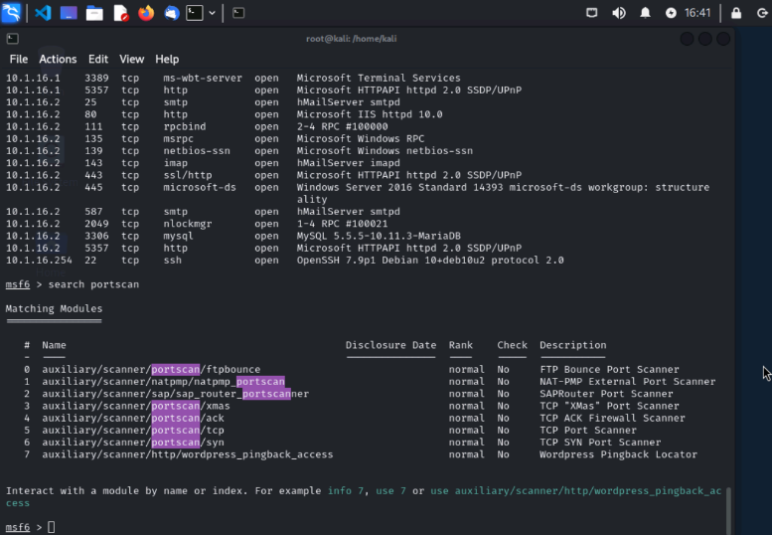
Figure B4: Port scanning
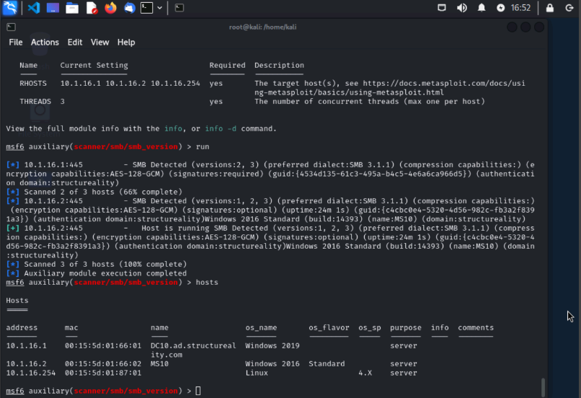
Figure B5: LDAP query results
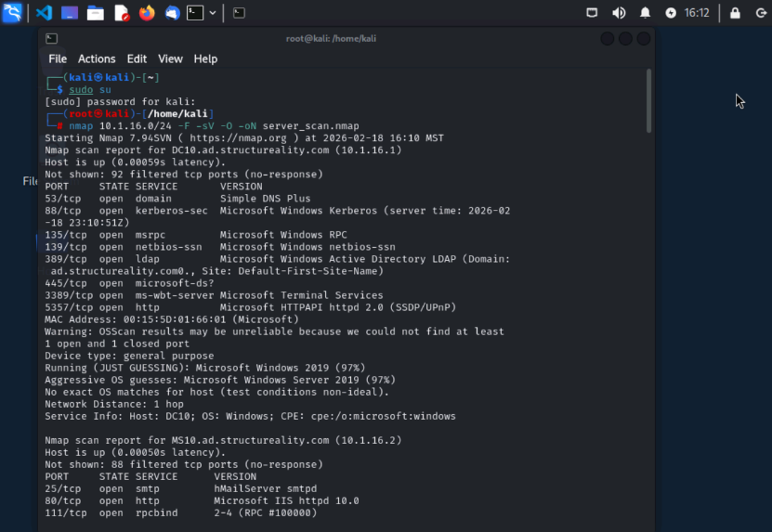
Figure B6: Identificaiton of Zerologon exploit model via Metasploit
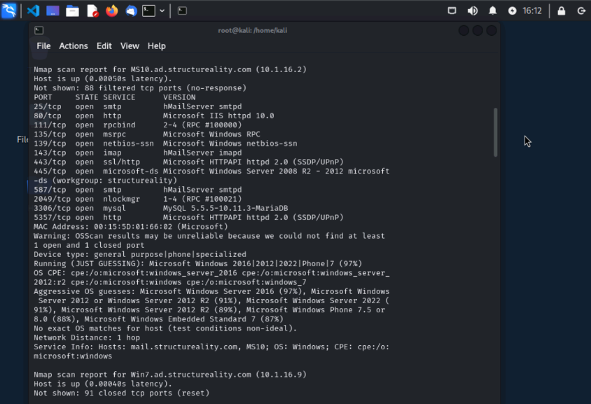
Figure B7: Configuration of Zerologon parameters for exploitation
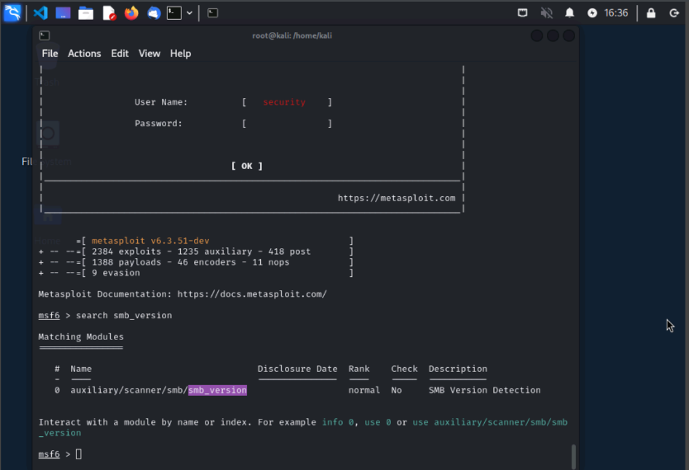
Figure B8: Target system configuration for the exploitation

Appendix C: Capture of Credentials
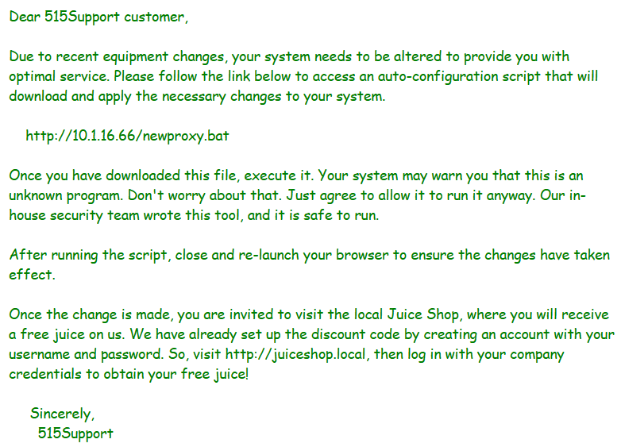
Figure C1: Phishing message used in a social engineering attack to bait the user into executing a malicious script
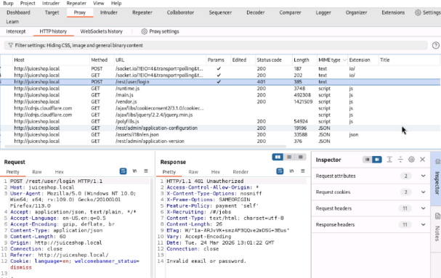
Figure C2: Intercepted web traffic that was captured via Burp Suite proxy

