All of the evidence relevant to this case was found on Hard Drive B, which is now assumed to be Marco’s hard drive. Hard Drives A and C did not contain any relevant files. Hard Drive B had much more data than the other two hard drives. The “Start” folder contained many miscellaneous text files. Among those files were an essay that made little sense, several files with gibberish, a file with simple math problems, and a text file that simply said, “Not that easy.” That file was found in a folder titled “Banana,” which made me think to check Hard Drive B. Then, I found all of the information on that hard drive and started my investigation there.
- What time did Marco clock out on 3/21/2020?
Marco clocked out at 10:00 PM on Saturday, March 21, 2020. He clocked in at 8:15 AM.
This information was available in Hard Drive B, in the USBCocktails&OysterMenu folder. That folder contains a text document titled “timeStamp”. This document contains Marco’s time card for the week of March 16, 2020.
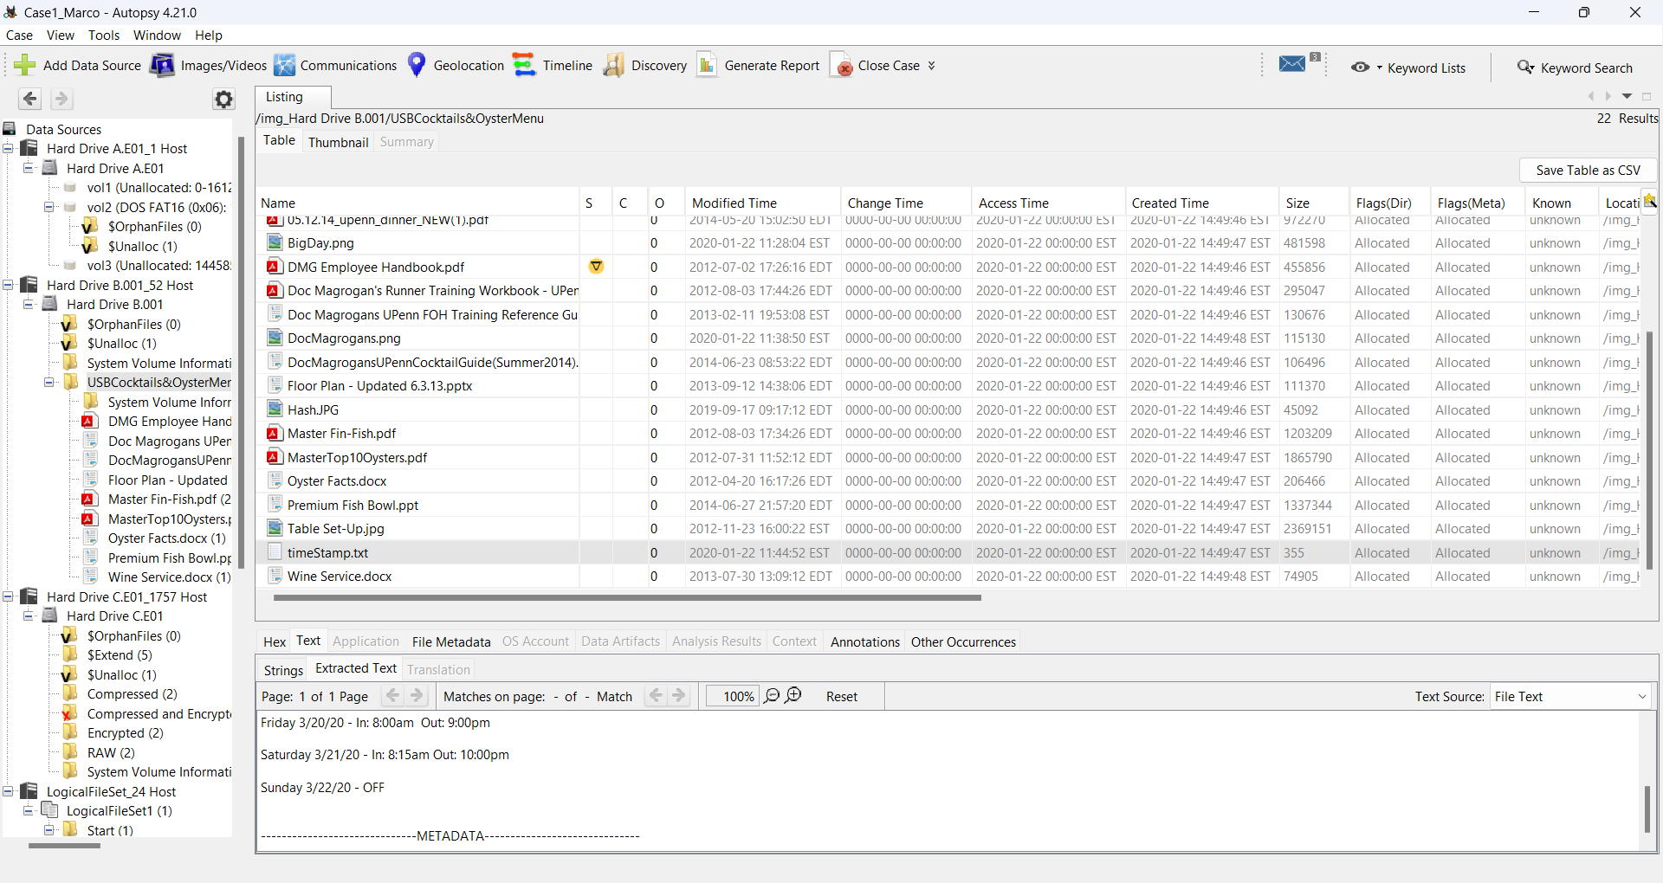
- What building was Marco in after dinner?
After dinner, Marco was in Building B.
This information was found in Hard Drive B, in the USBCocktails&OysterMenu folder. The folder contains an image titled “BigDay.png”. This image contains the crew’s schedule for Saturday, March 21. After dinner, Marco and the other crew members were to report to Building B to shoot an important scene.
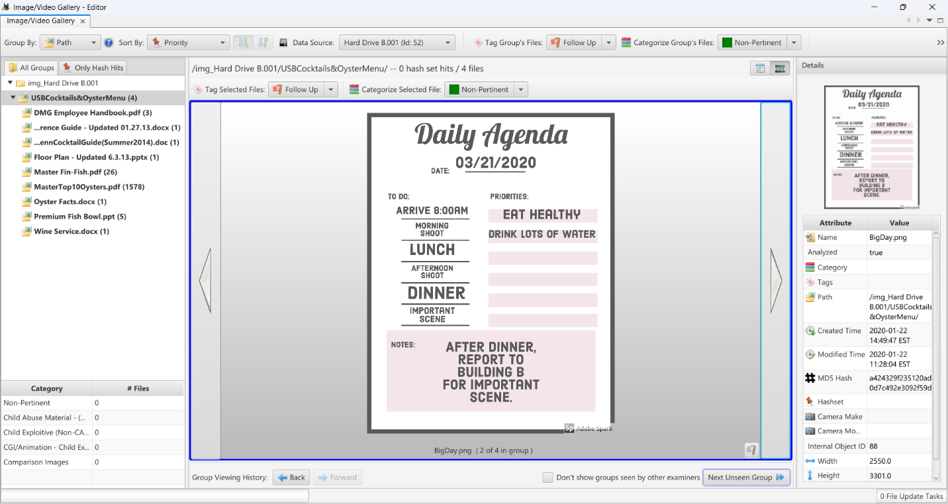
- What is Marco’s personal email address?
Marco’s personal email address is MicroMarco@gmail.com.
His email address was found in Hard Drive B, in the USBCocktails&OysterMenu folder. The folder contains a screenshot titled “DocMagrogans.png”. The screenshot is of an email Marco sent to the rest of the cast, inviting them to lunch at Doc Magrogan’s Oyster House the day after shooting the important scene. In this email, Marco left his personal email address, along with his phone number, for his castmates to contact him about the lunch.
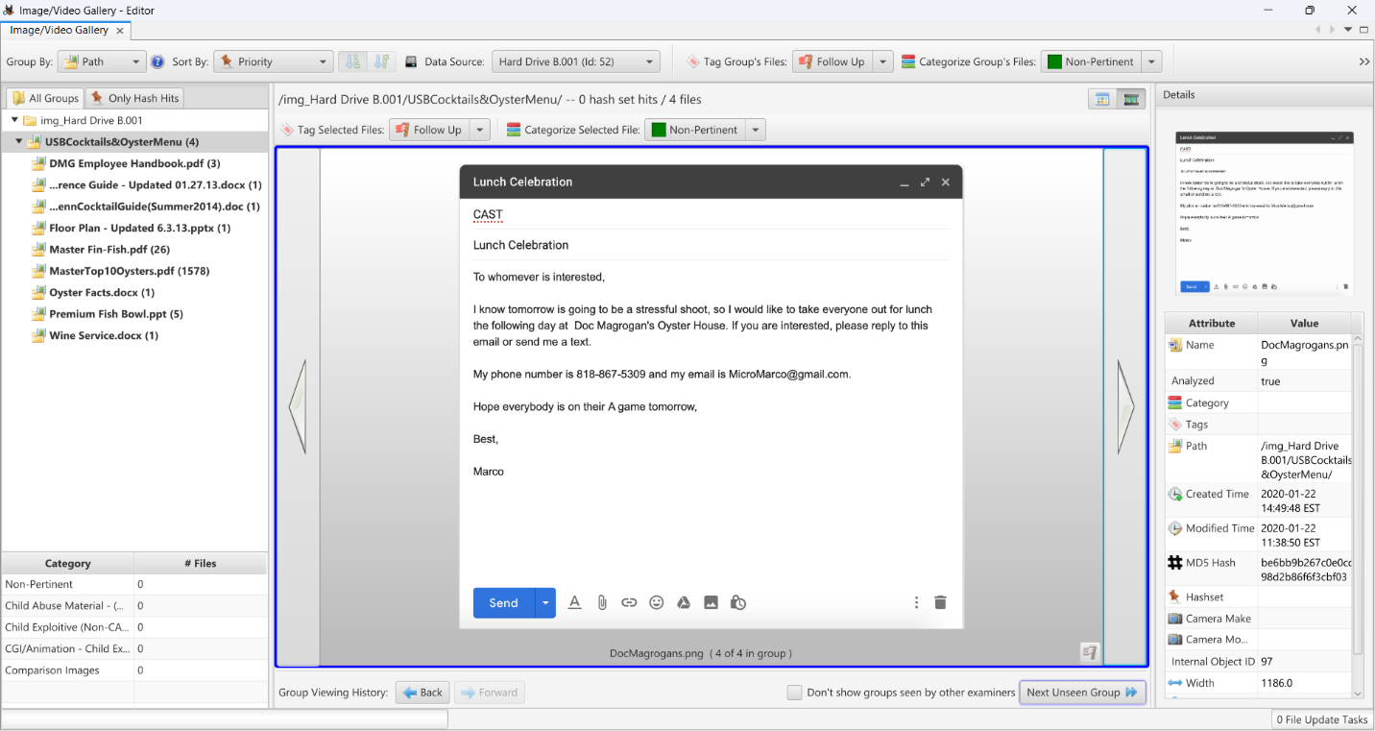
Additionally, an image in the the USBCocktails&OysterMenu folder titled “hash.JPG” contained hash information relevant to the case.
