
Access token manipulation
Madison Sleppy

October 21, 2024
cis-3605-702
PROFESSOR GIRALDO

Table of Contents
What is Access Token Manipulation? 3
Example 5
APT Groups that Use Access Token Manipulation 6
APT28 6
APT32 8
APT41 9
Example of an Access Token Manipulation Incident 12
Incident Trigger 12
Triage 12
Detection 13
Location of Evidence 14
Tools & Commands 15
Mitigation 16
Eradication 16
How the Attack was Carried Out 19
Preparation 19
Executing the Attack 20
Running LinPEAS 20
Locating Users 21
Granting Privileges 22
Final Thoughts 25
Works Cited 26

What is Access Token Manipulation?
- Access token manipulation is a procedure used to infiltrate services.
- Firstly, an access token is a token that is sent to a user to allow them to access a resource.
- Access tokens normally expire within an abbreviated time period, ranging from just a couple of minutes to an hour.
- If the access token expires before it is used, the user will need to obtain a new token in order to access the desired resource.
  - This is common with university credentials. If a student attempts to log into their account using their university e-mail address and password, they will likely be sent an access token via text message.
  - After entering their access token, they will be able to access their university’s resources, such as a Canvas page for their classes.
- There are several benefits to utilizing access tokens, such as scalability, improved security, and overall better user experience. (Descope 2023).
- While there are benefits to utilizing access tokens, they are not perfect and can easily be taken advantage of.
- According to Mitre (2017), “A user can manipulate access tokens to make a running process appear as though it is the child of a different process or belongs to someone other than the user that started the process.”
  - In other words, a malicious adversary can modify access tokens and log into another user’s account with the altered access token.
- Access tokens can also be stolen via Windows API functions.
- Built-in Windows API functions can be used to copy existing access tokens, which can then be used to log into a user’s account or start a new process altogether.
- To steal a token, the perpetrator must be an administrator or fulfill another role with system privileges.
- Access tokens can be altered, duplicated, and stolen in order to gain access to a particular resource.
- In addition to malicious users manipulating access tokens, malware services can also manipulate them.
- According to Shah (2021), malware has the ability to “abuse the Windows APIs to execute the token stealing or token impersonation to gain elevated privileges and advance its lateral movement activities.”

Example
- The following screenshot is an example of how access token manipulation attacks can be conducted.
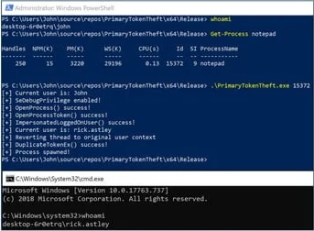
- In the example, the attacker is running an executable file that obtains a user’s login token.
- The token is duplicated to give the attacker the ability to gain access to the victim’s account.
- There are several ways that an access token manipulation attack can be executed.

APT Groups that Use Access Token Manipulation
- Groups are clusters of activity that are tracked by a commonly used name in the security community.
- APT groups are composed of hackers that complete the cyberattacks that are clustered.
- These groups focus on infiltrating networks to gather intelligence, sabotage other systems, or steal sensitive information.
- The attacks carried out by APT groups are often long-term.
- Many APT groups use access token manipulation as a method of stealing sensitive information.

APT28
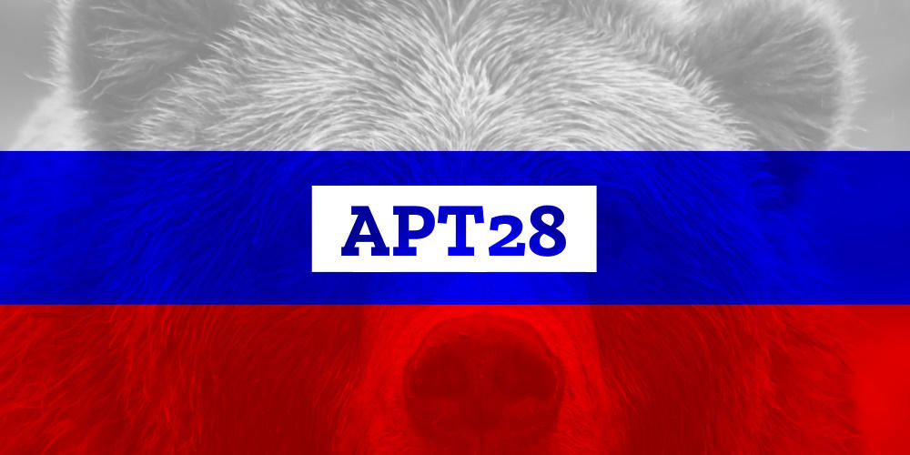
- APT 28 is a group based in Russia that has been active since 2004.
- This group allegedly compromised Hillary Clinton’s presidential campaign in 2016 to interfere with the U.S. presidential election.
- APT28 targets public affairs involving government, media, and politics.
- This group targets European and North American countries.
- APT28 is associated with several cybercrime groups, such as:
  - IRON TWILIGHT
  - Sednit
  - Pawn Storm
  - Fancy Bear
  - Forest Blizzard
- APT28 uses the software Mimikatz to conduct access token manipulation attacks.
  - Mimikatz is a credential dumping software that obtains Windows account login credentials, along with features that allow the attacker to assess the security of the network.
- APT28 has used access token manipulation to access the SYSTEM token and copy it into the current process of the system they were attacking.
  - This leads to privilege escalation, which then allows the attacker to access information that they were unauthorized to access.
- In addition to access token manipulation, APT28 has utilized several techniques to gain unauthorized access to information or infiltrate networks:
  - Brute force
  - Gathering victim information
  - Keylogging
  - Masquerading
  - Phishing

APT32
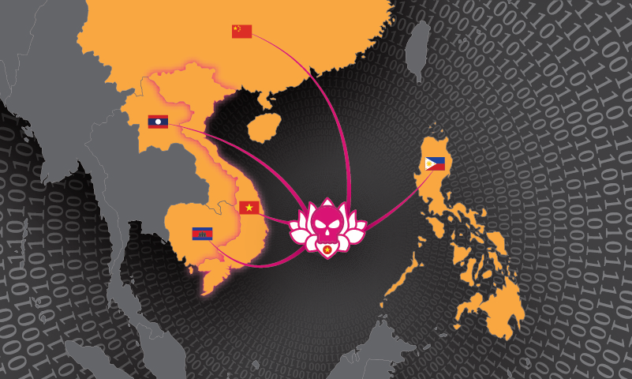
- APT32 is a group based in Vietnam that has been active since 2014.
- This group targets Southeast Asian countries.
- APT32 focuses on public relations involving the economy, foreign relations, and politics.
- APT32 is associated with the following groups:
  - SeaLotus
  - OceanLotus
  - Canvas Cyclone
  - BISMUTH
  - APT-C-00
- This group utilizes malware such as Cobalt Strike and Mimikatz to conduct access token manipulation attacks.
  - Cobalt Strike is a remote access tool that allows attackers to utilize several distinct types of cyberattacks.
    - This type of malware was designed to conduct targeted attacks and imitate the post-exploitation actions of advanced threats.
- APT32 uses access token manipulation by escalating their privileges so that its members can obtain information that they should not be able to normally.
- In addition to access token manipulation, APT32 uses several techniques to attack its targets:
  - Drive-by compromise
  - OS credential dumping
  - Process injection
  - Remote system discovery
  - User execution attacks via malicious files and links

APT41
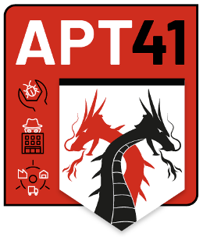
- APT41 is a group that is based in China and has been active since 2012.
  - APT41 is state-sponsored.
- This group targets several countries in Asia, Europe, and North America.
- APT41 focuses on attacking healthcare, technology, telecom, and video game industries.
- There are three groups associated with APT41:
  - Wicked Panda
  - Brass Typhoon
  - BARIUM
- APT41 utilizes several types of malware to execute access token manipulation attacks:
  - Cobalt Strike
  - Empire
    - Empire is an open-source framework that contains post-exploitation agents written in PowerShell for use on Windows, and Python for Linux or macOS usage.
    - The tool is publicly available on GitHub.
  - Mimikatz
  - PowerSploit
    - PowerSploit is an open source, offensive security tool that consists of PowerShell modules and scripts that can bypass anti-virus preventative measures.
  - ZxShell
    - ZxShell is a remote tool and backdoor that can be installed from Chinese hacking websites.
- APT41 uses access token manipulation to compromise corporate systems and gain intelligence on its targets.
- Besides access token manipulation, APT41 utilizes several types of attacks:
  - Command and scripting interpreters in PowerShell, Windows Command Shell, and Unix Shell
  - Data staging
  - Fallback channels
  - Network share discovery
  - Resource hijacking

Example of an Access Token Manipulation Incident

Incident Trigger
- An incident is triggered when a system administrator sees unusual API access patterns in their audit logs.
- These logs indicate that a user account with regular permissions accessed administrative resources, even though they did not have permission to do so.
  - This means that the user was able to access any sensitive information that the system’s administrator could access, including personal information of other users.
- The system administrator contacts their place of employment’s IT section to tell them about the incident.
- The administrator is confident that the user did not have any administrator privileges, and suspects that the user manipulated an access token to gain access to administrative privileges.

Triage
- Regarding access token manipulation, the logs that triggered the alert should be reviewed.
- This will contain the access token, user’s account, and the timestamp of the incident.
- The access token would then have to be retrieved and verified.
- The investigator would have to inspect the token for any signs of forgery or tampering.
- This can be done by checking the token’s encryption status.
- If a token was not encrypted, it was tampered with.
- After that, the investigator should ask the victim questions about their account.
- The investigator should find out if anyone else had access to the account or device, or if the online activity is normal for the victim.
- They should also ask if they know anyone who could have advanced technological skills that can get into their account.
- They should also ask what the victim was doing at the time of the incident.
- To see if the incident is a false positive, the investigator should check the device to see if there were any recent role changes, like if someone was given administrator access to change tokens.

Detection
- To detect the threat, investigators should check the system’s API gateway, the server that authenticates tokens, and the server that provides access to the administrative resources.
- To look for signs of access token manipulation, investigators should check to see if the access token has a valid signature.
- The token’s metadata would also need to be examined, such as who issued it and when it expired.
- Access logs should also be reviewed for suspicious activity.
- Evidence of an access token manipulation attack would be evident on API access logs, authentication service logs, and user devices.
- The API access logs will show what was accessed with manipulated tokens.
- The authentication logs will show if tokens were manipulated.
- Malware may be on the user’s device, which could have manipulated access tokens or create new tokens.

Location of Evidence
- A computer system’s metadata will have information that indicates if the system was affected by access token manipulation.
- It can be difficult to detect if a system was affected by access token manipulation, because these attacks do not leave a lot of evidence behind.
- Some of the actions that are conducted during access token manipulation will generate event logs (Madhuvantii 2021).
- Evidence of access token manipulation can be found in a device’s domain controller logs or in the endpoint logs, depending on the type of attack technique.
- If there is a pass-the-hash attack, the “hashed” token is stolen. Information of this attack can be found in endpoint logs.
- If the endpoint log contains the Windows Event ID 4624, log-on type 9, a negotiated authentication package, and “seclogo” as the log-on process, then there was an attack on the access token.
- Additionally, if the Sysmon Event ID is listed as 10, this also points to a pass-the-hash attack occurring.
- For a pass-the-ticket attack, a user steals an existing ticket or creates a forged one.
- The ticket is then used to access a resource. Information regarding this type of attack can be found in the domain controller logs.
- If the Windows Event ID is listed as 4678, 4769, or 4770, this means that a pass-the-ticket attack has occurred.

Tools & Commands
- Any user can create an impersonation token, or fake access token, by running the “runas” command, along with Windows API functions.
- In addition, there are several types of software that allow the user to manipulate access tokens.
- Software such as MegaCortex, Ryuk, and SUNSPOT allow the user to adjust access tokens by adding the “SeDebugPrivilege” command.
  - This command allows the user to access any process, regardless of any security features set in place.
- Programs such as AppleSeed, Cuba, and HermeticWiper utilize “AdjustTokenPrivileges” to alter user privileges.
- This command can enable or disable the access token’s privileges, allowing a user to access the resource.
- There are several other types of software programs that allow the user to alter an access token or bypass the need for one altogether.
- Access token manipulation can be completed via several procedures.
- There are multiple types of malware and commands that make this attack possible.
- One type of malware is AppleSeed. AppleSeed can manipulate access tokens by passing the SeDebugPrivilege to the AdjustTokenPrivilege API.
- This would manipulate the token and allow unapproved access.
- Another type of malware, KillDisk, can call the command OpenProcessToken to gain access to the token.
- Then, KillDisk can manipulate the token with the command AdjustTokenPrivileges.
- There are several types of malware that can be used to access and change tokens.
- There are some commands that only work for certain types of malware, but the AdjustTokenPrivilege, AdjustTokenPrivileges, and OpenProcessToken commands can be used universally.
- Access token manipulation can be evaluated by using penetration tools like Burp Suite to simulate an attack, so that investigators know what to search for.
- Access token manipulation can also be used in Kali Linux, with commands to elevate the user’s privileges.

Mitigation
- This issue can be mitigated by limiting account permissions so that users are unable to create tokens.
- This setting should only be defined on local systems.
- According to Mitre Att&ck, the permission can be limited by following this path: Computer Configuration > [Policies] > Windows Settings > Security Settings > Local Policies > User Rights Assignment: Create a token object.
- It should also be defined who can create process-level tokens.
- This should be defined on local and network services.
- That can be defined via this path: Computer Configuration > [Policies] > Windows Settings > Security Settings > Local Policies > User Rights Assignment: Replace a process level token.
- Users should be given minimal privileges to prevent an incident like this from occurring.

Eradication
- The issue of access token manipulation can be eradicated in different ways.
- Updating software and upgrading libraries can patch vulnerabilities that allow access token exploitation to occur.
- Keys should also be regenerated if they are stolen or changed in any way.
- Refresh tokens should also be revoked, because they can be used to generate new tokens and therefore be used by the attacker to gain unlawful access to sensitive information.
- Any affected users should be forced out of their sessions and have their accounts be reauthenticated.
- This would cause users to need a new access token, which would not be changed or forged.
- Enforcing multi-factor authentication would also be useful in eradicating access token manipulation.
- Asking for another way to verify ownership of the account would make it much more difficult for attackers to gain access.
- In order to eliminate access token manipulation, companies would have to revoke compromised tokens and force its users to reauthenticate their accounts.
- This can be done by implementing multi-factor authentication or by sending new access tokens that are not forged or manipulated.
- The software should be scanned for potential imperfections that would make it more vulnerable to access token manipulation, and then implement software updates that would make this much harder for attackers to exploit.
- Companies should also frequently monitor access tokens and relevant access token activities.

How the Attack was Carried Out
- There are several ways to conduct a cyberattack revolving around access token manipulation.
- Many attacks involving access token manipulation are used to grant regular users administrative privileges so that they can access information they would not be able to normally access.
- Since this attack involved a user giving themselves administrative privileges, there are multiple ways that this could have been done.
  - There are several types of software and other tools that make these attacks possible on any operating system.
- The following sections will display a simulated attack.
  - This is the approach that was most likely taken by the attacker.
  - In order to prevent potential damage to the device, the simulated attack was executed on a virtual machine containing Kali Linux.

Preparation
- To prepare for the attack, the attacker installed a virtual machine host, such as VM Workstation Pro.
  - This can be downloaded at VMware by Broadcom - Cloud Computing for the Enterprise.
- The user also downloaded the Kali Linux ISO and set it up in VM Workstation Pro.
  - This can be installed at Get Kali | Kali Linux.
- After that, the user set up their own account on Kali Linux.
- The user then opened the terminal to install Linpeas.sh.
  - Linpeas, also referred to as LinPEAS, is a Linux privilege escalation tool that allows the user to grant themselves higher privileges.
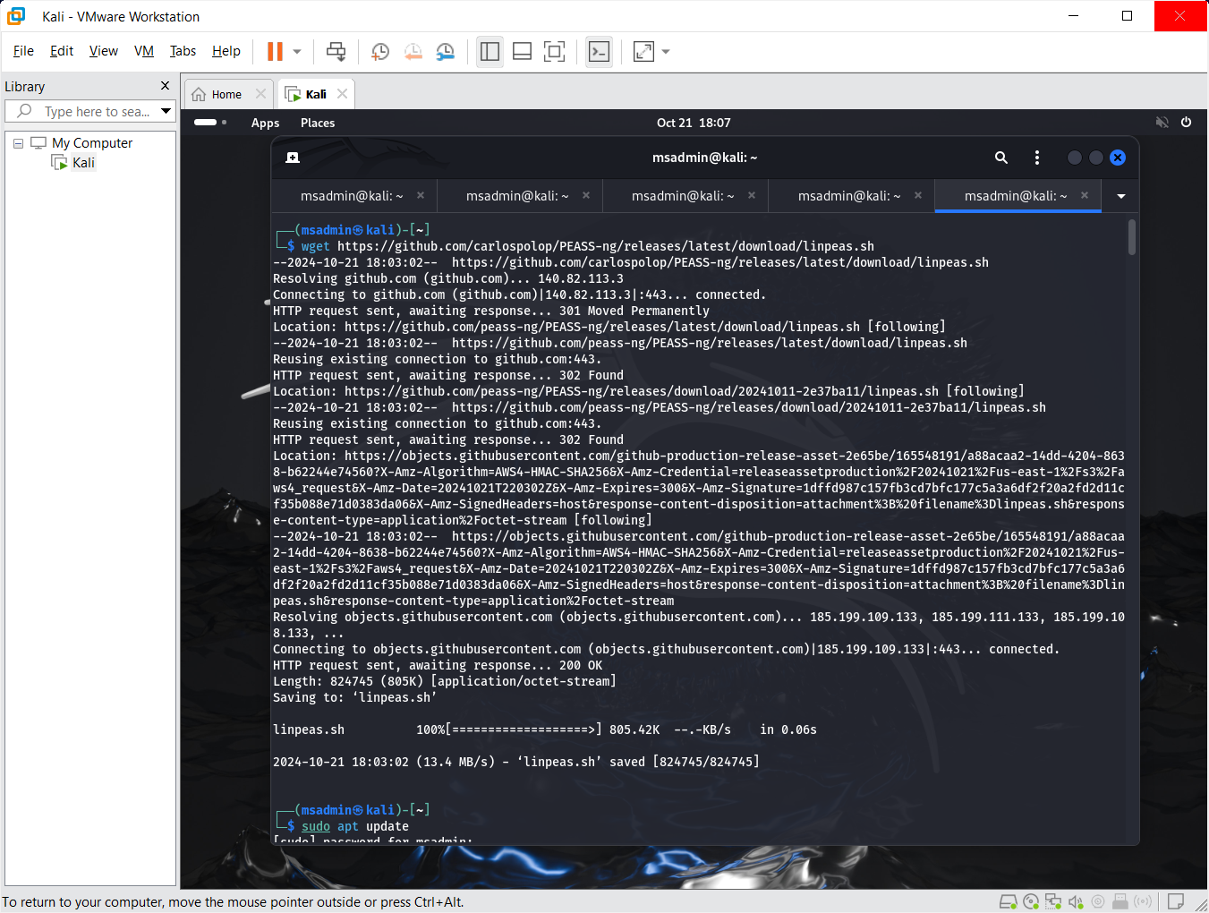
- The attacker installed LinPEAS by running the following command in the Kali Linux terminal:
  - wget https://github.com/carlospolop/PEASS-ng/releases/latest/download/linpeas.sh
  - This command obtained the latest version of LinPEAS.
- Now that everything is installed, the attacker can start the actual attack.

Executing the Attack
- After installing the necessary software, the attacker was ready to begin their attack.

Running LinPEAS
- The attacker ran the following command in the terminal:
  - chmod +x linpeas.sh
  - This command turns LinPEAS into an executable, allowing the user to run LinPEAS.
  - To run LinPEAS, the following command was entered:
    - ./linpeas.sh
  - The attacker is then greeted with the following screen:
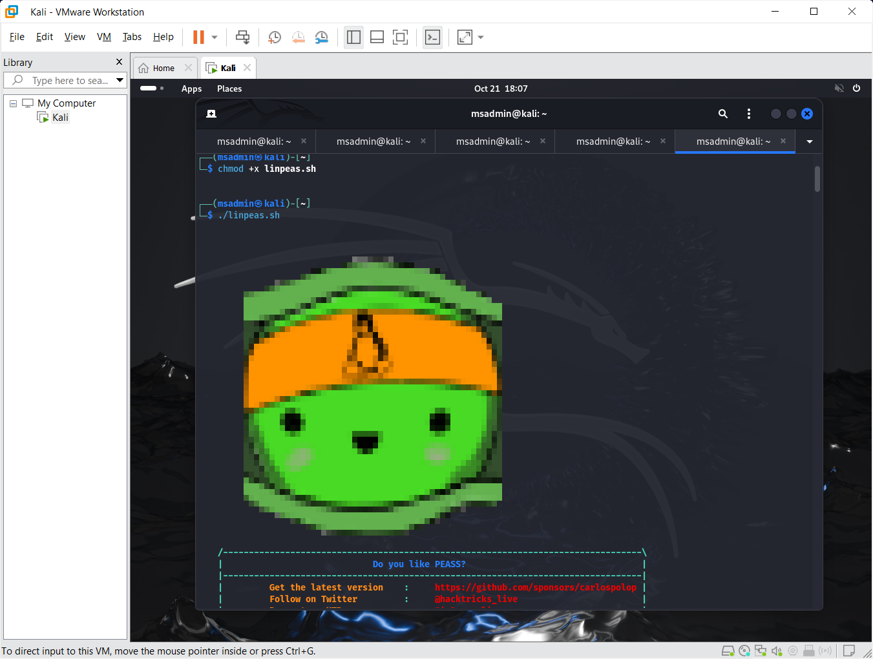
  - LinPEAS started to run and scanned the information on the device.
    - It takes three-to-five minutes for all of the information to load.

Locating Users
- After the information loaded, the attacker needed to access the list of users.
- The attacker scrolled to the user information section, which contained the information regarding the users who used the system, which is the terminal in this case.
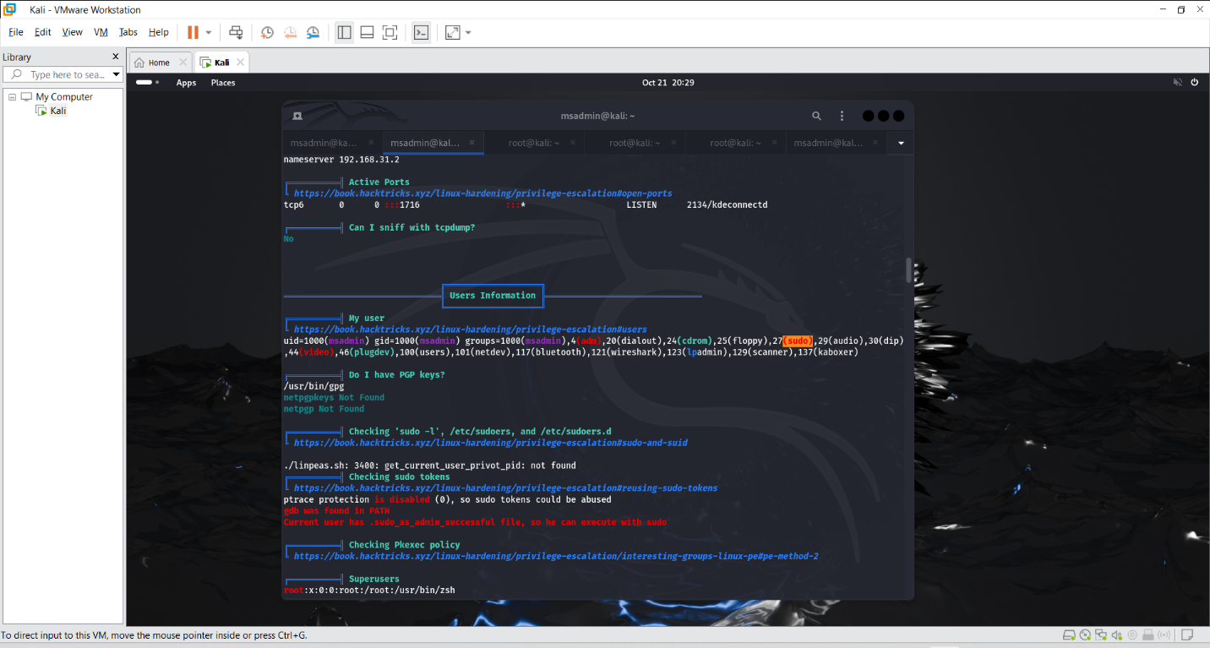
- The attacker located the user account that they wanted to grant elevated privileges and got started with the next phase of the attack.

Granting Privileges
- After selecting a user to grant administrative privileges to, the attacker opened a root shell by running the following command:
  - sudo -i
  - When prompted to enter a password, the attacker used brute force to correctly guess the password.
    - This gave the attacker root access.
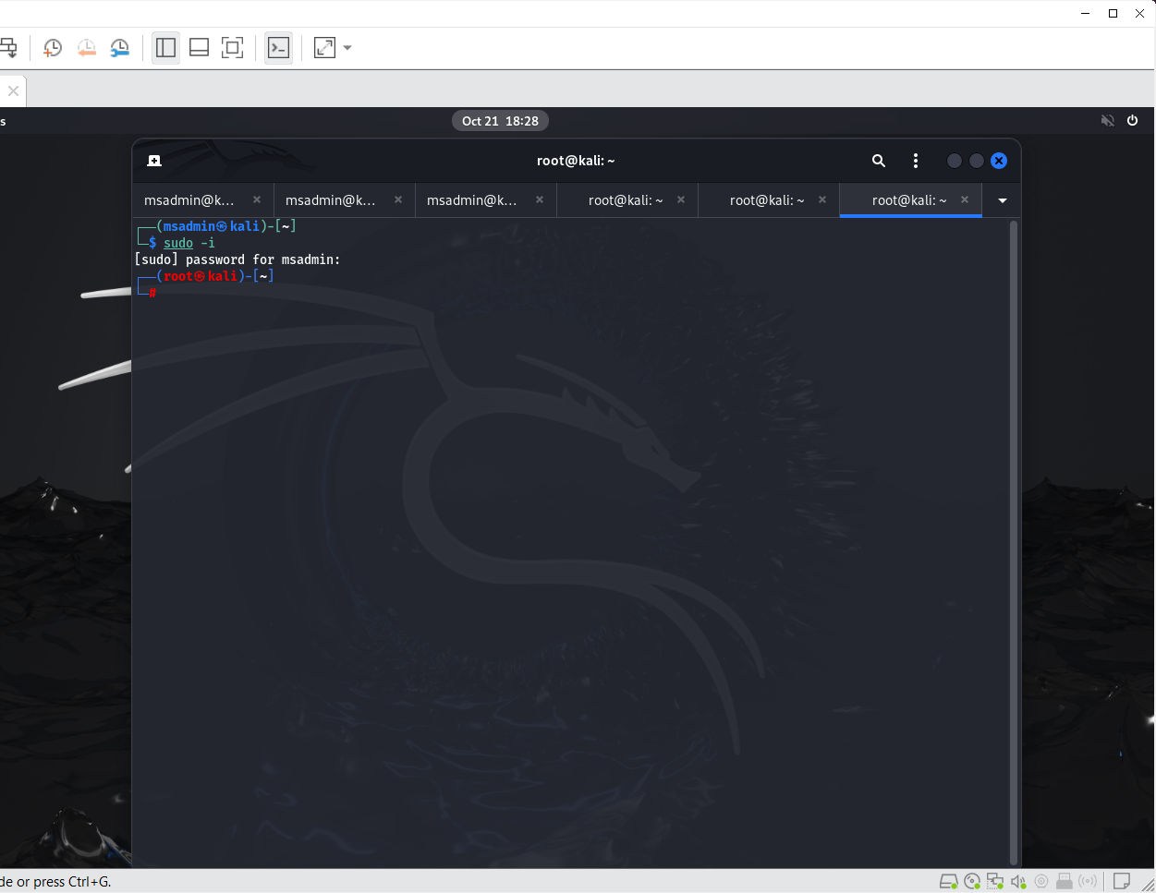
- After gaining access to the root of the terminal, the attacker was able to grant themselves escalated privileges.
- The attacker changed their own privileges by running the following command:
  - usermod -aG sudo msadmin
  - This escalated the user msadmin’s privileges to the administrative level.
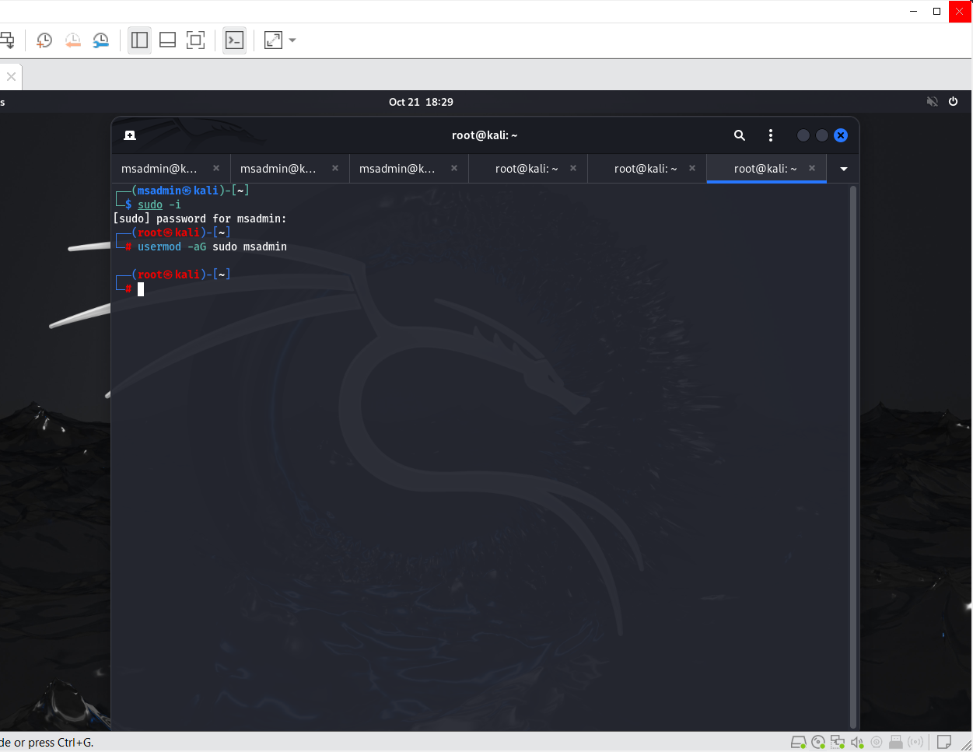
- To verify that the user’s privileges were changed, the attacker ran the following command:
  - groups msadmin
  - This command displays the type of user group that the user msadmin belongs to.
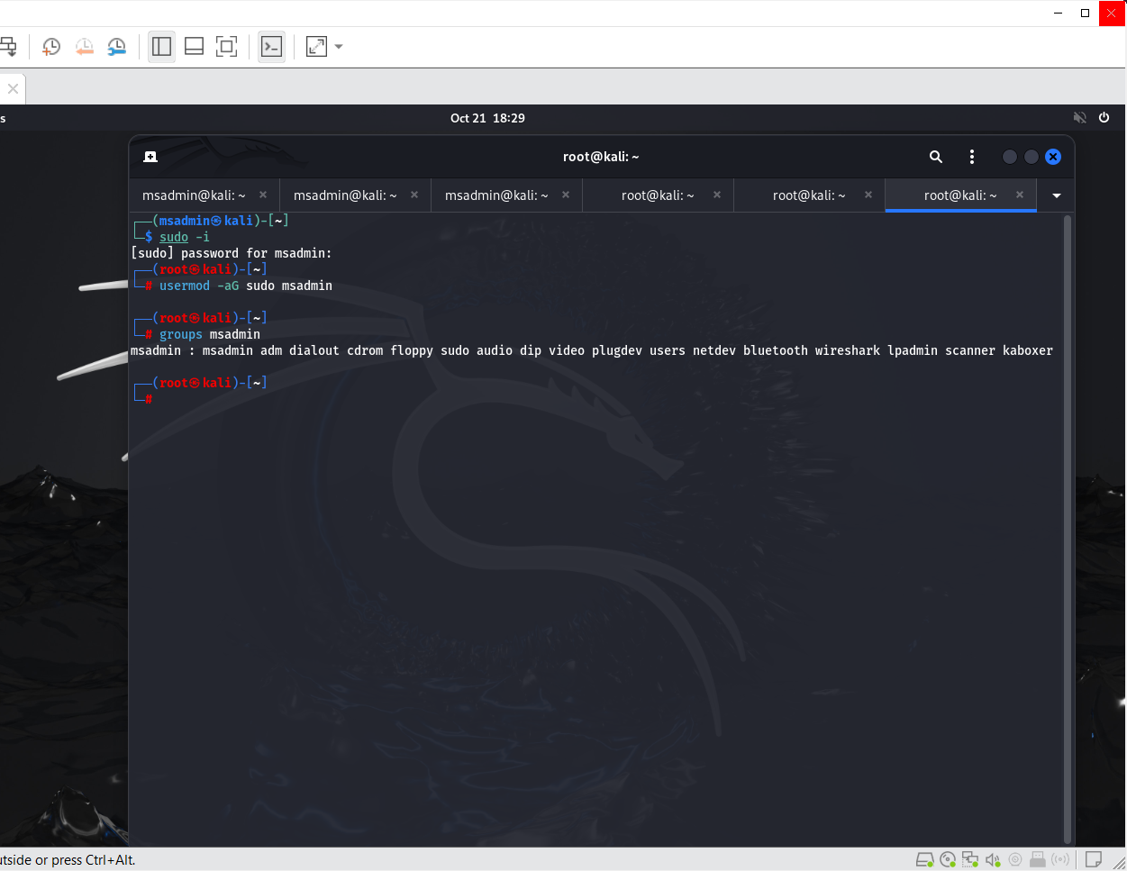
- After that command, the attacker checked the user’s sudo privileges:
  - sudo -l -U msadmin
  - This command displays the user’s privileges.

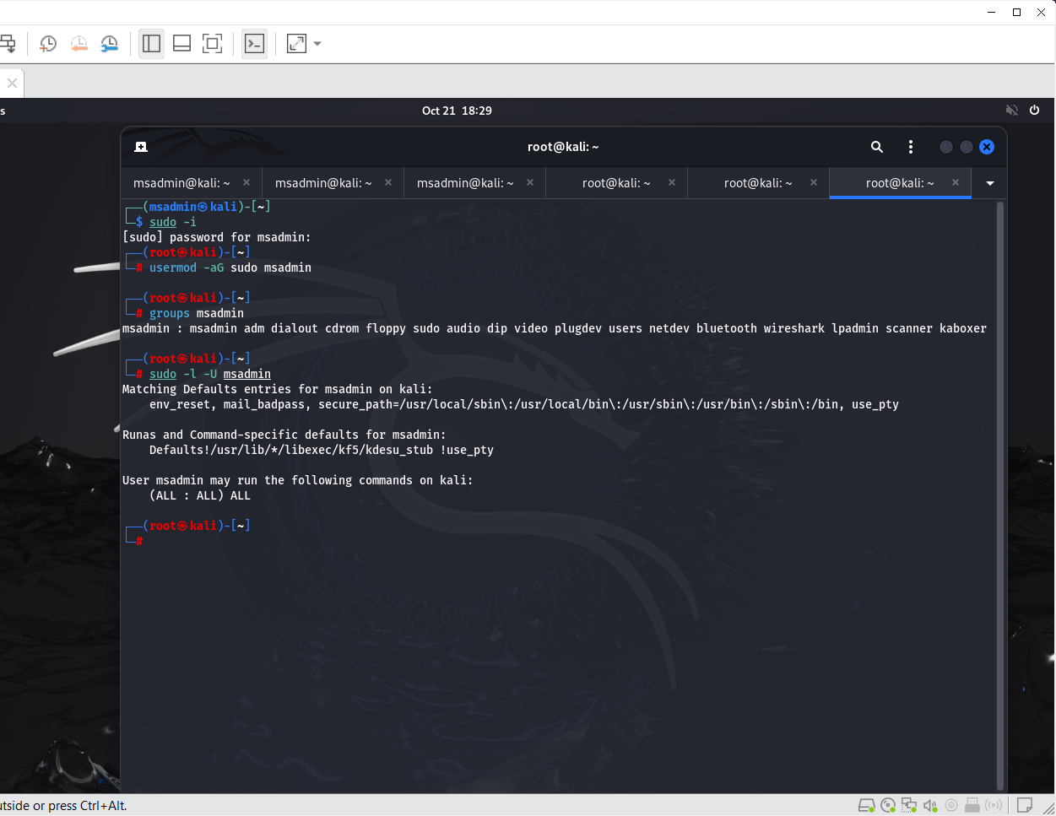
- The final stage of verification involved a simple command:
  - sudo whoami
  - If the user had administrative privileges, the output of the command would be “root.”
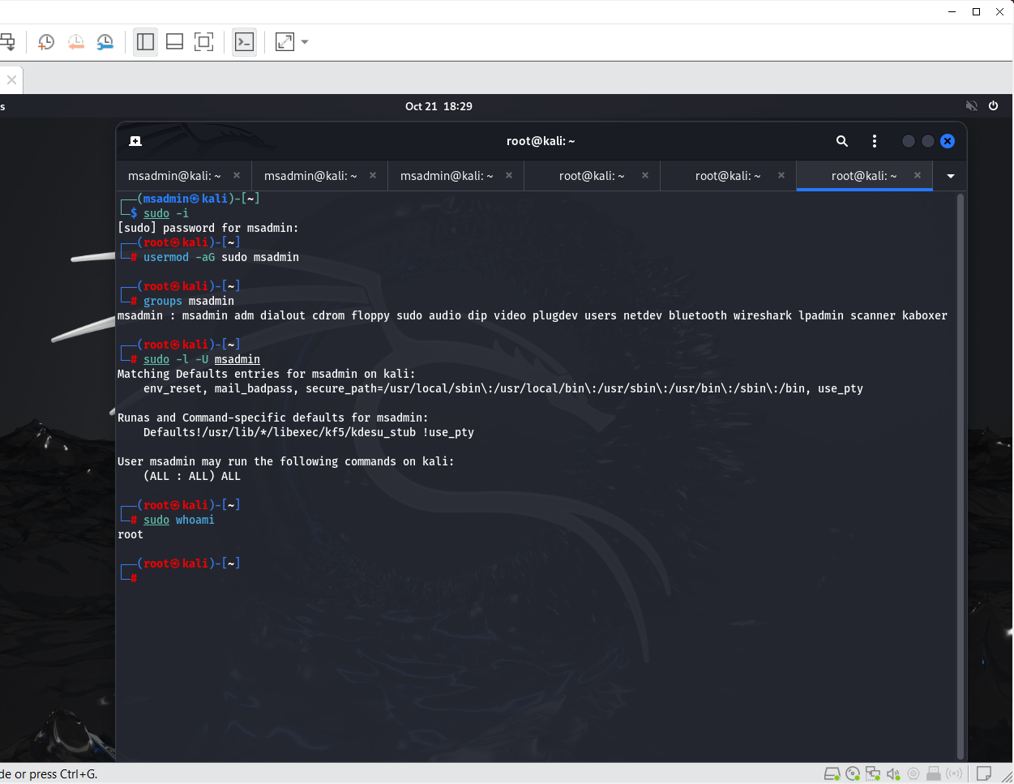
  - Since the output of this command was “root,” the attacker confirmed that they successfully gave themselves administrative privileges.

Final Thoughts
- Access token manipulation is a complex type of cyberattack that can be hard to trace.
- These types of attacks are not monolithic.
  - There are several ways that an attacker can conduct an attack revolving around access token manipulators, since there are hundreds of tools and types of malware that are readily available.
- It is possible for anyone to conduct these attacks utilizing the tools and malware.
  - Some attacks are simplistic, but other attacks can be very complex.
    - This depends on the attacker’s level of expertise.
- It is highly recommended for users to ethically utilize these tools for educational purposes, or for jobs such as penetration testing.
- It can be hard to defend against access token manipulation, but these attacks can be avoided by both corporations and everyday users:
  - Corporations can ensure that all of its users are at an appropriate privilege level, which would be the lowest level possible.
  - Everyday users can protect themselves against these attacks by enabling multi-factor authentication into their accounts.

Works Cited
- “Access Token Manipulation.” Access Token Manipulation, Technique T1134 - Enterprise | MITRE ATT&CK®, 14 Dec. 2017, attack.mitre.org/techniques/T1134/.
- “Access Token Manipulation.” Red Team Notes, 2020, dmcxblue.gitbook.io/red-team-notes/privesc/access-token-manipulation.
- “Process Token Manipulation.” Medium, Medium, 14 Sept. 2023, medium.com/@s12deff/process-token-manipulation-8983e92a824.
- “What Is an Access Token (and How Does It Work)?” Descope, 24 Oct. 2023, www.descope.com/learn/post/access-token.
- Bui, Justin. “Understanding and Defending against Access Token Theft: Finding Alternatives to Winlogon.Exe.” Medium, Posts by SpecterOps Team Members, 1 Oct. 2019, posts.specterops.io/understanding-and-defending-against-access-token-theft-finding-alternatives-to-winlogon-exe-80696c8a73b.
- Burgess, Will. “How Attackers Abuse Access Token Manipulation (ATT&CK T1134).” Elastic Blog, Elastic, 12 Dec. 2023, www.elastic.co/blog/how-attackers-abuse-access-token-manipulation.
- Madhuvantii, M. “ManageEngine - IT Management: Network Management Software.” ManageEngine Log360, 7 Sept. 2021, www.manageengine.com/log-management/cyber-security/access-token manipulation.html#:~:text=Access%20token%20manipulation%20is%20when%20an%20attacker%20uses%20built-in.
- Shah, Chintan. “Access Token Theft and Manipulation Attacks – a Door to Local Privilege Escalation.” McAfee Blog, 20 Apr. 2021, www.mcafee.com/blogs/other-blogs/mcafee-labs/access-token-theft-and-manipulation-attacks-a-door-to-local-privilege-escalation/.

