For this assignment, I decided to carve the file using Autopsy on Windows. Before carving the file, I had to properly set up Autopsy for proper use. First, I downloaded the necessary files from Canvas. Then, I booted up Autopsy and created a new case. After that, I uploaded the StolenInformation.001 file as evidence. When setting it up, I made sure to configure the ingest modules so that the contents of the image could properly be broken down and analyzed. I selected everything that was available, with the exception of premium options that required a paid subscription to use.
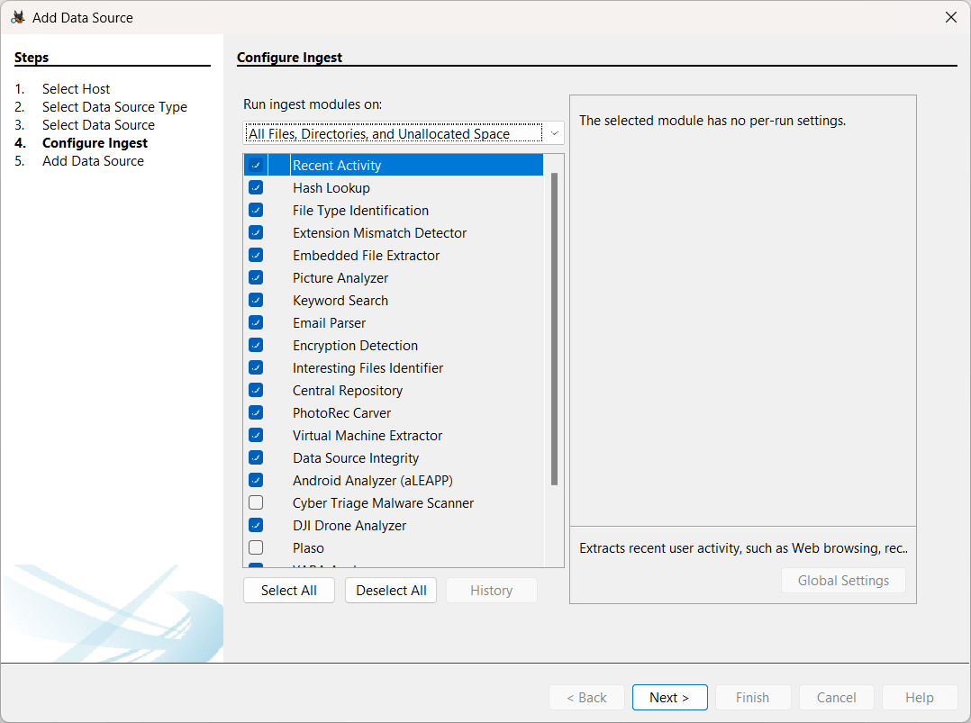
After that, I finished the uploading process and waited for Autopsy to analyze the files. When the image was uploaded, I went to the “tools” section and ran the ingest modules. I kept the same selection from when I uploaded the image.
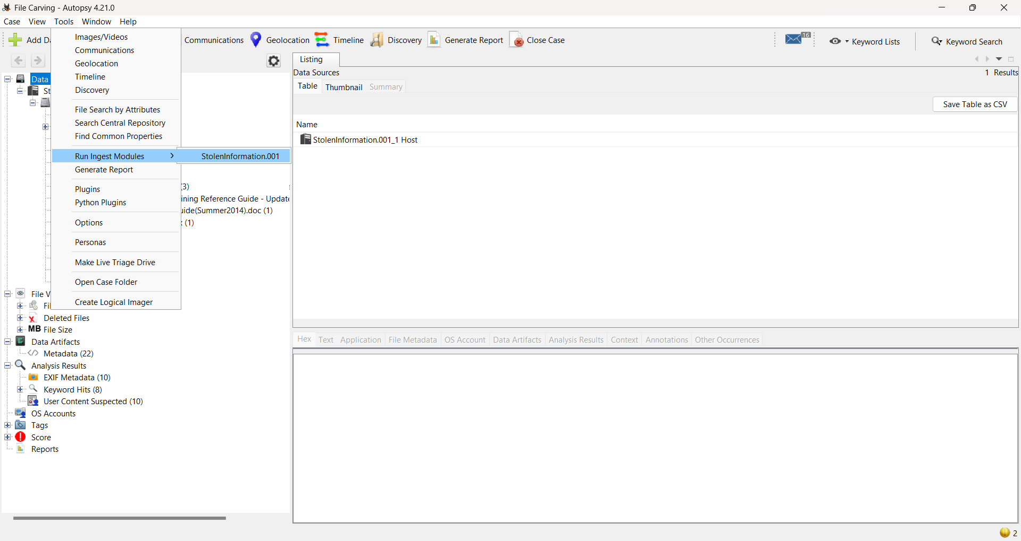
After that, I located the $CarvedFiles folder under StolenInformation.001 and found six items in that folder. It appeared that there were three separate files, but each file was duplicated, leaving six total files.
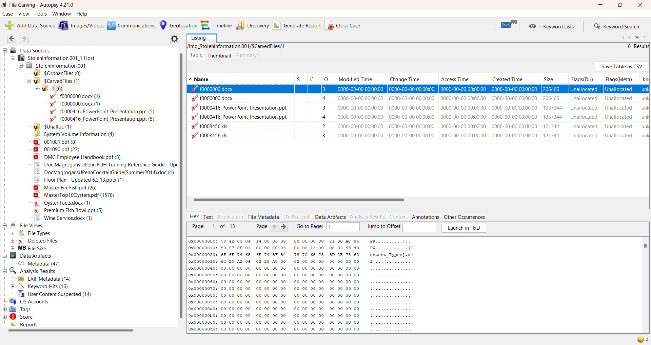
To locate the “magic numbers,” I clicked on each file and clicked on the “Hex” tab. The f0000000.docx file contained a document, but also had a .png file.
“Magic Number” for f0000000.docx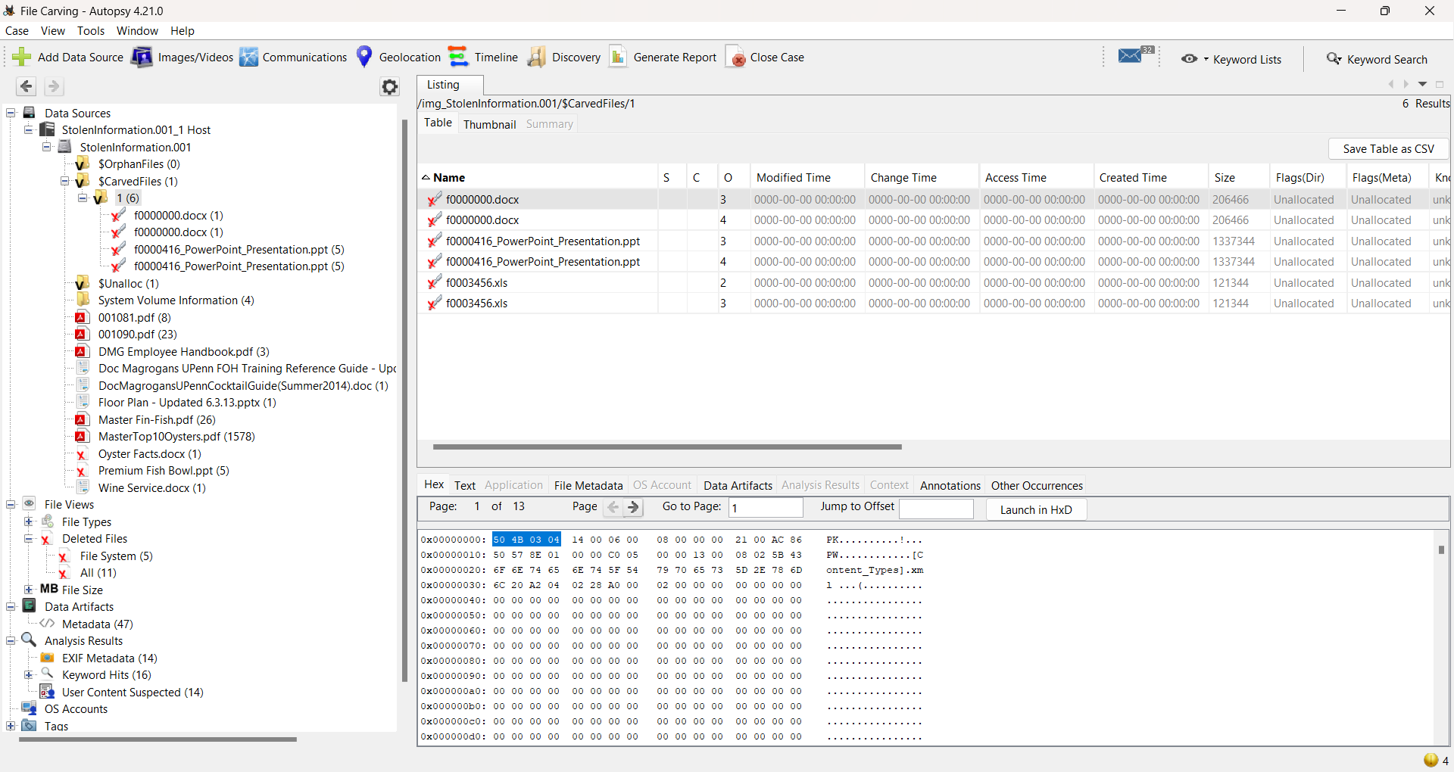
Recovered File: f0000000.docx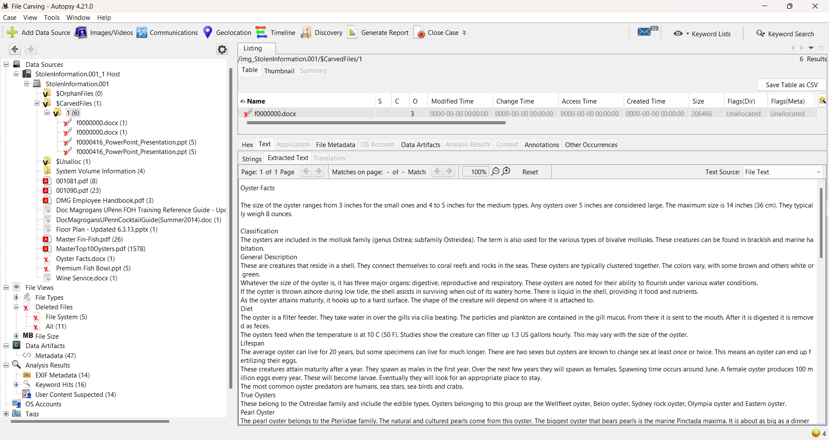
“Magic Number” for image1.png of f0000000.docx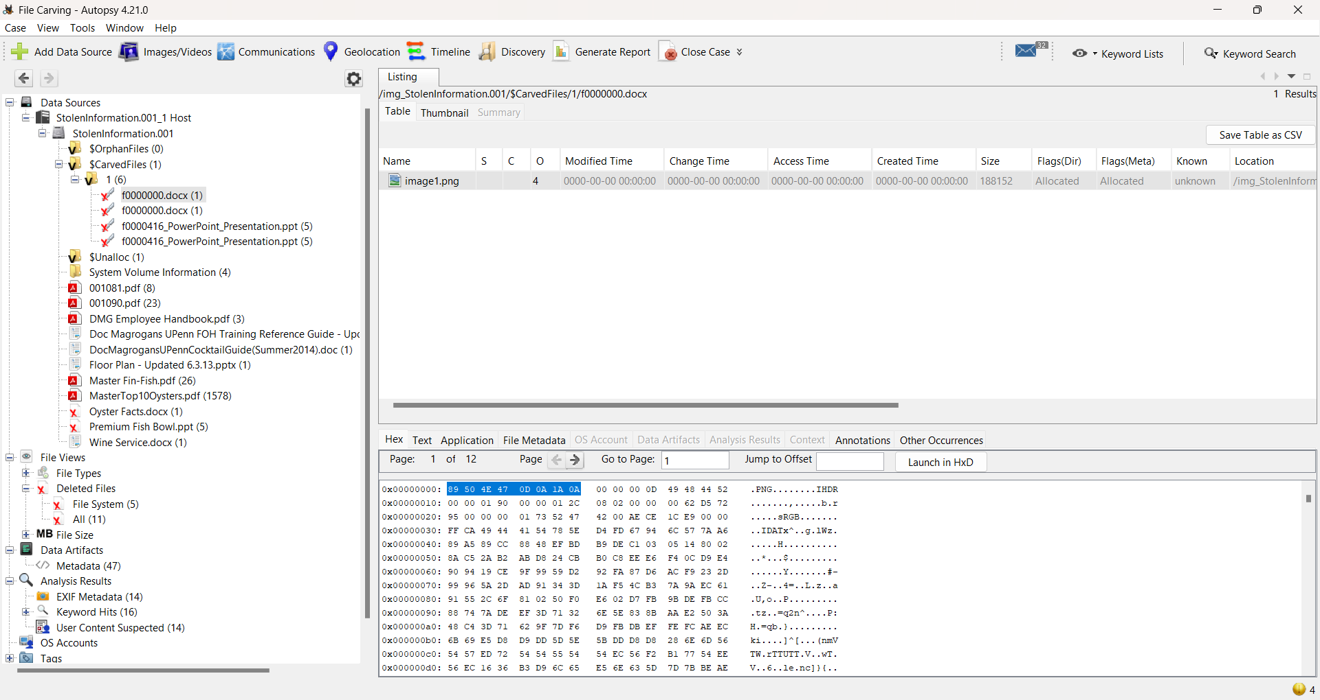
Recovered file: image1.png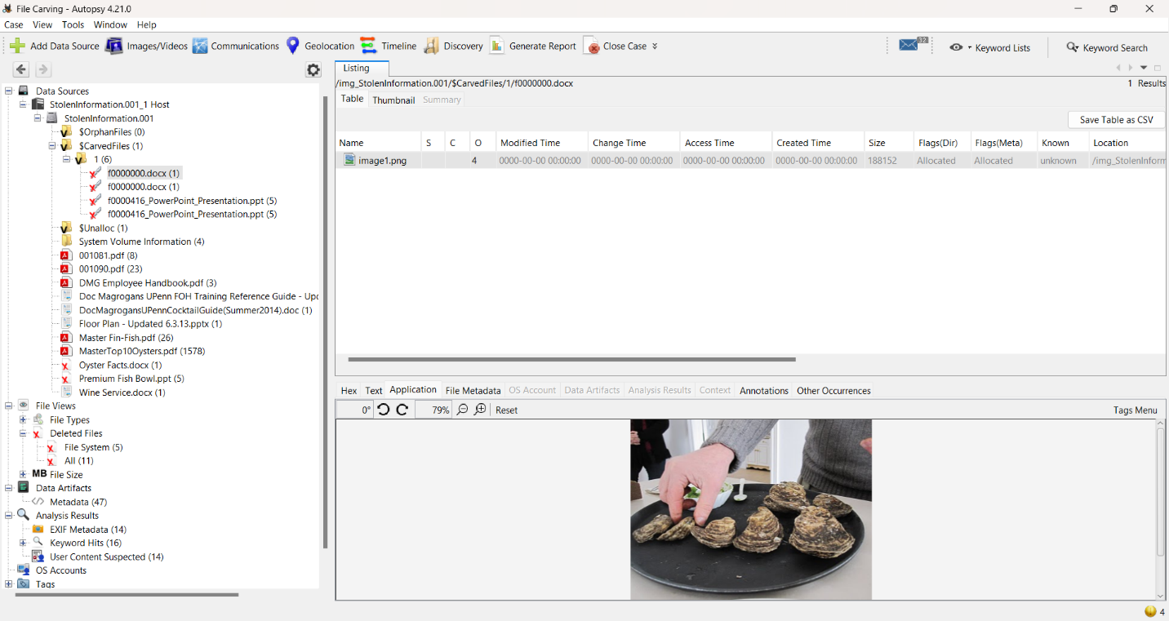
The .docx file contained information about oysters, while the image depicted oysters prepared for consumption. After that, I focused on the f0000416_PowerPoint_Presentation.ppt file. I clicked on the Hex tab and found its “magic number.”

“Magic Number” for f0000416_PowerPoint_Presentation.ppt
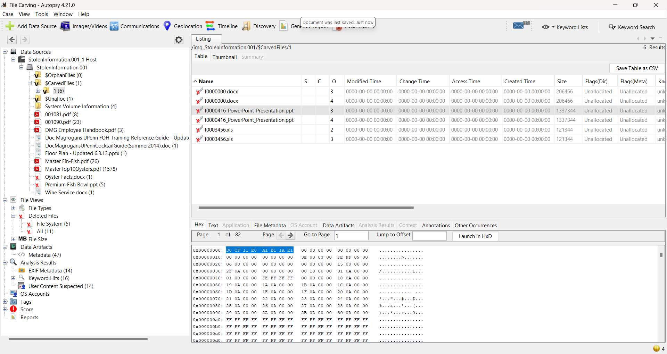
Recovered file: f0000416_PowerPoint_Presentation.ppt
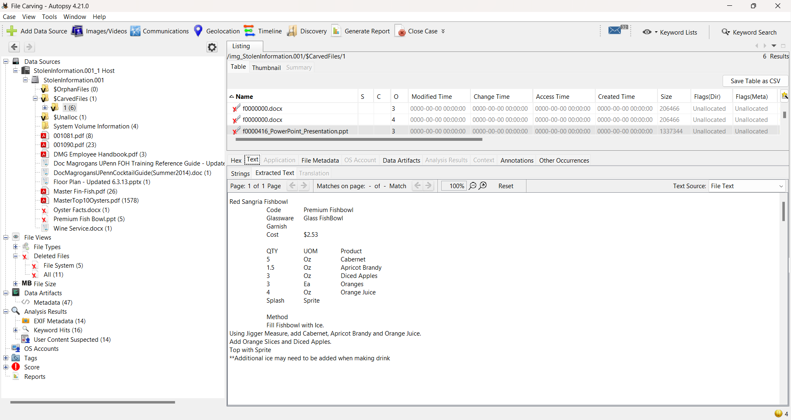
The .ppt file contained information regarding an alcoholic beverage, in PowerPoint format. After clicking on the f0000416_PowerPoint_Presentation.ppt file, there were six .jpg images present. They all had the same “magic numbers,” since they were all .jpg images.
“Magic Number” for image_0.jpg:
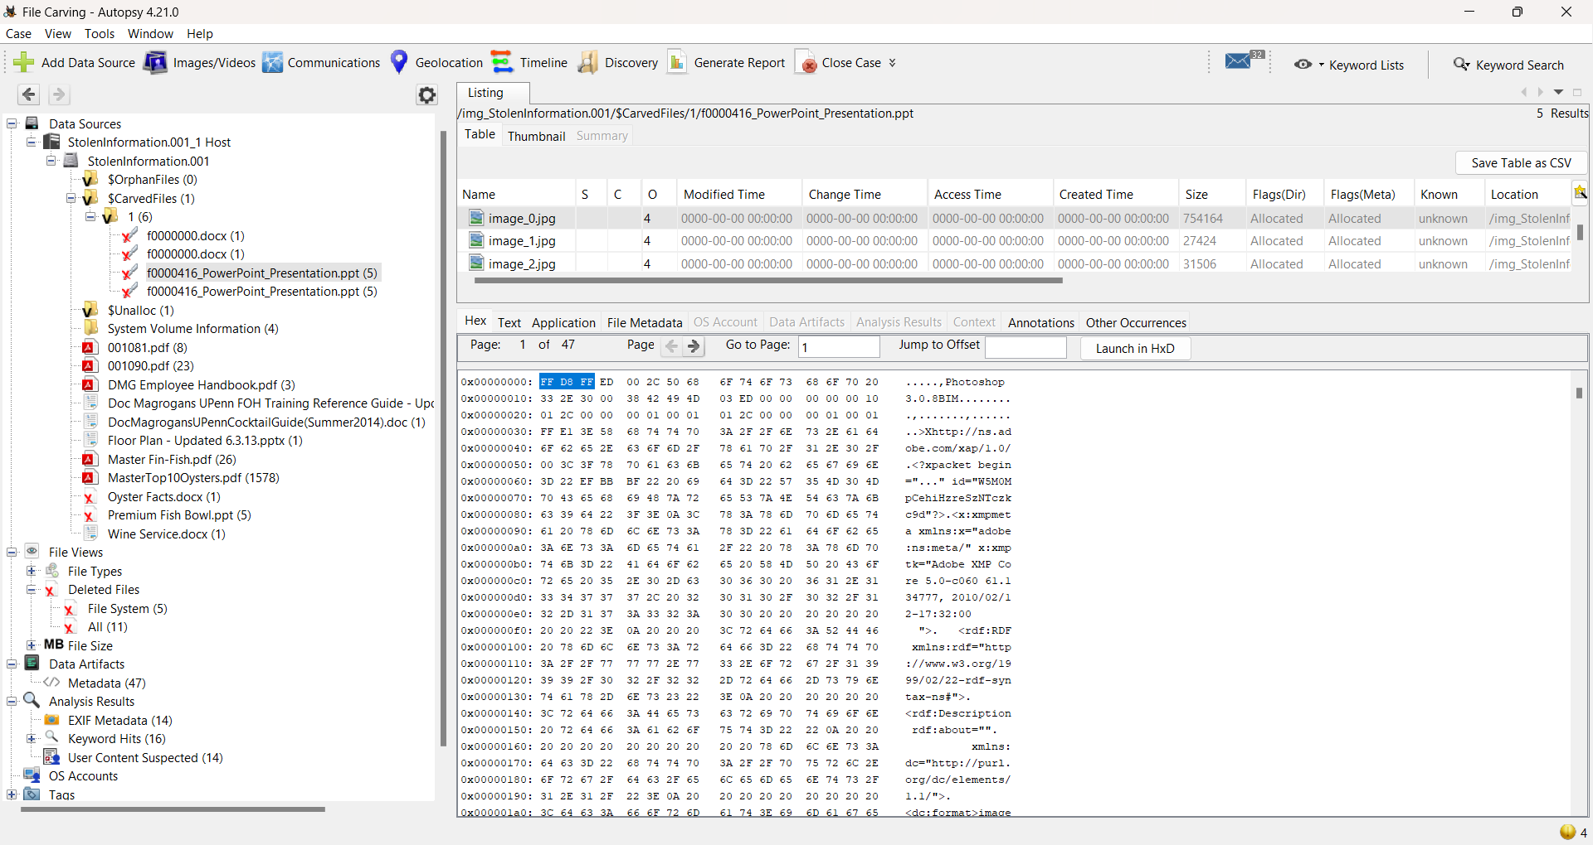
Recovered file: image_0.jpg
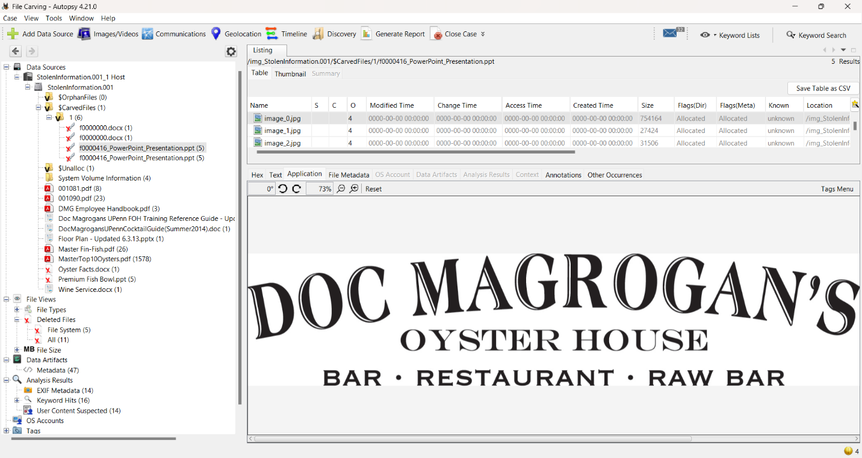
The image_0.jpg depicted a restaurant’s name, while the other images contained the alcoholic beverage that was described in the PowerPoint file. After that, I looked at the last carved file, f0003456.xls. This file did not have any images associated with it, and was just an .xls file. I clicked on the Hex tab and located its “magic number.”
“Magic Number” for f0003456.xls
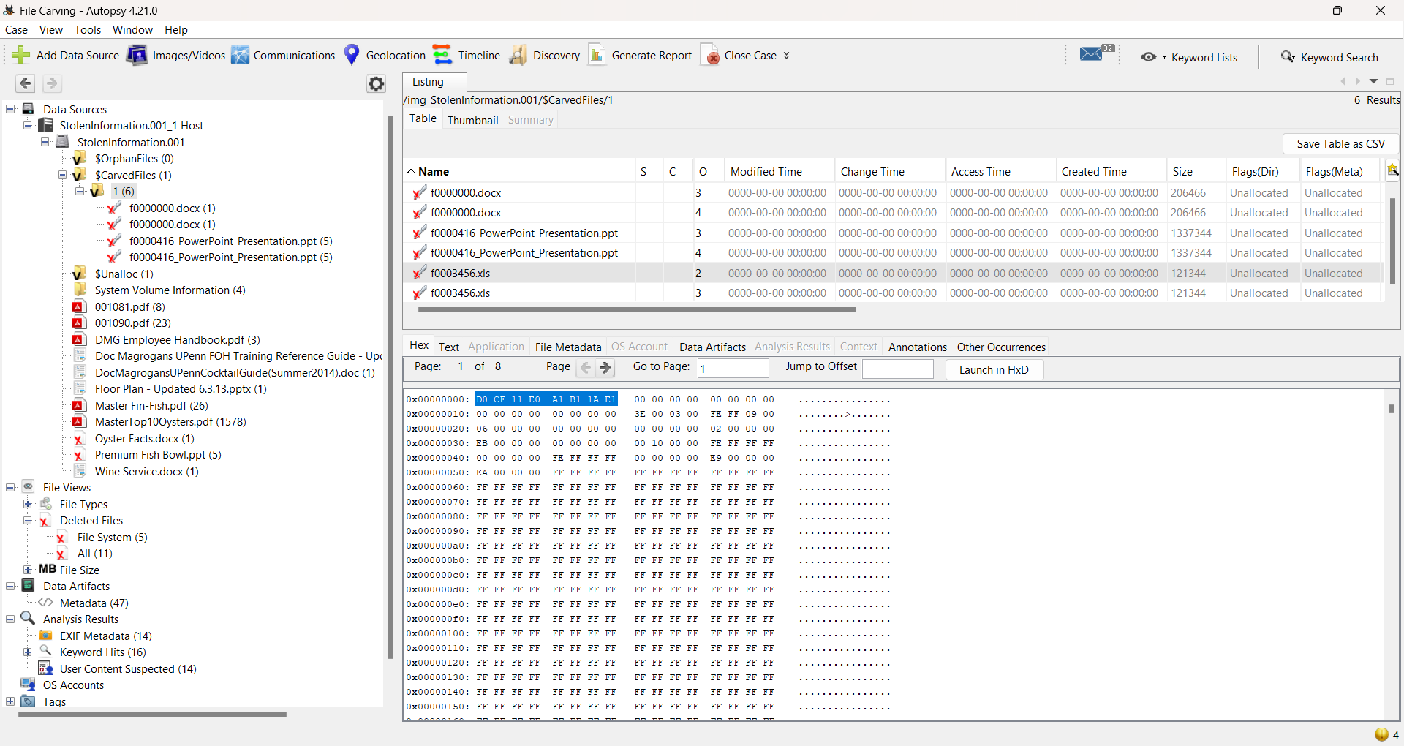
Recovered file: f0003456.xls
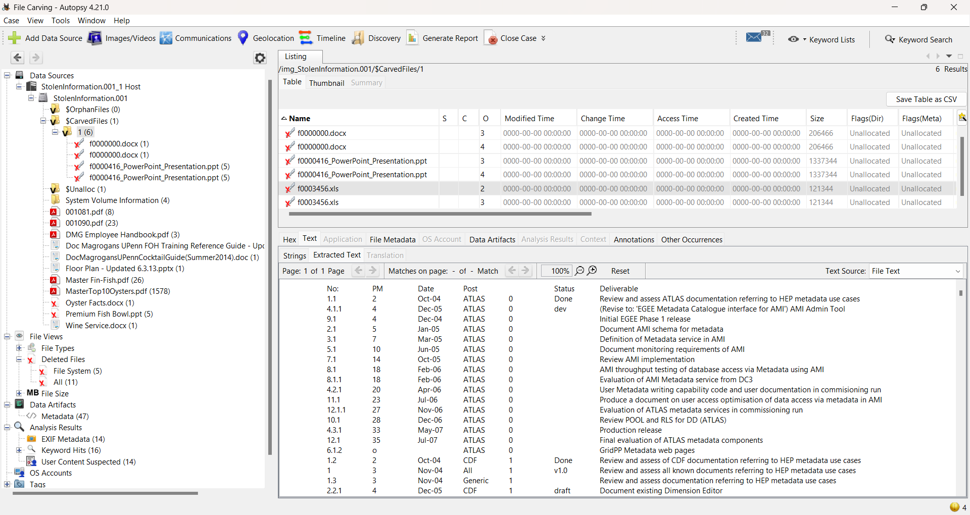
The .xls file contained metadata of the rest of the files, including when they were last edited and by whom.

