For this assignment, I ran the commands on Kali Linux. I was initially having connection errors, so before running the assigned commands, I had to ensure that my Ethernet interface was up and running. I did this by running the following command: sudo ip link set eth0 up. I verified that it was running by running the ip addr and ifconfig commands. To make sure my IPv4 address was set up, I ran the following command: sudo dhclient eth0. To verify that it was working, I ran the following command: ip addr show eth0. After running these commands, everything was working the way it should, and I was able to start running the assigned commands. I also had to double-check and ensure that I had Telnet installed. For some commands, I had to disable firewalls for them to work better. I re-enabled them after testing.

Grep: grep (info) [file] = single file; grep (info) * = all files
The grep command allows the user to search for information in files. The user can search for a string of characters in a single file, or multiple files. The user can use this to find information in a file without having to manually check the file.
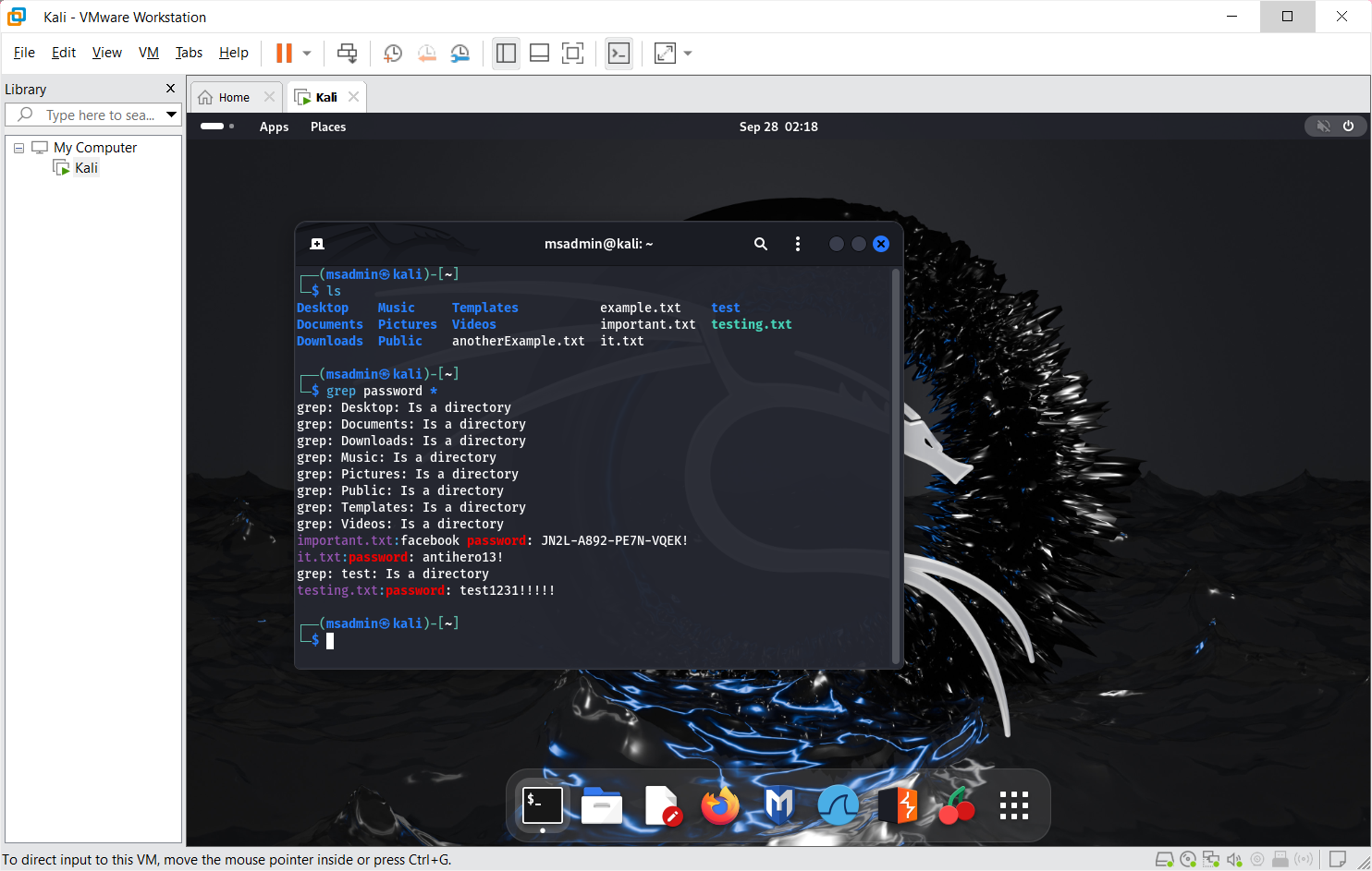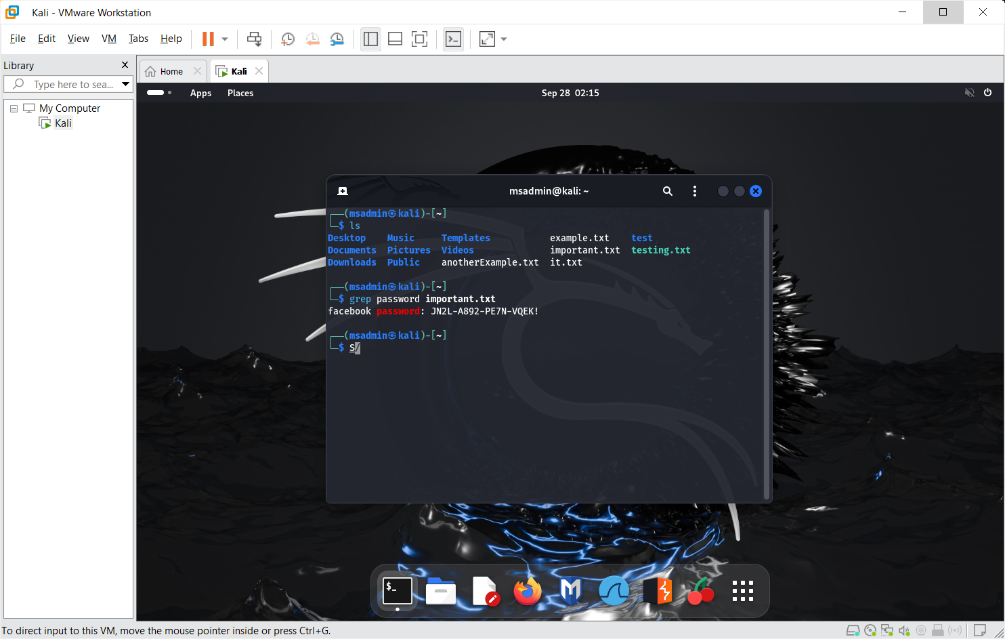
PING: ping (website OR IP address)
The ping command tests if a network’s host is able to be reached, along with the time it takes to send a message to and from the host. This is useful for checking to see if the desired host is online and able to send or receive messages, and can also detect network issues.
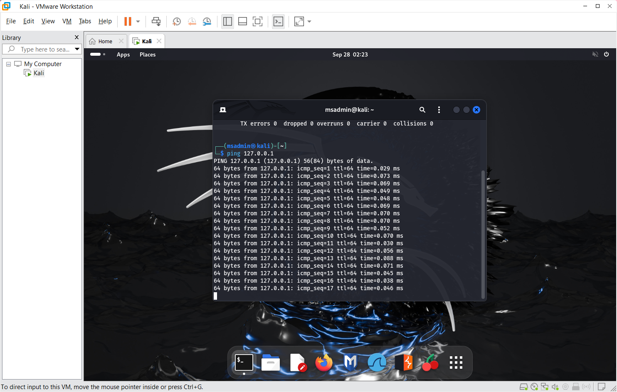
NSLOOKUP: nslookup (domain name)
The nslookup command is used to get the domain name or IP address mapping information. This can be used to find issues with the domain name system, along with finding out which IP addresses are associated with which domains.
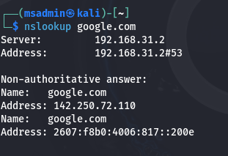

WhoIs: whois (domain)
The whois command grabs information about the desired domain. This can be used to gain information about a domain such as when it expires, who owns it, and other relevant information.
\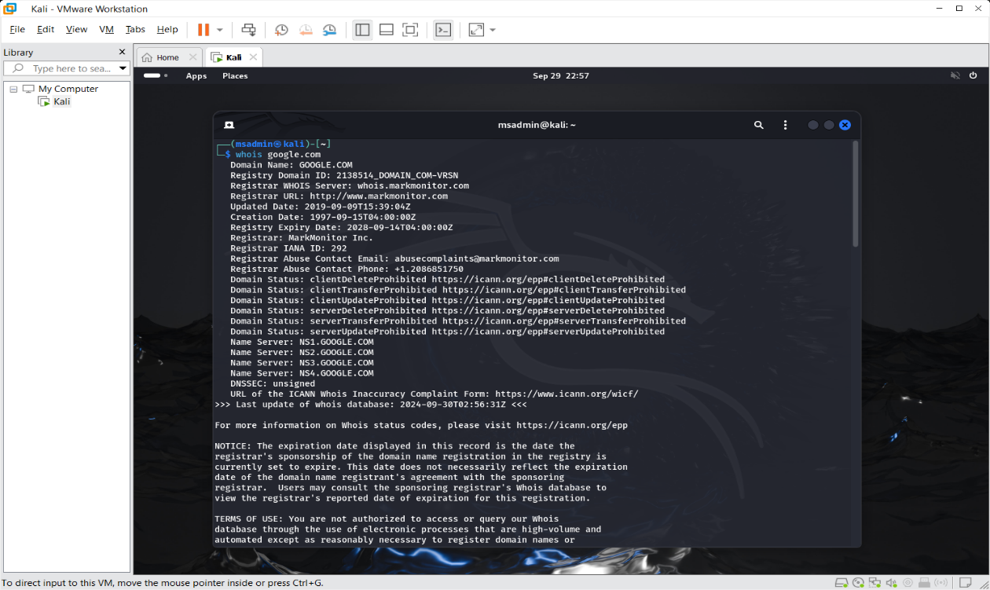
NMAP: nmap (IP address)
The nmap command is used to scan hosts and services in order to check for open ports, running services, and any vulnerabilities. This command would be useful for performing security audits and checking to see if there are any viable ports.
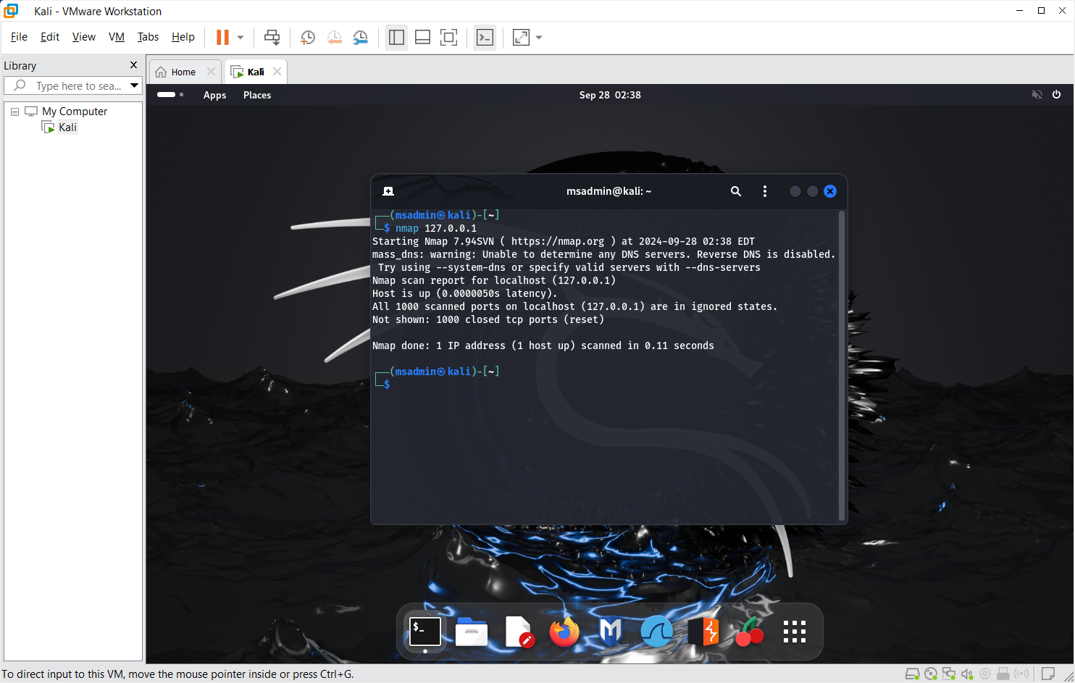
Telnet: telnet (domain) [port number]
The telnet command is used to establish a connection to a remote machine on the desired port. This would be useful for testing connectivity to a specific port, and is also useful for accessing systems remotely.
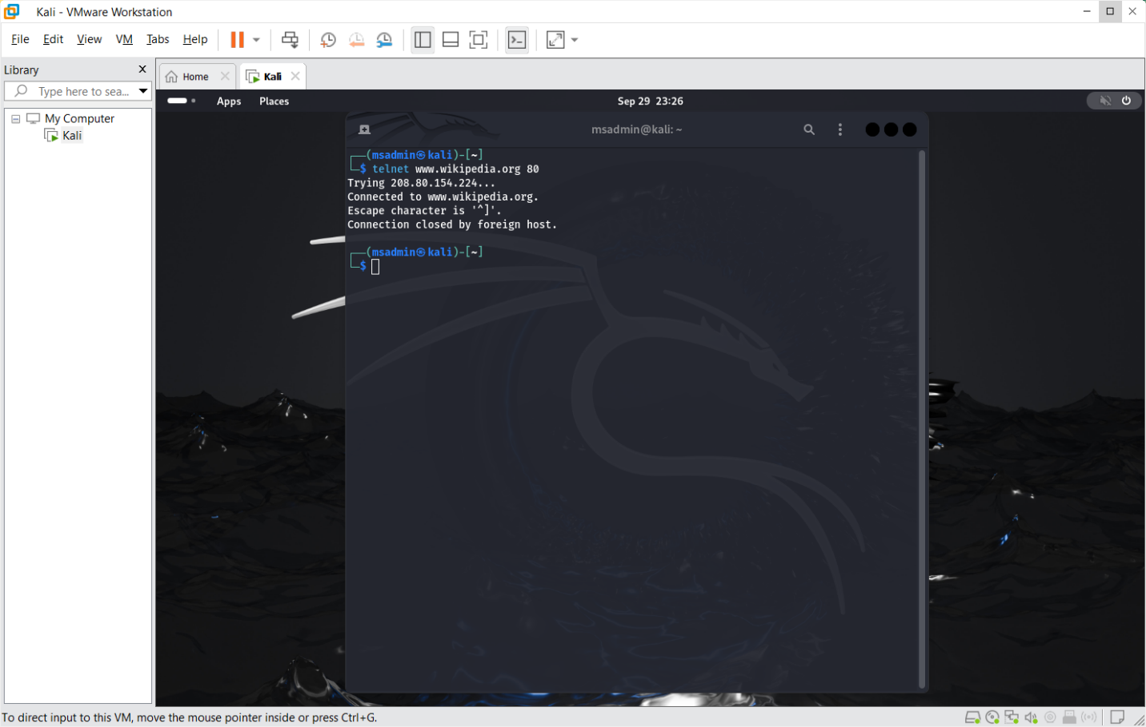
CURL: curl (domain)
The curl command is used for transferring data to or from a server. This command is useful for downloading files, as well as sending or receiving data over different protocols. 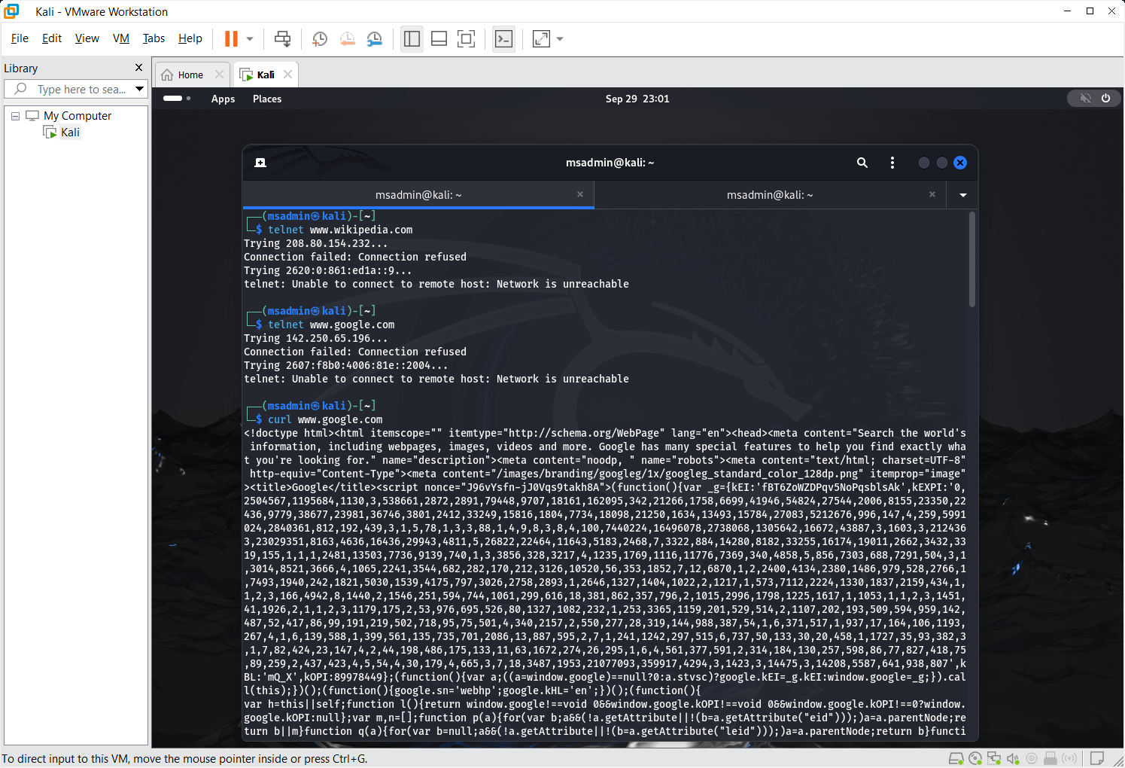
WGET: wget (domain) [file type - optional]
The wget command is used for downloading files. This command also mirrors websites. The wget command is useful for downloading files online, mirroring websites, and can retrieve the desired files in script.
