I decided to use the Windows PowerShell terminal for the system profile assignment. To get basic information about my computer, I started with the following command: Get-ComputerInfo. This command showed a variety of information about my computer, and all kinds of metadata.
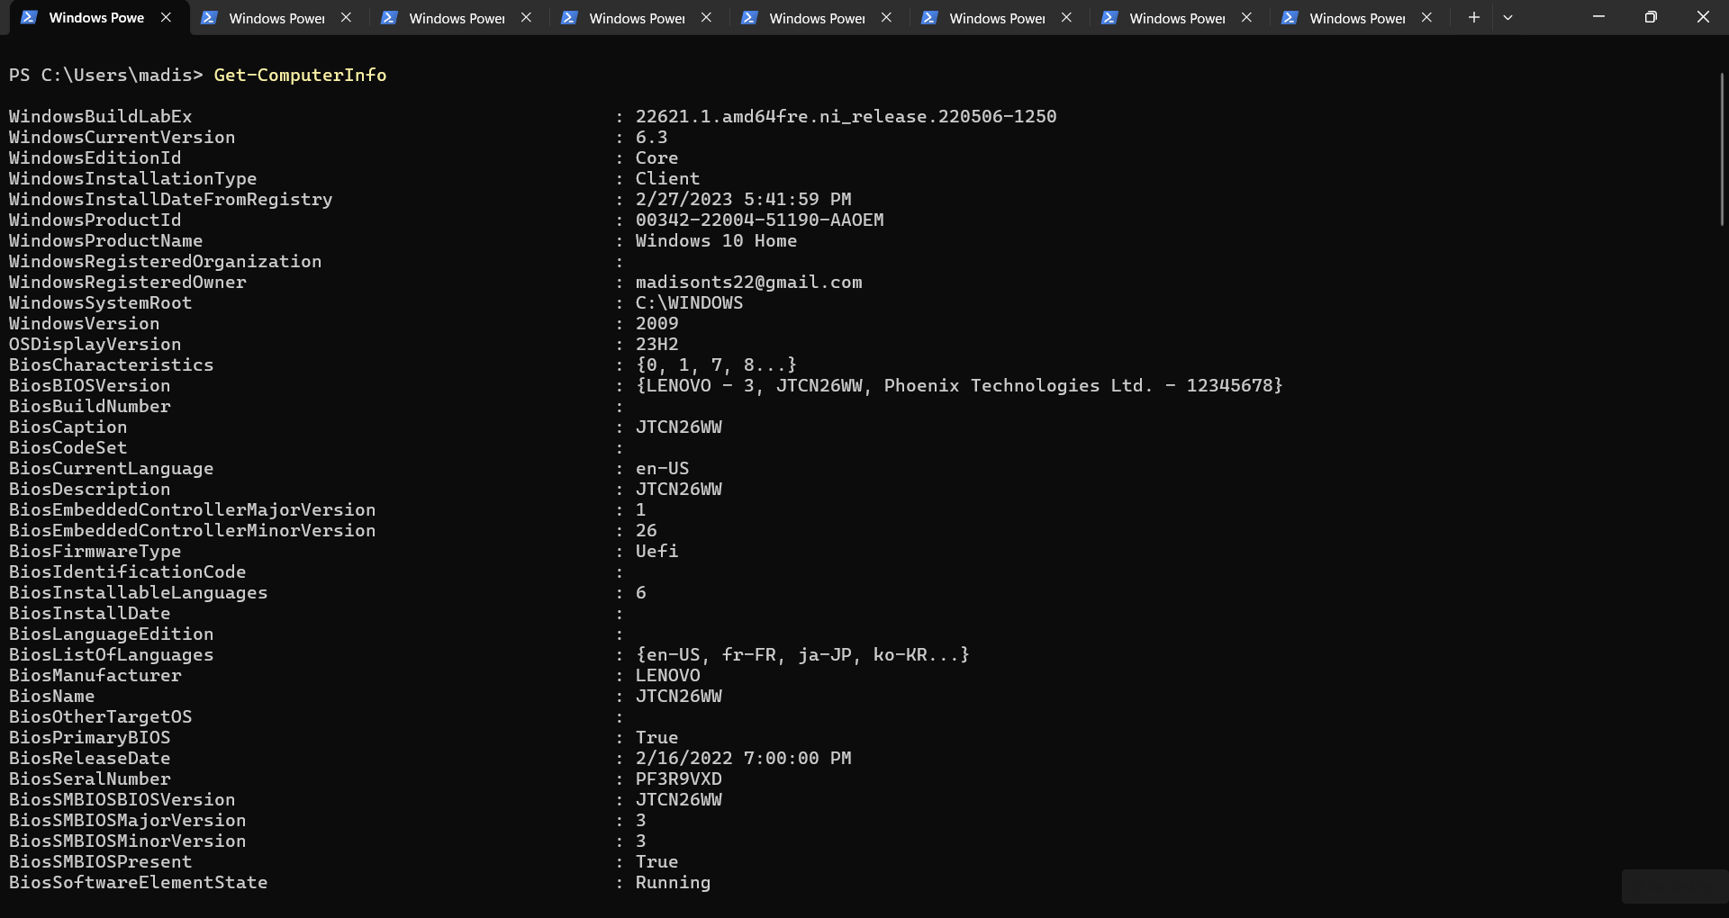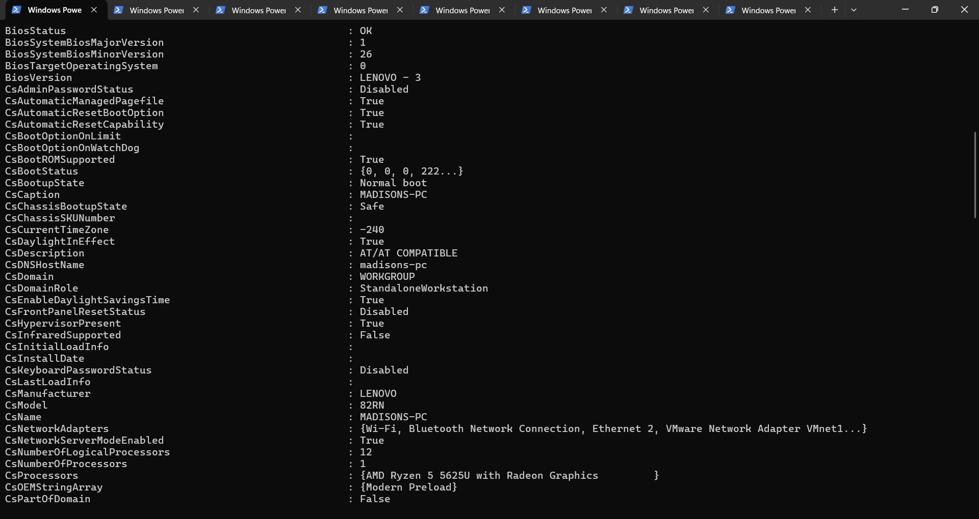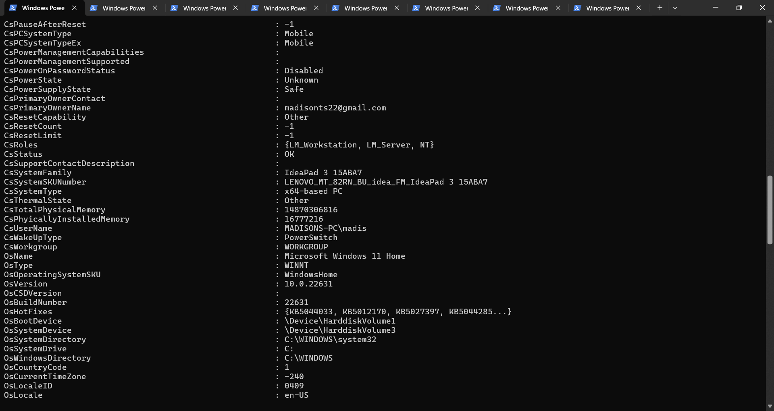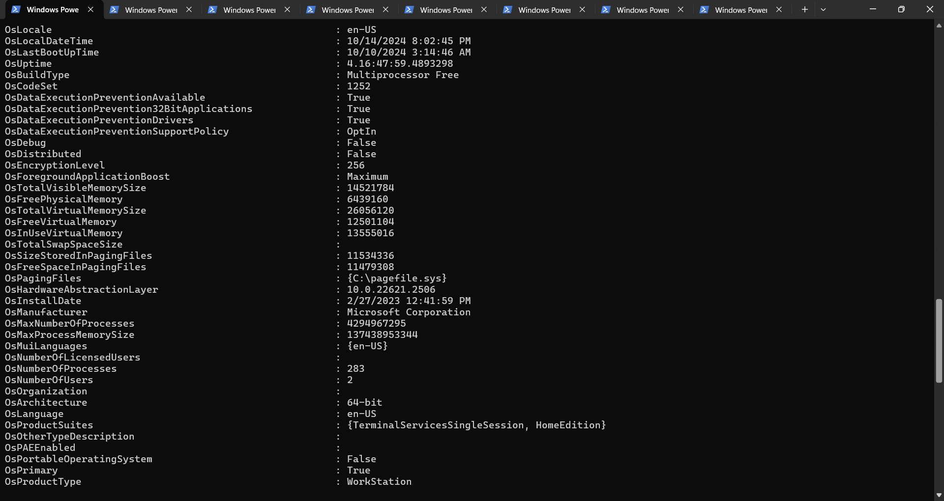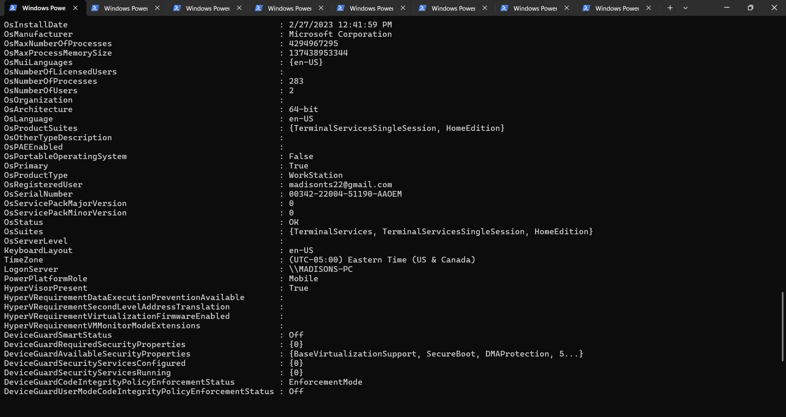
Then, I entered the Get-WmiObject -Class Win32_ComputerSystem command. This command obtains hardware information about the computer. This command shows information about the computer, such as the domain, model, name, manufacturer, owner name, and the computer’s total physical memory.
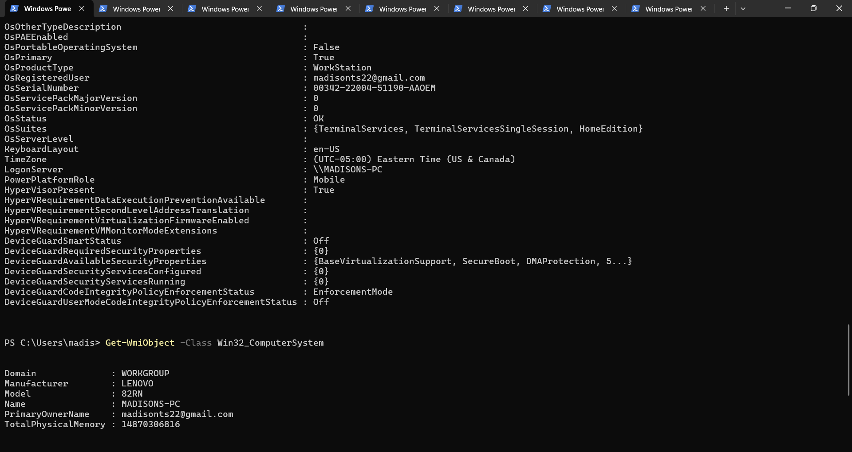
After that, I began looking for specific information. To do this, I typed in appropriate commands for each piece of metadata that would be relevant. To get the information for each piece of metadata, I entered a similar command. Each command started with a similar term: $(metadataType). For example, if I was looking for the serial number, I would start the command with $serialNumber. The last command I used for each piece of data involved obtaining the output of the earlier commands: Write-Output “(Metadata): $(metadataType)”. For example, if I was obtaining information about the serial number, the final command would be Write-Output "Serial Number: $serialNumber". Most of the commands involved the using Get-WmiObject, with the exception of the command for the computer’s name.
For the computer’s name, I entered the following command: $computerName = $env:COMPUTERNAME. This command obtained the name of the computer that was set by the user. To receive this information, I ran the following command: Write-Output "Computer Name: $computerName".
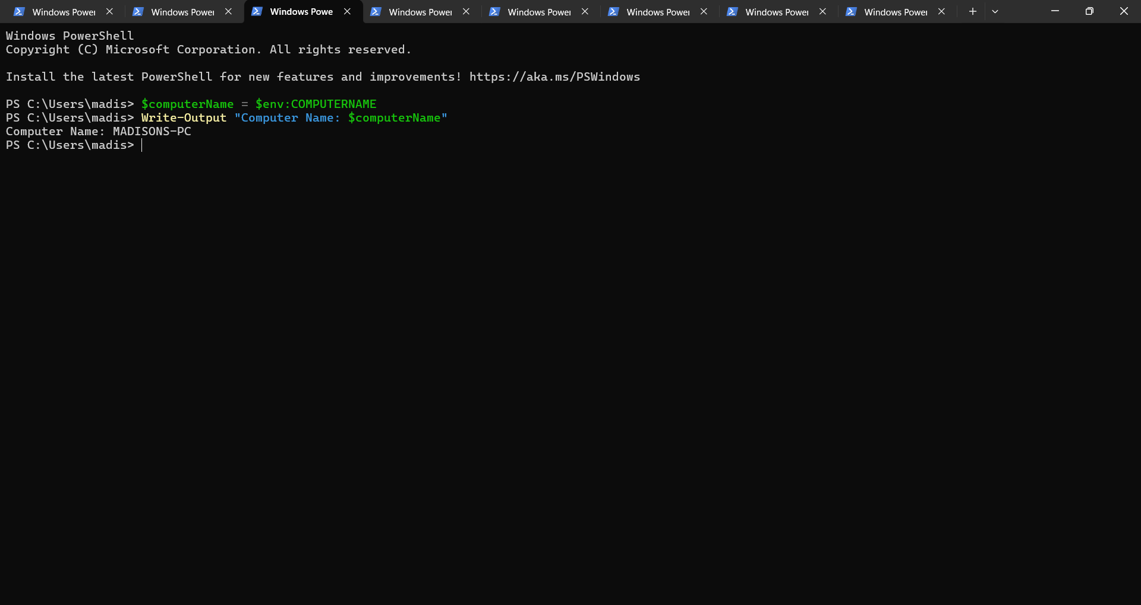
Then, to obtain the serial number, I ran the following command: $serialNumber = (Get-WmiObject -Class Win32_BIOS).SerialNumber. I used the Write-Output "Serial Number: $serialNumber" command to display the device’s serial number.
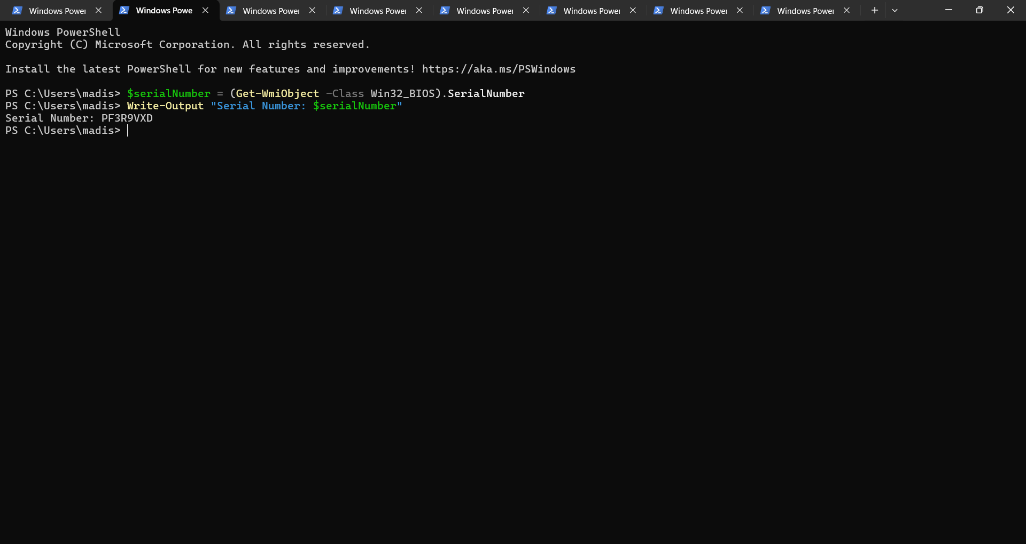
To find the drive information, I sent the following command: $drives = Get-WmiObject -Class Win32_LogicalDisk -Filter "DriveType=3" | Select-Object DeviceID, FileSystem, Size, FreeSpace. This would show all of the important information regarding the computer’s drive. That was followed by Write-Output "File Systems Information:", and $drives | Format-Table -AutoSize to show the drive data in a table.
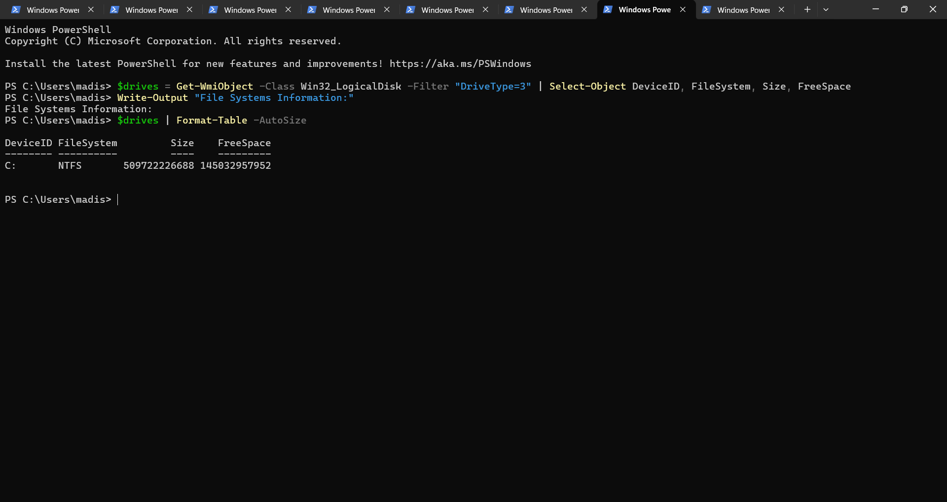
To find out more about the operating system and its specific information, I ran the following command: $os = Get-WmiObject -Class Win32_OperatingSystem. Then, I ran three different Write-Output commands: one for the operating system, one for the version of the operating system, and one for its architecture.
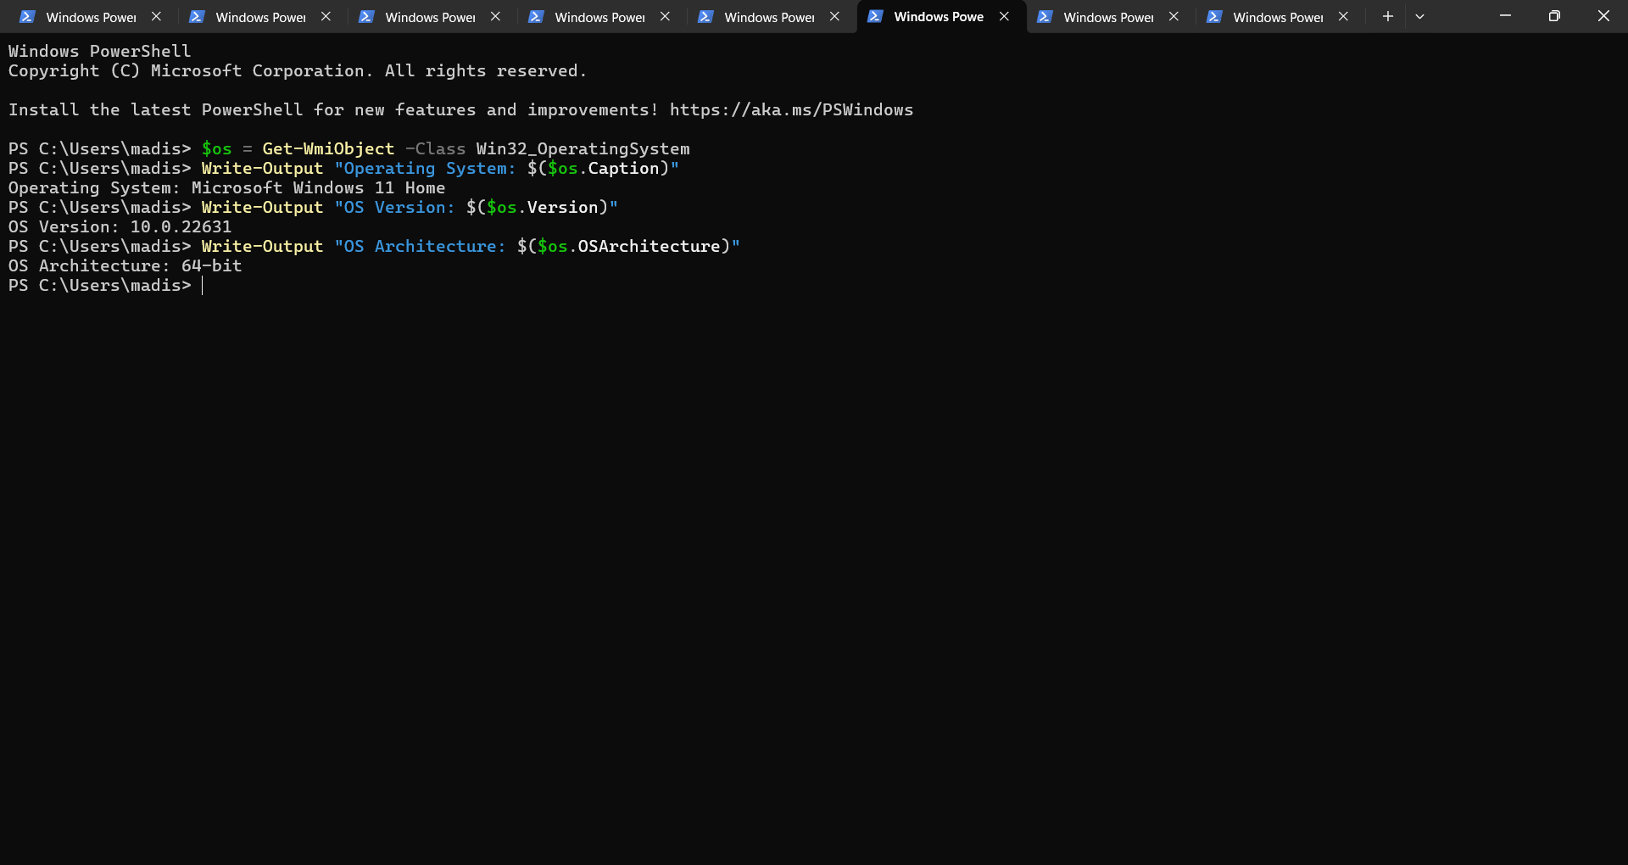
To find out about the memory capacity about my computer, I ran the following command: $memory = (Get-WmiObject -Class Win32_PhysicalMemory | Measure-Object -Property Capacity -Sum).Sum. Then, I ran a math command: $memoryGB = [math]::round($memory / 1GB, 2). These commands obtain the maximum capacity of the device, and round it to a full number. Then, I ran the write-output command to show the total physical memory in gigabytes: Write-Output "Total Physical Memory: $memoryGB GB".
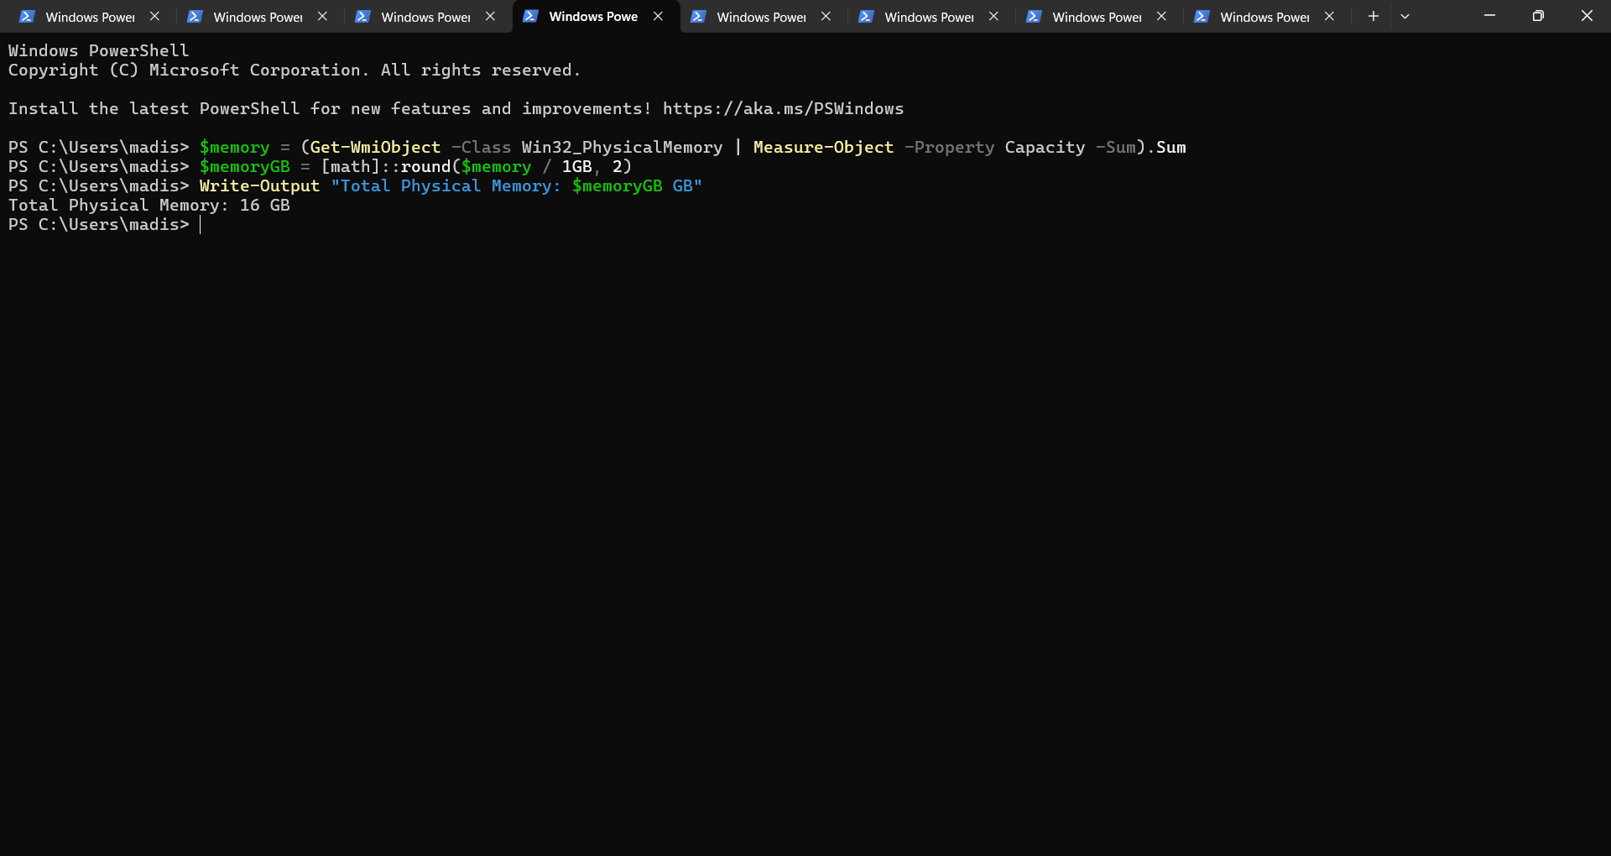
To learn about my device’s processors, I ran the following command: $processors = Get-WmiObject -Class Win32_Processor | Select-Object -Property Name, NumberOfCores, NumberOfLogicalProcessors. This obtained the information about my device’s cores and logical processors. To obtain this information, I ran the Write-Output command: Write-Output "Processors:" Processors:, followed by $processors | Format-Table -AutoSize. This showed the processor data in a table format.
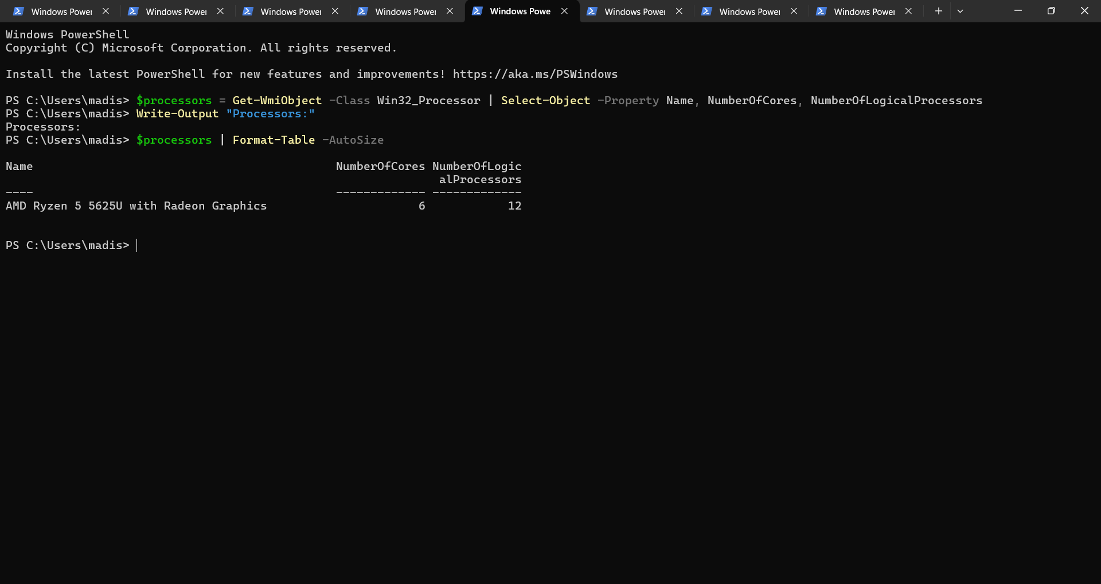
The last piece of data I needed to obtain was my device’s disk information. First, I focused on the physical disk data. I ran the following command: $physicalDisks = Get-WmiOnbject -Class Win32_DiskDrive | Select-Object Model, Size, SerialNumber. Then, I ran the following commands to display the information in a table format: Write-Output “Physical Storage:” , followed by $physicalDisks | Format-Table -AutoSize. For the logical storage, I ran the following command: $logicalDisks = Get-WmiOnbject -Class Win32_LogicalDisk | Select-DeviceID, VolumeName, FileSystem, Size, FreeSpace. Then, to display the information in a table format, I ran the following commands: Write-Output “Logical Storage:”, followed by $logicallDisks | Format-Table -AutoSize.
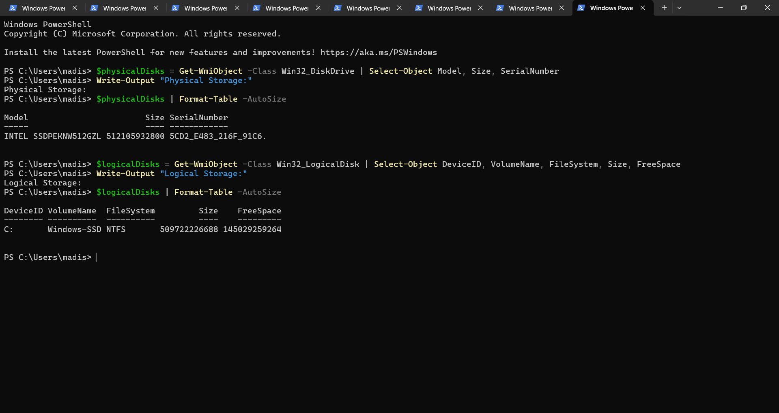
When filling out the chain of custody, metadata should be included. There are many important types of metadata that should be included in reports. This includes the device’s name, serial number, RAM specifications, processors, operating system information, file system information, physical storage specifications, and logical storage specifications. The device’s name and serial number are unique identifiers, and including these can ensure that the information came from the specific device. The other information can give insight on how actions were completed on the device in question, along with what type of data and how much data can possibly be stored on the computer.

