Tracking USB Activity on a Windows Device using Event Viewer
Source: How to track down USB flash drive usage with Windows 10's Event Viewer | TechRepublic
- First, open Event Viewer. This can be done by clicking on the Start button and typing “Event Viewer” into the search bar.

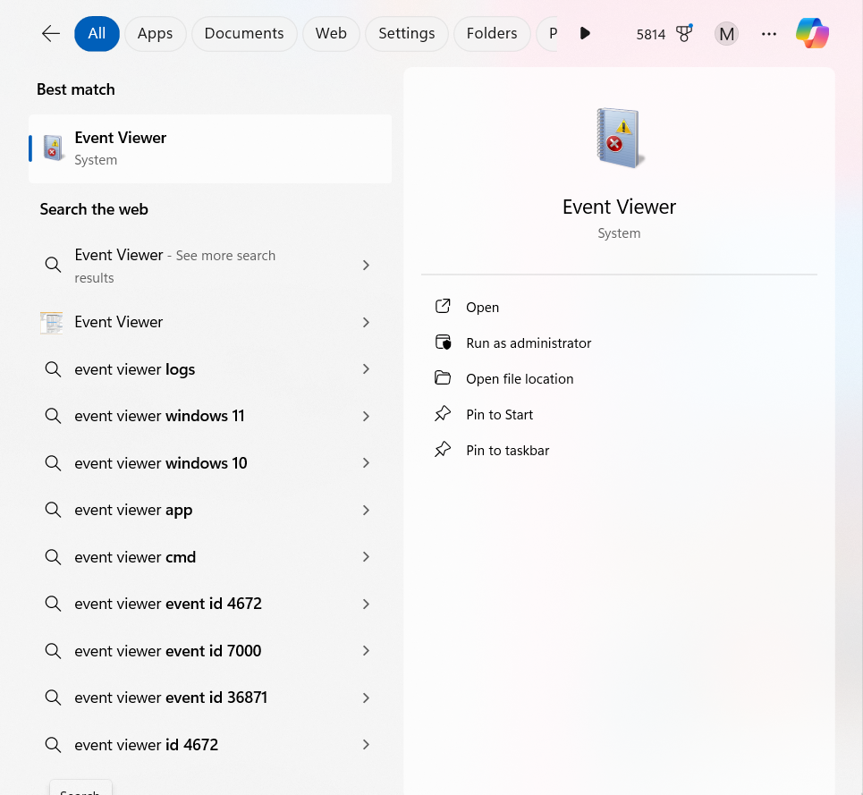
- After opening Event Viewer, navigate to the Operational event by following this path: Application and Services Logs > Microsoft > Windows > DriverFrameworks-UserMode > Operational.
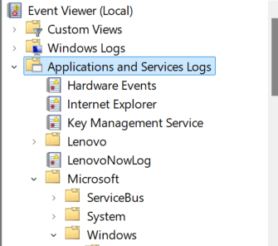

- This log needs to be enabled in order to view USB flash drive activities, which can be done by right-clicking Operational and clicking the “Enable” option.
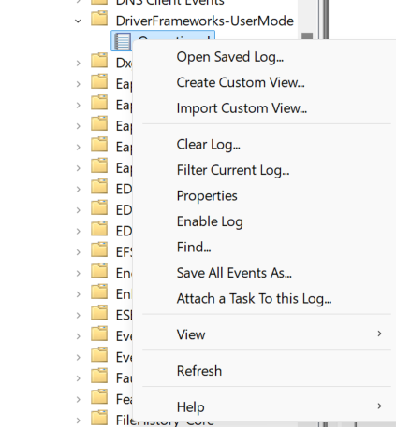
- After that, click on “Properties” from the context menu.
- Click the “Enable Logging” checkbox on that form to ensure that logging is properly enabled.
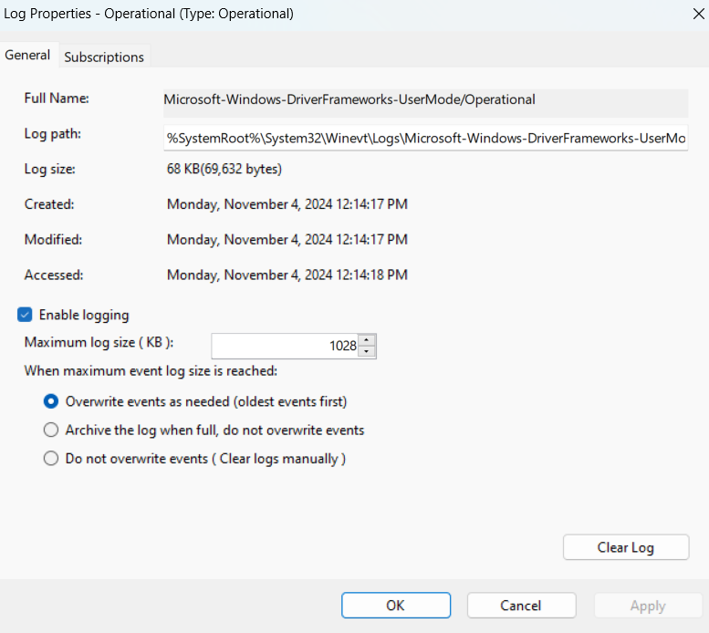
- Now that these events are properly enabled, the USB flash drive’s activities can be tracked.
- To make sure the changes are saved, close out Event Viewer and re-open it.
- Insert the USB flash drive.
- Navigate to Operational by following the same path as before. There should now be several events for the USB flash drive that was inserted.
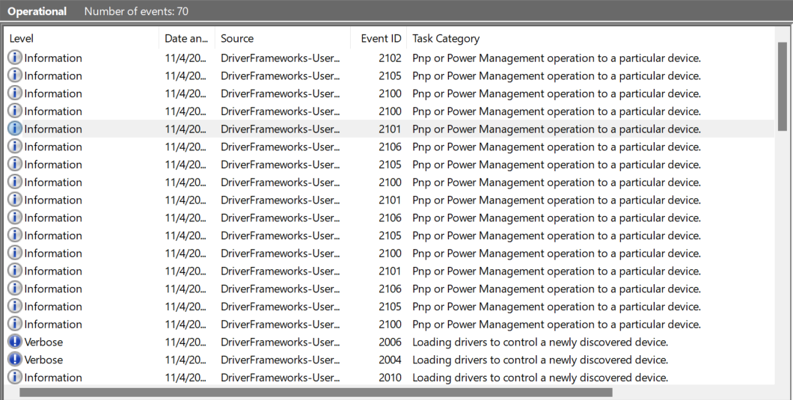
- The following Event IDs indicate that a USB flash drive was connected to the device:
  - 2003
  - 2004
  - 2006
  - 2010
  - 2100
  - 2101
  - 2105
  - 2106
- An event with an Event ID of 2003 represents when the flash drive was connected.
  - Double-clicking on this event will bring up more information.
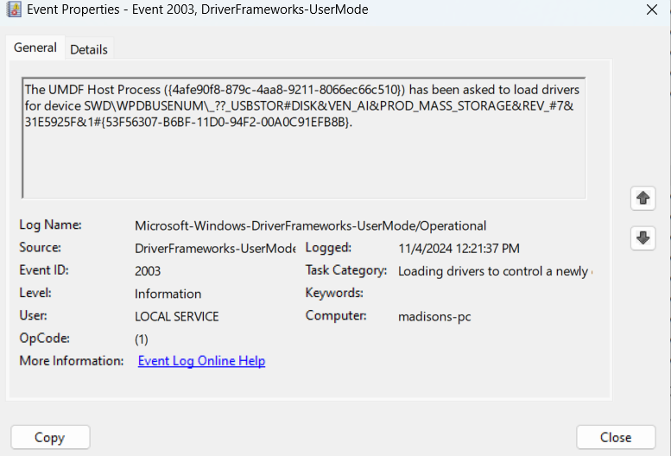
  - Based on the example:
    - The device’s coded name is USBSTOR#DISK&VEN_AI&PROD_MASS_STORAGE.
    - The device’s serial number is 53F56307-B6BF-11D0-94F2-00A0C91EFB8B.
    - The USB flash drive was connected to the device on November 4, 2024 at 12:21:37 PM.
- The following Event IDs are generated when the USB flash drive is disconnected from the device:
  - 2100
  - 2102
- An event with an Event ID of 2102 indicates that the USB flash drive was disconnected from the device.
  - Double-click the event to bring up more information.
    - This will display metadata such as the exact time of ejection, along with the USB flash drive’s product and vendor IDs.
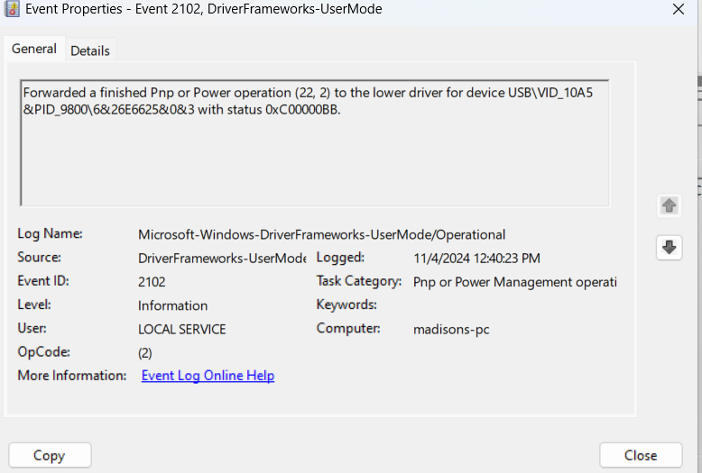
  - Based on the example:
    - The USB flash drive was ejected on November 4, 2024 at 12:40:23 PM.
- Here is a summary of the information that was gathered from this exercise:
  - Connection timestamp: November 4, 2024; 12:21:37 PM
  - Disconnection timestamp: November 4, 2024; 12:40:23 PM
  - Based on the timestamps, the USB flash drive was connected for eighteen minutes and forty-six seconds.
  - The flash drive’s Vendor ID is 10A5.
  - The USB flash drive’s Product ID is 9800.
  - The flash drive’s serial number is 53F56307-B6BF-11D0-94F2-00A0C91EFB8B.
  - The USB flash drive’s coded name is USBSTOR#DISK&VEN_AI&PROD_MASS_STORAGE.

