Madison Sleppy
Lab 3:
3.1.8: Perform Recon with NMAP
Part 1: Screenshots
Screenshots:
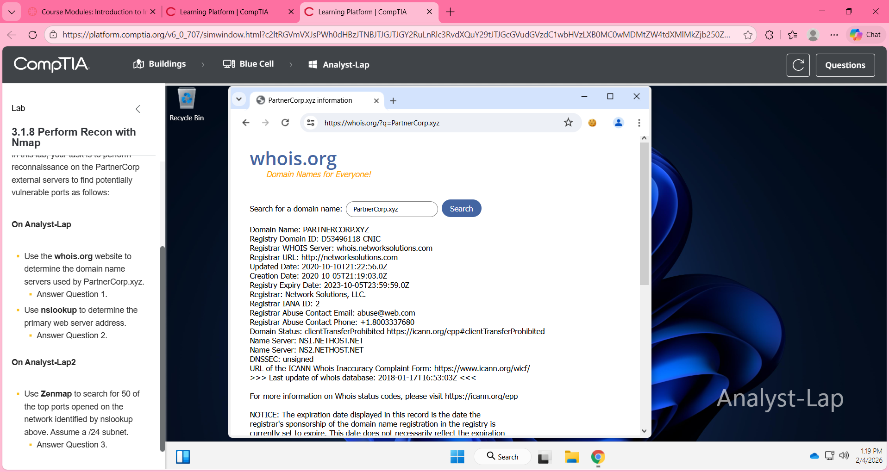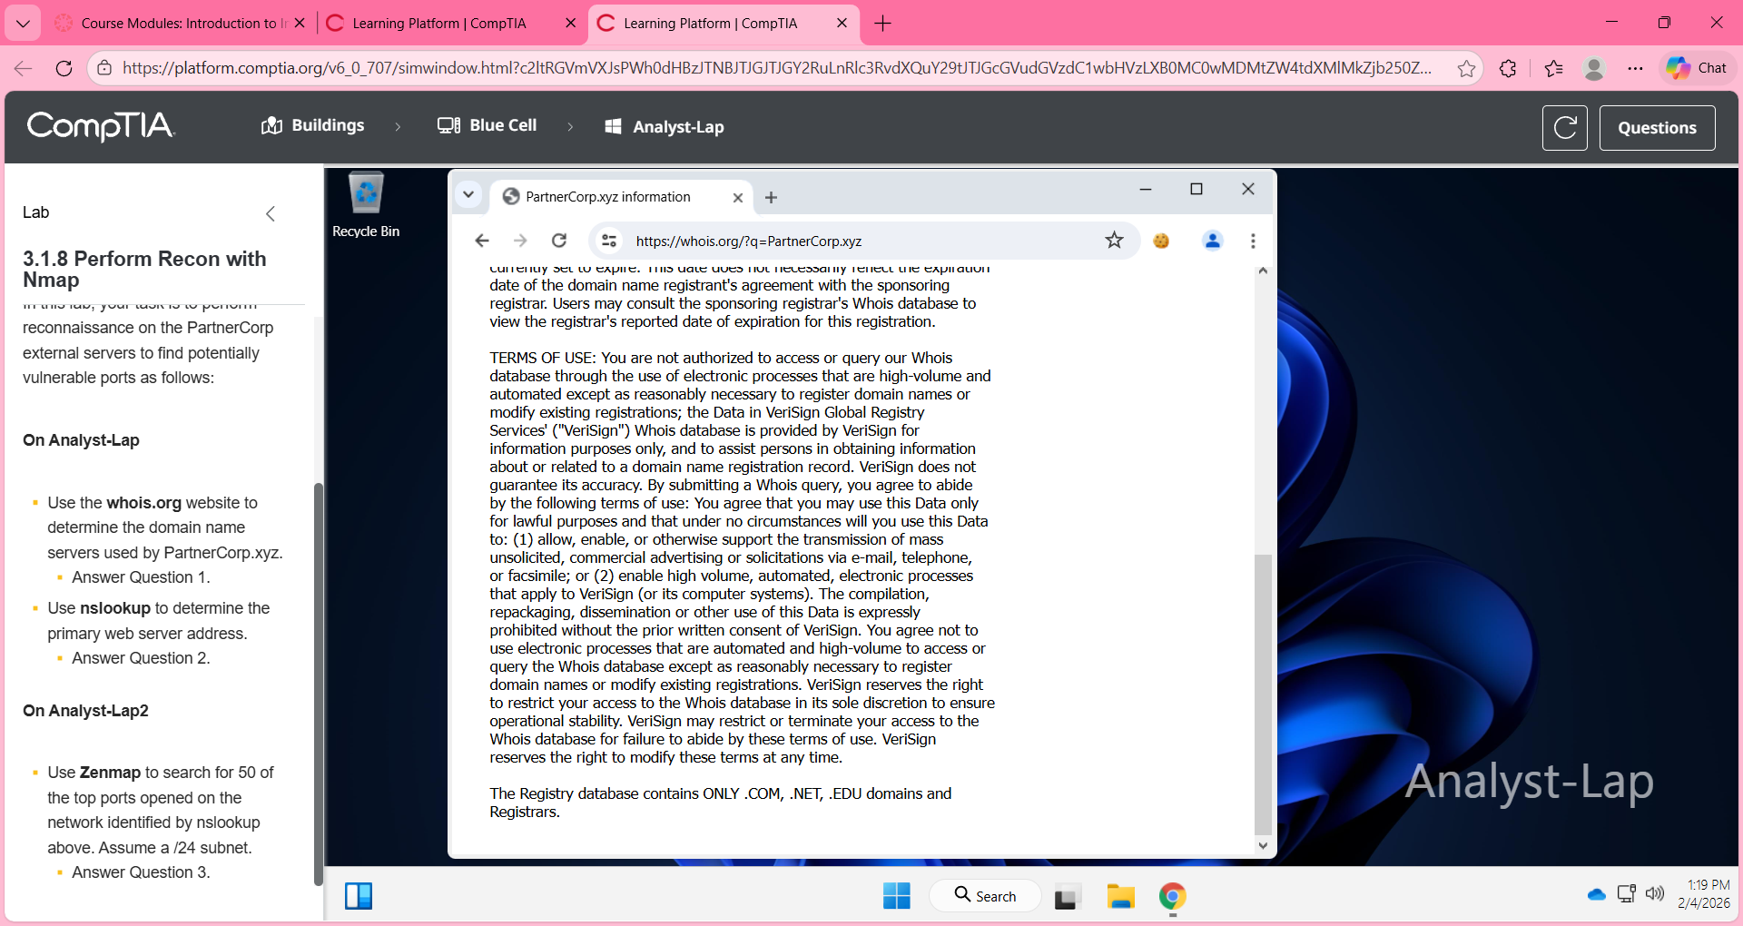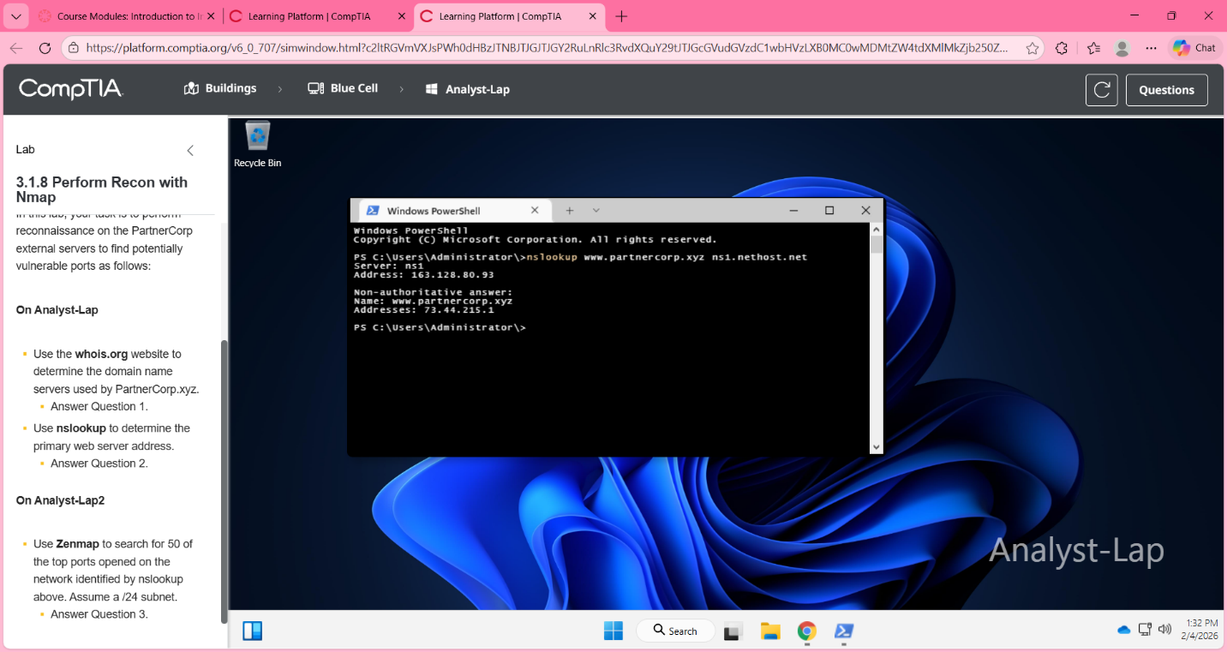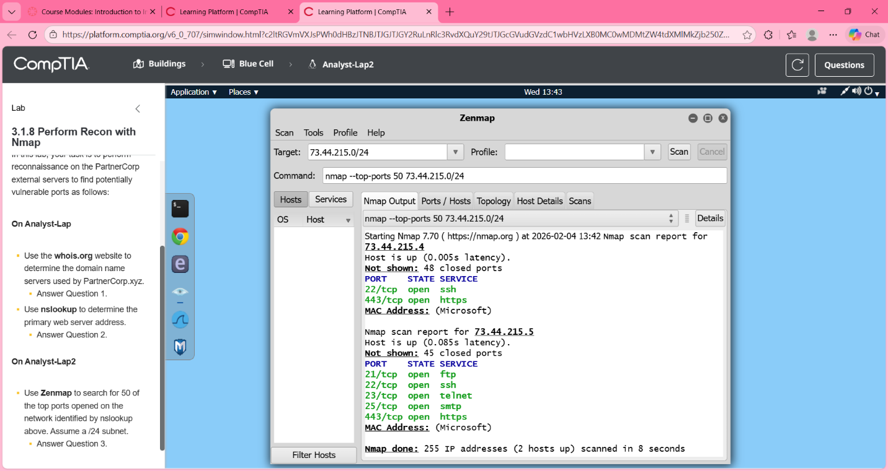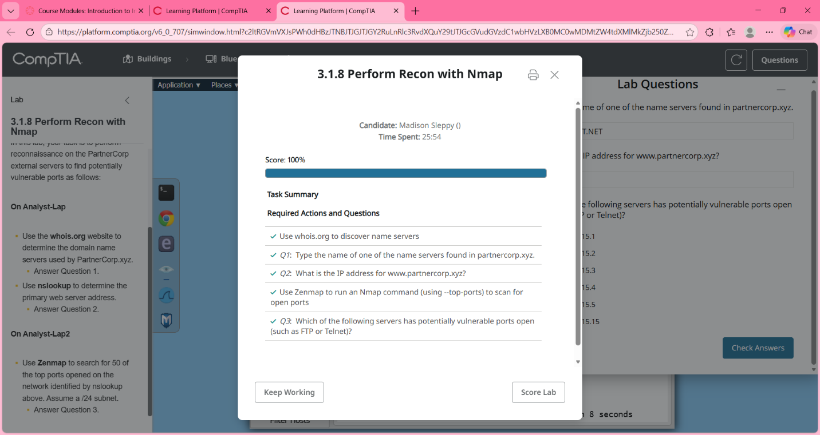

Part 2: Reflection for Lab 3
In Part 2, answer these questions based on this week’s lessons.
- What is the purpose of SET tools used in this week’s lab?
The purpose of SET tools (social engineering toolkit) is to simulate actual social engineering attacks. It allows penetration testers to understand how these attacks work so they can properly defend against them. The purpose of using these tools in the lab is to demonstrate how attackers can exploit human behavior and human errors instead of focusing on technological errors and vulnerabilities. This includes phishing emails, malicious websites, or credential harvesting (like passwords).
- What are some of the most widely used NMAP commands used? Review your list syntax for NMAP commands.
The most widely-used NMAP commands are:
- nmap <target> = Scan to identify any open ports
- nmap -sV <target> = Scan to identify service and version
- nmap -0 <target> = Scan to identify operating system
- nmap -A <target> = Aggressive scan of everything (OS, service, script, etc)
- nmap -p <ports> <target> = Scan specific port
- nmap –top-ports 50 <target> = Scan the 50 most common ports
- nmap <target>/24 = Scan the entire subnet (24)
- Review your list of social media profiles. How might the organization's social media profiles influence your further reconnaissance efforts?
The organization’s social media profiles influence future reconnaissance efforts by publicly displaying personal information, such as full employee names and roles, the technology being used or mentioned in posts or newsletters, the company’s hierarchical structure and departments, and contact information. This information is considered OSINT and can be used to facilitate social engineering or phishing attacks.
- Using https://haveibeenpwned.com, is any of your emails compromised?
No, none of my emails have been compromised. If an email appears in the database, it means the email was in a data breach. This does not always mean that the email or the associated account has been compromised, but means that the user’s credentials are vulnerable and should be changed as soon as possible.
- How might you take advantage of a contact whose email address is found in the Have I Been Pwned? database?
It is possible to take advantage of a contact whose email is found in the “Have I Been PWNed?” database by sending phishing emails that reference the data breaches. If an attacker can find an email and the websites or accounts associated with the data breach, they can reach out under the guise of an employee to get them to change their password.
- Review the Social Media Presence, Job Boards, Points of Contact/Email Addresses, and Have I Been Pwned sections. What does this information suggest?
This information suggests that the employees and company technologies are available for the public to see. Their digital footprint is visible and can be used by attackers to gather OSINT in order to perform phishing or social engineering attacks. This can also suggest that there are system vulnerabilities and lack of security awareness.
- How might knowing the IP address range used by the domain influence your further reconnaissance efforts?
Knowing the IP address range used by the domain may influence further reconnaissance efforts by allowing for network-wide scans to be performed and identify other hosts and services that are present. This data helps the penetration tester focus on specific systems that are most vulnerable, or most likely to be vulnerable at some point in time.
- What did you find when you ran the vulnerability scan?
Running a vulnerability scan can find open ports and any running services, outdated software and versions, and possible misconfigurations. These help decide what targets should be analyzed more, even if there are no vulnerabilities that can currently be exploited.
Visit the following link https://tryhackme.com/room/googledorking
- Explain site crawlers, site map, and search optimization.
Site crawlers are automated bots that scan websites to index their content. A site map lists a website’s pages to help the indexing process for crawlers. Search optimization is the process of adjusting or improving the website’s content and structure so that the pages are higher ranked in searches.
- What is Google Dorking?
Google Dorking is the process of using advanced search operators to find sensitive information that has been indexed by search engines. The information is hidden or mistakenly indexed. This includes any exposed files, login pages, error messages, or configuration files.
- Explain NMAP usage.
NMAP is a network scanning tool that is used to discover live hosts, identify open ports, and detect running services and the versions of the services being used. It is commonly used during the reconnaissance and enumeration phases to identify the target’s attack surface.

