Bonus Lab – DFIR Tools

Objectives

Part 1: Mounting Disk Arsenal Image Mounter

Part 2: Reflection Questions
Background / Scenario
The important capability in digital forensic is the ability to examine digital evidence contained within a forensic image format. Arsenal Image Mounter (AIM) is a free tool (there is also a commercial version with additional features) that can be used to mount forensic disk images on an forensic examination system.

Required Resources
Windows OS with Arsenal Image Mounter program

Part 1: Acquire Arsenal Image Mounter program
This program is shared on One Drive (same spot for our OS image files)

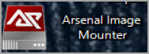

Note: You may see the following “Product Activation” dialog. This is for the professional version of the tool, which includes features that are not necessary for this class. Click “Cancel” and then “OK” in the subsequent dialog.
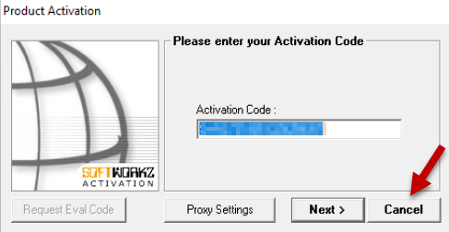
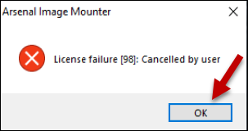
- Select OK
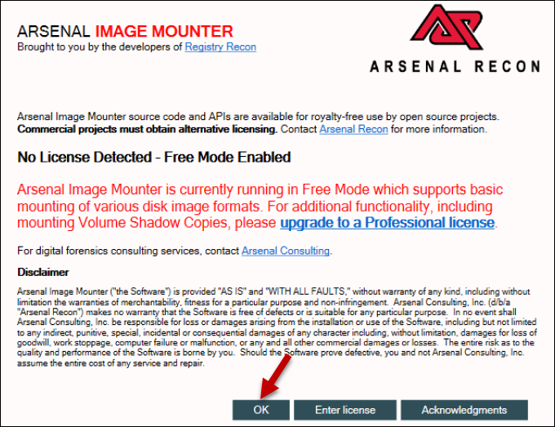

- Select Mount disk image
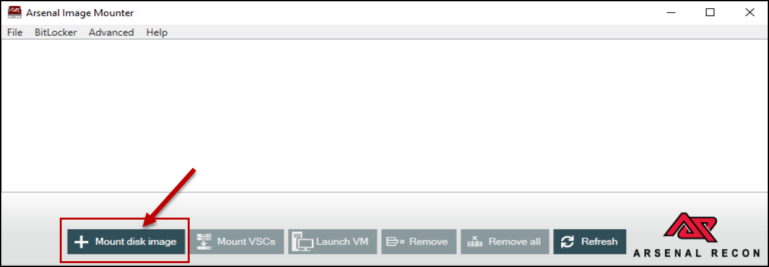

- Open your forensic evidence any on following link - https://digitalcorpora.org/corpora/scenarios/
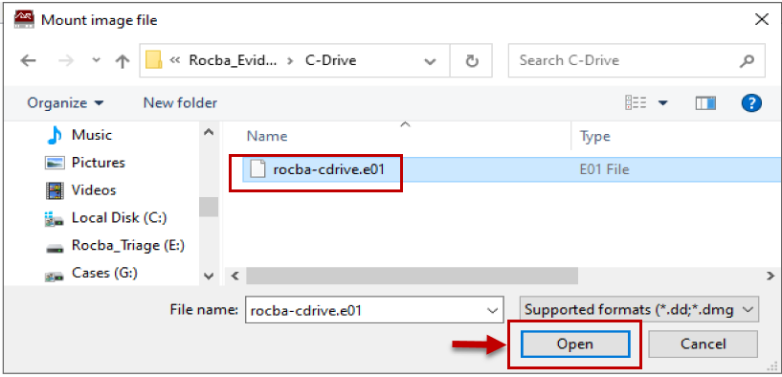

- Select the Disk device, write temporary in the Mount options window
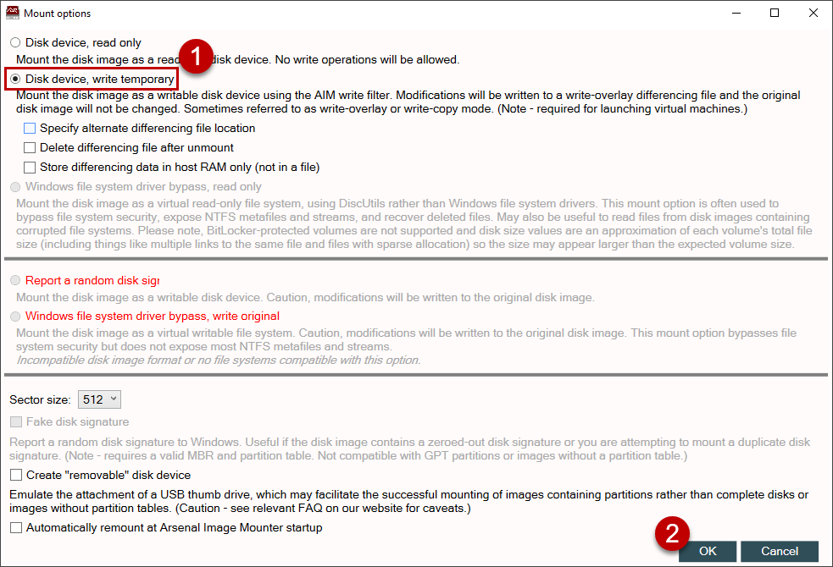

- After selecting OK in the Write Temporary disk device dialog, you may see the following popup about the write overlay file. You should select No to remove the existing file.
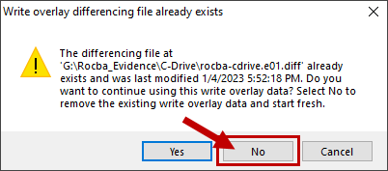

- Once mounted, you should see the Arsenal Image Mounter main window show the following screen:
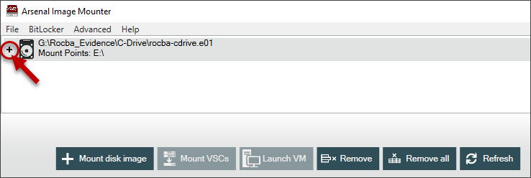
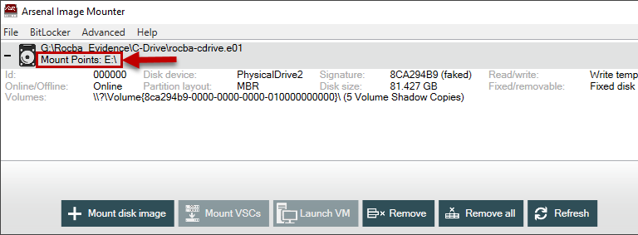

- In Windows Explorer the Mounted Partition will be displayed as shown below
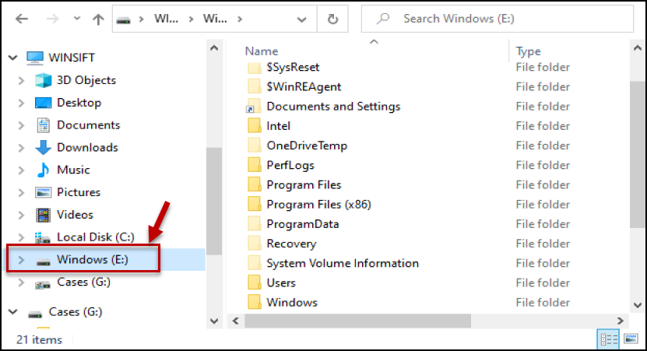

- Open the Mounted Partition in Windows File Explorer and browse to the \Users\fredr folder (Note: You will likely need to “grant” permission to access the folder) This may take a short while and you may even see an access denied dialog. Windows gets angry when NTFS permissions from other file systems (our mounted partition) do not match the current file system. Sometimes it may be necessary to remove the mount in Arsenal Image Mounter and mount it again to force Windows to relent.
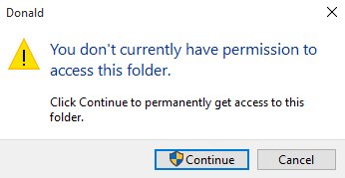

- Confirm you can see the NTUSER.DAT registry hive for this profile (you do not need to open it, just make sure it is present).
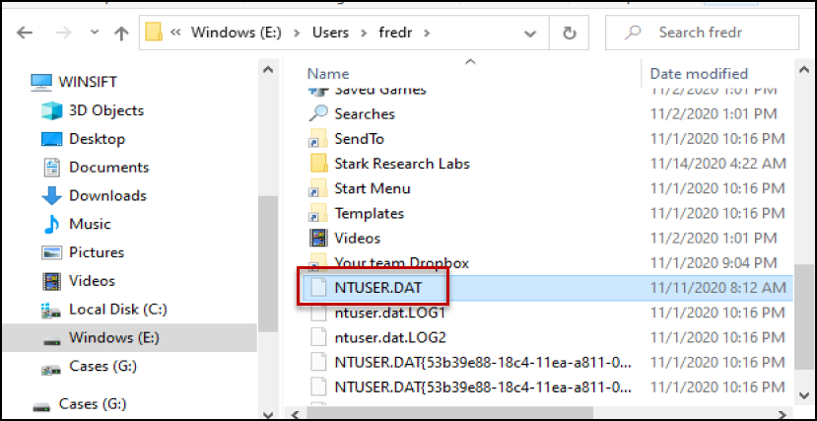
Note:
If you do not see the NTUSER.DAT file, within Windows File Explorer select View Tab -> OPTIONS and unselect Hide protected operating system files
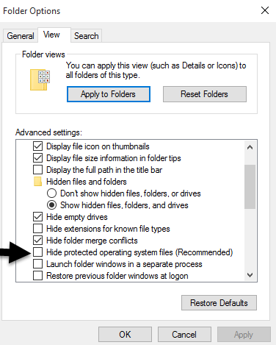
- Unmount the image – Unmount the image by highlighting the image in the Arsenal Image Mounter window and clicking the Remove button.
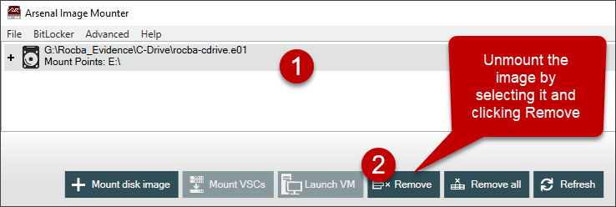

Key Takeaways
- Mounting a disk image with Arsenal Image Mounter allows for unrestricted access through your entire image and will be used by many of our tools that expect to operate on Windows artifacts, not forensic images.
- Mounting a disk image allows for analysis of both the files and directories in addition to having a handle to a representation of the physical disk (some forensic software can interact with a physical disk).

Part 2: Reflection questions

- What are the functions of IMT versus IRT?
The IMT/incident management team focuses on the coordination and management of the incident. They handle all communications, decision making, and ensure that the organization responds in an effective manner. The IRT/incident response team focuses on the technical investigation and response. This includes identifying and containing the threat, analyzing digital evidence, and recovering systems if necessary.
- List at least four incident types?
  - Malware/ransomware attacks
  - Phishing/social engineering attacks
  - Denial of service/DoS/DDoS attacks
  - Data breach/exfiltration attacks
- During stage 2 of identification of incident response, what is triage?
The triage stage involves quickly assessing and prioritizing the incidents based on their severity, impact, and urgency. This helps determine which incidents need to be focused on first, and which resource should be allocated for these incidents.
- What is the function of a chain of custody?
The chain of custody ensures that any digital evidence is properly tracked, handled, and documented from the time it is collected to the time that it is presented or when its investigation has been concluded. This is done to maintain the integrity and admissibility of the evidence, since evidence cannot be admitted if it has been tampered with or not handled properly.
- List types of pentesting described this week?
  - External pen-testing
  - Internal pen-testing
  - Blind pen-testing
  - Double blind pen-testing
  - Targeted testing

ALL Screen shot(s) here for evidence of work:
Note: I could not find the exact image that was used in the example, so instead of the fredr user, the user is jcloudy
