Lab 5: UDP Client-Server Application Documentation
Overview
The purpose of this lab is to design, implement, and test a client-server application using UDP, or User Datagram Protocol, in Python. This will focus on socket programming, error handling, string handling, and demonstrating a working networking application utilizing UDP and the socket API. The demonstration will be completed in class. The client and server programs will work together to obtain a string via user input, reverse the string, and then output the result. The client will receive a string as user input, which will then be sent back to the server. The server will receive the string, reverse it, and will send the result back to the server to display to the user. These programs will account for various errors, such as invalid input from the user, an unexpected data type, and network errors.
The server program will listen for an incoming string from the client. This program should be started before the client program, because the client needs an existing destination to connect to. This is also why the port numbers for the client and server programs are the same. Starting the client first will cause that program to attempt to send data to a server program that does not already exist, which will cause a connection error. When the string is received from the client program, the server program will reverse the string and then send it back to the client. The client program will prompt the user to enter a string. The string will then be sent from the client program to the server program. After the server program reverses the string and sends it to the client program, the client will receive the reversed string and then display it to the user.
This program cannot handle multiple clients at once because of how the server program is set up. The recvfrom() function means that the server is waiting to receive one message from one client. This means that the server is unable to process other messages from other clients until it receives data from the client it is connected to. The current client’s message must be fully processed before the server can move on and accommodate another client. Additionally, the server utilizes a single-thread approach, meaning that only one operation between a client and server can happen at once. While the server processes a message from one client, it is not able to respond to or even accept messages from other clients. This can be mitigated by using a multithreading approach, where a new thread is created to handle more clients. This can be done by importing threading.

Design
Throughout all of my classes, I have never had to write code in Python before. Most of my experience is with Java, JavaScript, HTML, and CSS. To prepare for this lab, I watched Python tutorials on YouTube and read guides on GitHub to determine the best approach for this lab. Before writing the code, I wanted to gather my thoughts and determine what I wanted each program to accomplish. For both clients, I had to import a socket in order to establish a connection between the two. I also set the server port to 20000 for both of them. Having the same port number is essential for the connection to work, so I chose a large port number. For both programs, I wanted to make sure they would close after their communication was completed. While rewriting the client and server programs, I left detailed comments in order to properly explain how the code works.
For my client program, I wanted it to be able to properly prompt the user to enter a string, send that string to the server, and then receive a reversed string from the server. I had to establish 127.0.0.1 as the server name, because it would be static, unlike an IP address or WiFi connection, which would change based on my location. Throughout the code, I have messages that will be displayed to the user based on circumstances. I encased most of the code in “try” blocks to handle any exception errors. This would ensure that any and all errors based on exceptional circumstances would be handled. If the client could not properly create a socket object, the program would time out and end. If there was a timeout, or if data could not be properly sent or received to and from the server, an error message would appear, and the program would close. If there were any unexpected errors, the program would display an error message and quit. I also employed a timer to ensure that within ten seconds of the communication with the server, the client would close the UDP socket, severing the connection. At the end of the code, I ensured that the program would close regardless of the circumstances, utilizing a “finally” block.
For the server program, I wanted it to be able to receive messages from the client, reverse the string that the message carries, and then send the reversed string back to the client to display to the user. Similarly to the client program, I encased most of the code in a “try” block in order to properly catch and handle all errors, including exception errors. I wanted this program to be able to decode the message that was sent from the client by converting it from bytes to string in order to preserve the data’s integrity. I used an “if not/else” block to handle the possibility of the user sending an empty string. I decided to utilize the “slicing” function to reverse the string because it seemed like the simplest approach. Outside of the “if not/else” block, I made sure to add exceptions for decoding errors and other unexpected errors, such as general server errors. To prevent errors regarding scope, I added “if” blocks into these “except” blocks focusing on the client address. If these errors occur while the client address is local, it would send a different message. Like with the client program, I made sure to close off the server socket at the end of the program to properly sever the connection.

Pseudocode/Flow Chart of Events
Client
Start program > create socket > get user input > send message to server > wait for response > display response to user > close socket > end program
Start program > create socket > 5 second timeout for socket > prompt user to enter message > send message to server > wait for response > receive response and display to user > FINALLY end program
SET TIMER to close UDP socket 10 seconds after communication is over
Error Handling (in TRY blocks to handle errors)
EXCEPTION Data sending error > print error message > close socket > close program
EXCEPTION Server timeout > print error message > close socket > close program
EXCEPTION Unexpected error > print error message > close program
Server
Start program > create socket > bind socket > wait for message from client > decode message > reverse message > send response back to client > end program via shutdown
Start program > import socket > establish socket as IPv4 and UDP > bind socket to server port > read message from client > decode message > reverse message > output modified message to client > end program via shutdown
Error Handling (in TRY blocks to handle errors)
IF message is empty > print error message --- ELSE reverse message
EXCEPTION Unicode error > print error message > IF client address is local > error message
EXCEPTION Unexpected error > print error message > IF client address is local > error message

Testing and Implementation
In order to test my programs to ensure that they worked properly, I entered various inputs to see how they would be reversed. Each and every string sent from the client to the server would be reversed, and then sent back to the client. The server will return an error message if an empty string is received, including a string of spaces.
- Empty String: “”
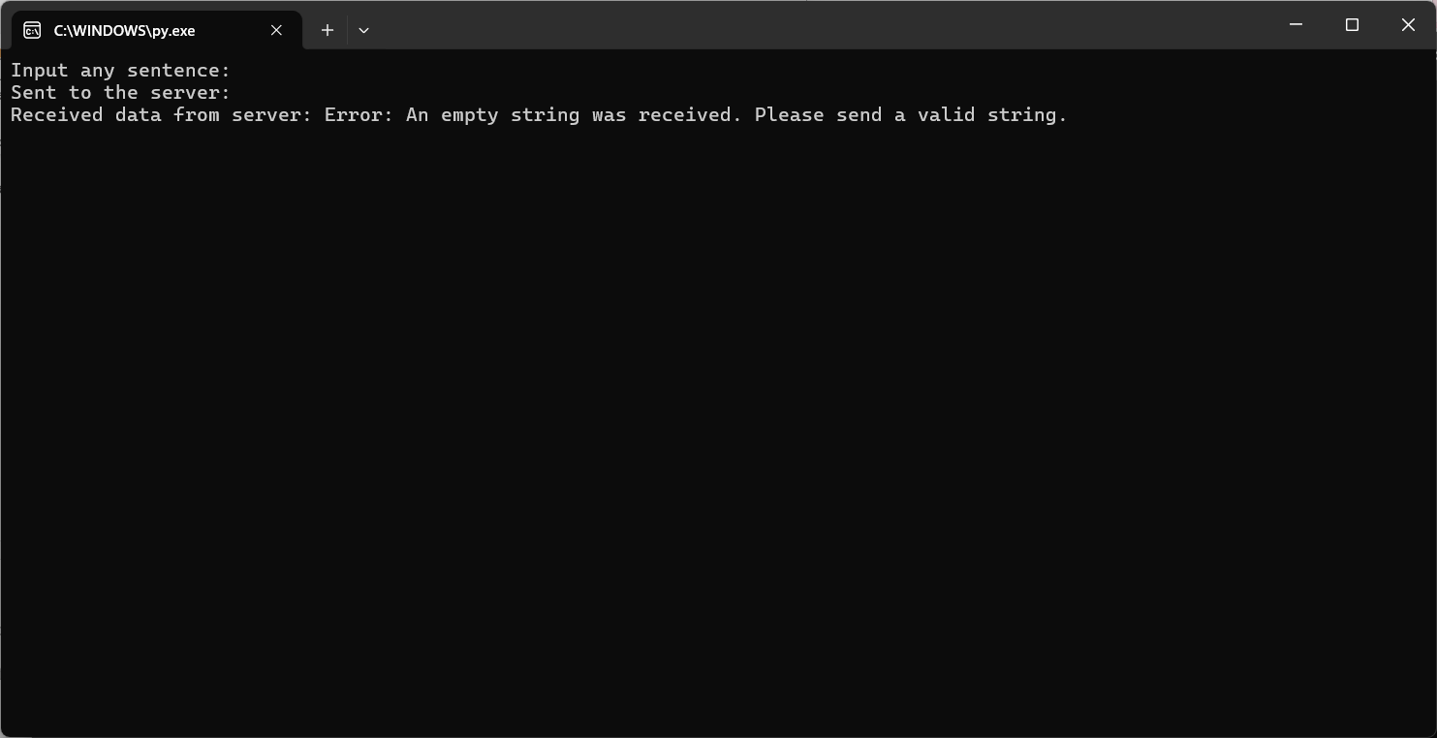

- Alphanumeric String: “Hello123”
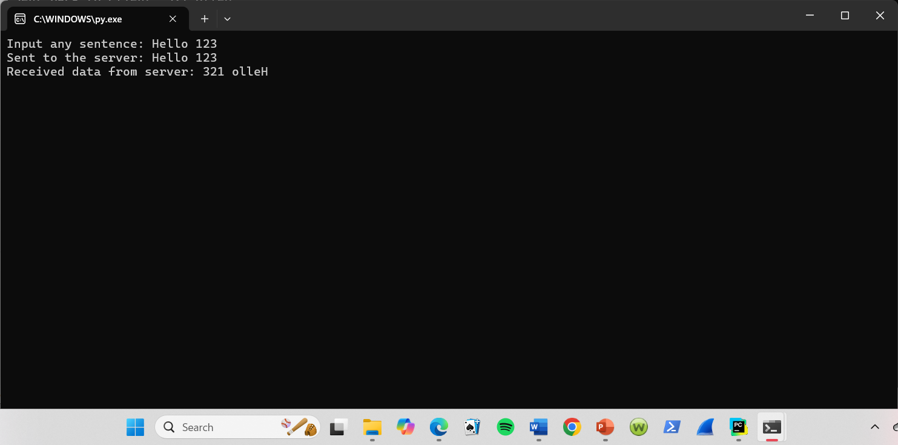

- String with Special Characters: “!@#$%^&*”
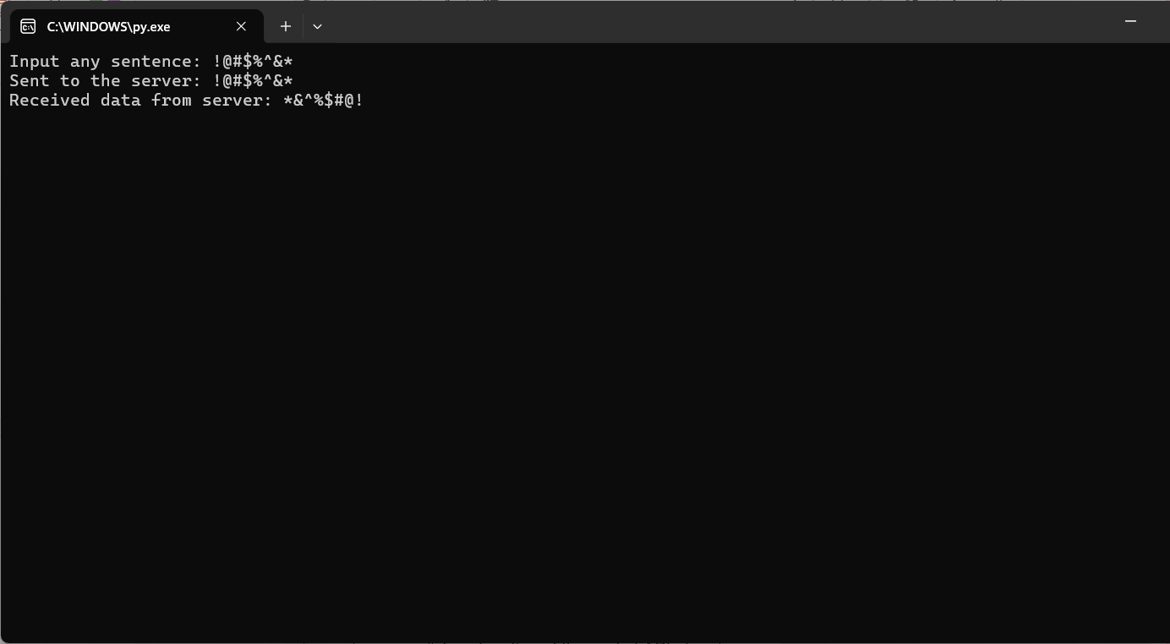
- String with Only Spaces: “ ”
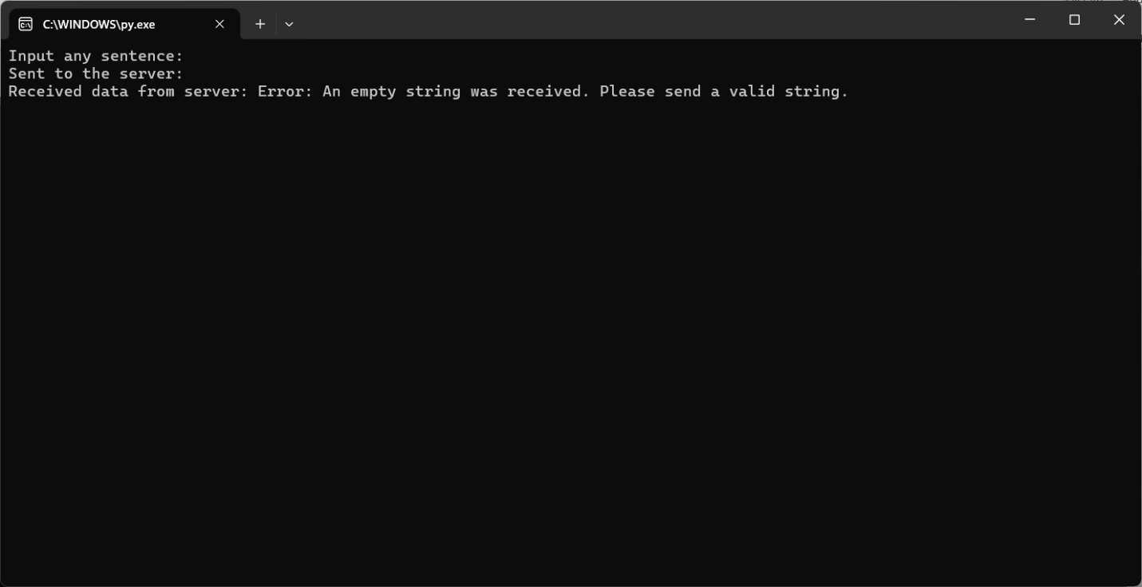
- Long String: “Hello, world! This is my first client-server program for CIS-3329, Lab 5!”