## Application Idea

The application is a way to analyze live streaming tweets to determine current trends of tweeters. The application takes in whole tweet texts, parses the tweet into individual words (and cleans out certain formatting), then counts the words. A database keeps track of how often individual words have been seen allowing analysis of word importance. Higher word counts indicate increased discussion about a topic. Changes in word counts relative to itself or other words indicate increased or decreased importance of the topic.

## Description of architecture

Streamparse works by X. The spout takes tweepy which needs x. The results then go into a postgres database

* Streamparse lets you run Python code against real-time streams of data. Integrates with Apache Storm.
* Look up how tweepy works
* Look up streamparse architecture
* Look up postgres architecture

## Directory and file structure:

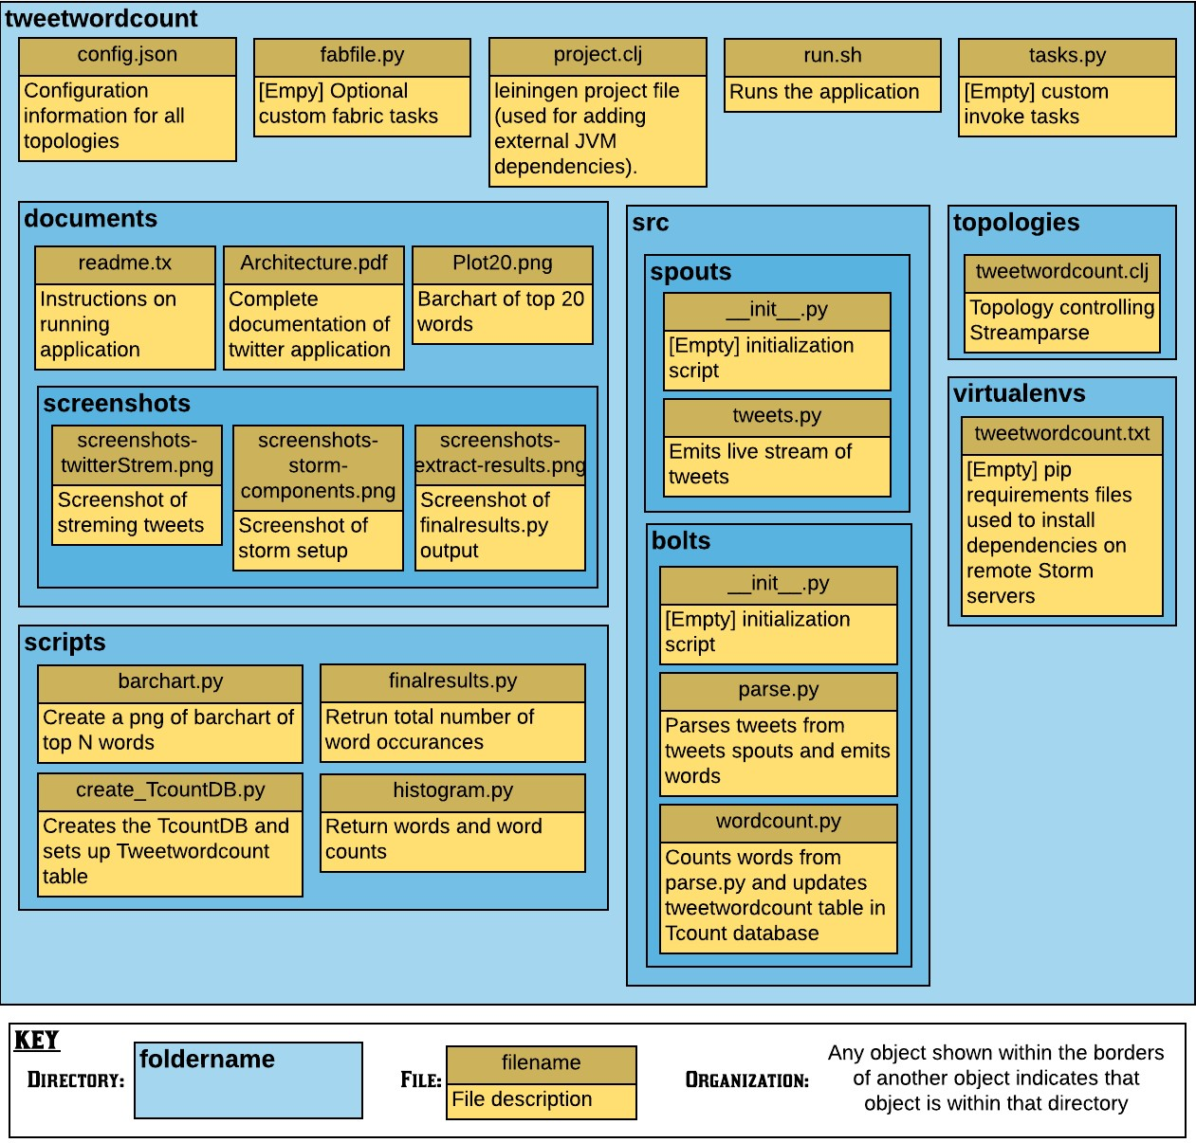

## File Dependencies

