Tien Vo, Moaaz Moazzam

ECES-450: Statistical Analysis of Genomics/ Computational Metagenomics

5/27/2021

Tutorial 10: KAIJU Classification Tutorial

1. Open the KAIJU web server at <http://kaiju.binf.ku.dk/server>
2. 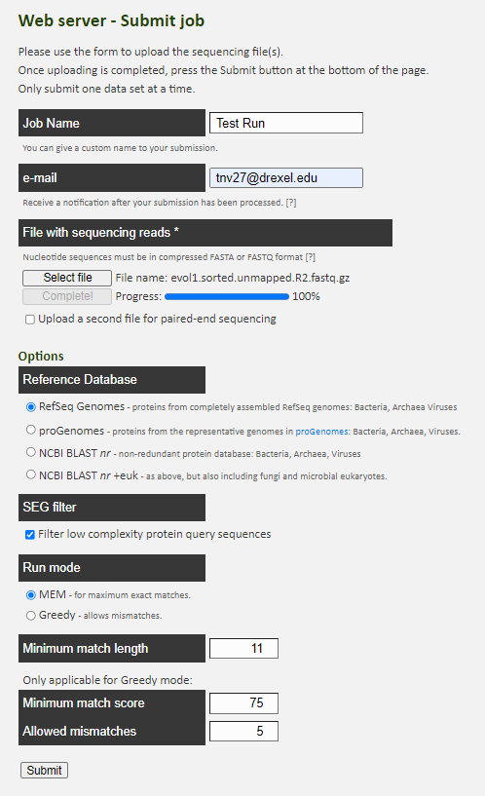

1

2

3

4

5

* 1. This is where the name of the job can be edited in addition to the email where result link will be sent.
  2. This section is where the data is inputted and uploaded for analysis.
  3. The reference database can be changed for varying classification results depending on the database chosen.
  4. In these two sections, the SEG filter can be turned off and on and the run mode can be changed between either maximum exact matches (MEMs) or Greedy algorithms
  5. These parameters apply to each of the run modes. The minimum match length applies to both the MEM and Greedy algorithm. Minimum match score and allowed mismatches only apply to the Greedy algorithm

1. Once the job is submitted and KAIJU emails the results, here is a sample result:

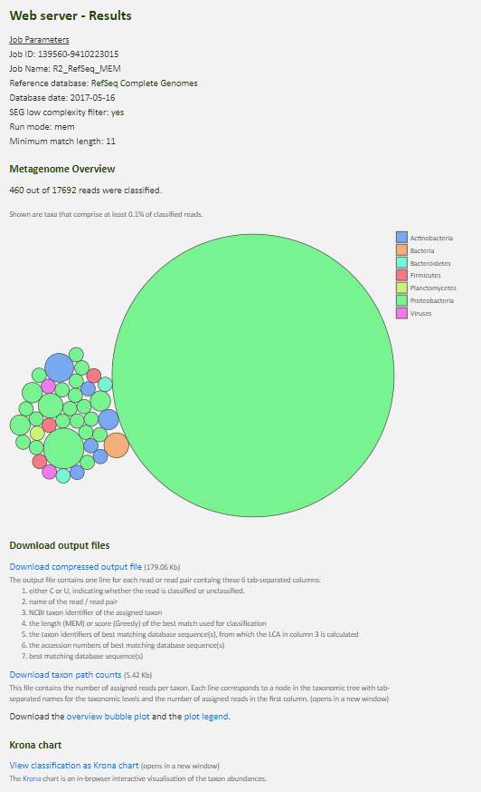

1. The results page includes the following:
   1. Job Parameters goes over the options the user chose for their job.
   2. Metagenome Overview is a bubble chart of the classified reads and the overall and the category they fall under
   3. The output files include a file of the input data, except with each line read there is addition information including whether it was classified or unclassified, the taxon assigned, etc. Additionally, a text file of the categories and their abundance in included.