Q: Can you provide similarly profiles (as diagrams) and settings (configurations) for all presets which we have coded in SimpleEA?

Let me first thoroughly examine all existing presets to understand their exact configurations.
Now I have all presets. Let me read the PRESET_CUSTOM section to complete the picture:
Now I have comprehensive understanding of all 5 presets. Let me create the diagrams and configuration reference:
Now let me create the diagrams. I'll build all 5 preset pipeline diagrams in a single interactive widget with tabs:
PRESET_MA, PRESET_FPM, PRESET_RRM_ PRESET_RRM_ORG, PRESET_TEST

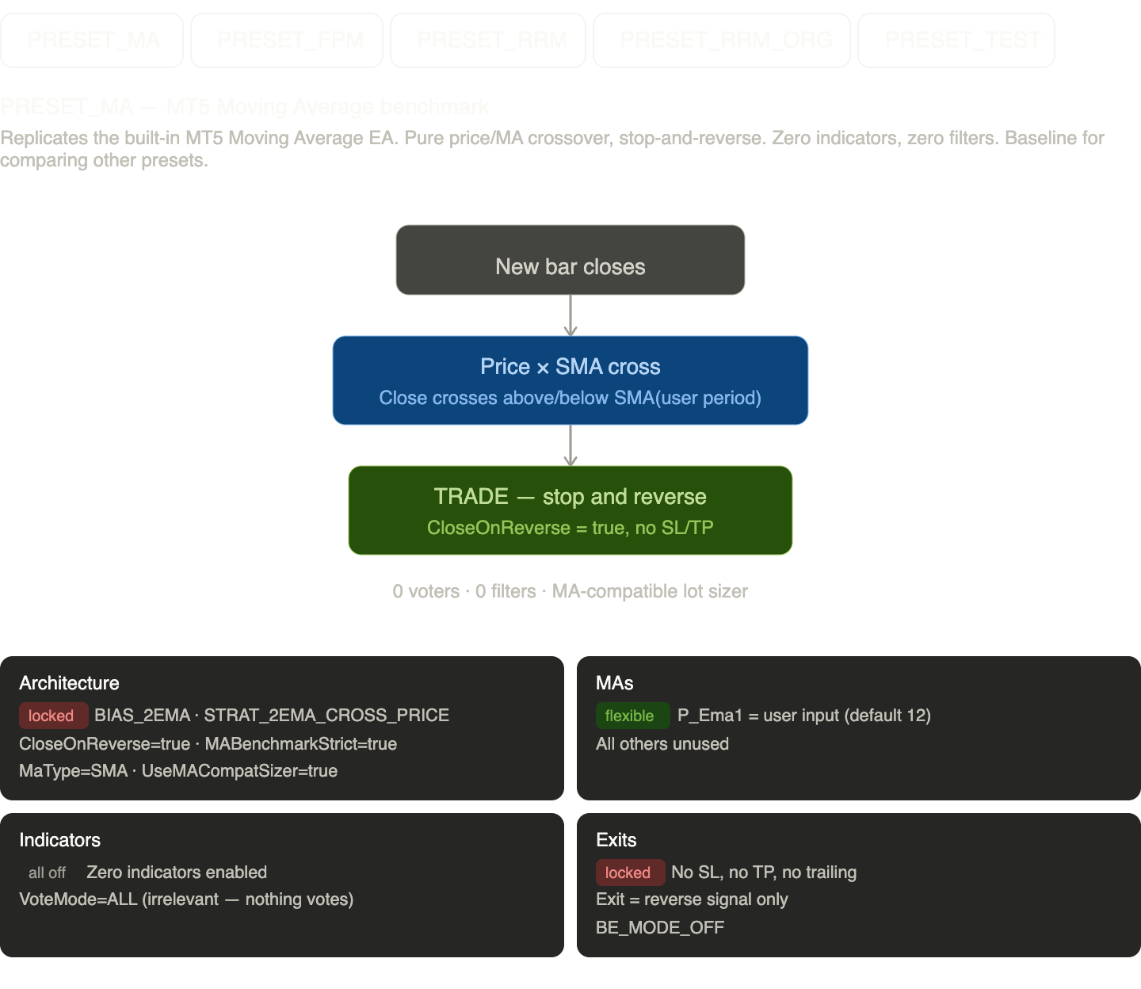

Now let me also create a comparison overview:

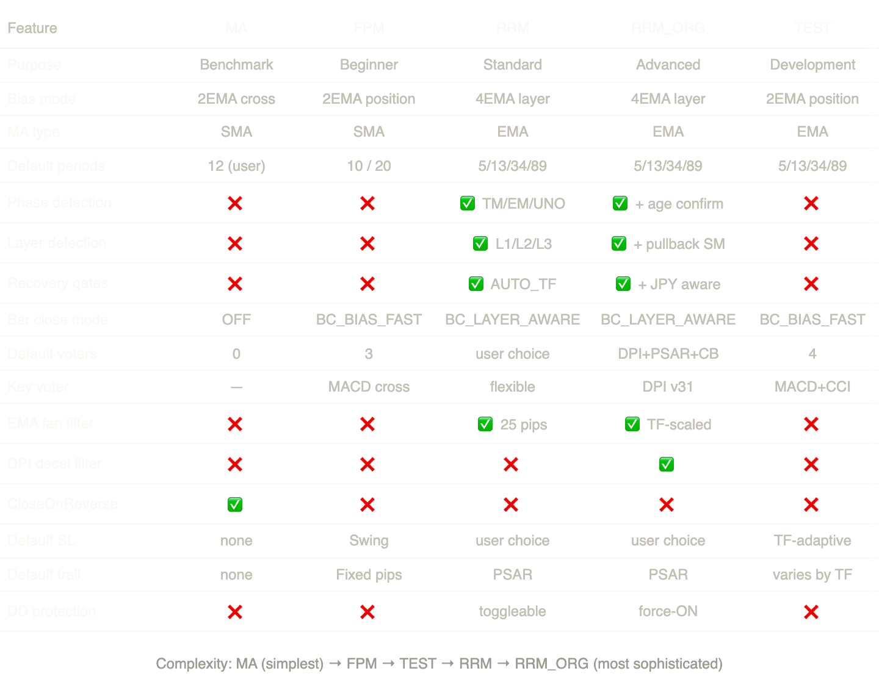
There you go — all 5 existing SimpleEA presets fully documented with interactive pipeline diagrams and a comparison matrix.
Here's the quick summary of the progression:
PRESET_MA is the simplest possible configuration — a bare price/SMA crossover with stop-and-reverse, zero indicators, zero filters. It exists purely as a benchmark baseline to compare other presets against.
PRESET_FPM (Five-Point Method) adds the first layer of sophistication: 3 locked voters (PSAR dot position, MACD crossover within 5 bars, BB widening) plus a bar-close gate. Still uses a simple 2-SMA structure (10+20) with no phase or layer detection. Good entry point for understanding the voting system.
PRESET_TEST is the sandbox — same simple 2-EMA bias as FPM but with 4 default voters (PSAR, MACD, CCI, CandleBody) and everything else disabled. Designed for enabling one indicator at a time to study its impact in isolation.
PRESET_RRM is the standard production preset — introduces the full 4-EMA phase system (TM/EM/UNO), layer detection (L1/L2/L3), recovery gates with AUTO_TF scaling, layer-aware bar close, and the EMA fan overextension filter. Indicator toggles are all user-controlled via Inp_RRM_* inputs.
PRESET_RRM_ORG is the most advanced — everything RRM has plus DPI v31 as the primary momentum voter (inline MACD-core with CCI reset), the pullback state machine (NONE→DETECTED→RECOVERED), phase-age confirmation to kill flickering entries, JPY-aware gate multipliers, per-layer PSAR flip delay overrides, TF-scaled EMA fan thresholds, force-on drawdown protection, and hardened TE execution (BC recheck, open delay, spread median). This is the "quality-first" preset derived from analysis of 100 reference trades.
The comparison table shows exactly how each feature escalates across the complexity spectrum, making it easy to see what each preset adds relative to the one before it.

Q: Comparison overview is great, however please create for all presets separate diagrams, similarly like for Conservative, Moderate and Full profiles

Here are all five preset pipelines as separate, standalone diagrams. I'll use the same consistent visual language — purple for phase/structure gates, teal for bias/position, blue for voting indicators, coral for recovery/quality gates, and green for the final trade output.
PRESET_MA — the simplest: just a price/SMA crossover with stop-and-reverse.
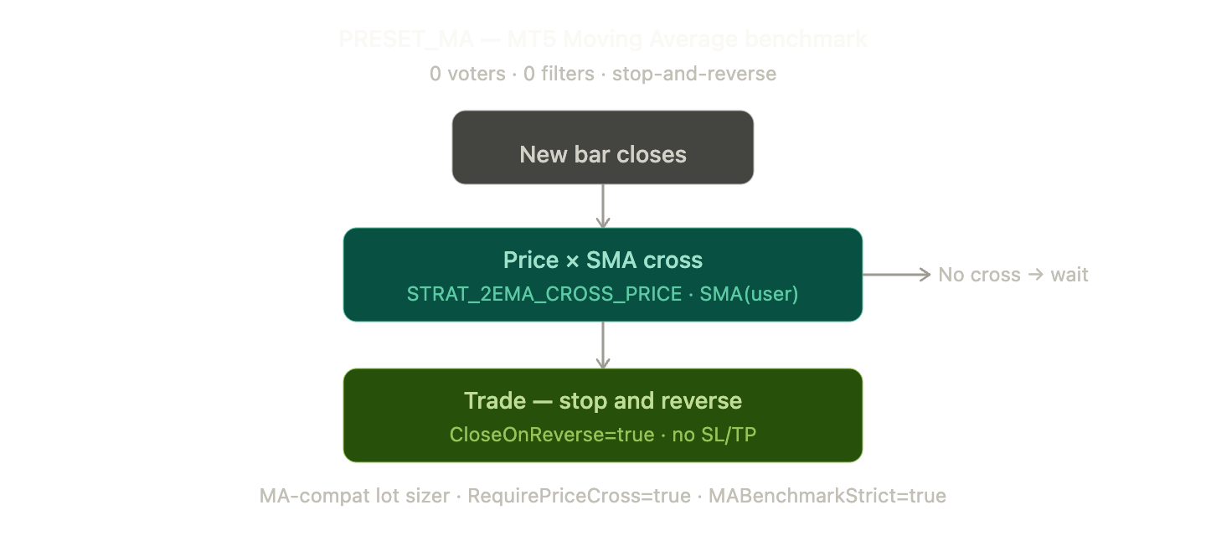

PRESET_FPM — the Five-Point Method adds a 2-SMA bias structure, a bar-close gate, and 3 locked voters (PSAR + MACD crossover + BB widening).
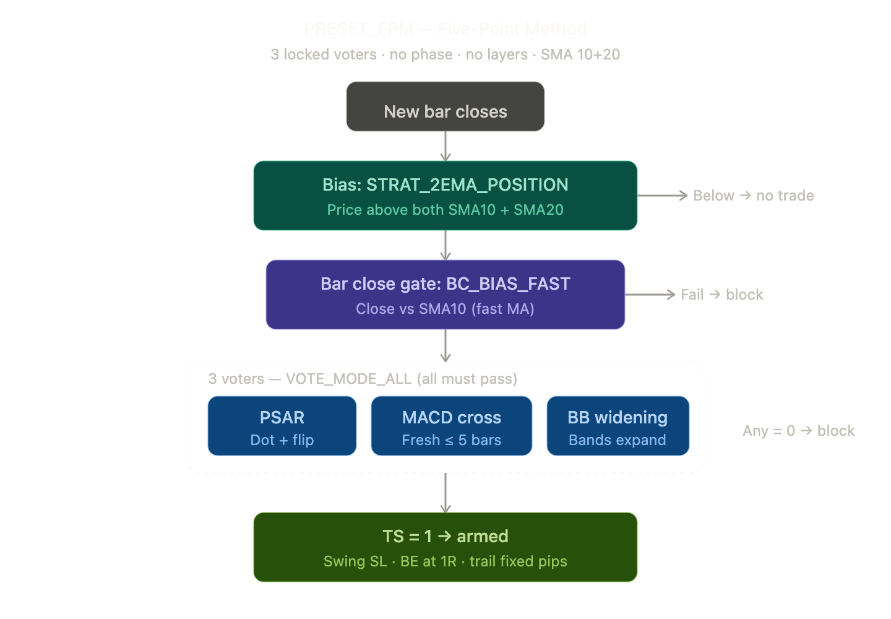
PRESET_TEST — the sandbox preset with simple 2-EMA bias, 4 default voters, no
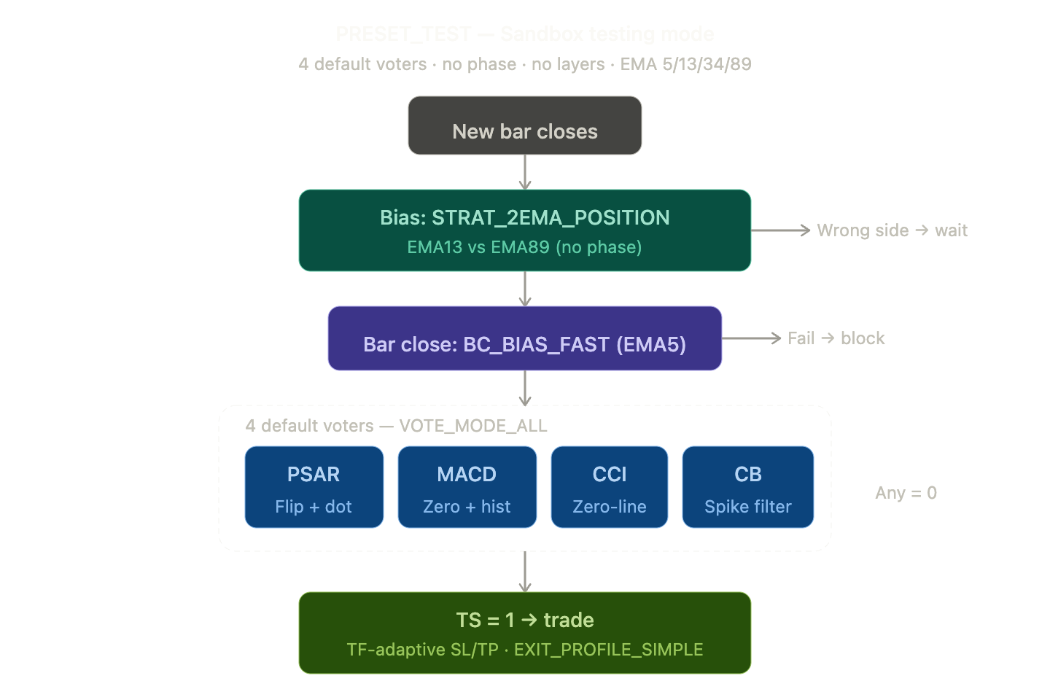
PRESET_RRM — the standard production preset. This is where the 4-EMA phase system, layer detection, and recovery gates first appear. Indicator toggles are all user-controlled.
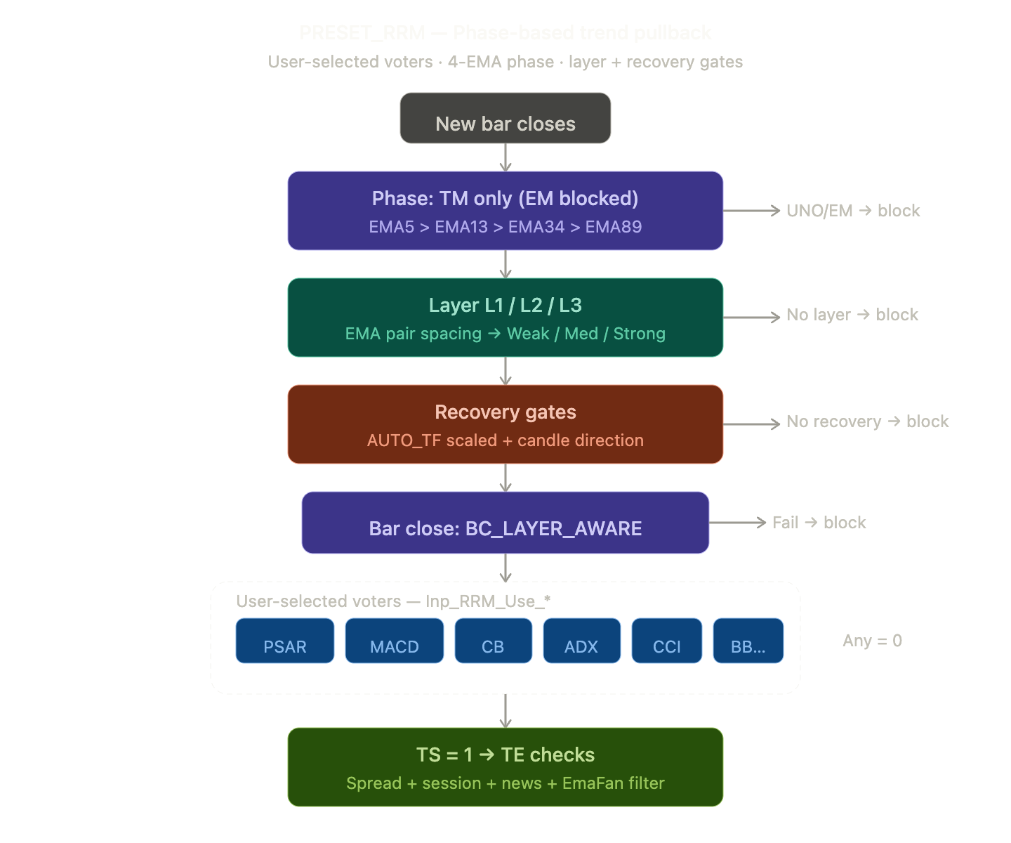

And finally PRESET_RRM_ORG — the most sophisticated preset. Every gate from RRM plus DPI v31, pullback state machine, phase-age confirmation, JPY-aware gates, EMA fan overextension, DPI decel filter, and hardened TE execution.
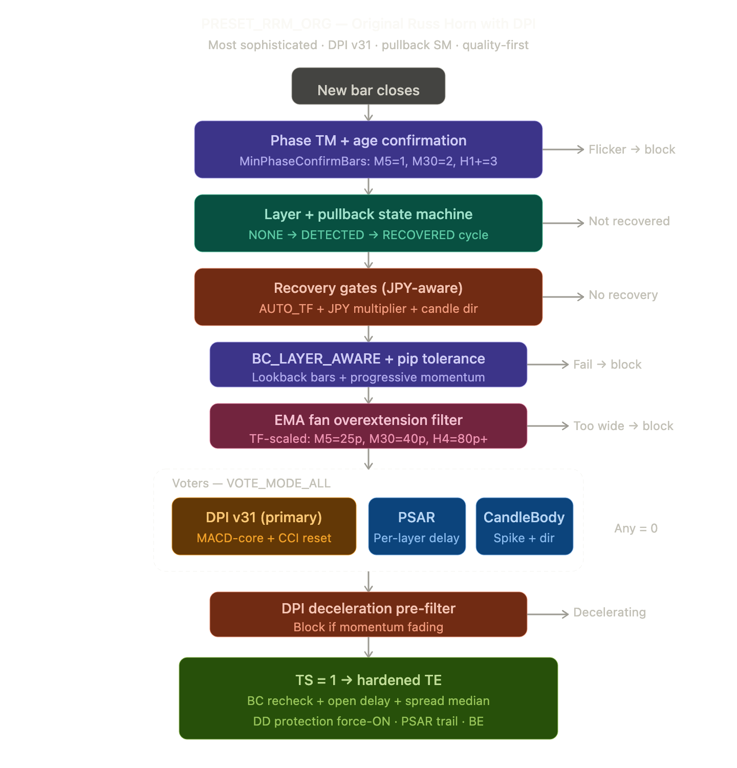

There you have it — all five presets as separate, standalone pipeline diagrams using the same visual language as the Conservative/Moderate/Full TopInvestor profiles.
The progression is now very visible across the diagrams: PRESET_MA has just one decision box (price cross), PRESET_FPM adds a bias check plus a voting tier of 3, PRESET_TEST is a sandbox with 4 voters but no structural gates, PRESET_RRM introduces the full purple/teal/coral stack (phase → layer → recovery → bar close) before voting, and PRESET_RRM_ORG takes every RRM gate and adds hardened variants (age confirmation on phase, pullback state machine on layers, JPY scaling on recovery, pip tolerance on bar close, EMA fan filter, DPI decel filter, and hardened TE execution).
The color coding is consistent throughout: gray for entry triggers, purple for structural/phase gates, teal for layer/bias, coral for quality/recovery filters, blue for voting indicators, amber for the DPI primary voter, pink for the EMA fan filter, and green for the final trade output. Red callouts on the right side mark every rejection path.

