THE ROAD TO BETTER BUSINESS INFORMATION:
MAKING A CASE FOR XBRL
A Conversation With Nasdaq, Microsoft and PricewaterhouseCoopers

by Al Berkeley, Vice Chairman of Thought Leadership at Nasdaq, with John Connors, Senior Vice President, Chief Financial Officer of Microsoft, and Mike Willis, Partner at PricewaterhouseCoopers

Table of Contents

Introduction 1
The Investor’s Situation 2
Getting to a More Efficient Market: A Conversation With Al Berkeley 4
An Adoption Case Study: A Conversation With John Connors 6
Enabling a Better-Managed Company: A Conversation With Mike Willis 9
Appendix A: XBRL Resources 11
Appendix B: Author Biographies 12
Alfred R. Berkeley, III 12
John Connors 12
Mike Willis, CPA 13

Introduction
The enormous success that developed economies have had in raising standards of living has come, in part, from the efficient allocation of capital. Capital has been provided to the effective competitor on better terms than to the less effective.

The investor knows the difference between more effective and less effective competitors because trustworthy, thorough and timely systems have evolved to distribute and evaluate corporate results.

It is in the best interest of the company, the investor and the public to make the availability of corporate results broad, complete and timely. This paper is, essentially, a conversation between these points of view. The participants all recognize the challenge of achieving more effective information delivery.

Nasdaq Stock Market Inc. is concerned about its entire range of companies, and the benefit to all investors and the general public, of easier distribution and analysis of corporate results.

Microsoft Corp. is concerned with meeting its obligation to communicate with arguably the largest and most involved shareholder base in the world.

PricewaterhouseCoopers is concerned with meeting the rising obligations that public opinion, case law and regulation are imposing on the capital markets: better reporting, more sophisticated analysis and greater trust in the information provided.

The market, the company and the accountant each need to add value for their customer. In this case, the customer is the public investor.

The Investor’s Situation
Investors effectively have been left to their own devices to analyze corporate results. A small industry of intermediaries has evolved selling analytical services on perhaps 20 percent of publicly traded companies.

The translation between the information a company reports and the information used by investors to analyze corporate results is a hand-tinkered and labor-intensive one. It is the least standardized, least-automated link in the entire value chain of capital markets.

It is true that corporate results are now available online, but even when the investor receives corporate results at the speed of light, there is a time-consuming, intellect-intensive process of converting data on the company report into data on the investor’s spreadsheet. Virtually every investor has to convert data received from the company into a form useful to the investor.

The new data needs to be analyzed and thought through for what it says:
- How big are revenues?
- How big are profits?
- How big are profit margins?
The new data must be compared to earlier data to answer these questions:
- How fast are revenues growing?
- How fast are profits growing?
- How are margins changing?
- How are growth rates changing?
The company’s results must be related to other companies’ results:
- How is this company doing relative to its competitors?
- How is this company doing relative to other places the investor can place his or her money?
The investor is basically in the business of comparing one company to another. And yet, so much energy, time and intellect is consumed at the lowest level of transposing data from the stand-alone format in which the company reports to the comparative format the investor needs that little time is left for comparative analysis. This is particularly true for small investors, who do not have the analytical staff available to professional investors.

The need is so great that a whole industry has grown up to provide investors with investment advice. But this industry has its own profit needs and does not provide analysis on most companies.

Of the roughly 10,000 public companies in the United States, we estimate that only about one-third have any meaningful Wall Street research available. On The Nasdaq Stock Market, the New York Stock Exchange and the American Stock Exchange, there are thousands of companies with no Wall Street research. Because Wall Street research only covers the most actively traded stocks, huge gaps exist.

At the same time, academic research demonstrates the value to a company and its shareholders of broad availability of financial results and analysis of those results. One of the primary benefits is that companies can significantly lower their cost of capital.¹ The ValueReporting™ movement,² which emphasizes the importance of non-financial measures as well, claims these same results.

Federal regulation also mandates broad and timely disclosure to the public.

Getting to a More Efficient Market:
A Conversation With Al Berkeley
Vice Chairman of Thought Leadership of the Nasdaq Stock Market Inc.
Nasdaq plays a unique role in the American economy, and is a piston in the engine of America’s rising standard of living. Its unique contribution lies in providing — better than any other market in the world — the one thing that markets exist to provide: liquidity. Without the ability to sell, to liquidate, customers are less willing to buy.
What XBRL Is NOT
- XBRL does NOT a set of accounting standards. Accounting standards are the domain of the existing Generally Accepted Accounting Principles (GAAP) and regulatory standards bodies. XBRL is a platform on which reporting standards content will reside and be represented.
- XBRL is NOT a detailed universal chart of accounts. Accounting organizational charts are the domain of the management (and in many countries, of the government itself), and it is their responsibility to define appropriate classifications for use in generating appropriate management information. XBRL can facilitate the implementation of such structures through its ability to transport data between disparate software applications that might be used within an organizations operational structure.
- XBRL is NOT a GAAP translator. XBRL does not provide transparency of existing GAAP information into lower levels of information that would be necessary for translating from one GAAP to another. The business-reporting document contains the same GAAP information, be it in an XBRL format or a Microsoft® Word or PDF format.
- XBRL is NOT a proprietary technology. XBRL is freely licensed and available to the public. XBRL is XML-based and therefore is expected to be widely available in software applications.
- XBRL is NOT a Transaction Protocol. XBRL is designed to address issues related to production and consumption of information contained within business reports and begins at the accounting classification level. XBRL is about business reporting information, not about data capture at the transaction level.

Nasdaq has become the engine of job growth in America by democratizing access to capital in a way that is the envy of the world. Nasdaq itself has lowered the cost, broadened the scope and sped the delivery of information about the market.

Nasdaq joins this conversation because it feels that improving the distribution and analysis of corporate results, especially for the 10,000 companies not covered by Wall Street analysis, will broaden the market for Nasdaq’s own trading services.

What has been needed is a technological way to address the reporting and analysis of the thousands of companies whose trading interest does not justify the hand-tinkered, labor-intensive model currently in use by investors and analysts around the world. XBRL is that technology.

“XBRL” stands for Extensible Business Reporting Language. It is a subset of Extensible Markup Language (XML), the common language of data exchange on the Internet, which provides a widely embraced open standard technology for data exchange and transformation.

XBRL is an effort to add “information about information” to the ways computers for financial functions relate to each other. Traditionally, if one computer sent another computer data on a company’s $5,000,000 in revenues, the number 5,000,000 would be transmitted. The receiving computer has to be programmed in a precise way to recognize the number and put it in a predefined bin called “revenues,” and ensure that bin was expecting figures in dollars, not cents or pounds. With XBRL, the 5,000,000 is sent along with a label that indicates it is revenues measured in U.S. dollars.

The sender standardized the information. Recipients can then view any data they choose, for example, receiving information about a company’s revenues and automatically comparing it to profit, to previous revenues, or to another company’s revenues. The highly labor-intensive requirement to map the sender’s data into the receiver’s analytical program goes away. It costs less for a receiver to “consume” a sender’s data.

There will be many benefits to using XBRL, such as these:
- Companies can distribute a higher value stream of information about themselves to the owners. They can send the same information they send today, but it will be more valuable because it is easier to use.
- Investors will have more time for analysis and insight, as less time is spent on translation and data entry.
- More companies will be used in investors’ screening, because the marginal cost of preparing data on additional companies for analysis will drop to zero. Undiscovered jewels will be discovered. The market will become more liquid.
We expect an industry to evolve selling analytical software that allows investors to receive and analyze corporate results. These programs should become progressively and cumulatively more complex, meaningful and valuable.

We expect trade associations, stock brokerages, financial publications, independent software houses and markets to provide analytical software for investors.

An Adoption Case Study:
A Conversation With John Connors

Senior Vice President and CFO of Microsoft
Microsoft’s goals in supporting and implementing XBRL are clear: 1) to ensure the integrity and credibility of the company’s financial information; 2) to streamline and reduce the costs associated with preparing and distributing Microsoft’s financial information; 3) to become an example of and an evangelist for XBRL’s potential to benefit the entire marketplace; and most important 4) to provide benefits to Microsoft’s stakeholder community.

Today it is extremely difficult for the investment community to perform a high volume of complex analysis in a cost-effective way. Adoption of XBRL as a standard format will reduce the cost barrier and level the playing field, empowering the entire community with the full data picture of Microsoft. XBRL will also help to ensure the integrity and quality of corporate financial data by removing the need for manual re-entry throughout the process. Investors also will be able to pull financial information automatically into whatever system they’re using without re-entering the information. XBRL will be an important tool for Microsoft’s Finance and Investor Relations teams in their efforts to provide benefits to investors, who will have immediate, comprehensive and extensible data. What’s more, Microsoft is presenting its data in a format that gives investors greater analytical flexibility and power at their fingertips than ever before.

Before XBRL we had to duplicate efforts in getting from our financial reporting model to all the necessary financial statement outputs, including regulatory filings, the company’s Web site and printed financial statements. XBRL enables us to reduce redundant efforts by allowing us to gather the data just once and then use it in many different ways without having to re-create it.

XBRL’s flexibility is also key to helping Microsoft react to changes without significant impact to our reporting system. XBRL addresses both current regulatory and GAAP financial reporting requirements, but is flexible enough to address future standards and new requirements.

The implementation
To accomplish our XBRL implementation, we created an internal tool we call the XBRL Builder. The XBRL Builder takes our completed financial data and automatically transforms it into XBRL (see diagram below).
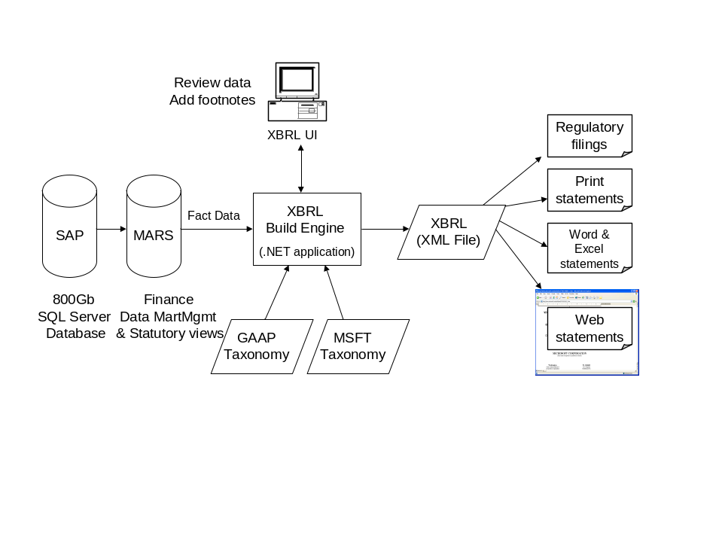

Microsoft’s internal XBRL Builder streamlines the following four processes to transform financial data into XBRL:
- Mapping the financial report line items with the appropriate XBRL tag
- Building and maintaining taxonomies (dictionaries of XBRL terms)
- Creating XBRL Instance Documents (the marrying of the XBRL tag with the actual financial result)
- Transforming Instance Documents into publishable format (create once, report in many formats)
Using the Microsoft® .NET framework and .NET enterprise servers, which enable information to travel seamless and securely between applications, Web sites and devices, we were able to rapidly implement XBRL. With no training or guidance, one internal developer was able to build our XBRL implementation in only 20 days.

XBRL represents not only a transformation in business reporting, but a new market opportunity and a growing industry in developing applications leveraging XBRL’s capabilities. By having financial information publicly available in XBRL, Microsoft also is providing a example for both internal and external software developers as they move forward in creating XML and XBRL driven tools. Software and services businesses will be able to expand their market reach by building new, sophisticated tools for everyone from company executives to individual investors to use for analysis.

Microsoft has a long-standing commitment to helping develop and promote the widespread adoption of fundamental Internet standards. The company sees XBRL as not only the future standard for financial reporting, but also a logical business choice. As such, Microsoft is a charter member of the XBRL Consortium, an international consortium of more than 140 of the world’s largest accounting, technology, government and financial services bodies devoted to developing and promoting the adoption of XBRL as a standard.

Enabling a Better-Managed Company:
A Conversation With Mike Willis

XBRL International Steering Committee Chair and Partner at PricewaterhouseCoopers
The benefits Microsoft is realizing from its XBRL implementation are available to companies of any size in any industry. For the financial executive, there are two key perspectives on the XBRL value proposition. The first is from the point of view of the company reporting business information both internally and externally. The second is from the point of view of the consumers of that business information. From both perspectives, the great virtue of XBRL is in how it simplifies and speeds up the process of assembling and moving information within the company and to its shareholders.

For company management, it is critical to be able to quickly spot problems and opportunities, to know what is going on in the company and to know it in time to make a difference. Getting the right information in a timely and consolidated way is often difficult, as data is typically stored in many different places throughout the organization. This is where XBRL comes in.

XBRL streamlines the communication between disparate technologies, allowing them to function in a more integrated way, resulting in higher-quality data, made available faster. Data aggregation for business reporting is often a costly, highly manual and error-prone process that can prevent accurate and timely data analysis. The consequences include unnecessary delays in decision making and poor decisions based on imperfect information that arrives late. XBRL automates what can be automated, and lets financial management be fully engaged in what matters — the issues, the strategies, the opportunities and the decisions to be made.

Thanks to its “produce once, use many times” capabilities, XBRL reduces the cost of producing business reports and facilitates more frequent reporting of key business information. Financial executives do not have to maintain separate documents for each reporting constituency; one underlying set of data can be reused for multiple reports. All this serves to enhance communications and strengthen relationships with the full range of stakeholders, including investors, analysts, vendors, suppliers, regulators and other companies.

XBRL allows all shareholders, from the smallest individual investor to the largest institutional investor, to more easily process financial and other business performance information in a matter of seconds, rather than hours or days. There is no rekeying of information into spreadsheets or laborious data checking. This diminishes data input errors, thereby greatly increasing the integrity of the data and the quality and efficiency of the analysis process.

Increased reporting frequency, more accurate information and improved shareholder ability to analyze companies’ information all result in greater transparency of data. This is consistent with the SEC’s desire to level the playing field among all investors and its recent call to provide better and more timely information to the market. Further, the ability of shareholders to analyze different components of financial statements (e.g., financial statement line items or footnote information) will act as a catalyst for increased levels of reliability at this more detailed level.

XBRL is not about establishing new accounting standards but about enhancing the usability of financial information via a digital language of business. XBRL not only addresses today’s accounting standards and policies, but also is flexible enough to accommodate future accounting standards and direction. XBRL does not require additional or more frequent disclosure from companies to outside audiences. Instead, it makes the financial information companies are required to report more accessible to stakeholders via the Internet.

For XBRL to take hold in the marketplace, however, and for its benefits to become widespread, it is important for financial executives to take an active leadership role in developing it and adopting it for regular use in business reporting. The most immediate benefit will be a better-managed company using better information to make decisions and reporting that information across a more useful medium. Further benefits include a lower cost of capital and more accurate stock price valuation based on more efficient and complete analysis of the company’s reported performance. Before too long, those companies not reporting in this fashion will be at a real disadvantage to those who are.

Appendix A: XBRL Resources
To learn more about XBRL, readers can do the following:
- Visit the Microsoft, MSDW and Reuters Web pages to see the human-readable format of XBRL financial statements:
  - http://about.reuters.com/results/2001-pr/html/xbrl.asp
  - http://www.morganstanley.com/xbrl/
  - http://www.apra.gov.au/
  - http://www.microsoft.com/msft/
- Visit the XBRL.org site at http://www.xbrl.org/ and view some of the demo pages at http://www.xbrl.org/demos/demos.htm
- Talk with their company’s investor relations manager and assess the communication benefits of the XBRL platform
- Talk with lead analysts about how they might value the more useful XBRL format
- Send a representative to the next XBRL event: a calendar is available at http://www.xbrl.org/events/events.htm
- Review internal information flow for any point at which custom bridges are created or manual entry is required
- Talk with their company’s accounting software supplier, consolidation tool developer or Internet service provider about their readiness for XBRL
- Discuss XBRL with their CPA, bank and analyst
- Encourage their federal, state and local governments to use XBRL
- Become part of the XBRL consortium effort

Appendix B: Author Biographies

Alfred R. Berkeley, III
Vice Chairman of Thought Leadership
The Nasdaq Stock Market Inc.

Alfred R. Berkeley III was appointed vice chairman of the Nasdaq Stock Market Inc. on July 27, 2000. Since 1996, Berkeley had served as president of Nasdaq. Before joining Nasdaq, he was managing director and senior banker in the Corporate Finance Department of Alex, Brown & Sons Inc., financing computer software and electronic commerce companies.

Berkeley joined Alex, Brown & Sons in 1972 as a research analyst and became a general partner in 1983. From 1985 to 1987, he served as head of Information Services for the firm. In that capacity, he was responsible for all corporate information services, including both the firm’s back- and front-office technology. Berkeley then moved to Alex, Brown’s Merger and Acquisition department where, from 1987 to 1989, he developed the firm’s technology practice.

Berkeley served as a captain in the United States Air Force from 1968 to 1972. He is a graduate of the Wharton School at the University of Pennsylvania (MBA, 1968) and the University of Virginia (bachelor’s degree, 1966).

John Connors
Senior Vice President and Chief Financial Officer
Microsoft Corp.
As senior vice president and chief financial officer at Microsoft, John Connors is responsible for Microsoft’s information technology organization and manufacturing and licensing operations, in addition to business operations including finance, investor relations, administration and real estate.

Since joining Microsoft in January 1989, Connors has held a variety of positions. Most recently he was vice president of the Worldwide Enterprise Group, responsible for the sales, services and relationship strategy for large, medium-sized and small businesses across all industries. Before that, Connors served as vice president and chief information officer, responsible for worldwide internal technologies infrastructure, corporate information and key internal systems. Before serving as CIO, he held a number of positions within and outside Finance, including corporate controller responsible for worldwide accounting, forecasting and fiscal planning processes and organizations; general manager of Worldwide Financial Operations; director of Business Operations of Microsoft’s European headquarters in Paris; and director of Business Operations of the Worldwide Sales and Support Strategy Group.

Before joining Microsoft, Connors was corporate controller for PIP Printing Inc. and worked in the finance departments of Safeco Corp. and Deloitte, Haskins & Sells.

Connors is a certified public accountant and graduated from the University of Montana in 1984 with a bachelor’s degree in accounting. He received the 1997 Distinguished Alumni Award from the University of Montana for helping build a new business college.

His external responsibilities include membership on the board of directors for the Montana Power Company, Avanade and Primus Knowledge Solutions Inc.

Connors and his wife, Kathy, have four children: Mick, Sean, Shannon and Ross.

Mike Willis, CPA
XBRL International Steering Committee Chair
Partner
PricewaterhouseCoopers
Mike Willis serves as the chairman of the XBRL International Steering Committee and also chairs the Preparers and Accountants Working Group. XBRL is a consortium currently composed of more than 170 leading software, accounting and finance companies from around the world, charged with creating an international extensible business reporting language (an XML-based open specification). XBRL is an enabling platform that is revolutionizing the business reporting supply chain benefiting both preparers and consumers of business financial information.

Willis has more than 22 years of accounting industry experience and is a partner with PricewaterhouseCoopers, where he has responsibilities for collaborative applications, software tools and business process used by PwC professionals and their clients. Willis joined PricewaterhouseCoopers in 1983, was promoted to partner in 1991 and has served clients in the software, Web services and electronic commerce sectors.

Willis graduated from the University of Florida’s Fisher School of Accounting in Gainesville, Fla., and is a member of the American Institute of Certified Public Accountants and the Florida Institute of Certified Public Accountants. He currently serves on the board of trustees at the University of Florida's Fisher School of Accounting.

#########

¹ Journal of Applied Corporate Finance, Volume 12, Number 4, Winter 2000.
² The ValueReporting Revolution, by Robert G. Eccles, Robert H. Herz, E. May Keegan and David M.H. Phillips, © 2001 by PricewaterhouseCoopers, published by John Wiley & Sons Inc.

Microsoft and Windows are either registered trademarks or trademarks of Microsoft Corp. in the United States and/or other countries.
The names of actual companies and products mentioned herein may be the trademarks of their respective owners.

