FX - EMA TREND FOLLOWING

Q: what trend following trading system using EMAs (3 or 4?) would you recommend to use as known institutional or banks or founds trading system or are these using different systems?

Yes. Banks and funds do use EMA-based trend logic, but usually not as a simple “3 EMAs cross = buy” system. EMAs are more often used as a trend/regime filter combined with breakout, volatility, risk sizing, and sometimes momentum.
For the kind of systematic trend following we were discussing, I’d prefer 3 EMAs rather than 4:
EMA 20 / EMA 50 / EMA 200

The interpretation is straightforward:
Condition | Meaning
20 > 50 > 200 | Strong bullish trend
20 < 50 < 200 | Strong bearish trend
EMAs mixed | No trade / transition
200 rising/falling | Long-term regime
Price pullback toward 20/50 | Potential trend entry area

But I would not use the EMA crossover itself as the entry. Crossovers are late and get chopped badly in ranging FX markets.

A considerably stronger systematic version would be:
LONG: EMA20 > EMA50 > EMA200
- EMA200 rising
- price breaks a 20-bar high
- ATR-based stop, e.g. 2 × ATR(20)
SHORT: exact inverse.
Then manage the trade using either a 10/20-bar opposite breakout, ATR trailing stop, or loss of the EMA20/50 trend structure.

This is actually closer philosophically to institutional CTA / managed-futures trend following than a classic moving-average crossover. Large systematic funds generally diversify trend signals across different horizons, instruments and often signal types rather than relying on one EMA configuration.

For your M15 FX idea, I would make it stronger still by using HTF confirmation:
H1: EMA20 > EMA50 > EMA200 → only look for M15 longs M15: EMA20 > EMA50 > EMA200 → trend confirmed Entry: M15 20-bar breakout after consolidation/pullback Risk: ATR-based rather than fixed pips

That gives you a hierarchy:
H1 regime → M15 trend → M15 breakout → ATR risk management

I prefer that substantially over adding a fourth EMA. A fourth EMA often adds complexity without adding much independent information.

One alternative worth testing is EMA 20 / 50 / 100 / 200, but I would use 100 only as an additional structural filter, not another crossover trigger.

And there is an important distinction from the Turtle system we discussed: Turtles = breakout defines the trend; EMA system = EMA structure defines the trend. A hybrid of the two can be stronger than either used naively.

If you want, I can build you a precise “institutional-style M15 FX trend-following system” with exact entry, HTF filter, ATR stop, position sizing, pyramiding, exit and no-trade rules, so it can later be backtested in MT5.

Q: please and visualise it please
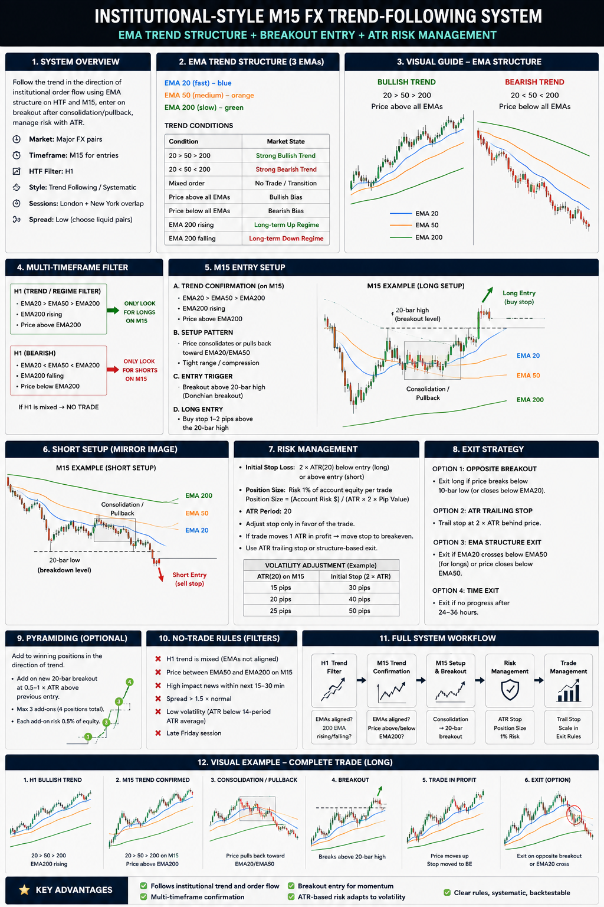

Q: its not clear what are conditions for trade entries and exits?

Yes — the infographic mixed trend filter, setup, trigger, and management, which makes the actual trade rules unclear.

Use this much stricter version:
Stage | LONG | SHORT
1. H1 filter | EMA20 > EMA50 > EMA200, EMA200 rising | EMA20 < EMA50 < EMA200, EMA200 falling
2. M15 filter | EMA20 > EMA50 > EMA200, price above EMA50 | EMA20 < EMA50 < EMA200, price below EMA50
3. Setup | Pullback/consolidation while M15 structure remains bullish | Pullback/consolidation while M15 structure remains bearish
4. Entry trigger | Buy only when price breaks the highest high of previous 20 completed M15 bars | Sell only when price breaks the lowest low of previous 20 completed M15 bars
5. Initial stop | Entry − 2 × ATR(20) | Entry + 2 × ATR(20)
6. Exit | Close when price breaks the 10-bar low | Close when price breaks the 10-bar high

So the actual LONG entry is not simply “EMAs bullish.” All four conditions must be true:
H1 bullish → M15 bullish → pullback/consolidation → M15 20-bar high breakout.

For example:
H1
EMA20 > EMA50 > EMA200
EMA200 rising
↓
M15
EMA20 > EMA50 > EMA200
↓
WAIT
price consolidates / pulls back
↓
ENTRY
price > previous 20-bar HIGH
↓
LONG
SL = Entry − 2 ATR
↓
HOLD
until price < previous 10-bar LOW
And SHORT is exactly mirrored.

One correction to my previous version: I would not move the stop automatically to breakeven after +1 ATR. That tends to cut trend trades too early. For a proper trend-following system, let the 2 ATR initial stop + 10-bar trailing breakout exit do the work.

Also, I would remove EMA-cross exits from the primary rules. Otherwise you end up with several competing exits and cannot properly backtest what the system actually is.

So I would define Version 1 for testing as:
EMA 20/50/200 regime + H1 confirmation + M15 20-bar breakout + 2 ATR stop + M15 10-bar opposite breakout exit.

That is clean, objective and programmable.

I can redraw the infographic with only these exact rules, showing one LONG and one SHORT trade from filter → setup → entry → stop → exit.

Q: please redraw

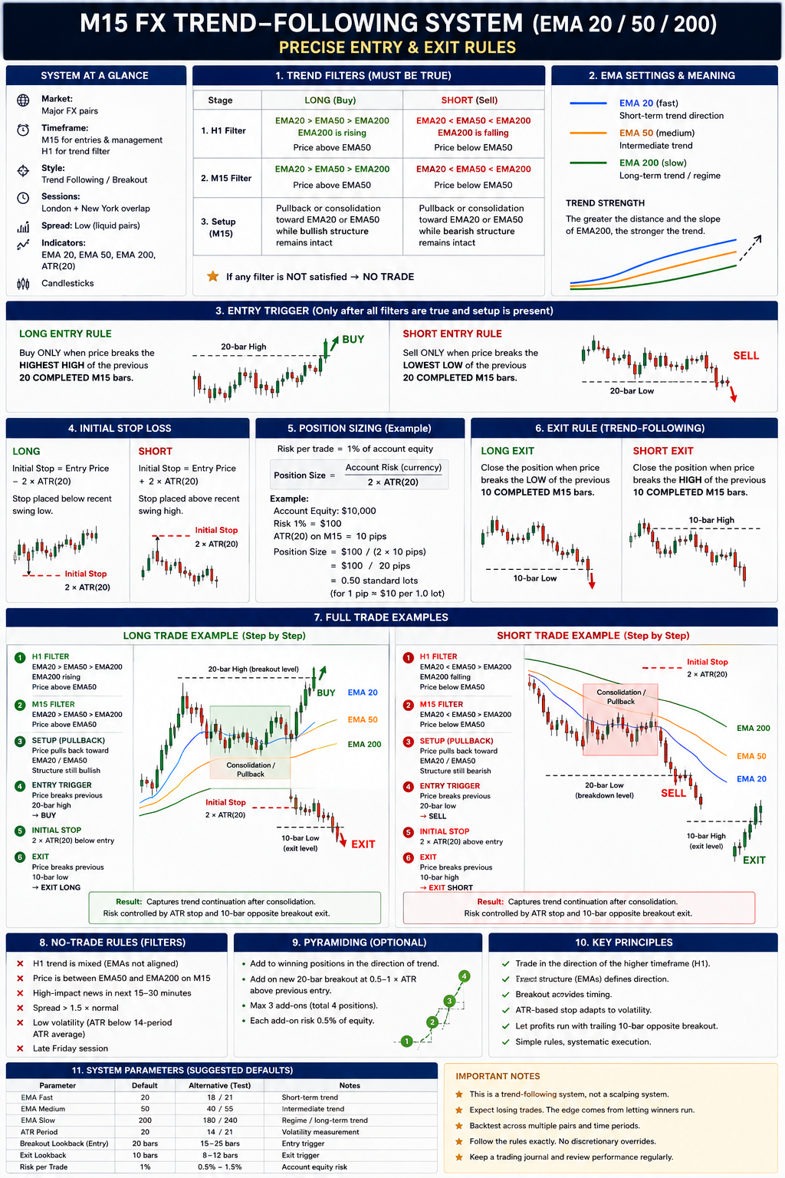

Q: we can actually implement in our SimpleEA, using RRM ORG presset as base, both turtle and modified turtle trading systems as you proposed in previous two chata?

Yes. That is actually a sensible way to do it.

I would keep RRM ORG as the base preset and implement the Turtle logic as an additional selectable entry/exit strategy, without changing the existing risk-management architecture.

Something like:
SimpleEA setting | RRM ORG | TURTLE | TURTLE MOD
Position sizing / risk | existing RRM | same | same
SL/risk handling | existing framework | ATR/N based | ATR/N based
Entry type | current | Donchian breakout | Donchian + filters
Entry channel | — | 20 / 55 | configurable, e.g. 20
Trend filter | existing | none | HTF / EMA
ATR filter | existing | N = ATR(20) | ATR(20) + volatility filter
Pyramiding | existing option | +0.5N, max 4 units | configurable / possibly reduced
Initial SL | RRM | 2N | e.g. 1.5–2N
Exit | current | opposite 10/20 channel | channel / EMA / ATR
Timeframes | existing | any | designed especially for M15–H4

For Original Turtle, I would implement the rules quite literally:

System 1
- LONG: price breaks previous 20-bar high
- SHORT: price breaks previous 20-bar low
- optional original Turtle “previous breakout winner” skip rule
- SL = 2 × ATR(20)
- add position every 0.5 × ATR
- maximum 4 units
- exit LONG: break below previous 10-bar low
- exit SHORT: break above previous 10-bar high

System 2
- 55-bar breakout
- no previous-breakout filter
- 20-bar opposite-channel exit
- otherwise same ATR/pyramiding concept.

Then I would add our Modified Turtle as a separate mode, particularly for FX and M15/H1:

LONG Donchian breakout AND HTF bullish trend AND EMA alignment
For example:
Close > High[20] AND EMA20 > EMA50 AND HTF EMA50 > HTF EMA200 AND optionally ADX / ATR volatility condition
SHORT = inverse.

That gives SimpleEA a clean architecture:
Strategy = RRM_ORG / TURTLE_S1 / TURTLE_S2 / TURTLE_MOD
with RRM continuing to handle money management, lot sizing, limits, trade protection, daily controls, etc.

I prefer this over building another EA. It means we can backtest the exact same execution/risk engine while changing only the signal model. That makes comparisons between RRM ORG, Turtle and Modified Turtle much more meaningful.

