FX - TURTLE TRADING SYSTEM

Q:trading turtles in late 1970? please provide trading methodology: entry, trade management, exit rules. then visualisation of these

You mean the Turtle Trading system developed by Richard Dennis and William Eckhardt in the early 1980s. It was formalized in 1983–84, rather than the late 1970s. I can give you the original-style rules and then visualize them.

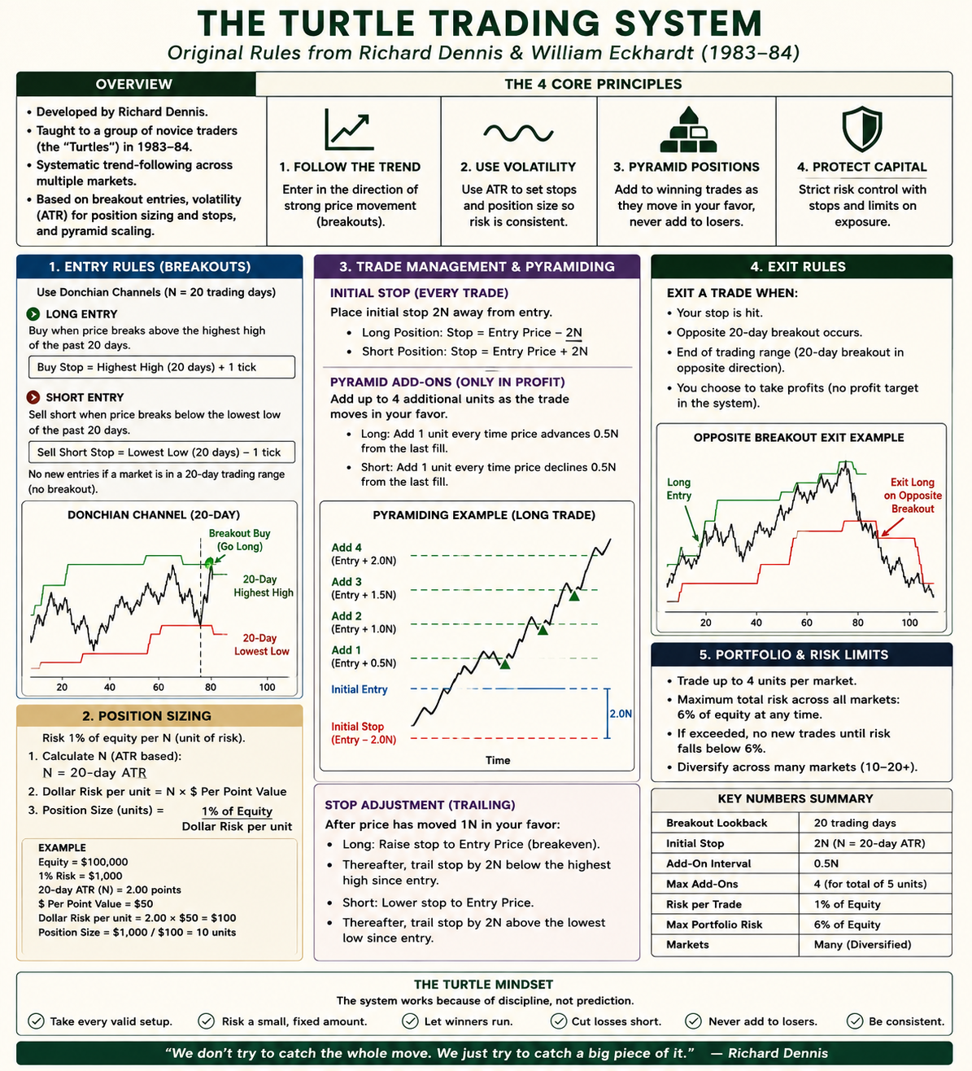

Yes. The Turtle logic can be adapted to FX and different timeframes, but I would preserve the structure rather than mechanically translating “20 days” into “20 candles.”

The original system is essentially a volatility-normalized breakout model:
Breakout → enter → ATR-based risk → add only to winners → channel exit.

For FX, a practical translation could be:
Style | Chart | Entry | Volatility N | Exit | Typical use
Position | D1 | 20/55 bars | ATR(20) | 10/20 bars | Closest to original
Swing | H4 | 30–60 bars | ATR(20) | 15–30 bars | Very suitable
Short swing | H1 | 40–100 bars | ATR(20) | 20–50 bars | Possible, noisier
Intraday | M15 | 50–150 bars | ATR(20–50) | 20–75 bars | Needs stronger filters
Scalping | M1–M5 | — | — | — | Poor fit for original concept

The important issue is time equivalence. For example, 20 candles on H1 represents only 20 hours, whereas the original 20-day breakout represents roughly a trading month. So Donchian(20) on every timeframe is not really the same strategy.

For FX I would start with something like H4:
LONG: price breaks the previous 40-bar high SHORT: price breaks the previous 40-bar low N: ATR(20) Initial stop: 2 × ATR Add: every +0.5 × ATR Maximum: 4 units total Exit long: break of previous 20-bar low Exit short: break of previous 20-bar high

And it can absolutely be applied across EUR/USD, GBP/USD, USD/JPY, USD/CHF, AUD/USD, EUR/JPY, etc. In fact, diversification across markets was fundamental to the Turtle philosophy: you don't know beforehand which market will produce the big trend.

There is one FX-specific complication: correlations. Being long EUR/USD, GBP/USD and AUD/USD simultaneously can effectively become three versions of a short-USD position. So portfolio-level exposure limits matter as much as individual-trade stops.

Also, I should correct one detail in my previous generated graphic: it shows some rules that aren't an accurate representation of the original Turtle rules, particularly the pyramiding count/stop-management section. The text explanation above the graphic is more accurate than the generated infographic.
If you're thinking about implementing this in MT5, I can make a precise modern Turtle-FX specification for D1/H4/H1, including entry, ATR sizing, pyramiding, correlated-pair limits and exits, suitable for backtesting.

Q: 1. please as you suggest 2. please correct infographic. 3. also what is stronger filter you mentioned for TF M15?

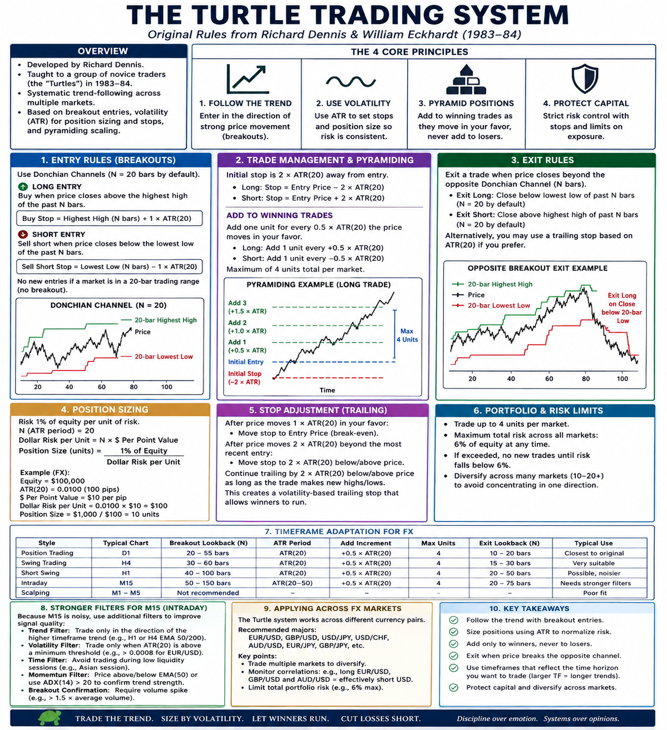

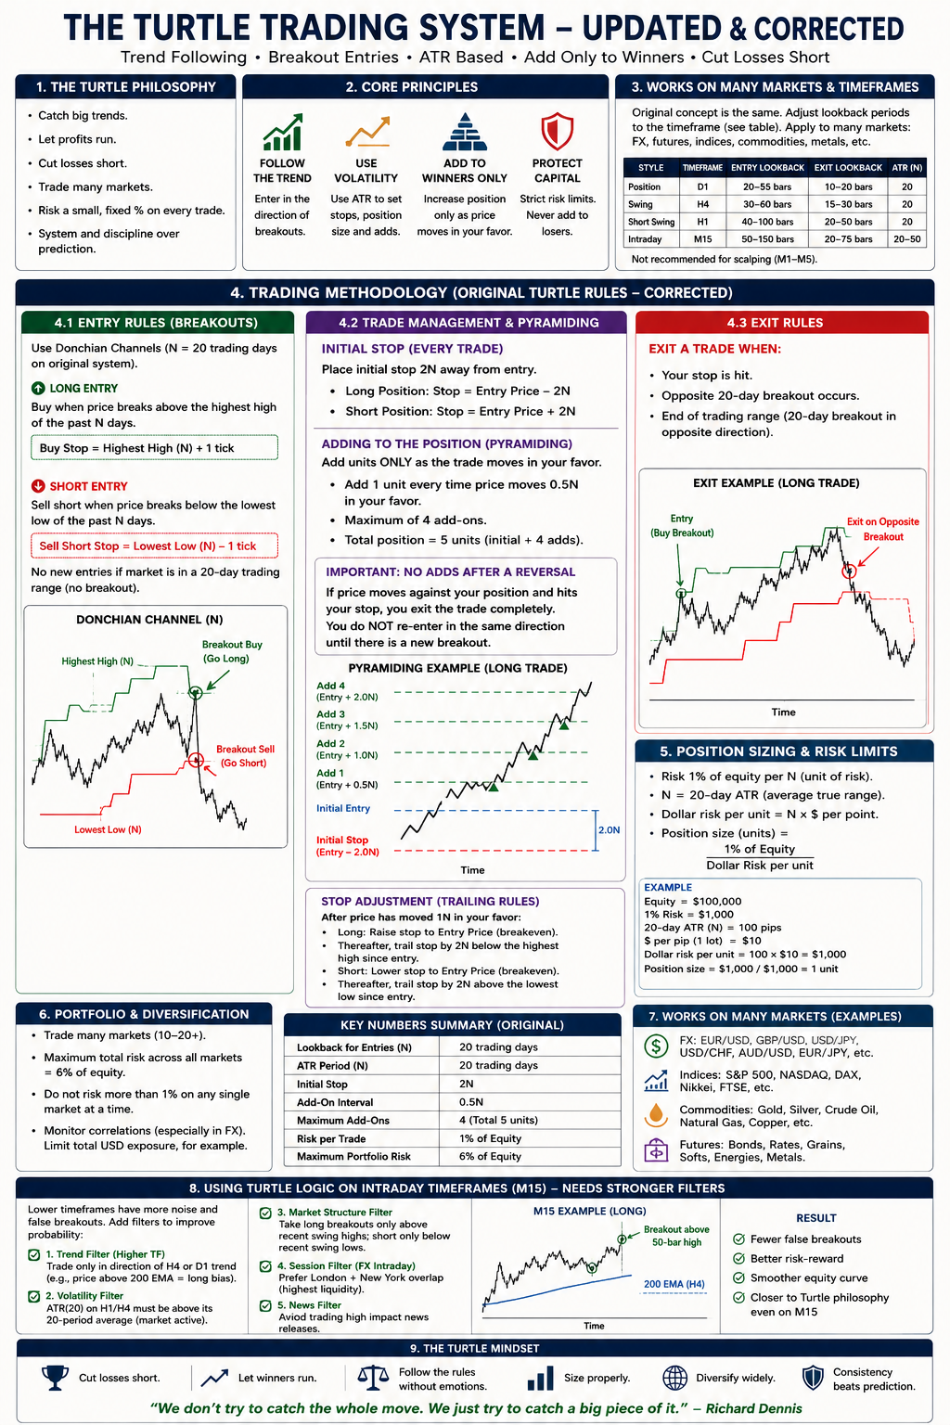

Q: what is stronger filter for TF M15? Is it HTF?

Yes. HTF = Higher Time Frame, and for M15 Turtle-style trading I’d consider an HTF trend filter one of the strongest filters.

For example:
M15 execution + H4 trend filter
- LONG: only M15 long breakouts when H4 is bullish.
- SHORT: only M15 short breakouts when H4 is bearish.
- Ignore M15 breakouts against the H4 trend.

The key question is how to define “H4 bullish/bearish.” I’d test these:
Filter | Long allowed when | Comment
H4 EMA200 | H4 close > EMA200 | Simple, robust
H4 EMA50/200 | EMA50 > EMA200 | Slower, stronger trend confirmation
H4 Donchian | H4 recently broke upper channel | Closest to Turtle philosophy
H4 ADX | ADX > 20–25 + directional condition | Filters weak/ranging markets

For an M15 Turtle-FX system, my starting configuration would actually combine three filters:
1. HTF direction: H4 close > EMA200 → longs only; below → shorts only. 2. M15 volatility: ATR(20) above its own longer-term average → don't trade dead markets. 3. Session: trade mainly London and London/New York overlap → avoid low-liquidity periods.

Then the actual M15 signal could remain purely Turtle-like:
H4 trend → M15 50-bar breakout → entry → 2 ATR stop → add every 0.5 ATR → Donchian exit.
So the HTF filter does not trigger the trade. It simply says which direction M15 is permitted to trade.

For example:
H4
Price > EMA200
↓
LONG ONLY

M15
50-bar High ────────────────
↑ breakout
Price ────────╱╲─────╱╲╱───●────→
BUY

Stop = Entry − 2 ATR
Add = +0.5 ATR
+1.0 ATR
+1.5 ATR
Exit = 20–25 bar low

I would not pile on five or six indicators. That easily overfits the system. HTF direction + volatility + session is already a sensible M15 adaptation worth backtesting against the completely unfiltered version.

