Internal Fit Check Prep Note
Companion to the Discovery Summary — used to walk into Discovery already informed by a prospect's online Fit Check. Keep this file in your own internal working folder only. Never rename it into the client deliverable set, never attach it to an email, never export it to PDF for a client.
Client name: [FILL IN]
Fit Check submitted: [FILL IN]
Discovery date: [FILL IN]
Prepared by: [FILL IN]

1. Fit Check classification
For your own reference only. This section, and everything under it on this page, must never appear in anything the client receives.
Bucket (lead / warm / other): [FILL IN]
Profile (FireFight / Refine / Build / Optimize): [FILL IN]
Matrix position: [paste or reference the marked-up matrix image here if useful — internal reference only]
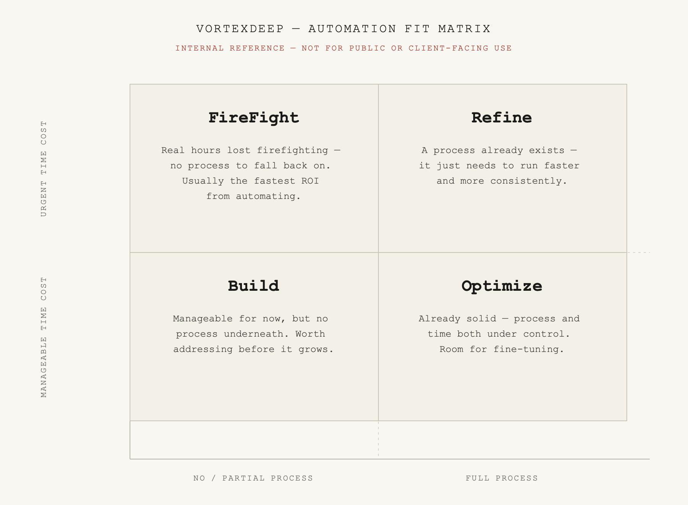

2. What the client already saw on screen
Paste the tagline + description from the “What the client saw on screen” section of the notification email. Useful so Discovery builds on what they already read, rather than repeating or contradicting it.
[Paste tagline + description here]

3. Raw Fit Check notification email
Paste the full email received at info@vortexdeep.ch, verbatim, for your own archive alongside this prep note.
[Paste full email body here]

4. Discovery prep notes
[What to confirm or probe further, based on the Fit Check answers]
[Anything that looks inconsistent between the Fit Check answers and expectations]
[Open questions to raise on the call]

