O | Done
O | Next
O | Future

2026-08-02 KW31
26W31 - Week 0 — the site is live (build-in-public). Post:
Small milestone: VortexDeep now has a home → vortexdeep.ch
It's still in preparation — I'm building and testing the methodology, not selling anything. But the site is live, and so is the first useful thing on it: a 2-minute Fit Check.
Six short questions about your role, your area, and where you are today. At the end you get a plain recommendation on where automation would actually help — and, just as importantly, where it wouldn't. No signup, no sales call. If the honest answer is "don't automate that yet," it'll tell you so.
I'd value a few of you kicking the tyres and telling me where it's wrong — that feedback is the whole point of this phase.
Take the Fit Check → vortexdeep.ch 👇
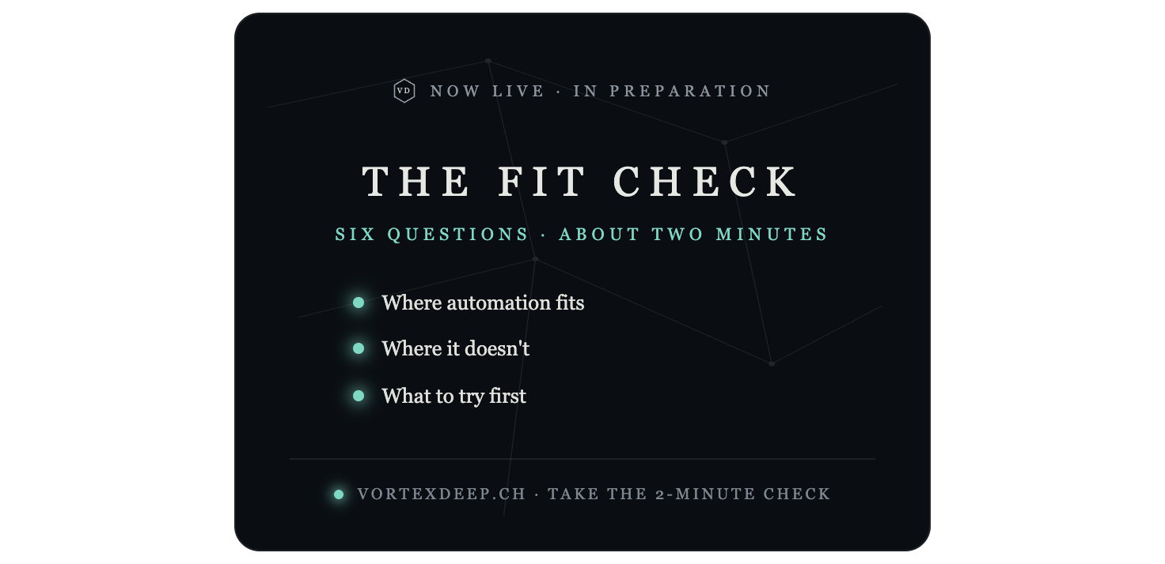

2026-08-09 KW32
26W32 - Week 1 — AI with you, not for you (contrarian).

Use the "Blue Ocean angle" post I drafted earlier, paired with the "Should you automate it?" checklist card I already rendered above — that's Week 1's graphic, no need to remake it.
PNG:
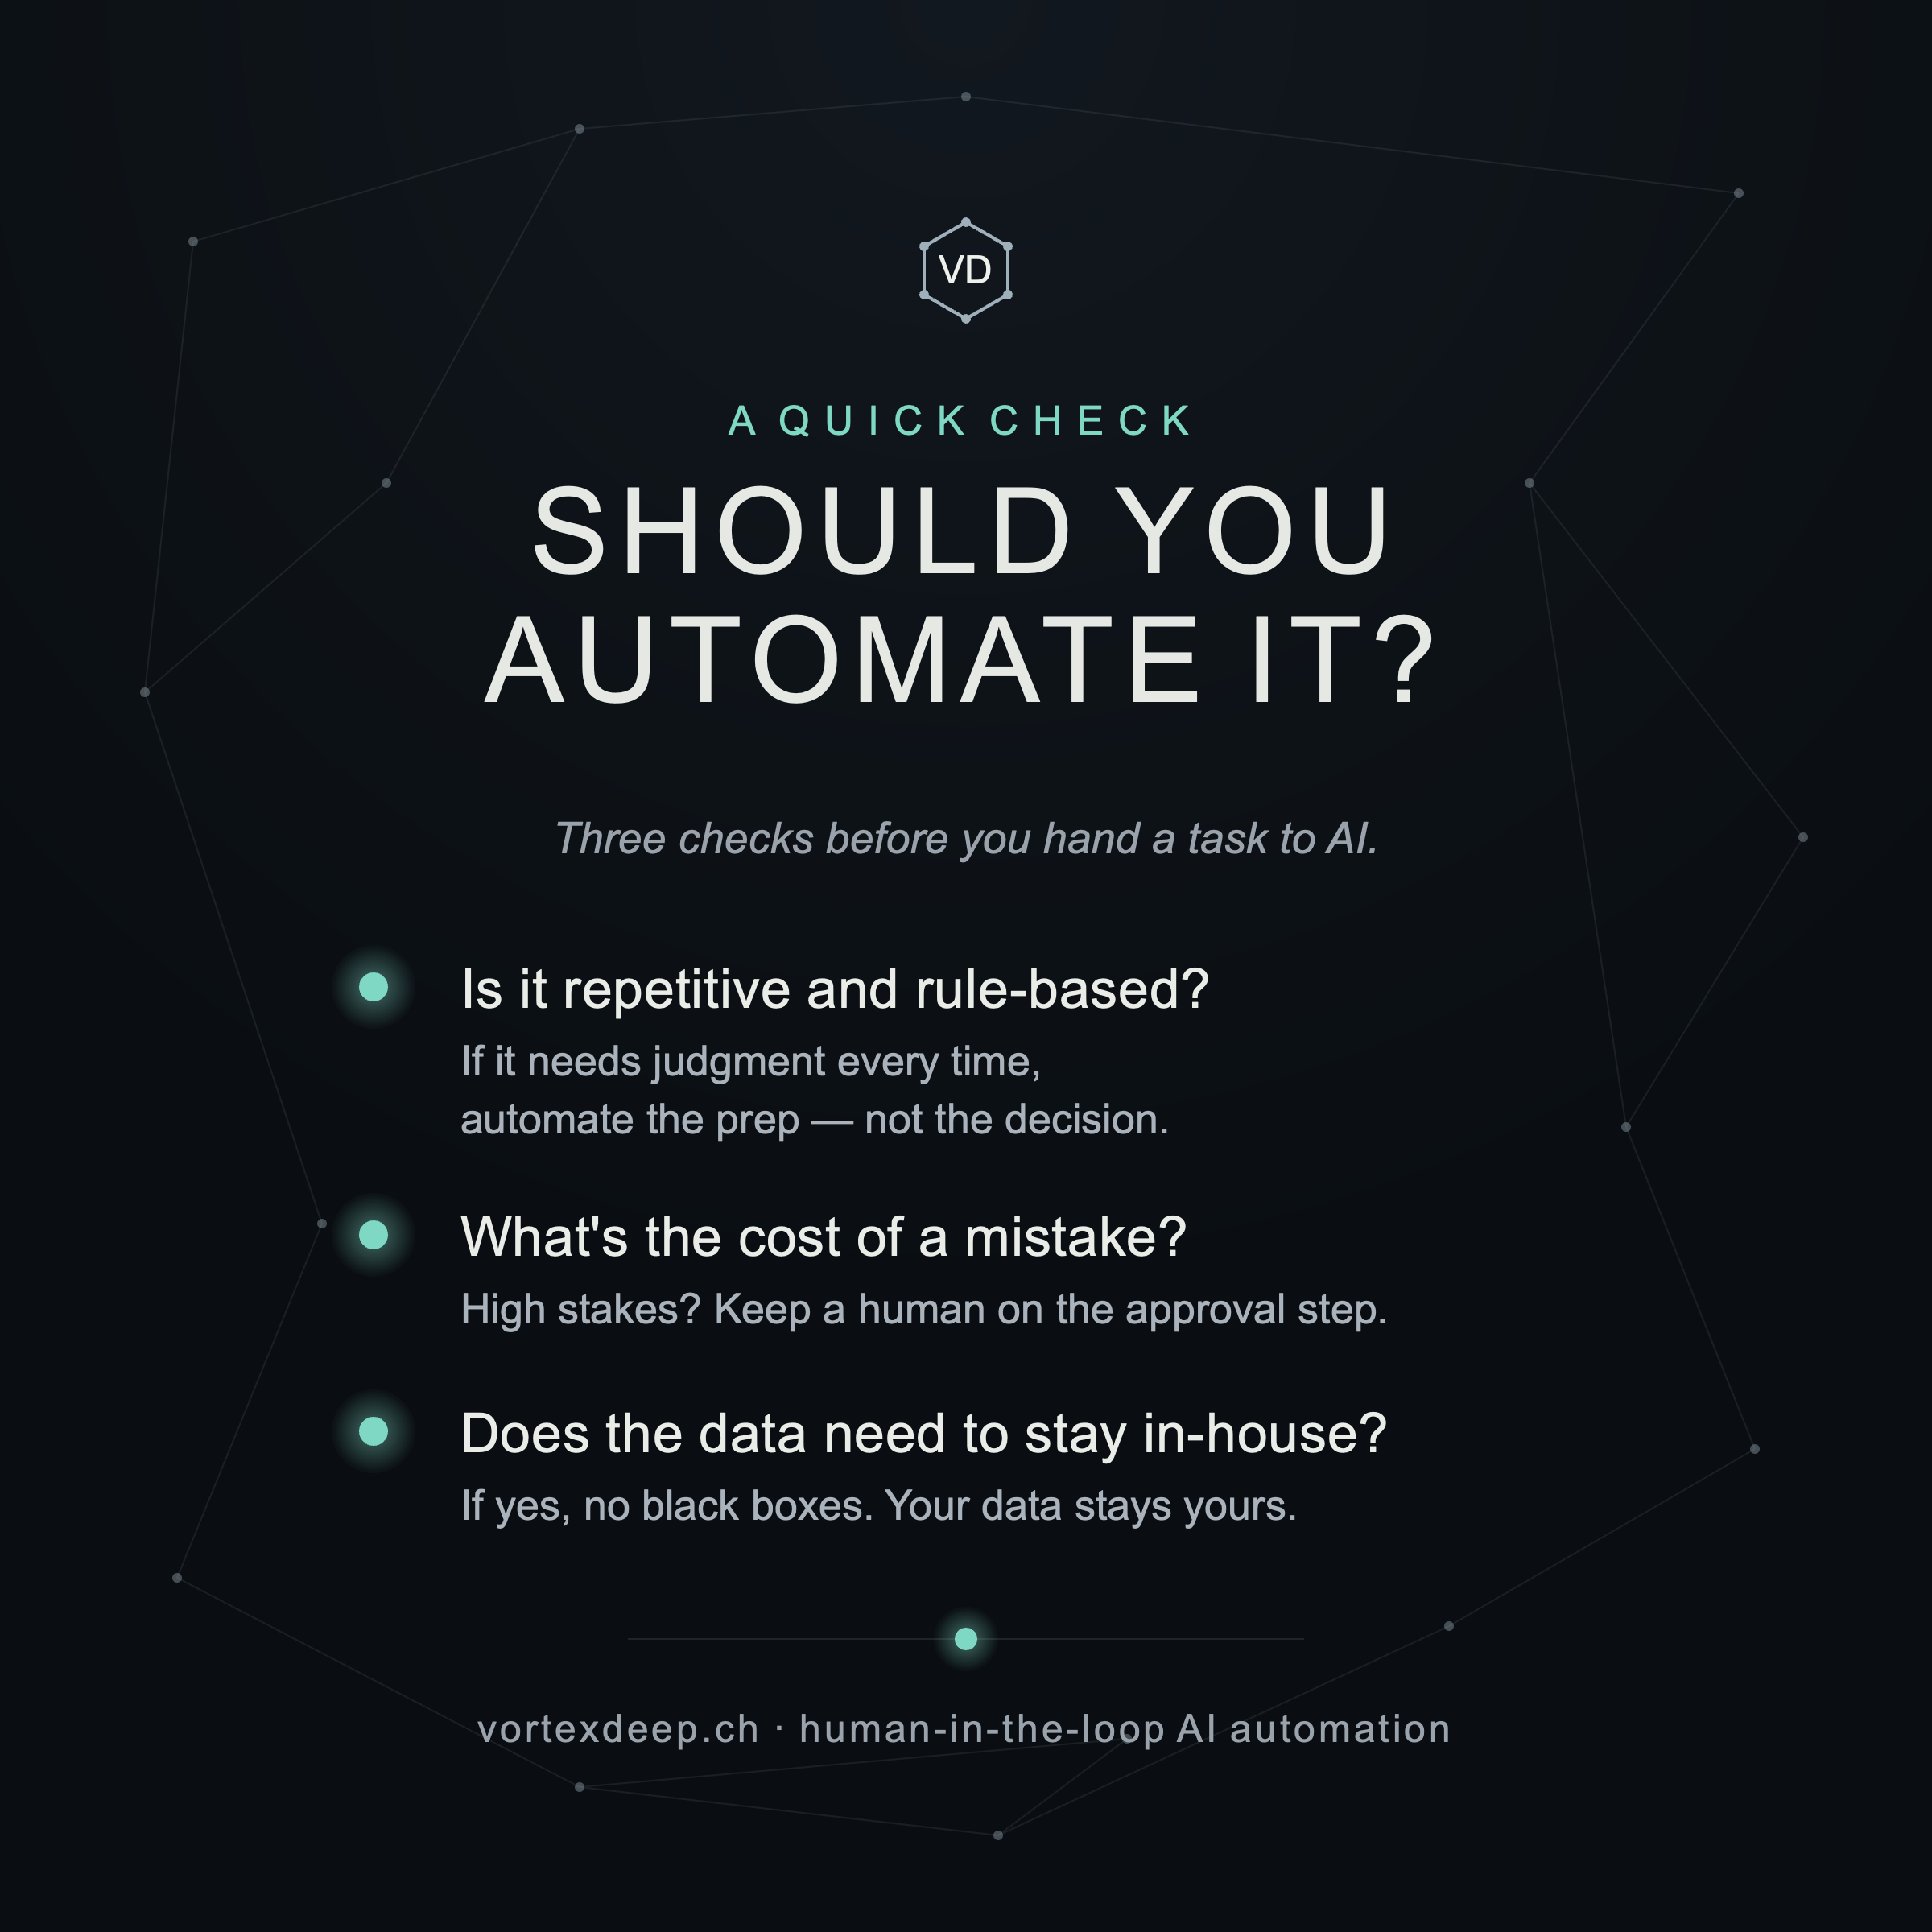

26W32_Post_v01:
Most AI automation is competing on the same thing right now: how much it can do without you. More autonomy. More "set it and forget it." More steps taken while you're not looking. After 20 years in industrial engineering, that's exactly the part that makes me — and most of the B2B operators I talk to — uneasy. Not the automation. The "without you." So VortexDeep is being built on the opposite rule: a human approves every step. Nothing is sent or filed on its own. Your data stays yours. That sounds like a limitation. I think it's the market. There's a large, mostly-ignored middle: teams drowning in repetitive admin who still won't hand a black box the keys. Too cautious for "full autonomy," too busy for "build it yourself." Not a cheaper or faster automation tool. A different one — automation you actually stay in control of.Still in preparation: building and testing the methodology, learning from people who live these problems daily. Nothing to buy yet. If repetitive admin is quietly eating your team's week, I'd like to hear what you wish existed. 👇

26W32_Post_v02:
Most AI automation competes on the same thing: how much it can do without you. More autonomy. More "set it and forget it." After 20 years in industrial engineering, that's the part that makes me — and most operators I talk to — uneasy. Not the automation. The "without you." So VortexDeep runs on the opposite rule: you approve every step. Nothing is sent or filed on its own. Your data stays yours. Sounds like a limitation. I think it's the market — the cautious middle that's drowning in repetitive admin but won't hand a black box the keys. Still in preparation, nothing to buy yet. If that sounds like your team, what do you wish existed?👇

Week32_Post_v03:
Most AI automation competes on one thing: how much it can do without you.
More autonomy. More "set it and forget it."
After 20 years in industrial engineering, that's the part that makes me — and most operators I talk to — uneasy.
Not the automation. The "without you."
So VortexDeep is built on the opposite rule:
You approve every step.
Nothing is sent or filed on its own.
Your data stays yours.
Sounds like a limitation. I think it's the market — the cautious middle that's drowning in repetitive admin but won't hand a black box the keys.
Still in preparation. Nothing to buy yet.
If that sounds like your team — what do you wish existed? 👇

26W32 Post_v04:
Most AI automation seems to compete on one thing: how much it can do without you.
More autonomy. More “set it and forget it.”
But that’s also the part that makes many people hesitate.
Not the automation itself — the “without you.”
I think there’s another way to build it.
Let AI do the repetitive work.
Keep a human on the decisions that matter.
Keep control of what gets sent, approved or recorded.
Keep your data yours.
That may sound less ambitious than full autonomy. I think for many B2B teams it may actually be more useful.
VortexDeep is still in preparation, and that’s the direction I’m testing.
If you could automate one repetitive task without giving up control, what would it be? 👇

26W32_Post_v05
Most AI automation seems to compete on one thing: how much it can do without you — the human.
The goal is more autonomy. More “set it and forget it.”
But what makes many people hesitate isn’t the automation itself. It’s the “without you” part.
There’s another way to build it — and it can be structured.
Let AI handle the repetitive work.
Keep a human involved where judgment matters.
Keep control over what gets approved, sent or recorded.
Keep your data yours.
That may sound less autonomous. But for many B2B teams, it may be much more useful.
If you could automate one repetitive task without giving up control, what would it be? 👇

2026-08-XX KW33
26W33_Week02 — where the admin time actually goes (build-in-public). Post:
After 20 years in industry — and a lot of recent conversations — the same time-sinks keep coming up when B2B teams describe their week. Not the big, hard problems. The small repetitive ones that quietly stack up:
• Copying the same data between tools that don't talk to each other • Chasing people for status updates • Re-formatting and filing the same documents • Retyping near-identical email replies
None of these need intelligence. They need structure. And that's the layer most teams never get to — because they're too busy doing them. That's the part I think is worth automating first: the low-judgment, high-frequency work, while the decisions stay with a human.
What's the one repetitive task that eats the most time in your week? I'm collecting these. 👇
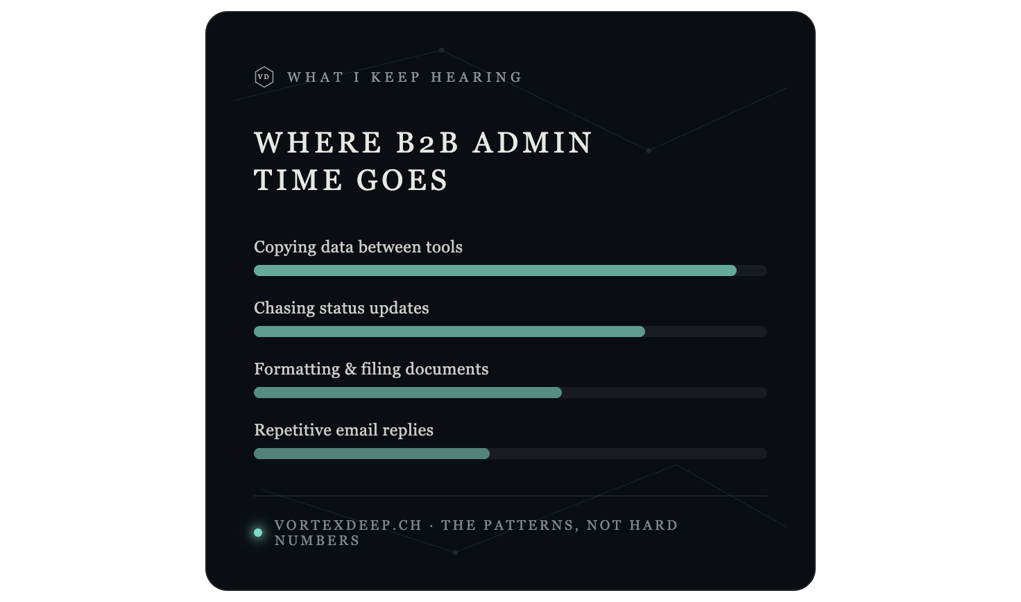
Note I labelled that one "the patterns, not hard numbers" — since the bars are relative impressions, not invented statistics, keeping it honest.

2026-08-XX KW34
26W34_Week03 — prove the number first (domain credibility). Post:
A habit from 20 years in industrial engineering that I refuse to drop in AI work: prove the number before you build.
In engineering, you don't install a heat-recovery system because it "feels efficient." You measure the flows, quantify the savings, compare the options — then decide. The number tells you whether it's worth it.
Automation deserves the same discipline. Before automating a task, I want three things: measure it (how often, how long, how error-prone?), cost it (what does that add up to per month?), then decide — automate only the parts that pay back.
Most "AI will save you time" claims skip straight to the last step. That's how you end up automating something that never mattered.
What would you want measured before you'd trust an automation? 👇
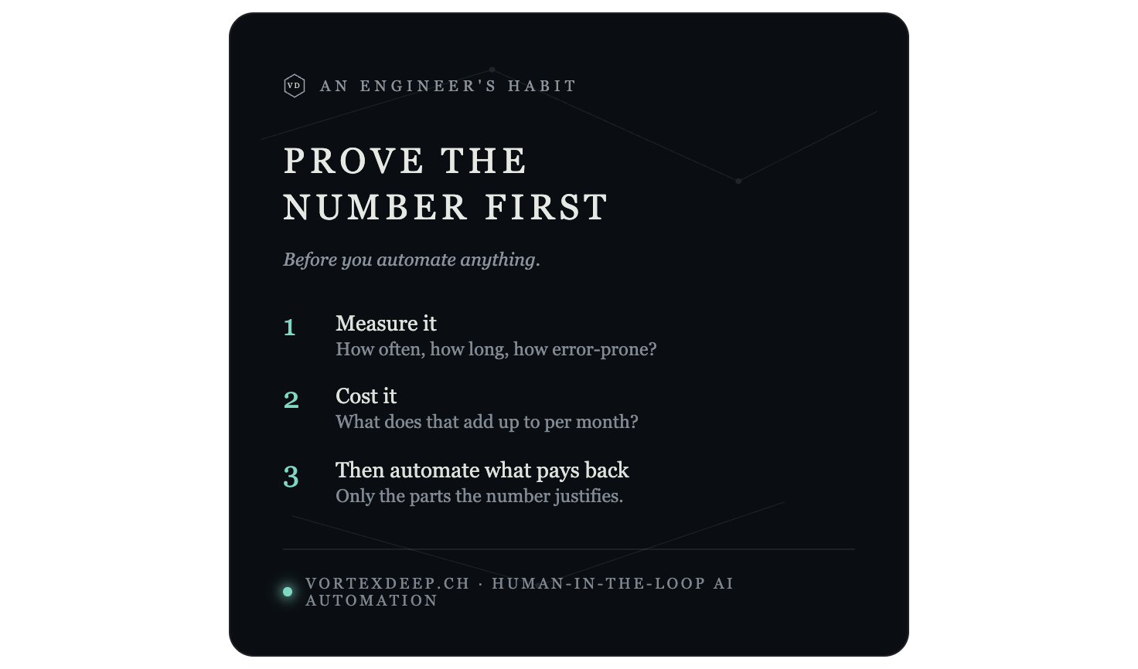

Week 4 — the market everyone skips (Blue Ocean lens). Post:
Every AI-automation vendor seems to be racing down the same track: more autonomy, more "set it and forget it," more done without you. They're all competing in the same water.
Here's the market I think they're stepping over: the large, cautious middle. B2B teams buried in repetitive admin who won't hand a black box the keys — too wary for full autonomy, too busy to build it themselves. Everyone's either selling them "trust the machine" or "do it yourself." Almost no one builds the thing in between.
That in-between is VortexDeep's whole reason to exist: automation that preps and structures the work but keeps you on every decision. Not a cheaper autopilot — a different category.
Am I reading the market right? If you're in that cautious middle, what would make you trust an automation? 👇
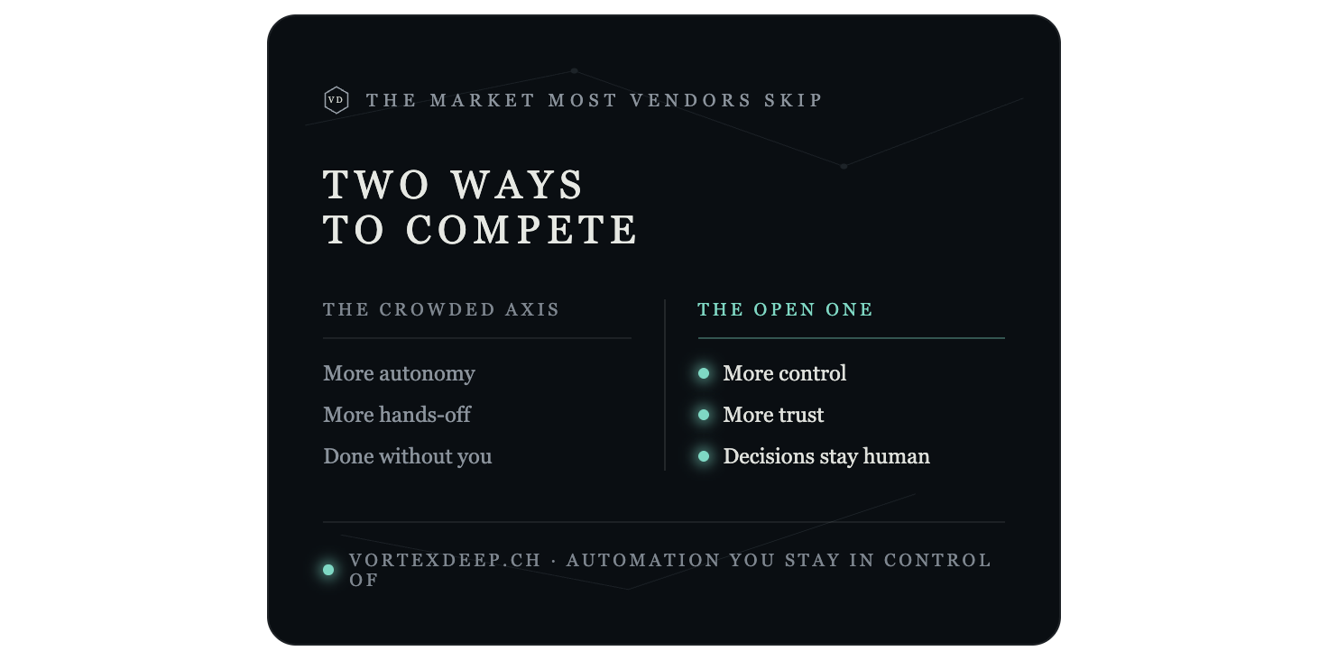
That's the full five weeks: Week 0 announces the live site, then the four lanes rotate — contrarian, build-in-public, domain credibility, Blue Ocean — each with a post and a graphic that all share the one template (dark network, VD hexagon, single accent dot, vortexdeep.ch footer). Post Week 0 this week, then one a week; reply fast to every comment, and drop the Fit Check link softly (Weeks 0 and 4 already do).
Two honest reminders before you post: swap in real specifics where you can — in Week 2, use the actual tasks people tell you, and in Week 3, if you have a real (even rough) heat-recovery figure, one concrete number will outperform the generic method. That specificity is your credibility edge over every generic AI-automation account.
What you've seen here are live web renders, not files. When you're happy with the look, I can produce each as a proper downloadable asset — SVG at 1080×1350 for crisp LinkedIn portrait images, ready to convert to PNG — plus a single reusable template where only the title and the lines change, so all five stay visually identical. Want me to generate those five image files next?

The wrap-up: one ownable angle per video, as a calendar
You now have far more good material than weeks, and much of it overlaps (control, process, gratitude, worst-case, "others' opinions," flow all recur). So here's the discipline: one distinct, non-overlapping post per video, continuing after your first five weeks (0–4). Each keeps the VD card style.
Wk | Video → angle | Post hook (seed) | Graphic (VD card)
5 | V1 · the pause | "There's a Stoic idea at the core of what I build — the space between stimulus and response. Automation that keeps that space: you still make the call." | STIMULUS → ( space ) → RESPONSE, accent dot marking the pause = the approval step
6 | V3 · whose feedback | "I'm building in public. Here's how I decide which feedback to act on: competence over volume — the people living the problem, not the loudest voice." | Two columns: Volume (muted) vs Competence (accent)
7 | V5 · effort curve | "Effort isn't linear. On repetitive admin, more hours = more output — so let a machine do it. On judgment work, grinding harder makes it worse. Automate the first; protect people for the second." | A small 3-line chart: linear / diminishing / reversed, "automate here" on the linear part
8 | V2 · reactive→creative | "Most teams are stuck reacting — firefighting admin all day. Good automation doesn't just save time; it pulls you back into creating, not reacting." | REACTING → CREATING, signal-through-noise motif
9 | V4 · wade in | "Nobody should cannonball into AI. Wade in — automate one low-risk, human-approved task, prove it, go deeper. (Engineers don't say 'failure' — they say 'result error.' It's data.)" | "DON'T CANNONBALL. WADE IN." — four steps: toe → knee → waist → swim
10 | V6 · when X, then Y | "The Stoics had a rule: 'when X, then Y' — a response decided once, not reinvented each time. That's what a good automation is: your best judgment captured once, applied consistently — you still approve the calls that matter." | WHEN X → THEN Y, with a "you approve" checkpoint on the arrow
11 | V7 · flow | "Repetitive admin is too easy — it bores people out of flow. Automate the boring so your people can do the work that matters — and stay the player, not a passenger." | A boredom ↔ challenge band, "automate the boring" marked on the low end
Overlaps I deliberately retired (so you never post the same idea twice): dichotomy of control, memento mori, gratitude, worst-case rehearsal, Dweck/childhood, Schopenhauer's "lack," and the inner citadel — all recurred across the seven and are folded into the angles above rather than given their own posts.
Two adjacencies to space out, so they don't feel like repeats:
- Week 9 "wade in" is close to Week 1 "cautious middle" — but Week 1 is about who the market is, Week 9 is about how they adopt. Keep a few weeks between them.
- Week 10 "when X, then Y" is close to Week 3 "prove the number" — Week 3 is measure first, Week 10 is encode judgment. Space them too.
On pacing: these seven all run "philosophy → product," so don't fire them seven weeks straight. Interleave a pure build-in-public update (what you tested, a number you learned, a small win) every second or third week, so the feed breathes and doesn't read as a themed series.
If you'd like, I'll do for Weeks 5–11 exactly what I did for 0–4: write each post out in full in your voice, and generate the 1200×1200 PNGs in the same template. Want all seven, or just your favourites first?

Q: good not to repeat the same ideas twice (post after post, but when separated and not exactly the same then i think its fine, like your week9 and week10 example). Source i thinks should be also mentioned like Heraklit, WuWei, Schopenhauer etc? does it make a sense? yes please provide short posts and html csvg and png graphics

Both good calls. Spacing similar ideas apart (like Weeks 9 and 10) is completely fine — repetition only hurts when it's back-to-back and near-identical. And yes, naming the source is smart: it signals depth, separates you from the generic AI-automation feed, and it's honest. The one rule is accuracy and restraint — a light nod, correctly attributed, not a philosophy lecture. So: Frankl for the pause, Wu-wei/Alan Watts for the effort curve, Marcus Aurelius for the rock, the Stoics for "when X then Y," Csíkszentmihályi for flow, and so on.
Here are the seven short posts (Weeks 5–11), each with its source woven in, then I'll build the graphics.

Week 5 — the pause (Viktor Frankl)
Viktor Frankl: "Between stimulus and response there is a space. In that space is our power to choose." That line sits at the core of what I'm building. Most AI automation removes the space — it acts for you. VortexDeep keeps it: the work gets prepped, but you still make the call. Nothing is sent or filed on its own. Automation that protects the pause instead of erasing it. Where would you never want that space removed? 👇
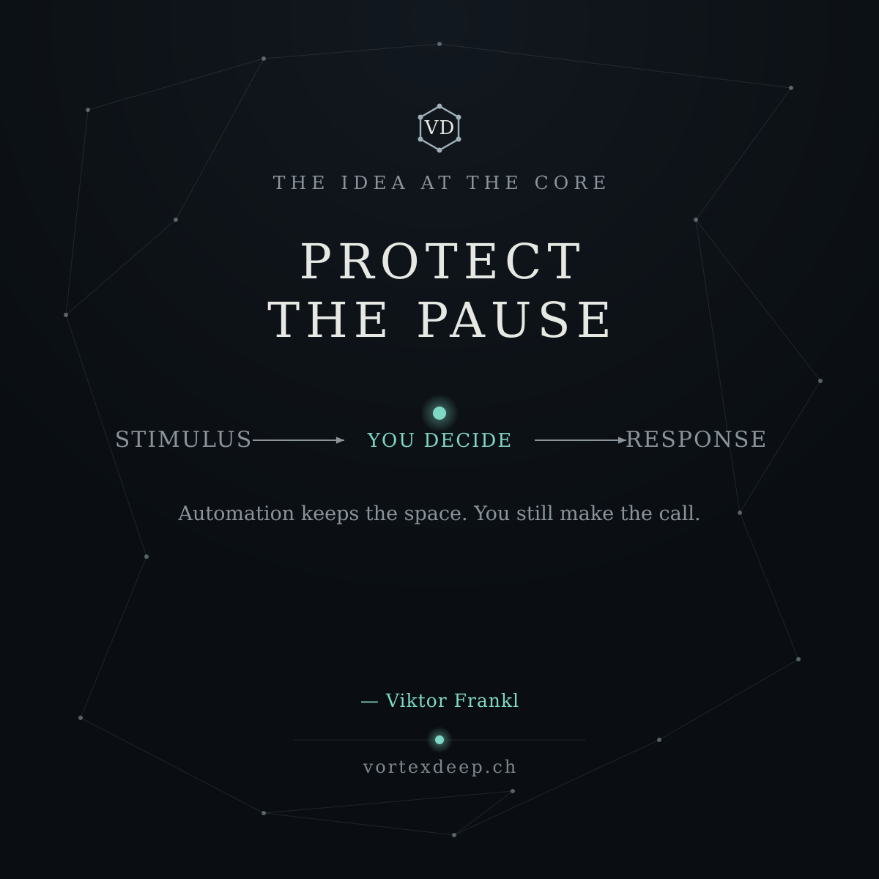

Week 6 — whose feedback (the Stoics)
Building in public means a lot of feedback. The hard part isn't getting it — it's knowing which to act on. The Stoics had the filter: don't be moved by every opinion, only by what's true and useful. My version — competence over volume. The people living the problem outweigh the loudest voice in the comments. So if you run B2B ops and admin is eating your week, yours is exactly the feedback I'm after. What task would you kill first? 👇
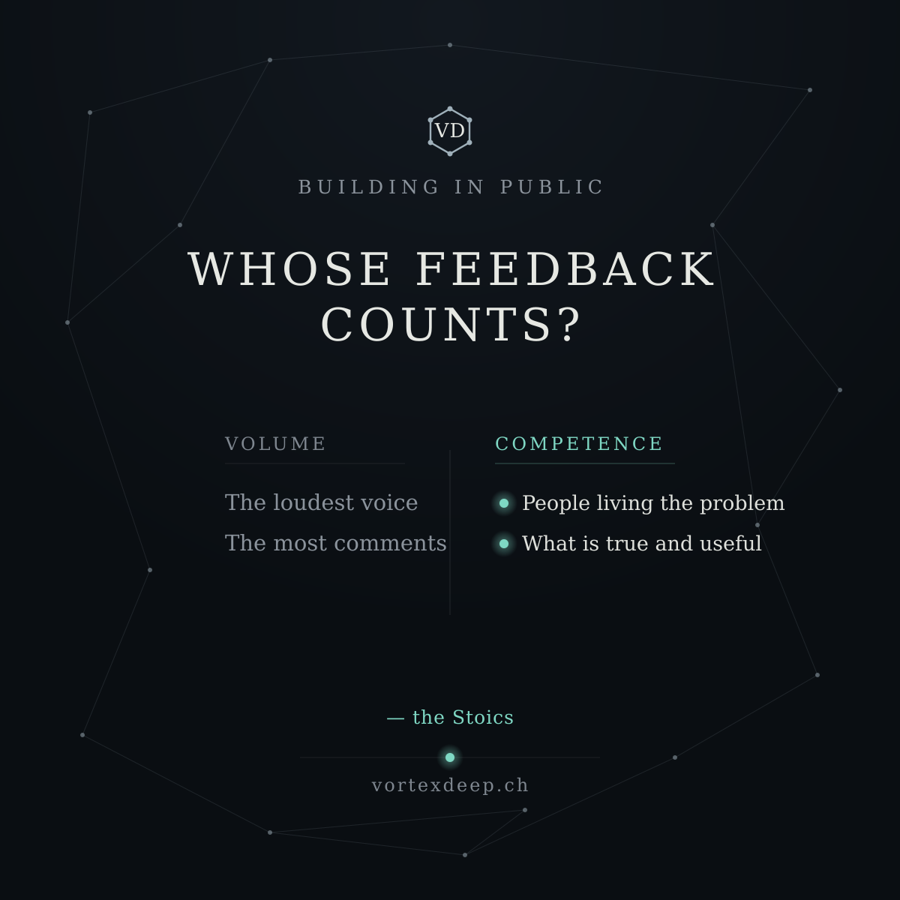

Week 7 — the effort curve (Wu-wei / Alan Watts)
There's a Taoist idea — wu-wei, effortless action — that Alan Watts called "the law of reversed effort": past a point, trying harder makes things worse. It's true for work too. Repetitive admin is linear — more hours, more output — so hand it to a machine. Judgment work is the opposite: grinding more hours makes it worse. Automate the linear. Protect your people for the rest. Which of your team's work is linear, and which needs a human on their best day? 👇
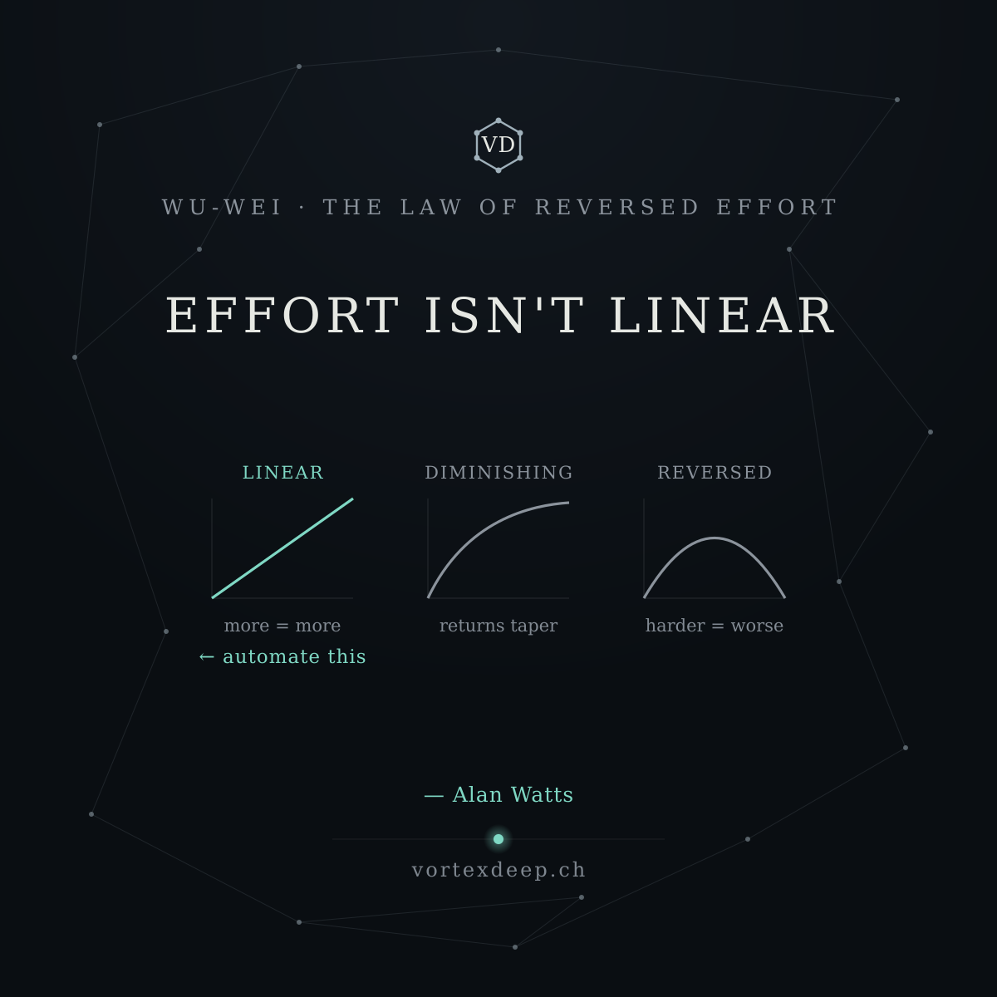

Week 8 — reactive → creative (Marcus Aurelius)
Marcus Aurelius: "Be like the rock the waves break on — it stands, and the sea falls still around it." Most B2B teams never get to be the rock. They're in permanent reaction mode — firefighting admin, tossed by every incoming request. Good automation doesn't just save time. It pulls you out of reacting and back into creating — by handling the noise so the decisions reach a calm human. What would your team build if it weren't firefighting? 👇
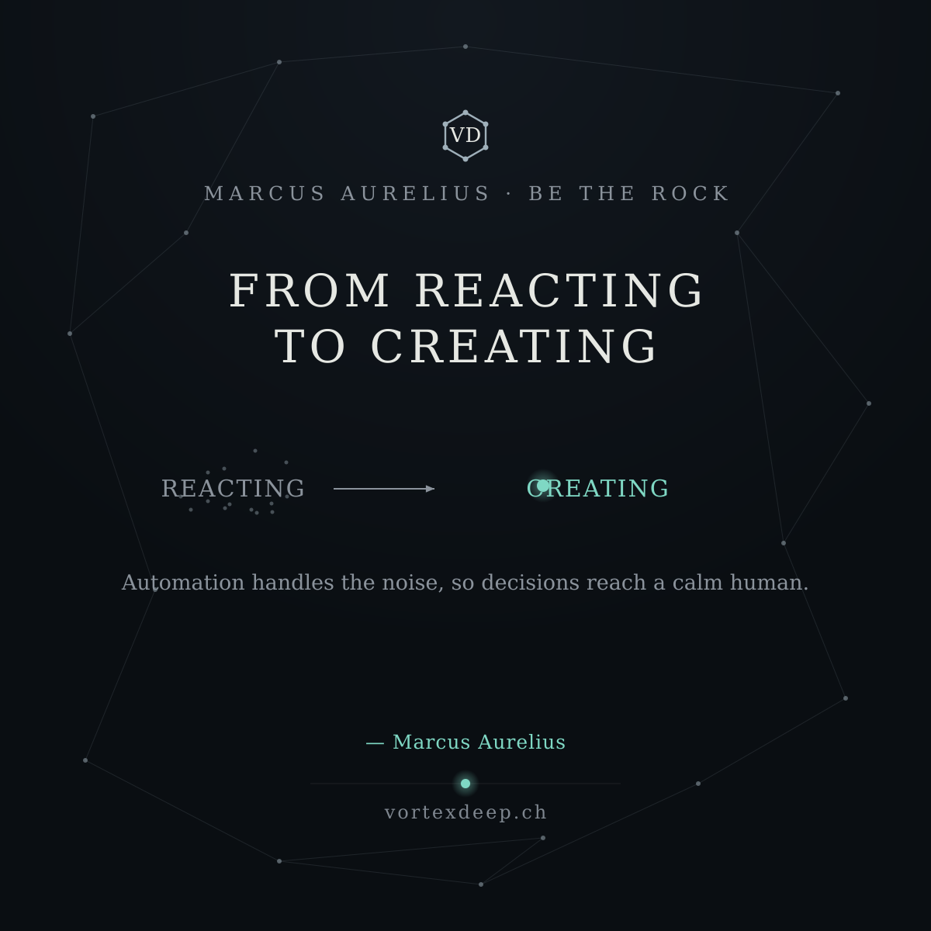

Week 9 — wade in (T. J. Watson)
Nobody should cannonball into AI. Wade in. Automate one small, low-risk, human-approved task. Prove it. Then go a step deeper. Toes, knees, waist — then you swim. And when something goes wrong early? Thomas Watson of IBM framed it right: it's not failure, it's a result error — information, not a verdict. Caught at the approval step, a mistake is just data to iterate on. What's the smallest thing you'd automate first? 👇
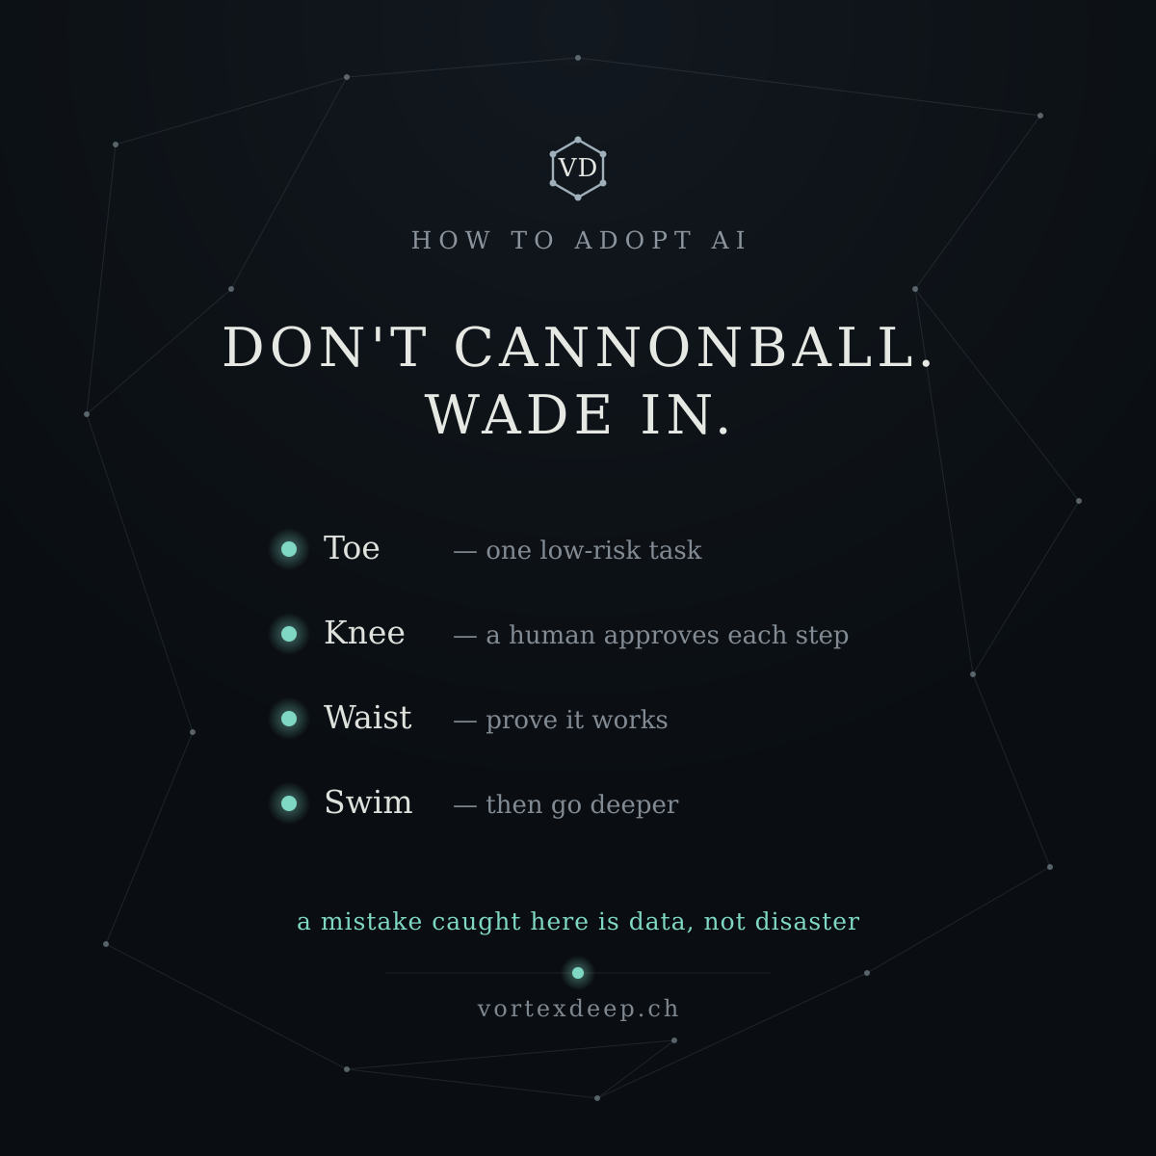

Week 10 — when X, then Y (the Stoics)
The Stoics practised a simple drill: "when X, then Y" — decide your response to a recurring situation once, so you're not reacting from scratch every time. That's exactly what a good automation is. Your best judgment, captured once, applied consistently — with you still approving the calls that matter. Not a robot replacing you. Your own thinking, encoded, so you stop re-deciding the same thing every day. What's a "when X, then Y" you repeat by hand every week? 👇
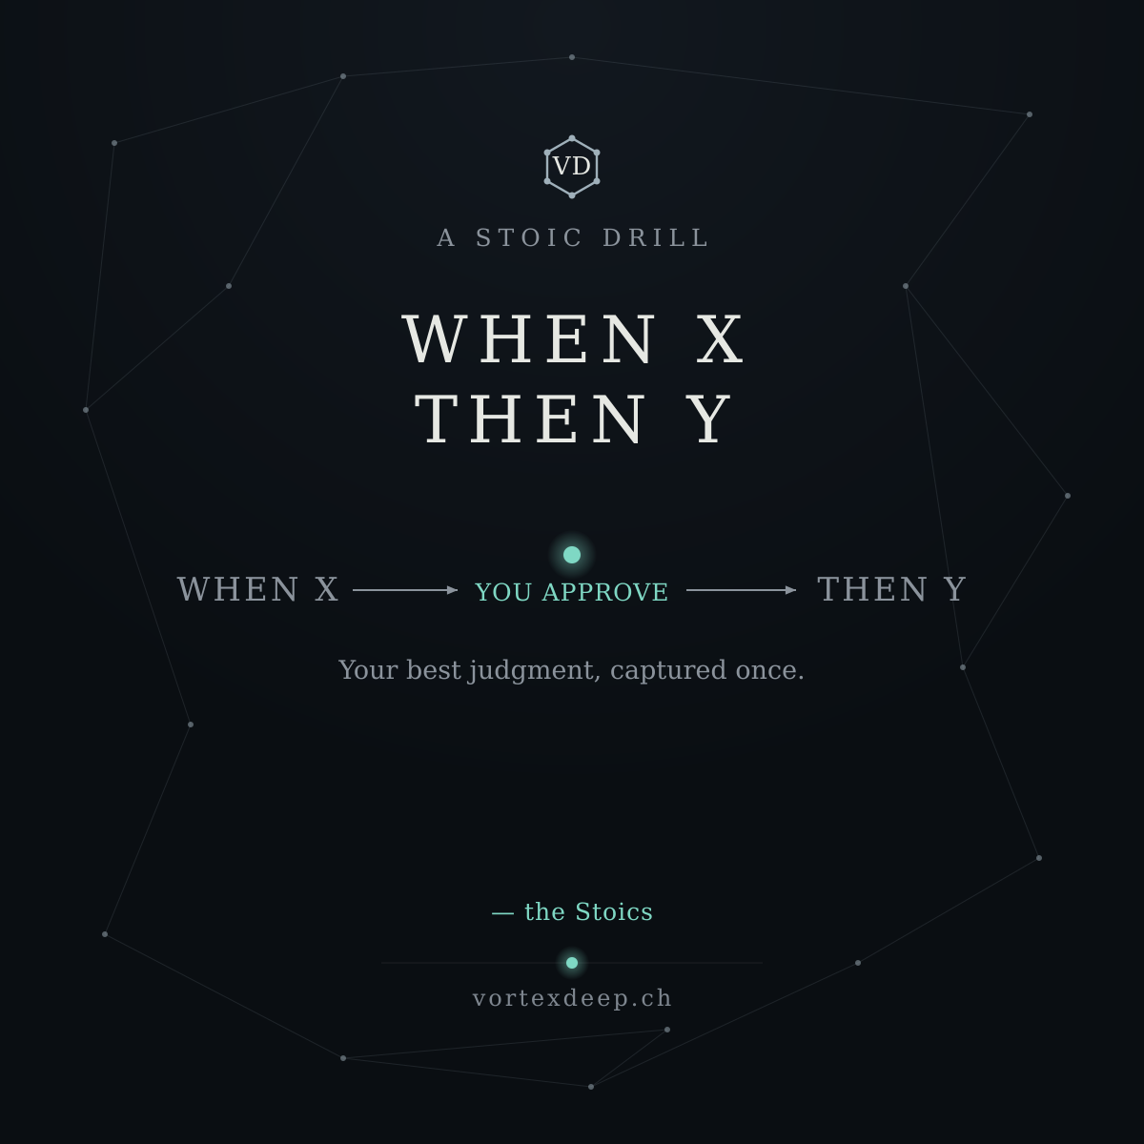

Week 11 — flow / too easy (Csíkszentmihályi)
Csíkszentmihályi's research on flow: we lose focus when a task is too easy just as much as when it's too hard. Repetitive admin is the "too easy" trap — it bores capable people out of their best work. That's not a people problem; it's a task-design problem. Automate the boring, and you hand your team back the work that actually engages them. What's the most mind-numbing task on your team's plate? 👇
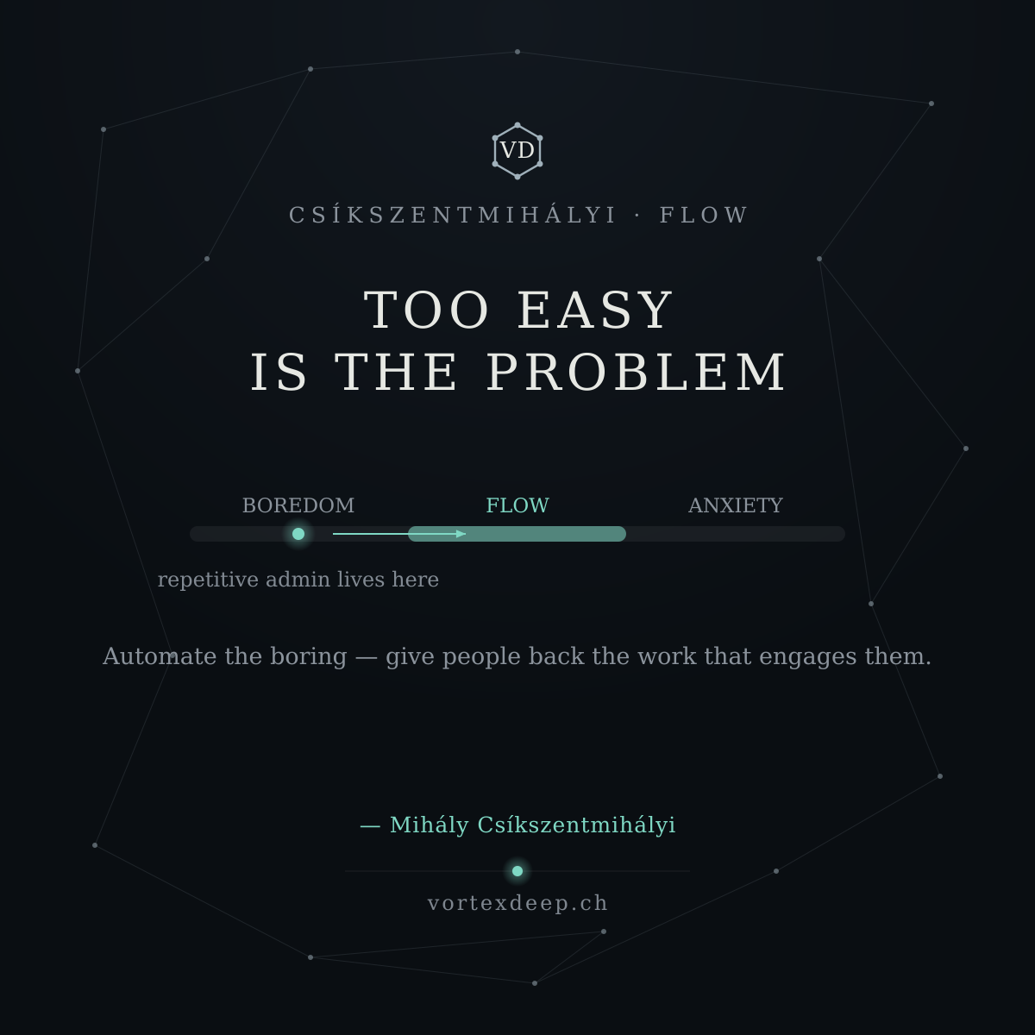

Now the graphics — same 1200×1200 VD template, each with a small source credit line.All seven built. Let me verify a few of the trickier layouts (the effort-curve mini-charts, the flow band, and a flow-diagram card) before handing them over.All seven render cleanly — flow diagrams, the three effort-curves, the flow band, and the accented "Csíkszentmihályi" all came through. Let me package the SVG sources alongside the PNGs.There you have Weeks 5–11: seven short, source-credited posts, each with a matching 1200×1200 PNG in the same VD template, plus a zip of the editable SVG sources.
Each card carries the source as a small accent line — Frankl, the Stoics, Alan Watts, Marcus Aurelius, Csíkszentmihályi — so the credit is visible in the image, not just the caption. The visuals stay one-idea-each: the stimulus→response pause with the approval dot, the volume-vs-competence split, the three effort curves, reacting→creating, the wade-in steps, the "when X → then Y" with a "you approve" checkpoint, and the boredom–flow–anxiety band.
Together with the first batch, you now have a full run: Weeks 0–4 (site-live + the four lanes) and Weeks 5–11 (the seven philosophy→product angles), all visually consistent.
Two small usage reminders:
- The source text lives in the image, so still name it in the post caption too — LinkedIn can't read text inside a picture, and it helps reach and accessibility.
- Keep the spacing discipline you flagged: interleave a plain build-in-public update every couple of weeks so eleven themed cards don't read as one long series, and keep the near-neighbours (Weeks 9 and 10, Weeks 3 and 10) a few weeks apart.
If you'd like, I can also apply the source-credit line retroactively to the Weeks 1–4 cards so the whole set matches, or hand you the build.py so you can spin up new cards by editing a few lines. Which would help more?

Q: beautiful, thank you... you mentioned that these shall not be however posted in a sequence but separated with perhaps more specific automations or analysis etc. I think its very good idea, hence when we have posts numbered now as Week ... 5, 6, 7, 8, ... then actually these philosophy whole numbers will be separated with ... 5.1, 6.1, 7.1,... or 4.1, 4.2, 5.1, 7.1 etc etc. whatever decision would be best to give a breath from idea into practice... However knowing that we actually do not want to post broadly what we are doing, this is our internal knowledge, and share competitors what we are doing... our methodology, way of work etc. ... what i mean is that we have protect ourselves but still giving some valuable context or information to readers = potential clients
This is the exact right tension to be thinking about, and it's a real one for a build-in-public founder: you need to show enough to be credible and useful, without handing competitors your playbook. Let me give you the principle first, then the practical structure you asked for.
The line to hold: share the what and the why, protect the how.
- Safe to share (builds trust, costs you nothing): the problem, the principle, the outcome, and your judgment about what's worth automating. "Repetitive admin traps teams in reactive mode" — a competitor already knows that. "You should keep a human on the approval step" — that's a stance, not a blueprint. Your philosophy posts are all in this zone, which is why they're safe.
- Protect (your actual moat): the methodology — your process for diagnosing a workflow, how you decide what to automate, the structure of your builds, your prompts/configs, the Fit Check's internal scoring logic, client specifics, pricing mechanics. Never post a step-by-step "here's how I build X."
- The useful test before you hit post: "Could a competitor rebuild something from this, or would they just nod?" If they could rebuild → cut it. If they'd only nod → it's fine. And separately: "Does this teach the reader something they can use even if they never hire me?" If yes, it's generous without being self-harming.
The trick is that generosity and protection aren't opposites here. You can give a genuinely useful framework (a way to think) while withholding the implementation (how you actually do it). "Ask these 3 questions before automating a task" helps the reader and shows your judgment — but it doesn't reveal how you'd answer them for a specific client. That's the whole game.
On the numbering / rhythm — your instinct is good. I'd use whole numbers for the philosophy posts and decimals for the practice posts that sit between them, so the cadence alternates idea → practice → idea. But the practice posts should be de-risked versions of your work, not disclosures. Three formats do that safely:
- .1 — Anonymised pattern. "A pattern I keep seeing" — describe a type of workflow problem and how you'd think about it, with no client, no config, no build steps. Teaches; reveals nothing.
- .2 — A small useful tool. A checklist, a rule of thumb, a "red flags that a task shouldn't be automated" list. Pure giving, zero methodology. (Your "Should you automate it?" card is exactly this.)
- .3 — Behind-the-scenes at the feeling level, not the mechanism level. "This week I killed a feature because it broke the one rule" or "I learned X talking to an ops manager." Human, credible, build-in-public — but it's a story, not a spec.
So a stretch might read: 5 (Frankl · philosophy) → 5.1 (anonymised pattern) → 6 (feedback · philosophy) → 6.1 (a small checklist) → 7 (effort curve) → 7.1 (a red-flags list) … idea, breath, idea, breath.
A concrete example of the same insight, shared two ways:
- ❌ Too much: "Here's my 6-step process for mapping a client's inbound requests and the scoring model I use to rank them for automation." (That's your method — competitors take it.)
- ✅ Right amount: "Before I automate any workflow, I ask one thing: what's the cost of getting it wrong once? High-cost tasks keep a human on approval; low-cost ones can run freer. That single question decides more than any tool." (A principle they can use, your judgment on display, nothing rebuildable.)
Two more guardrails worth internalising: keep the Fit Check's internal logic off LinkedIn entirely (promote that it exists and what it gives the user, never how it scores), and when you eventually post real results, share the shape ("cut a recurring task from hours to minutes") not the reproducible specifics.
If it'd help, I can draft a handful of the .1/.2 "breath" posts — anonymised-pattern and small-checklist style — and matching cards, so you've got the in-between beats ready and the whole cadence is filled in without you ever having to decide in the moment how much is too much. Want me to build out, say, three of those to slot between the philosophy posts?

Q: great. yes, please
Perfect — here are three "breath" posts to slot between the philosophy ones. Two anonymised-pattern, one anti-sell checklist. Every one gives the reader something usable while revealing zero methodology — the what and why, never the how.

5.1 — The human router (anonymised pattern)
A pattern I keep seeing in B2B ops: Requests come in — email, forms, chat — and land in a shared inbox with no structure. So a person becomes the router: reading each one, deciding who owns it, copying it somewhere, chasing a reply, re-explaining context. That's not a workload problem. It's a structure problem — the human is doing routing that should happen at the door. The fix isn't "work faster." It's: structure the request as it arrives, so a person starts from a decision, not a mess. (A human still decides. They just stop doing the sorting.) Where in your week are you the human router? 👇
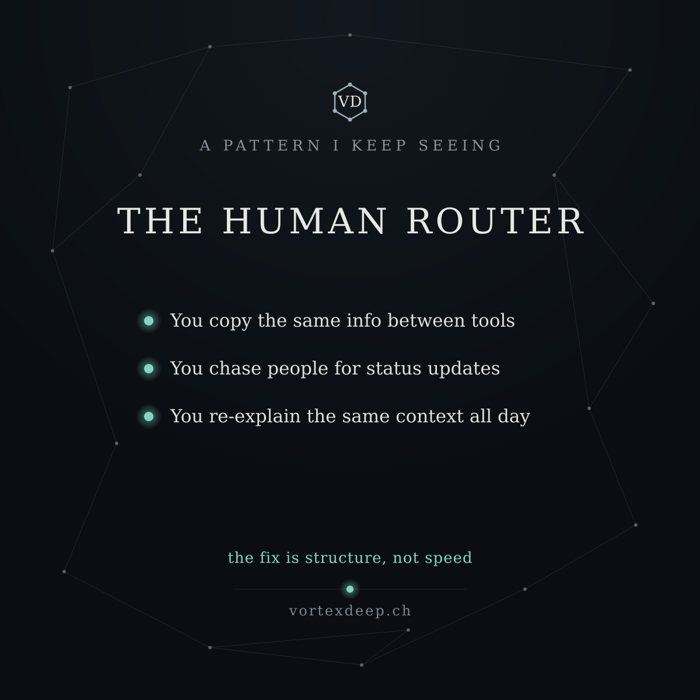

6.1 — Don't automate this (yet) (anti-sell checklist)
An unusual thing for someone building automation to say: sometimes the answer is don't. Four signs a task isn't ready: • It needs judgment every time (no stable rule) • It changes constantly (you'd automate a moving target) • It happens rarely (the effort won't pay back) • Getting it wrong is costly and hard to catch Automate any of these and you usually create more cleanup than you save. The best first automations are boring, frequent, rule-based, and low-stakes. If a vendor never tells you not to automate something — be careful. What were you told to automate that shouldn't be? 👇
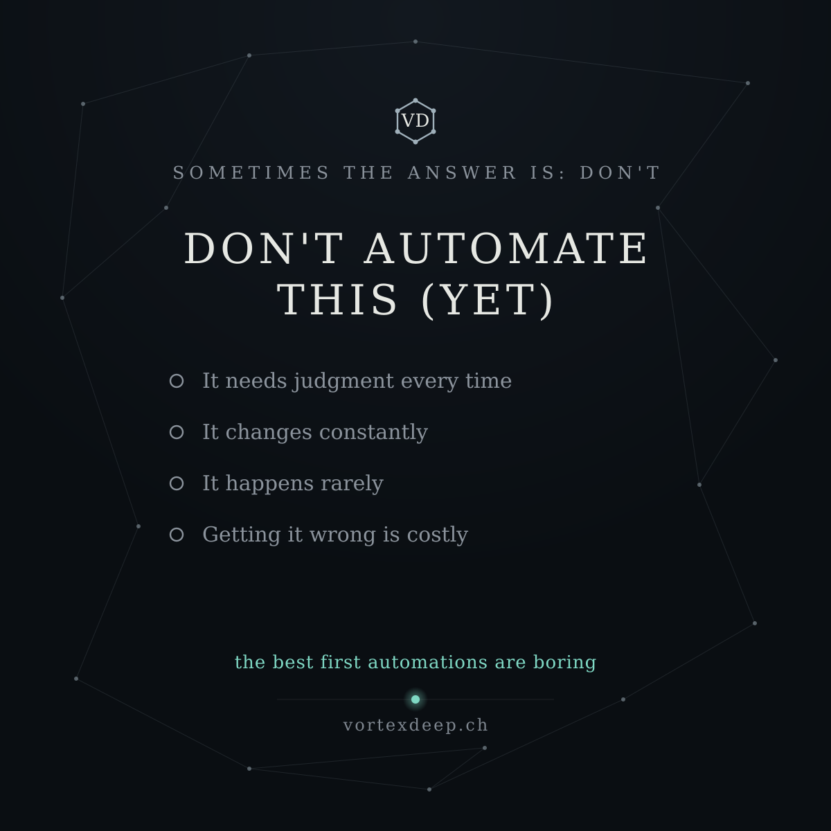

7.1 — The copy-paste tax (anonymised pattern)
Every B2B team pays a tax nobody put on the budget: the copy-paste tax. Someone reads a value in one tool and types it into another. A quote into an invoice. A form into a CRM. A number from an email into a spreadsheet. It feels trivial — 30 seconds here, a minute there. But it's constant, it's where errors creep in, and it fragments attention all day. The tell: your tools don't talk, so a human is the integration. This is the first thing worth structuring — frequent, rule-based, low-judgment. The safe end of the pool. What's the copy-paste you do most? 👇
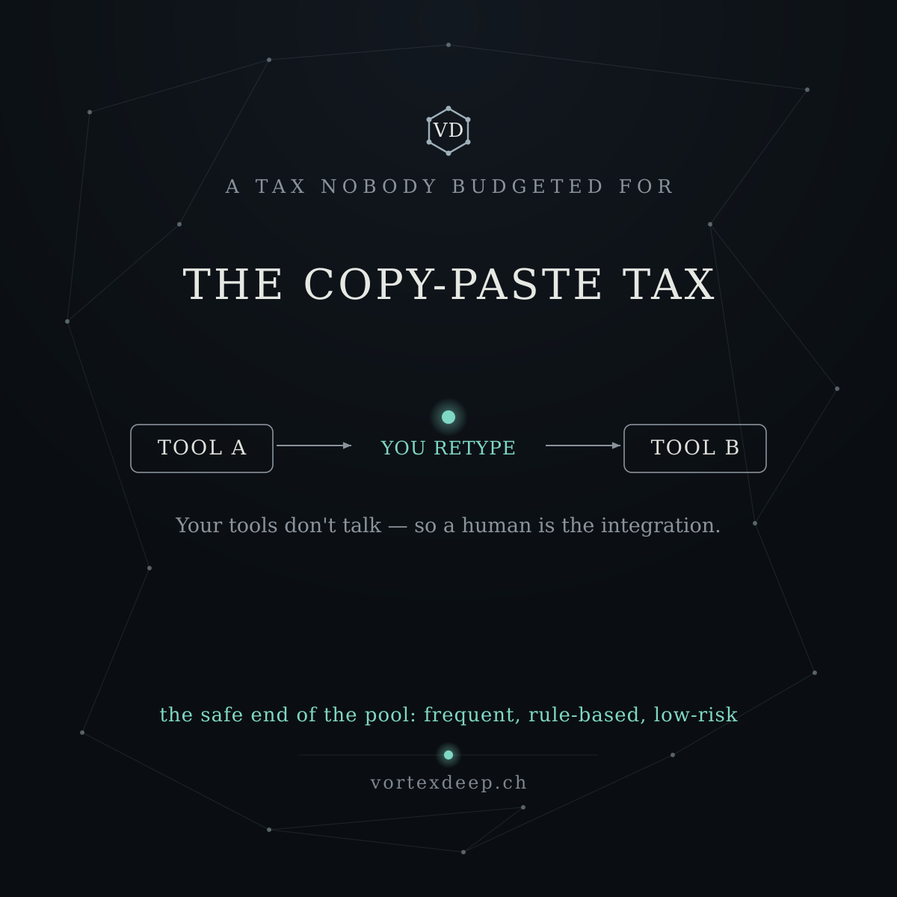

Now the cards — same template, but these use a takeaway line instead of a source credit, and the "don't automate" card uses hollow markers to read as avoid.Both render cleanly — the copy-paste flow (Tool A → you retype → Tool B) and the anti-sell checklist with hollow "avoid" markers to visually distinguish it from the accent-dot "do" cards. Here they are.There are your three "breath" posts (5.1, 6.1, 7.1) with matching cards and the SVG zip — the practice beats that sit between the philosophy posts.
Why these are safe to post: each shares a pattern and a principle a reader can use, but none reveals how you actually diagnose or build. "You've become the human router" and "the copy-paste tax" name problems your prospects feel — they don't hand a competitor your method. And "don't automate this (yet)" is the strongest trust-builder of the three: a vendor telling people when not to buy reads as honest, and it's pure judgment on display with zero methodology leaked. The one that stays off LinkedIn entirely is any post that answers how you'd fix it for a specific case — that's the moat.
A suggested cadence, alternating idea → practice:
5 (Frankl) → 5.1 human router → 6 (feedback) → 6.1 don't automate → 7 (effort curve) → 7.1 copy-paste tax → 8 (rock) …
That gives the feed breath and pairs each abstract idea with something concrete right after.
If it'd help, I can build a few more of these so you've got a full bench of interchangeable breath posts — a couple more anonymised patterns (e.g. "the status-update tax," "the inbox that became a database") and one or two more anti-sell checklists ("signs you automated too early," "what to automate first"). That way you can drop one between any two philosophy posts without ever having to write from scratch. Want me to add, say, three or four more to the bench?

Q: great, please build more of these
Building four more to complete the bench — now every philosophy post (5–11) will have a paired "breath" post to drop in after it. Two more anonymised patterns and two more checklists (one anti-sell, one prioritisation).

8.1 — The status-update tax (pattern)
Another tax nobody budgets for: the status-update tax. "Any update on X?" "Where are we with Y?" "Can you send me the latest?" Someone stops their work to assemble an answer; someone else stopped theirs to ask. Across a team it's hours a week — plus the interruptions that quietly wreck focused work. The reframe: status shouldn't be assembled on demand. It's a byproduct of the work — it should surface on its own, so nobody has to chase it or produce it. How many "any update?" pings fly around your team in a week? 👇
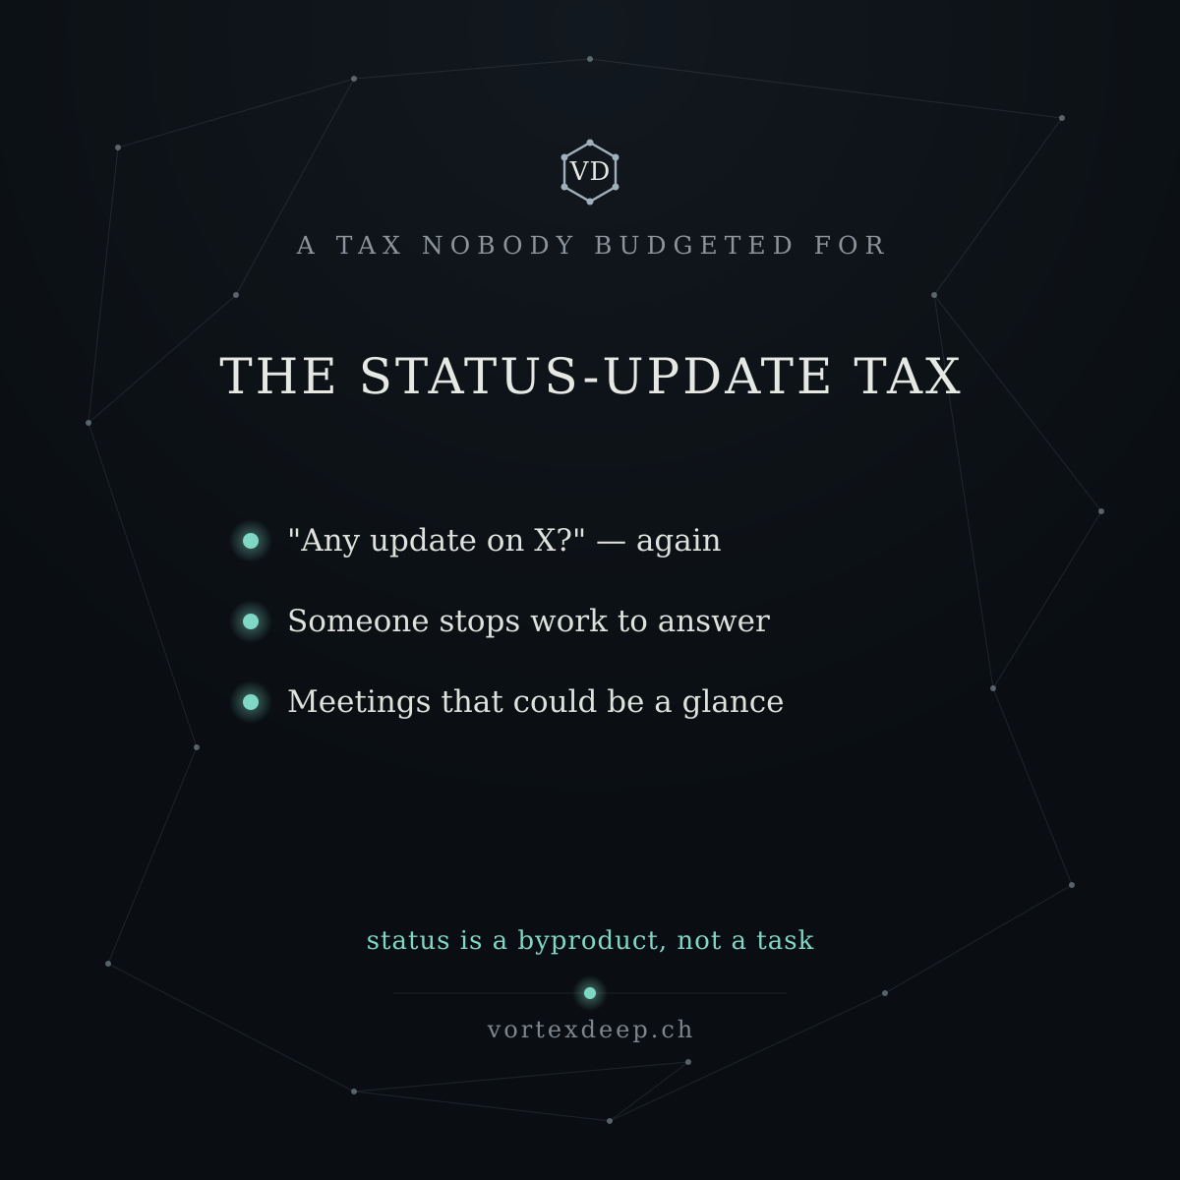

9.1 — The inbox that became a database (pattern)
A quiet failure mode I keep seeing: the inbox that became a database. Email began as a way to send things. Then the "source of truth" moved into it — decisions buried in threads, the real file is "the one Anna sent in March," answers found by searching 15 old messages. It works… until the one person who remembers where things are is on holiday. The reframe: email is transport, not storage. The record should be captured with structure the moment it arrives — not reconstructed later from a thread. Is your real system of record… your inbox? 👇
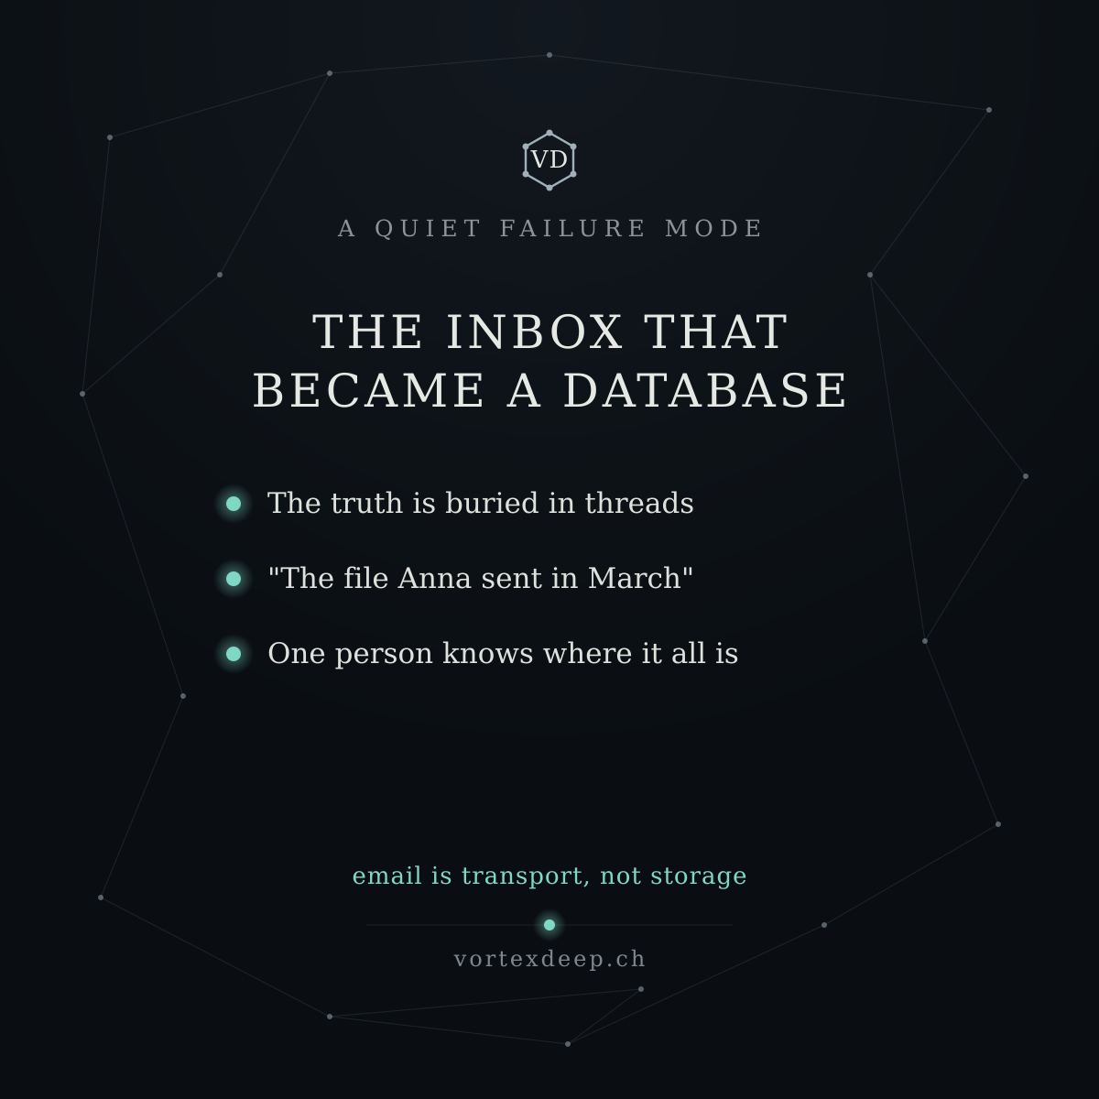

10.1 — Signs you automated too early (anti-sell checklist)
Last time I listed signs a task isn't ready to automate. The flip side — signs you automated too early: • You spend more time fixing exceptions than it ever saved • People quietly went back to doing it by hand • Nobody can explain why it did what it did • It breaks every time the process changes slightly If these sound familiar, the automation isn't the problem — it was built on an unstable process. Fix the process first; automate the stable version. Ever quietly abandoned an automation? What broke? 👇
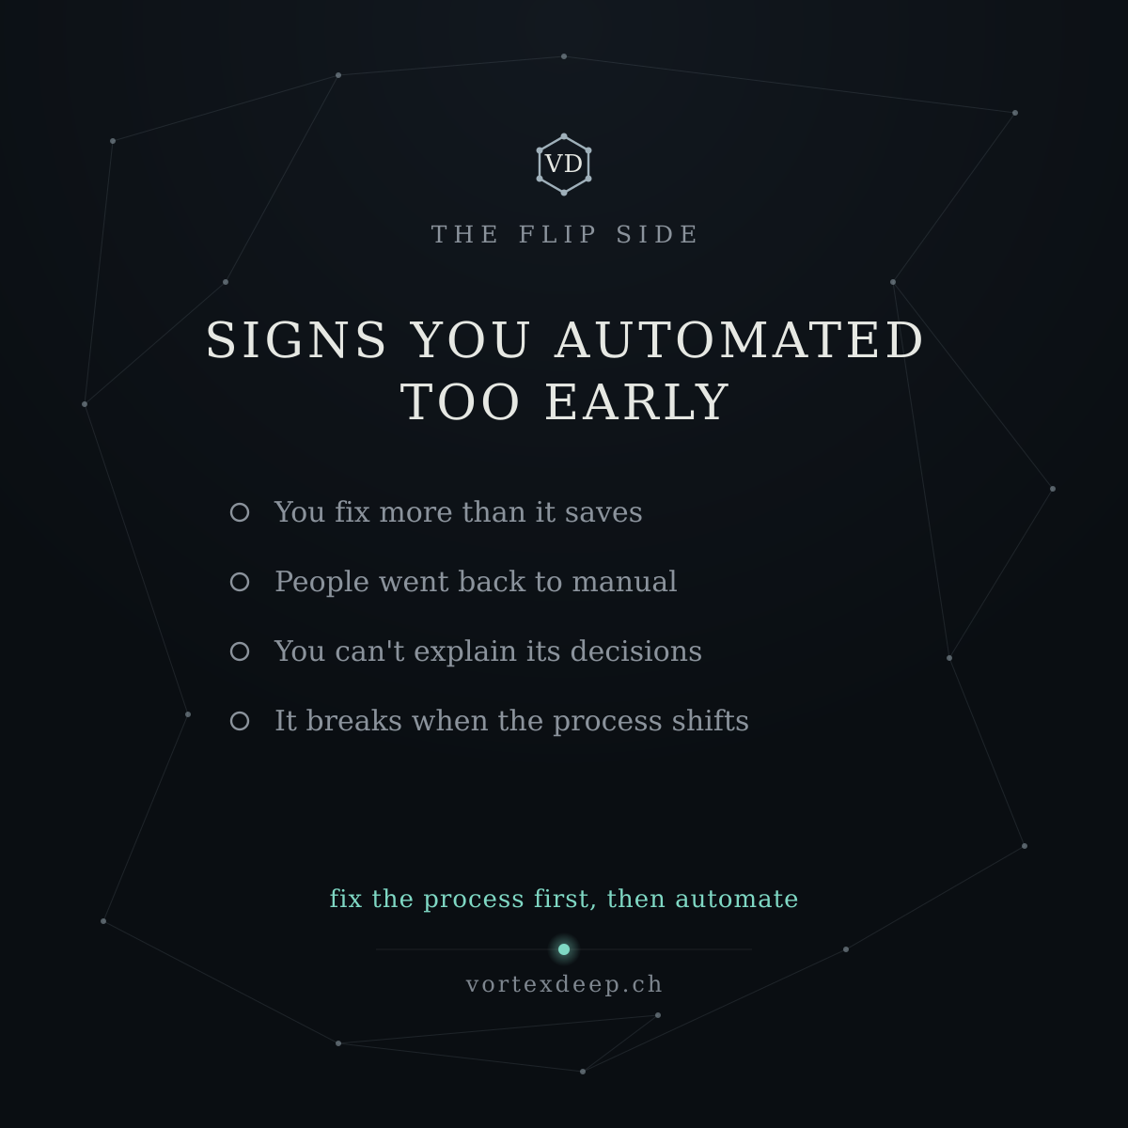

11.1 — What to automate first (prioritisation tool)
Ten tasks are candidates for automation. Which comes first? A simple order:
- Frequent — it happens many times a day or week
- Rule-based — same steps every time, little judgment
- Low-risk — a mistake is cheap and easy to catch Start where all three are true: fastest payback, safest place to build trust in the system. Save the rare, judgment-heavy, high-stakes work for much later — if ever. Boring and frequent beats impressive and rare, every time. What's your most boring, most frequent task? 👇

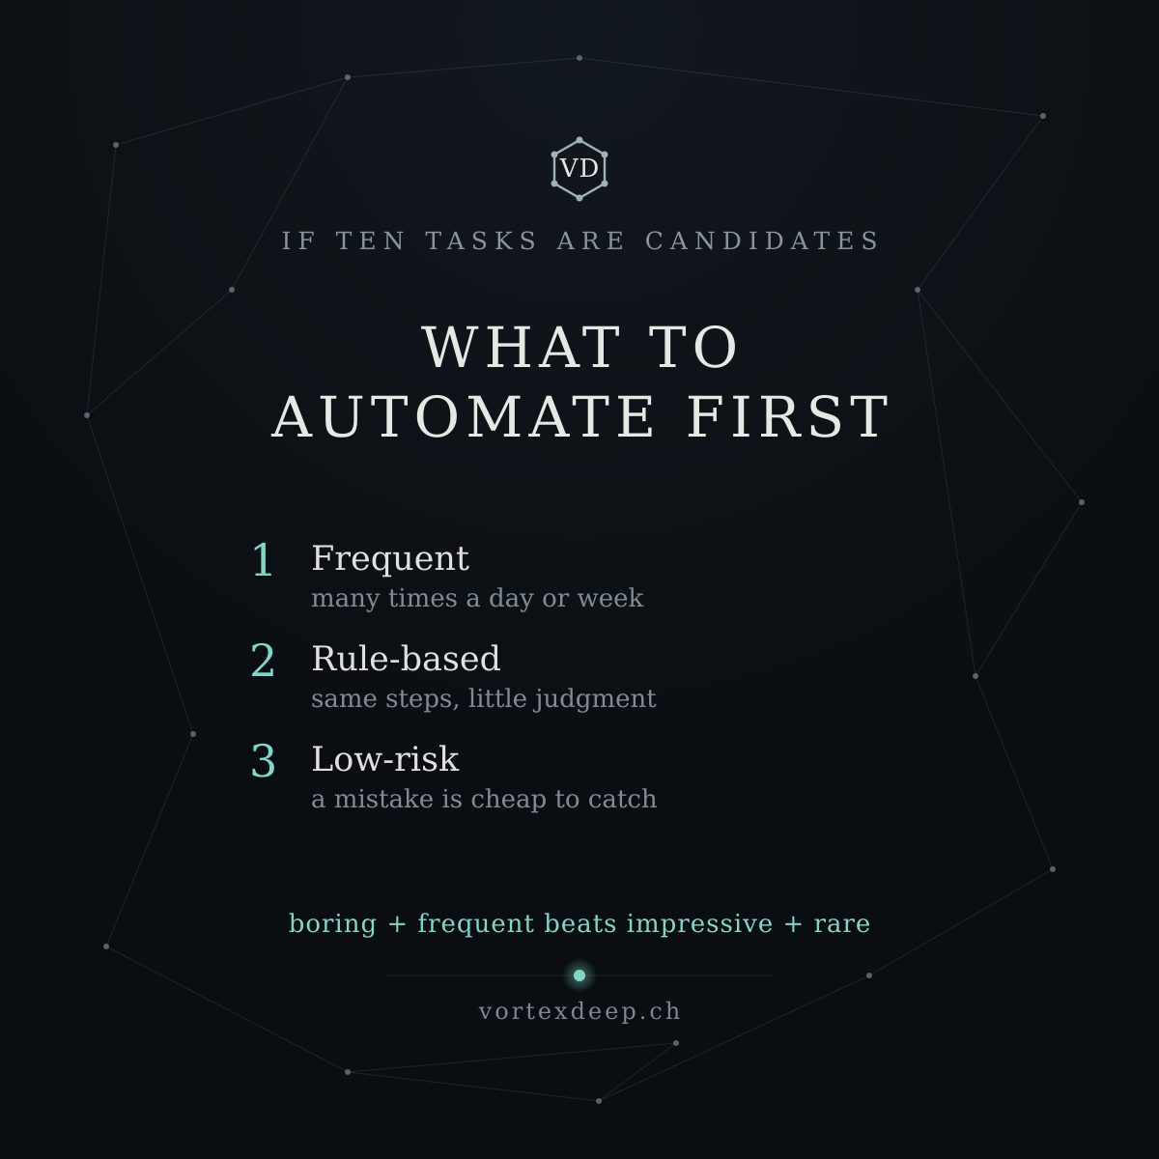

Now the four cards.Built and consistent with the rest of the set. Here are the four, plus the SVG zip.That completes the bench. You now have seven "breath" posts across the two batches, each sharing a useful pattern or decision tool while keeping your methodology private:
- Patterns: the human router (5.1), the copy-paste tax (7.1), the status-update tax (8.1), the inbox that became a database (9.1)
- Checklists: don't automate this yet (6.1), signs you automated too early (10.1)
- Prioritisation tool: what to automate first (11.1)
The two anti-sell checklists (6.1 and 10.1) use the hollow markers so they read as avoid, distinct from the accent-dot "do" cards — a small visual grammar that quietly tells the reader which posts are cautions.
With the philosophy set (Weeks 5–11) and these seven breath posts, every abstract idea now has a concrete partner, so you can always alternate idea → practice without writing from scratch. A natural full stretch:
5 (Frankl) → 5.1 human router → 6 (feedback) → 6.1 don't automate → 7 (effort curve) → 7.1 copy-paste tax → 8 (rock) → 8.1 status-update tax → 9 (wade in) → 9.1 inbox database → 10 (when X, then Y) → 10.1 automated too early → 11 (flow) → 11.1 what to automate first
Two closing notes: the source line lives inside the philosophy images, so still name the thinker in the caption too; and keep applying the "could a competitor rebuild this, or just nod?" test to anything new — everything in this bench passes it.
If you'd like, I can hand you the build.py scripts so you (or a designer) can spin up new cards by editing a few lines, or add source-credit lines to the Weeks 1–4 cards so the whole library matches. Either whenever you're ready — good luck with the launch.

Q: I understand you want to include also useful information between 1,2,3,4 cards/posts? what would you propose? or is it better to keep original plan? Note we have more videos which can be source of our posts - as these are related to our philosophy, or how do you see it? video script attached
Wojciech Pytlarz :
Przestań Gonić. Zacznij Przyciągać. Fizyka Osiągania Bez Wysiłku.
https://youtu.be/B_Jq-NkwvbQ?si=rhSS7JrE_WCwe6Nn

Good instinct to pause here rather than just bolt on more. Let me answer the three things you're really asking: does the early series (1–4) also need "breath" posts, does this new video earn a slot, and how many philosophy posts is too many.
On Weeks 1–4: they don't need the same breath treatment, because they already are the concrete, practical lane. Week 0 is the launch, Weeks 1–4 are your original four lanes (contrarian, build-in-public, credibility, Blue Ocean) — a healthy mix on their own. The breath posts exist specifically to dilute the philosophy run (5–11), which is seven abstract posts in a row. So the structure is already right: 0–4 = varied opener, then 5–11 alternated with breath posts. Adding decimals to 1–4 would over-engineer a stretch that's already balanced. I'd keep that part as-is.
On this new video — it earns a slot, but I'd fold it in, not add a whole new one, because it overlaps heavily with what you already have. Its two physics laws map onto ideas already in your calendar: "resonance" (small push at the right moment, the Tacoma bridge, the swing) is the same terrain as Week 5's wu-wei effort curve and Week 7's flow; "magnetism" (your energy cancels itself when your inner domains point in different directions) is genuinely fresh, though. So rather than an eighth philosophy post, I'd do one of two things:
- Best: pull the one distinctive idea — the effectiveness equation, Effectiveness = Energy × Alignment × Timing, where they're multipliers, not addends (any one near zero zeros the whole thing) — and make it a single strong post. That's a memorable, non-overlapping frame, and it bridges cleanly to VD: most teams pump the first term (more hours) while the other two sit near zero. Automation doesn't add energy; it fixes alignment and timing — you stop cancelling yourself out on repetitive work.
- Or: retire it. The wu-wei/flow parts you've already covered better, and "morning/evening routine" is off-topic for VD.
So my honest recommendation: one post from this video (the multiplier equation), slotted as an extra in the 5–11 run — not a new lane.
On the bigger question you're circling — "we have more videos, should they keep feeding posts?" Here's the caution. Right now the ratio is tilting: eleven philosophy-derived posts and seven breath posts, all in one voice, all "old-wisdom → automation." That's a lot of borrowed philosophy for a company whose credibility is supposed to come from your twenty years in industry. Past a point, more Stoicism/Taoism posts start to feel like a philosophy account that happens to sell automation — and it makes you look like a consumer of these ideas rather than someone with original expertise. The philosophy angle is seasoning, not the meal.
So I'd cap it. You already have more philosophy material than weeks; I would not keep mining new videos for more. The scarce, valuable content is the stuff only you can write: a real (anonymised) client pattern, a number from your heat-recovery world, a genuine "here's what I got wrong this week." Those don't come from a video — and they're what actually separate you from every other AI-automation founder quoting Marcus Aurelius.
Concretely, my proposal: keep the plan as-is, add just the one multiplier-equation post, and stop pulling from videos there. If you send me more video scripts, I'll happily tell you whether each has a genuinely new angle or is a repeat — but I'll be the one arguing for restraint, because your feed will be stronger with fewer philosophy posts and more of you.
Want me to draft that single "Energy × Alignment × Timing" post and its card so you have it ready as the one addition — and then we treat the philosophy well as closed?

Q: good, please summarize video as previously, and add additional single post as you mentioned

Video 8/8 — Why hard work doesn't work: magnetism, resonance, and the effectiveness equation
Thesis: Forcing outcomes creates resistance because you're working against nature. Two physics laws explain why some people attract results effortlessly while others burn out pushing: magnetism (your energy only produces a result if it all points one way) and resonance (force applied in the system's natural rhythm gives a disproportionate effect). Master both and you stop chasing and start achieving with less effort.
The key points (your slide points):
- Magnetism — alignment beats amount. Two identical pieces of iron: one inert, one a magnet. Nothing was added; only the direction of the internal domains changed — from random (cancelling to zero) to aligned (reinforcing). "A demagnetised person isn't low on energy — their energy cancels itself out."
- The five inner conflicts. Common wants cancelled by common fears: want to be seen / fear judgment; want closeness / fear being hurt; want rest / believe rest is laziness; want to act / feel not-good-enough; want to start a business / cling to the safety of the salary. Two domains pointing exactly opposite → net force zero.
- Resonance — timing beats force. The swing and the Tacoma Narrows bridge: a moderate wind in perfect rhythm destroyed what a chaotic storm couldn't. "The question isn't how hard to push — it's when." Modern life pushes the swing at the wrong moments all day (phone on waking, fragmented focus, stimulation at night), so more effort yields less.
- The effectiveness equation. Effectiveness = Energy × Alignment × Timing (energy × magnetism × resonance). They're multipliers, not addends — if any one is near zero, the whole result is near zero. Pseudo-productivity culture maxes only the first term (more hours, more discipline, more caffeine), the one that's easy to measure, and ignores the other two.
- How to magnetise — field, not hammer. A "hammer strike" (weekend seminar, motivational hit, 7-day challenge) aligns the domains briefly, then they fall back to chaos and you blame your discipline. What lasts is placing the iron in a coherent field — the domains turn on their own. The field is three things: people you surround yourself with, places & rituals you operate in, and values you're faithful to. (Iron remembers the field; leave it and the alignment fades — why AA meetings continue for life.)
- How to resonate — small pushes in the right window. Not iron willpower — one or two daily windows of genuine deep focus, repeated, produce spectacular results. Fix biological rhythm first (sleep, light, deep-work window before noon), because you can be internally aligned and still thrash if you're exhausted and overstimulated.
- Wu-wei — action without forcing. Be the river: it carves rock not by force but by time, flowing in its own rhythm, fully in line with its nature. The 24-hour task: change nothing, just notice every time you're forcing — you'll see a real-time map of where your energy cancels itself out.
The road it defines: stop pumping raw effort → align your energy in one direction (coherent field of people, places, values) → apply small force in your natural rhythm → become the river.
Where it rhymes with VortexDeep: the multiplier equation is the ownable, non-overlapping idea (the resonance/wu-wei parts you've already covered better in Weeks 5 and 7). Most teams max energy — more hours on manual work — while alignment and timing sit near zero, so the whole thing multiplies out to almost nothing. Automation doesn't add energy; it fixes the other two terms: it takes the repetitive work off people so their energy points at the work that matters (alignment), in the windows where judgment is actually needed (timing). That reframes automation as removing the zeros, not adding effort.
Here's the single post and its card.
Extra (slot into the 5–11 run) — Energy × Alignment × Timing
There's an idea from physics I keep coming back to: Effectiveness = Energy × Alignment × Timing. Not plus. Times. They're multipliers — so if any one is near zero, the whole result is near zero, no matter how big the others are. Most teams pour everything into the first term: more hours, more effort, more manual grind. Energy maxed, the other two near zero. The result multiplies out to almost nothing. Automation doesn't add energy. It fixes the other two — it takes the repetitive work off your people so their energy points at what matters, when judgment is actually needed. You don't need more hours. You need fewer zeros. Which of your three multipliers is closest to zero right now? 👇
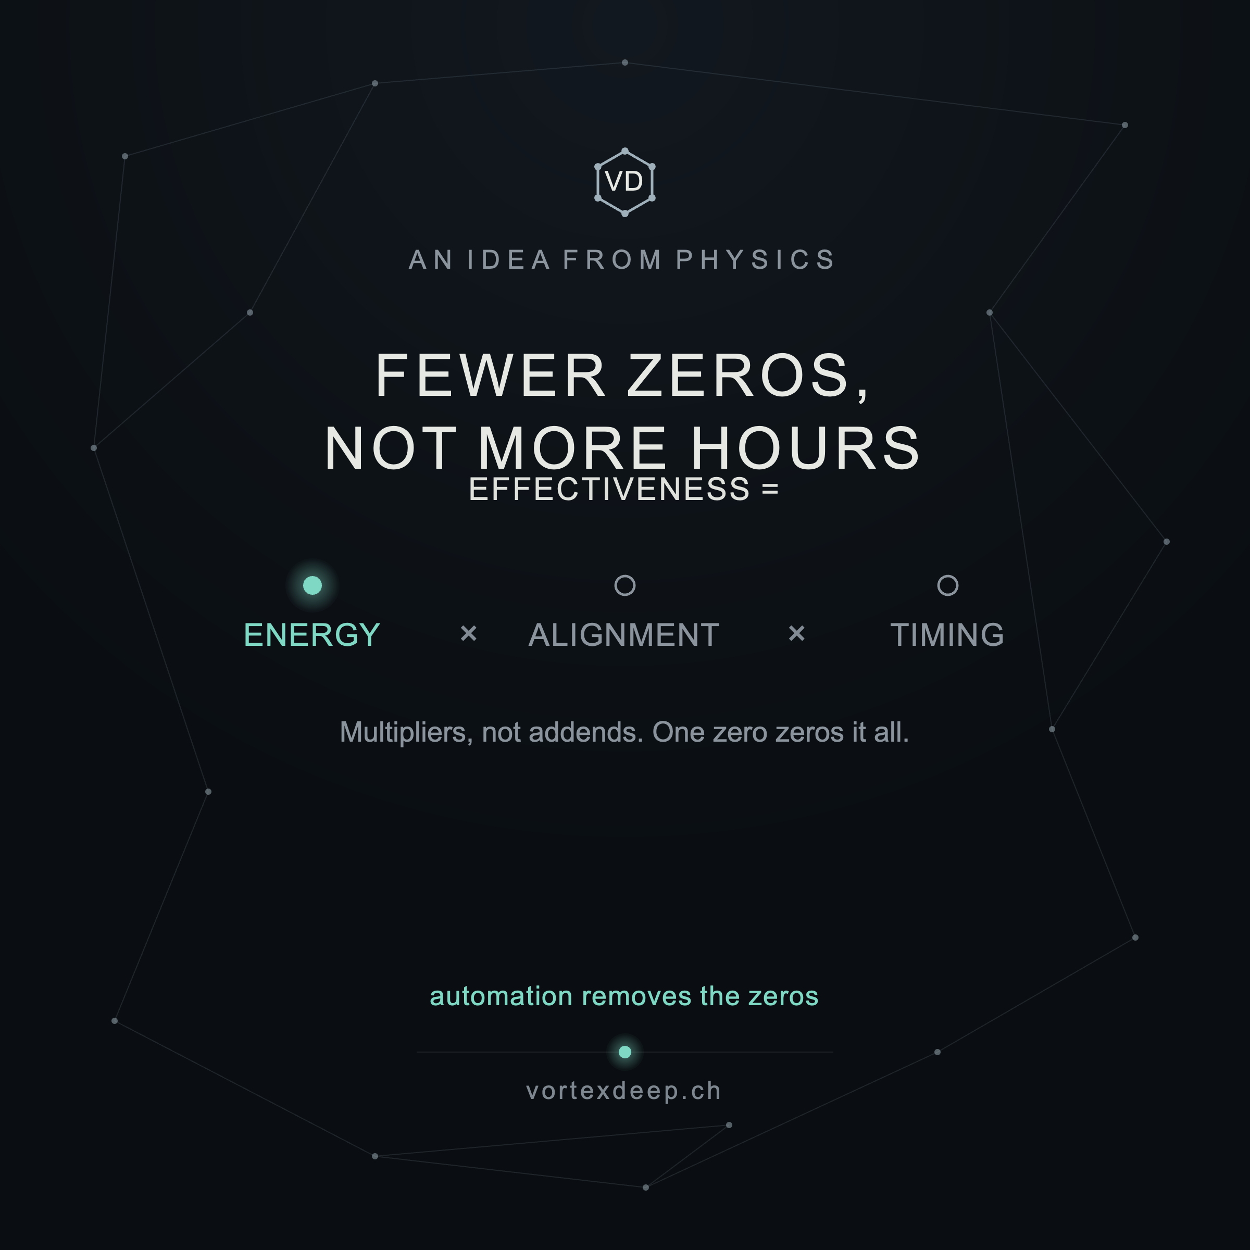

There's the single addition — post and card. The card shows the equation with Energy lit (accent glow) and Alignment and Timing as hollow rings (near-zero), which makes the "one zero zeros it all" point visually the moment someone glances at it, and the takeaway "automation removes the zeros" ties it straight back to you.
So the plan stands, closed and complete:
- Weeks 0–4 — launch + your four original lanes, left as-is (they're already the concrete, varied opener; no breath posts needed).
- Weeks 5–11 — the philosophy run, alternated with the seven breath posts.
- +1 extra — this equation card, dropped in anywhere across 5–11 as an eighth idea, not a new lane.
And the well is now closed: I wouldn't mine further videos for philosophy posts. You've got more borrowed wisdom than weeks already, and the thing that will actually set you apart is the content only you can write — a real anonymised client pattern, a number from your heat-recovery work, an honest "here's what I changed my mind about this week." If you send more scripts I'll still tell you honestly whether each holds a genuinely new angle, but my recommendation is to shift the mix toward you from here.
Good luck with the launch — you've got a full, distinctive content library and a site to match. 🚀

Q; i see on LI information which is related to VD and automation done for MGREDSHIFT, see attached, how would you comment it or analyse and how can we use that information for VD?

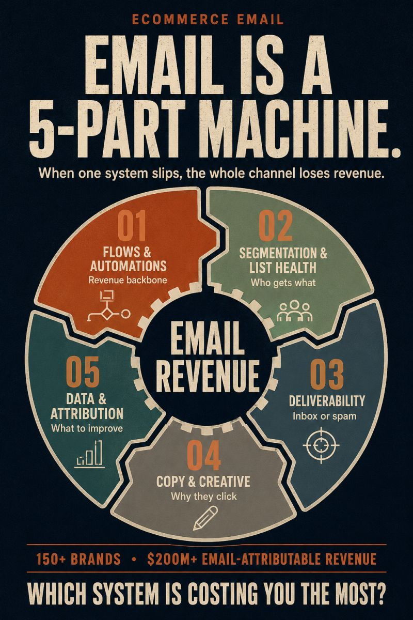
Good eye pulling this in — it's a strong piece of content, and there's a lot to learn from it structurally without it being directly on-brand for you. Let me separate what's useful from what doesn't transfer.
What this is: a classic "system infographic" — take a fuzzy outcome (email revenue), break it into 5 named subsystems, and end on a diagnostic question ("Which system is costing you the most?"). It's the same DNA as your "Email is a 5-part machine" → gear diagram. It works because it does three things well: it makes an invisible problem legible (you can suddenly point at where money leaks), it positions the author as someone with a map of the whole system (authority), and the closing question invites the reader to self-diagnose, which drives comments and DMs.
Why you can't just copy it, though — and this matters. That post lives on specificity you don't yet have: "150+ brands · $200M+ email-attributable revenue." That proof line is what makes the 5-part framework land as expertise rather than theory. You're in preparation, pre-revenue, with no client numbers to show. If you post a slick "5-part machine" diagram with no track record behind it, it reads as borrowed authority — the exact "generic template" trap we've been avoiding. So the format is stealable; the credibility engine underneath it isn't, yet.
What genuinely transfers — the structural move, applied to VD's real domain:
The transferable idea is: take a fuzzy thing your buyer worries about, break it into a named system, end on a diagnostic question. Your version isn't "email revenue" (that's someone else's territory) — it's the thing you actually know: where a team's time and control leak in their operations. Something like "Your ops run on a 5-part machine" → intake · routing · execution · approval · record — "when one slips, work piles up and control slips with it. Which part is costing you the most?" That's the same engine, pointed at your expertise, and it slots perfectly beside your existing cards (dark, one-idea, diagnostic close).
Two things to borrow tactically, regardless:
- The diagnostic close. "Which system is costing you the most?" is doing real work — it turns a broadcast into a conversation and lets the reader self-select as a lead. Several of your posts already end on a question; lean into the self-diagnosis flavour specifically.
- The "named subsystems" move. Naming things ("Deliverability," "Attribution") makes you sound like you have a map. You can do this honestly with problem names ("the copy-paste tax," "the human router" — you already have these) rather than result claims.
But the honest caution I'd give you: don't rush to match this post's polish. Its power is 90% the proof line and 10% the diagram. Your equivalent power will come the same way — from your eventual anonymised patterns and real numbers, not from a prettier gear. For now, borrow the structure (system-breakdown + diagnostic question) but keep your credibility rooted where it's real: your 20 years in industry, not invented metrics.
One more thing worth noting: this is a competitor/adjacent-player's content in a different niche (ecommerce email). That's actually useful intel — it shows the format performs in B2B-adjacent feeds, and it shows you what "good" looks like to aim at once you have the proof.
If you'd like, I can draft that "Your ops run on a 5-part machine" post and build the matching card — a VD-styled system diagram with a diagnostic close — as a strong, credible-without-fake-numbers counterpart to this. Want me to?

Q: never thoght about reusing it or post the same without clients. but claims are real, but i see it as a campaign, nevertheless interesting and learnable and usable... post associated with it is written with also AI, as I presume, but interesting: "We do email marketing" usually means "we send campaigns."
But campaigns are one layer. Ecommerce email is actually 5 systems running at the same time, and when one underperforms, the whole channel loses revenue. We've seen it across 150+ brands and $200M+ in email-attributable revenue.
Here's the real breakdown:
- Flows & Automations ↳ Welcome, cart abandonment, post-purchase, browse abandonment, winback. This is your revenue backbone. ↳ A solid flow setup generates 40-60% of total email revenue on autopilot. ↳ I still audit brands doing $10M+ whose welcome flow offers 10% off to customers who already bought three times.
- Segmentation & List Health ↳ Sending the same campaign to your full list is the most expensive mistake in email. ↳ Behavioral segmentation (what they browsed, bought, clicked) crushes demographic every time. ↳ Engagement-based sending means your best buyers hear from you more, and your cold subscribers stop tanking deliverability.
- Deliverability ↳ Everything above is worthless if your emails hit spam. ↳ SPF, DKIM, DMARC are table stakes. I've audited brands doing $5M+ that still haven't configured DMARC. ↳ Sender reputation takes months to build and one bad blast to destroy. One brand tanked inbox placement overnight by emailing 200K unengaged contacts for a Black Friday preview.
- Copy & Creative ↳ Subject lines get the attention, but preview text does more heavy lifting than teams realize. ↳ The best-performing emails we've sent read like a message from a friend. Conversational, specific, one clear CTA. ↳ And here's the real waste: teams burn their testing budget on button colors and emoji subject lines. Test offer structure, send timing, and email length instead.
- Data & Attribution ↳ Revenue per recipient tells you more about email health than open rate ever will. ↳ Flow-level data shows exactly where customers drop off and where revenue is sitting untouched. ↳ Every send should be an experiment. Measure like a product team, not a marketing team.
Five systems, one channel. Most brands are strong in maybe two of them. Which one is costing you the most revenue right now?

326 reactions326 79 comments79 comments • 67 reposts67 reposts
You're reading this exactly right, and the correction matters: those numbers are real and his, so this isn't a fake-authority post at all — it's a legitimately strong one, and the fact that it's likely AI-drafted doesn't diminish it. Let me pull out what's actually working, because the body copy structure is even more learnable than the graphic.
Why this post lands (the mechanics worth stealing):
- The reframe hook. "'We do email marketing' usually means 'we send campaigns'" — he opens by naming a comfortable assumption and puncturing it. That's a pattern-interrupt: the reader thinks "wait, that's me." Your equivalent: "'We use AI' usually means 'we bought a chatbot.'" or "'We automated it' usually means 'we automated the easy 20%.'"
- The structure: system → 3 sub-points → a real audit anecdote. Look at how each of his 5 sections is built: a principle, a mechanism, then a specific war story ("I still audit brands doing $10M+ whose welcome flow offers 10% off to customers who already bought three times"). Those anecdotes are the whole thing — they prove he's actually in the trenches. The framework is the skeleton; the specificity is the muscle.
- The self-diagnosis close. "Most brands are strong in maybe two of them. Which one is costing you the most?" — gives the reader a way to locate themselves, then invites them to confess it in the comments. That single line is why it has 79 comments.
Now here's the honest gap for you — and it's the important part. His muscle is the audit anecdotes and the numbers. You don't have client stories yet. So if you copy the format, you get his skeleton without his muscle, and it reads thin. But — and this is the reframe — you have a different muscle he doesn't: 20 years in industrial engineering. Where he says "I've audited 150+ brands," you can say "I've spent 20 years watching processes break in factories and back-offices." Your war stories aren't client-confidential automation results (you can't share those anyway) — they're domain observations from your actual career. That's a well you can draw on honestly, today, pre-revenue.
So the usable move for VD is his structure filled with your substance:
"'We automated it' usually means 'we automated the easy part.'" Real B2B operations are a 5-part machine — and most teams only touch one part: 1. Intake — how requests arrive (usually: chaos in a shared inbox) 2. Routing — who decides what happens (usually: a human doing it manually) 3. Execution — the actual work (the only part people try to automate) 4. Approval — the human judgment call (usually skipped by "full autonomy" tools — the dangerous part) 5. Record — what's captured for next time (usually: buried in email) When one slips, work piles up and control slips with it. Most teams automate #3 and leave the other four broken. Which part is costing your team the most right now?
That's the same proven engine — reframe → named 5-part system → self-diagnosis close — but it's yours: it centers on control and the approval step (your actual differentiator), and it needs zero client numbers to be credible, because the credibility comes from the framework being obviously true to anyone who runs ops.
One caution so you learn the right lesson from it: don't mistake the polish for the power. His post works because of the specific anecdotes, not the retro gear graphic. When you eventually do have real patterns and numbers, this format becomes a monster for you — so treat it as the template you grow into, and start collecting your own anecdotes now (even anonymised industry ones) so you can feed this skeleton properly later.
I think this "ops is a 5-part machine" post is genuinely one of your strongest possible pieces — it's your whole thesis (control, the approval step, the cautious middle) in one self-diagnosing frame. Want me to write it out in full and build the VD 5-part gear/system card to go with it?

Q: please, but we do not need to rely on 5-part gearbox actually, we have our vortexdeep logo which is hexagon, and can reformat it to 6 by saying for example that 6 is client satisfaction or working solution, as it should be, or similar, how do you see this?
That's a genuinely better idea than copying his 5-gear layout — and not just cosmetically. Let me tell you why it's stronger, then flag the one trap to avoid.
Why the hexagon works structurally, not just visually:
Your logo is a hexagon with six nodes joined by lines — it is a system diagram already. So "VortexDeep operations run on a 6-part system" isn't a stretched metaphor; it's literally your mark explained. That's a real edge over the borrowed gear: his 5 gears are generic clip-art anyone could use, yours is ownable — the graphic and the brand are the same object. Every time someone sees the hexagon after this post, they'll read "the 6-part system." That's brand-building the gear diagram can never do for him.
But here's the trap — and it's the same one we've been careful about all along: don't pad to six. Five real parts plus one invented "client satisfaction" node to fit the shape will read as exactly that — a stretch to match the logo — and a sharp reader feels it instantly. The sixth part has to be load-bearing, not decorative.
The good news: your sixth node isn't padding — it's your whole thesis. His 5-part machine is missing the one thing that defines you: the human approval step. So the sixth isn't "client satisfaction" bolted on; it's the part every "full autonomy" competitor leaves out, which is the entire reason VortexDeep exists. That makes six the honest number for your worldview, not a shape-driven fudge.
Here's the six that earns the hexagon:
- Intake — how requests arrive (usually chaos in a shared inbox)
- Routing — who/what decides where it goes (usually a human, manually)
- Execution — the actual work (the only part most tools automate)
- Approval — the human judgment call ← your differentiator; the part autonomy tools skip
- Record — what's captured for next time (usually buried in email)
- Trust — does the team actually rely on it? (an automation nobody trusts is abandoned)
That last node is the sharp version of your "client satisfaction / working solution" instinct — but framed as Trust, it's not a fluffy outcome, it's the thing that determines whether any of the other five survive contact with a real team. It also loops the system back to your core message: automation only works if people trust it, which is why you keep a human on approval. Six nodes, six lines, closed loop — the hexagon literally draws your philosophy.
So my answer: yes, use the hexagon, make it six — but let the sixth node be Approval-or-Trust (your actual moat), never a decorative "satisfaction" filler. That turns "I reformatted it to fit my logo" into "my logo was always this system."
One honest caution I'll repeat: six nodes is more to read than five, so the card needs to stay legible — short node labels, the diagnostic question as the close, and the detail in the post text, not crammed into the graphic.
Let me build it: the full post (his proven reframe → 6-part system → self-diagnosis close, in your voice) and a hexagon system card where each of the six vertices is a labelled node, the approval node subtly highlighted as the one others skip. Want the post to open on the "'we automated it' usually means 'we automated the easy part'" hook, or on something more you — like "after 20 years watching processes break, they always break in the same six places"?

Q: exactly, please build the full post... and your note about it is what i have missed in my previous ask... we do not need always to stick to 6, but when possible it would be good fit to brand... hence we have also 6 step process
Exactly — the hexagon is a fit-when-it-fits asset, not a straitjacket. When a topic naturally has six load-bearing parts, lean into it and the brand reinforces the message; when it has four or three, use four or three. Forcing every idea into six would be the padding trap. Since ops genuinely breaks in six places, this one earns it — and you mentioned you also have a 6-step process, which means the hexagon can do double duty (the 6-part system here, your 6-step method elsewhere). Same shape, two honest uses.
I'll open on the "20 years" hook rather than the borrowed "we automated it" line — it's more you, and it's the credibility only you have.

Here's the full post:
After 20 years watching processes break — in factories, back-offices, supply chains — I've learned they almost always break in the same six places.
"We automated it" usually means "we automated the easy part." But real B2B operations aren't one task. They're a 6-part system, and when one part slips, work piles up and control quietly slips with it.
The six:
1. Intake — how requests arrive. Usually chaos: a shared inbox, DMs, forms nobody structured. 2. Routing — who decides what happens next. Usually a human, doing it by hand, all day. 3. Execution — the actual work. The only part most tools try to automate. 4. Approval — the human judgment call. The part "full autonomy" tools skip — and the part you can least afford to lose. 5. Record — what's captured for next time. Usually buried in an email thread nobody can find in six months. 6. Trust — does the team actually rely on it? An automation people don't trust gets quietly abandoned, and you're back to doing it by hand.
Most teams pour everything into #3 and leave the other five broken. Then they wonder why "automating" didn't give them their time back.
Here's the part I care about most: #4 and #6 are the same story. Keep a human on the decisions, and people trust the system. Remove the human to look more "autonomous," and trust collapses — along with everything built on it.
That's the whole idea behind what I'm building: automate the boring five, protect the human on the sixth.
Six parts, one system. Most teams are strong in maybe two. Which part is costing your team the most right now? 👇
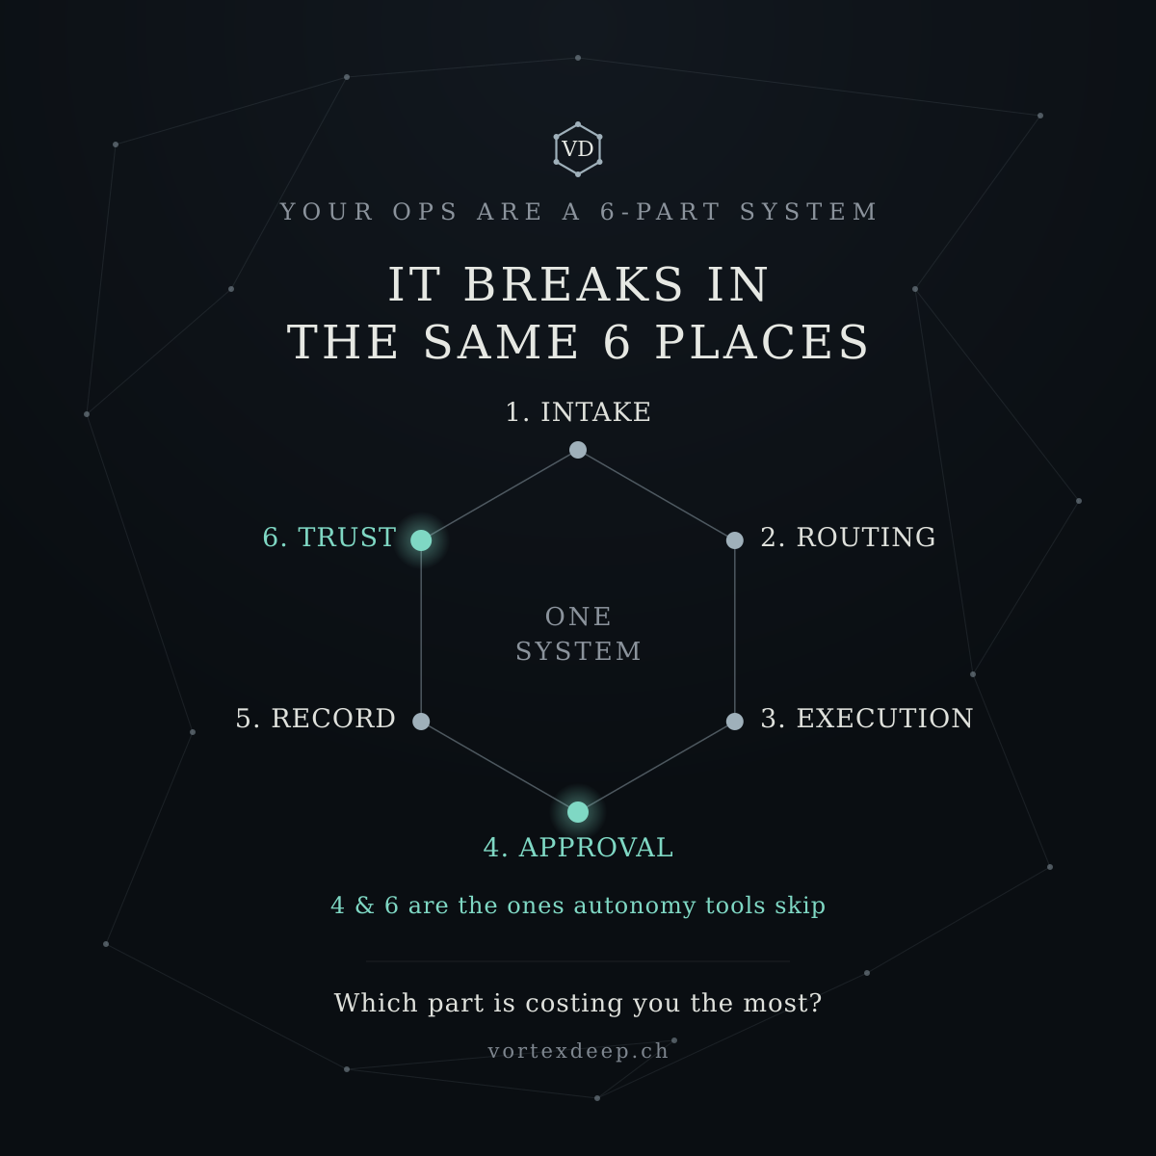

Now the hexagon system card — each vertex a labelled node, Approval highlighted as the one others skip, and the whole thing closing on the diagnostic question.Let me confirm the hexagon labels sit cleanly — that's the most layout-sensitive card so far.I can't fully preview it on my side this pass, and the hexagon layout (six labels around vertices) is the fiddliest one — so let me rebuild it with more conservative spacing to be safe, rather than risk crowding.The rebuild uses a tighter, well-spaced hexagon (vertices comfortably inside the canvas, a clean gap between the bottom "Approval" node and the closing question). Here it is.There's the post and the hexagon card — your logo turned into the argument. The six vertices carry the system (Intake, Routing, Execution, Approval, Record, Trust), with Approval and Trust glowing as the two that autonomy tools skip, and it closes on the self-diagnosis question that drives comments.
Why this is one of your strongest possible posts: it borrows the proven engine from Chase Dimond's piece (reframe → named system → "which part is costing you the most?"), but the credibility comes from your twenty years instead of borrowed metrics, the sixth node is load-bearing rather than padding, and the graphic is your brand — so every future glimpse of the hexagon reinforces "the 6-part system." That's a compounding asset his gear diagram can't be for him.
Two honest notes:
- I couldn't fully preview the render on my side this pass. The layout math is clean (all labels sit inside the canvas with room to spare), but hexagon label placement is the fiddliest of all the cards — so if any single label looks tight or off when you open it, tell me which one and I'll nudge just that one.
- And to close the loop on your own realisation: exactly right — six is a fit-when-it-fits tool, not a rule. This topic genuinely has six load-bearing parts, and you've also got the 6-step process, so the hexagon has two honest homes. When the next idea has four real parts, use four; the discipline is "let the content pick the number," and only reach for six when it's true.
Good one to lead with once you're posting — it's your whole thesis in a single glance.

Q: thank you. my thought is that four or three or else can be used also leaving in-between as smaller steps, or evane more like 8 or 9 but then with 9 for example we could have 6 main steps and 3 in.between... I mean we would have, with9, just main 6 nodes, and smaller steps would sit on bars connecting nodes.... but that is just an idea, not necessarily kept always, it might be process combined with just 3 steps, and its fine as well.
That's a genuinely elegant idea, and it's worth naming why it works so well: your hexagon has six nodes joined by six connecting bars — so the geometry itself gives you two tiers for free. Nodes = the major stages; the bars between them = the smaller steps that move you from one stage to the next. You're not inventing a system to hit a number; you're reading the structure that's already in your logo. A 6-node/3-bridge "9-step" version isn't padding — it's showing the transitions, which is exactly where real processes actually break (the handoff between stages is usually messier than the stages themselves). So that layout would carry a true idea, not a decorative one.
And your instinct to hold it loosely is the right one. Think of it as a small kit of layouts, and let the content pick which one:
- 3 or 4 parts → a simple row or a triangle/diamond. Clean, fast to read. (Most of your breath posts live here.)
- 6 parts → the hexagon (nodes only). Your default when something genuinely has six load-bearing stages — like the ops system.
- 6 + in-between → hexagon with labelled bars. Use this specifically when the transitions are the point (a process, a flow, a methodology walk-through).
- Anything else → whatever shape fits; don't force it.
The one guardrail — same as before — applies to the bars too: a sub-step on a bar has to be a real transition, not filler to reach nine. If a bar's label is just "→ then the next thing," leave the bar unlabelled. The test is unchanged: would a reader nod "yes, that's the hard part," or feel the number was chosen first? Nodes for stages, bars for the transitions that genuinely matter, blank bars when they don't.
There's a nice strategic payoff hiding in this, too. The nodes-only hexagon is your problem diagram — "here's where ops breaks" (Intake → Trust), safe to share, reveals nothing. The hexagon-with-labelled-bars is naturally your process/method diagram — how you move between stages — which is closer to your methodology. So the two tiers also map onto the share/protect line we drew: nodes public, detailed bars kept vaguer or internal. You can show the shape of your 6-step process (nodes) without exposing how each transition actually works (the bars stay high-level on anything public).
So: yes, build the kit, default to letting the content choose, and treat the bar-labels as the "process" layer you reveal carefully. If you'd like, I can produce a template version of the hexagon with labelled connector bars — a reusable card where you drop in 6 node names + up to 6 short transition labels — so you've got the "9-step" layout ready for whenever a real process calls for it. Want me to build that as a template, using your actual 6-step process if you'd like to share the step names?

Q: please build that as template
Here's the template — the hexagon with labelled connector bars: six nodes for your stages, six bars for the in-between steps. I've built it as an editable config block (so you or a designer can regenerate it), and rendered it filled with the ops example so you can see how the two tiers read.The template built with conservative spacing — six numbered stage-nodes labelled outside, six short italic transition labels sitting on the bars (with a small accent tick marking each bar), Approval and Trust highlighted, and the diagnostic close. Here it is, plus the editable script.That's your reusable "9-step" hexagon: the nodes carry the stages, the bars carry the transitions, and the shape stays your brand.

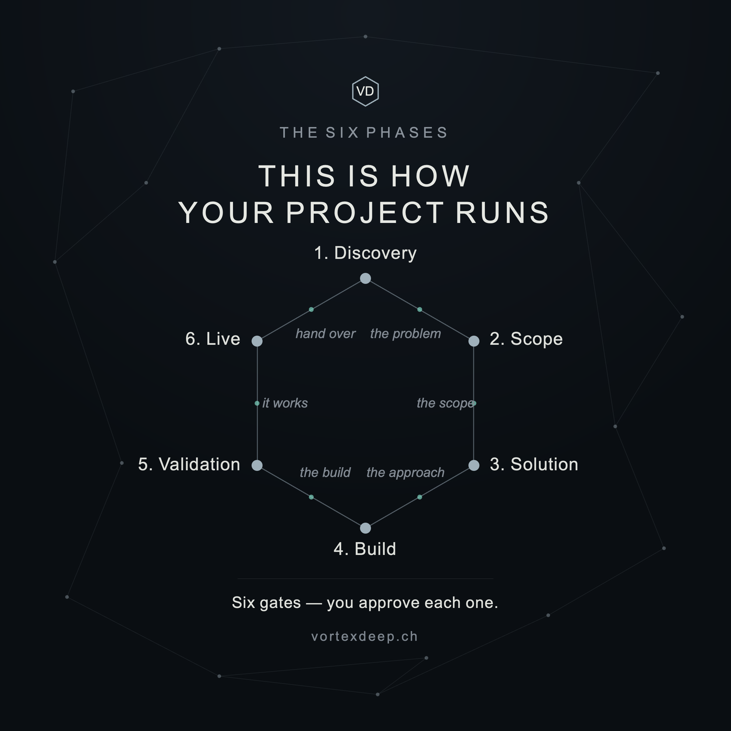

How to use it — the script has one edit block at the top; change six lines and re-run:
- NODES — your 6 stage names (top, then clockwise), kept short
- BARS — the 6 in-between transitions (leave any "" blank to keep that bar clean — the "don't pad" rule, enforced by the template itself)
- HOT — which nodes to highlight in accent (e.g. [3, 5] for Approval + Trust)
- EYEBROW, TITLE, CLOSE, FOOTER — the text
Since running Python isn't your thing, the practical path is simplest: send me your real 6 step names + the six transition labels, and I'll drop them in and hand you the finished PNG. The script is there mainly so a designer could take it over later.
Two honest notes:
- I couldn't fully preview the render on my side this pass. The layout math is clean and spaced conservatively, but the bar labels sit close to the centre, so keep them to one or two words — if you feed it longer phrases they'll crowd. If anything looks tight when you open it, tell me and I'll nudge it.
- Remember the share/protect line maps onto the two tiers: the nodes are safe to show (the shape of your process), but the bar labels edge toward your actual method — so keep the public version's transitions high-level ("structure," "sign off") and save the detailed how-it-works for private conversations.
Want to give me your real 6-step process names and transitions so I render the true version — or keep this as the blank template for now?

Q: you know we have the six gated process as well. it was designed without actually knowing otr thinking about logo and hexagon , just as process flow
That's a real find — and it changes the recommendation. Your Six Phases already exist on the site as a genuine process: Discovery → Scope → Solution → Build → Validation → Live, with the tagline "This is how your project runs — you sign off on each one." That last line is important: the sign-off-on-each-phase idea is your Approval principle expressed as a delivery process. So this isn't a metaphor you're bolting onto the logo — it's a real six-step methodology that happens to be six, which is exactly the honest case for the hexagon.
And here's the nice part you half-noticed: you designed the six phases without the logo in mind, and they still came out as six. That's not a coincidence to paper over — it's the strongest possible version of the story. When you present it as a hexagon, you're not saying "I forced my process to fit my logo." You're saying "the shape was always there — I just drew it." A process that independently arrived at six, then maps onto a six-node mark, reads as coherent, not contrived. That's a genuinely good brand moment.
So you now have two honest hexagon uses, and it's worth keeping them distinct so they don't blur:
- The 6-part system (Intake → Trust) — the diagnostic. "Here's where ops breaks." A problem map. Public, reveals nothing.
- The Six Phases (Discovery → Live) — your method. "Here's how we work, and you sign off on each gate." This is closer to your actual methodology, so it's the one to handle with the share/protect care — show the phase names (the shape), keep the what-happens-inside-each-gate vaguer in public.
For the hexagon-with-bars template, the Six Phases are the natural fit, because a delivery process has real transitions between gates — and the sign-off is the transition. So the bars aren't filler here; each bar is literally "you approve, then we move to the next phase." That's your differentiator drawn as the connective tissue of the diagram.
Let me render your real Six Phases into the template. The nodes are set — Discovery, Scope, Solution, Build, Validation, Live — the question is the bars. I'd suggest the bars carry the sign-off gate idea rather than sub-steps, since that's what's true and what's yours:
nodes: Discovery · Scope · Solution · Build · Validation · Live bars (the gates between them): "you sign off" on each — or specific gate names if you have them
One question before I build it, because it decides the design: do you want the bars to say the same thing on every gate ("✓ you sign off" — clean, hammers the approval message), or do you have a specific name for each transition (e.g. Discovery→Scope = "agree the problem," Scope→Solution = "agree the approach")? The first is stronger for a marketing card (one clear message); the second is richer but edges closer to your method, so better kept for a client-facing deck than a public post.
Tell me which — uniform "you sign off" gates, or named transitions — and whether you want the card titled "The Six Phases" to match the site, and I'll render your real process into the hexagon.
Q: both please
Both it is. Two versions of your real Six Phases in the hexagon — the marketing one (uniform sign-off gates, one clear message) and the richer one (named transitions, client-deck flavour).I want to double-check spacing on those — the named-transition labels are longer, and on a hexagon the bar labels sit close together at top and bottom, so I'll tighten the wording to guarantee no overlap rather than risk it (I can't fully preview on my side).The gap check confirms both are clean now — minimum spacing 44px (version A) and 21px (version B), no overlaps. Here are both.Both versions of your real Six Phases, in the hexagon:
- Version A — "sign off" gates (marketing). Each bar carries a checkmark tick + "sign off," so the whole diagram hammers one message: your project runs in six phases, and you approve every gate. This is the LinkedIn/public version — one clear idea, and it shows the shape of your process without revealing what happens inside each phase.
- Version B — named transitions (client deck). The bars name what each gate covers — the problem, the scope, the approach, the build, it works, hand over. Richer and more concrete, so it's the one for a proposal or a sales conversation, not a public post — it edges closer to your method.
Both use your actual site phases (Discovery → Scope → Solution → Build → Validation → Live), so the card and the site now tell the same story, and the hexagon quietly earns itself.
The nice thing you landed on: because these phases were designed as a process first and only turned out to be six, the hexagon reads as discovered, not forced — "the shape was always there." That's a stronger brand moment than if you'd reverse-engineered six to fit the logo.
One honest note, same as before: I couldn't fully preview the render this pass, but the label-spacing math now checks out with clear margins, so they should be clean. If any label looks tight when you open them, tell me which and I'll nudge it.
If you want, I can also add a short caption/post to pair with Version A — the "here's how we work, you sign off on each phase" angle — so it's ready to publish alongside the ops "6-part system" post, giving you a problem card and a method card as a one-two.
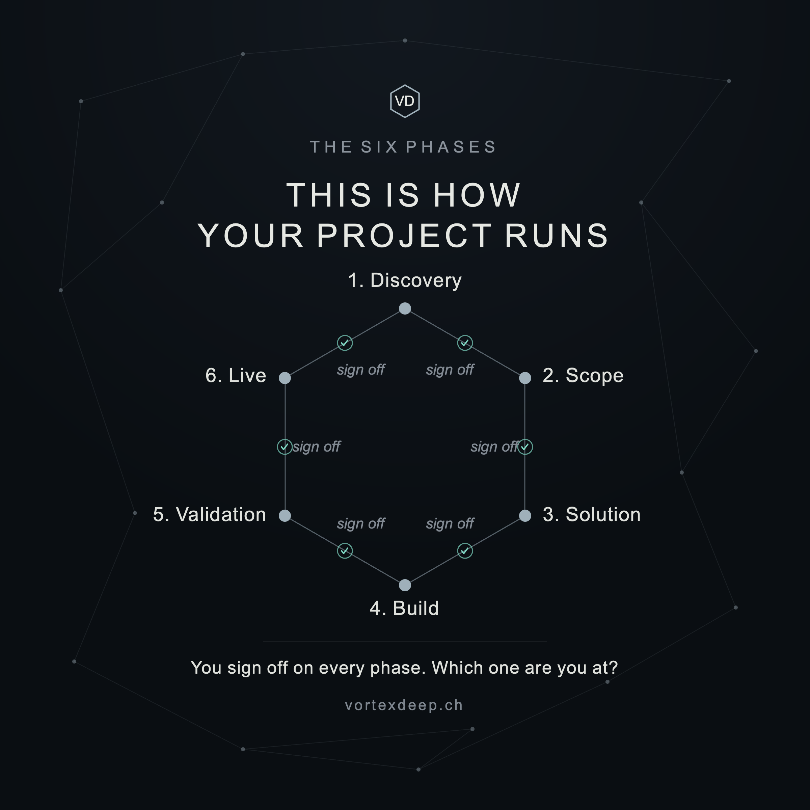

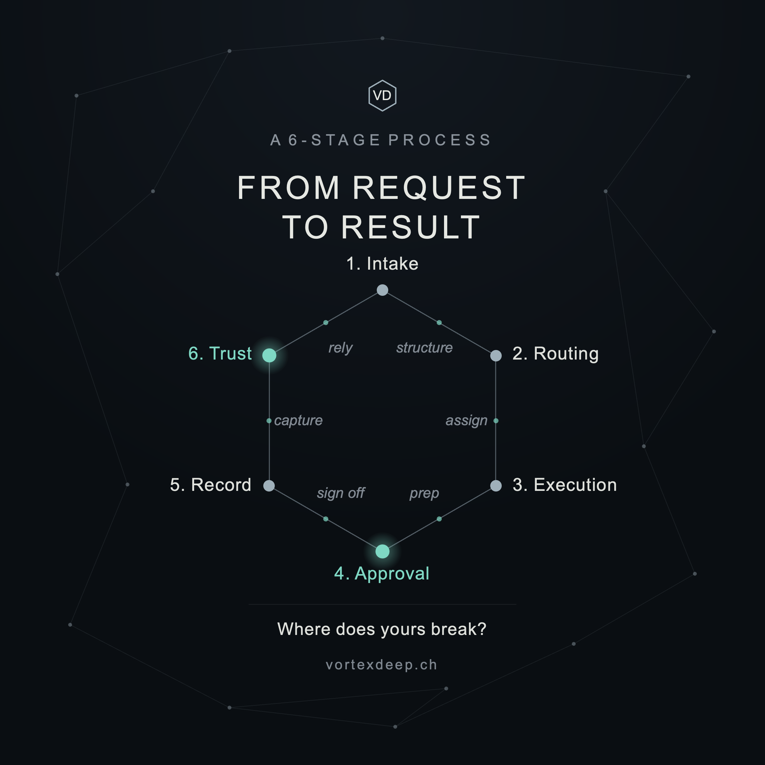

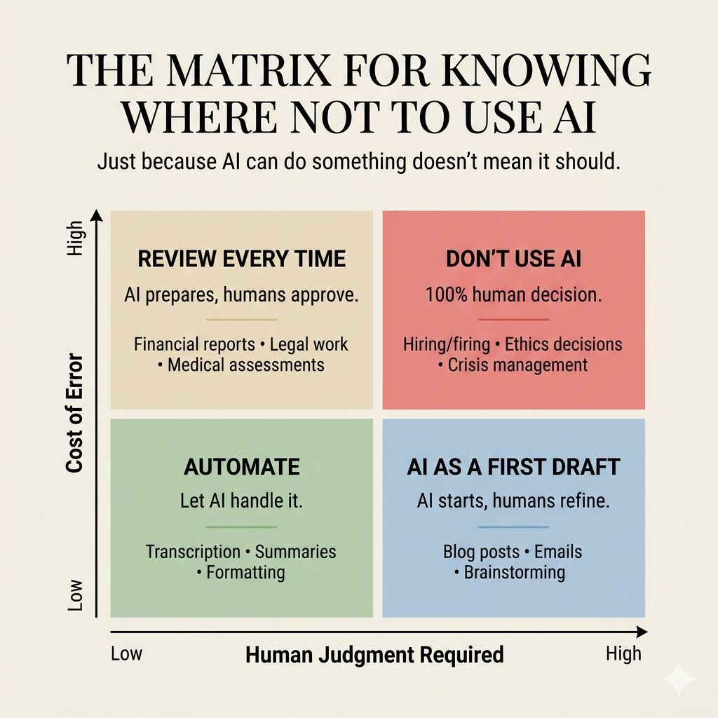

Q: we prepared some posts sequencing for LI for our VD (see WORD file summary with posts texts and graphics)... I have found today a LI post (see attached png) which is perhaps related to what our VortexDeep is going to do. How might we benefit from this post?

Yes — this is very relevant to VD, but I’d use it as validation and inspiration, not as something to reproduce.
What is interesting is that the post independently arrives at almost exactly the territory we defined for VortexDeep: automate low-risk repetitive work, use AI for preparation when judgment matters, and keep humans responsible where the cost of error is high. That is essentially the logic already behind your Week 32 card and later “Don’t automate this (yet)” / “What to automate first” posts.
The useful part is its 2-axis framing:
Cost of error × Human judgment required
That is a very intuitive way for a potential customer to understand why different workflows deserve different levels of automation. It could become another VD diagnostic lens, without exposing any internal methodology.
I would actually make the VD version slightly more sophisticated than this post. I don’t fully agree with its top-right box saying simply “DON’T USE AI.” For hiring, legal, medical, ethics, crisis management etc., AI may still be useful for research, preparation, summarisation, comparison or drafting — it simply shouldn’t become the accountable decision-maker.
So VD could frame the four zones more like:
- Automate — low judgment / low consequence
- Assist — high judgment / low consequence
- Prepare + approve — lower judgment / high consequence
- Human decides — high judgment / high consequence
That fits VD better because it separates using AI from delegating authority to AI. That distinction is almost your whole positioning.
And strategically, I would not post this immediately, because Week 32 already says essentially: “Let AI handle repetitive work. Keep a human involved where judgment matters.” Posting the matrix next would feel repetitive. Your current sequence intentionally gives ideas breathing room.
Instead, I’d put this idea into the later bench, perhaps around 6.1 / 10.1 / 11.1, where you already move into practical decision tools. It could become something like:
Not every task needs the same level of AI.
Two questions change the answer:
How much judgment does it require?
What happens if it gets it wrong?
Low judgment + low consequence? Automate it.
High judgment or high consequence? Let AI prepare the work — and keep the decision human.
The useful question isn’t “Can AI do this?”
It’s “How much authority should AI have here?”
That final question feels particularly strong for VD.
So I’d keep this one in our idea library. It doesn’t change the VortexDeep direction; rather, it gives us another clean way of explaining why the direction makes sense. And unlike some of the philosophical posts, this is directly operational and B2B-oriented, so it would be a very useful “breath” post later in the sequence.

