O | LinkedIn | Post | Done
O | LinkedIn | Post | Next
O | LinkedIn | Post | Future

26W26
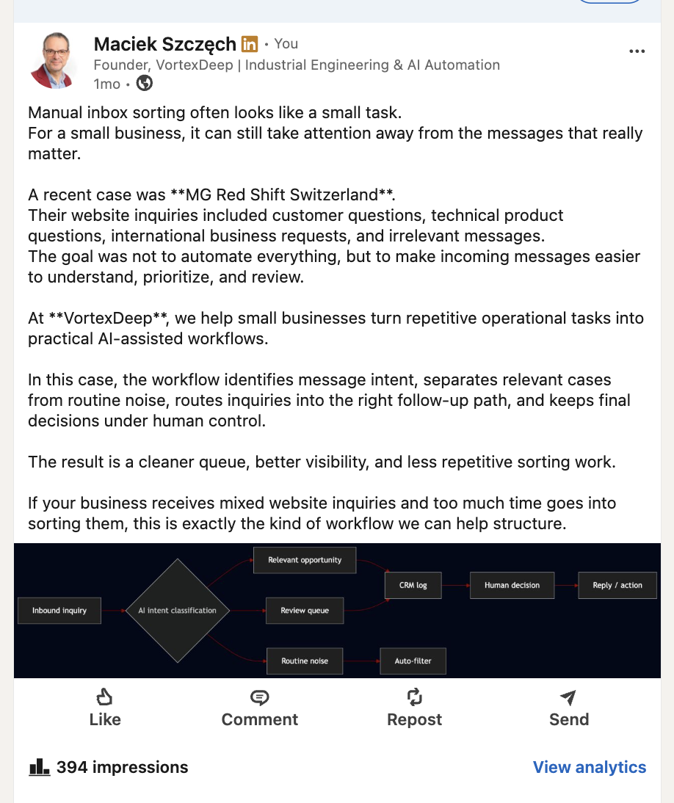
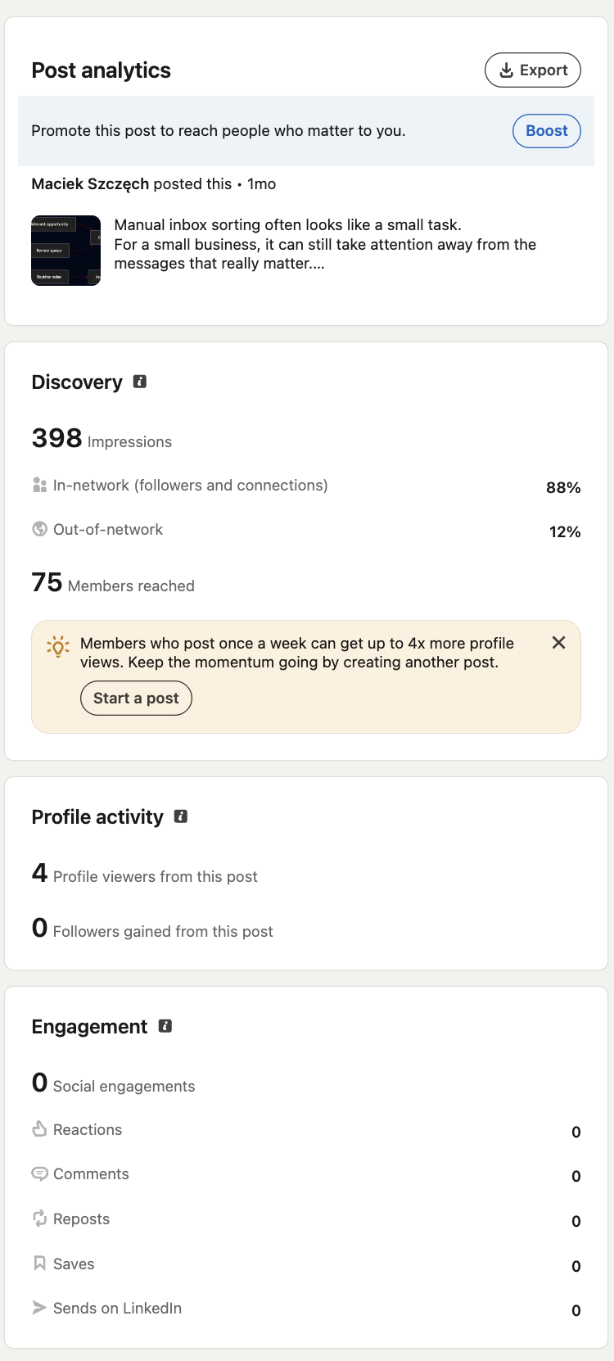

26W29

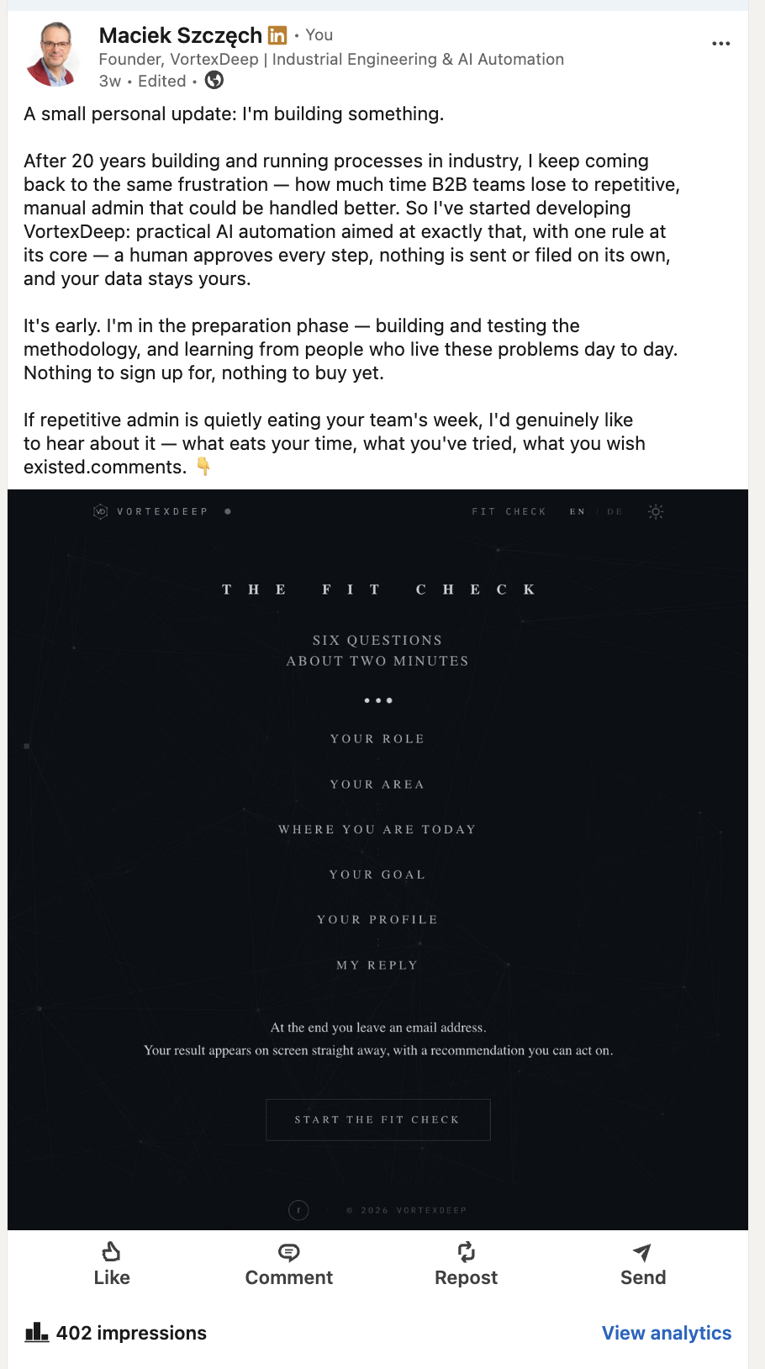
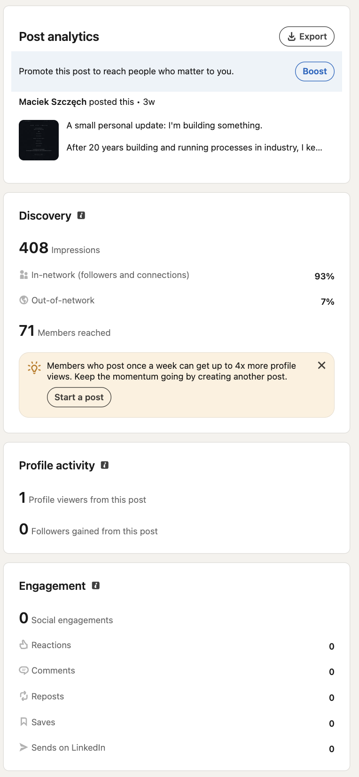
26W31
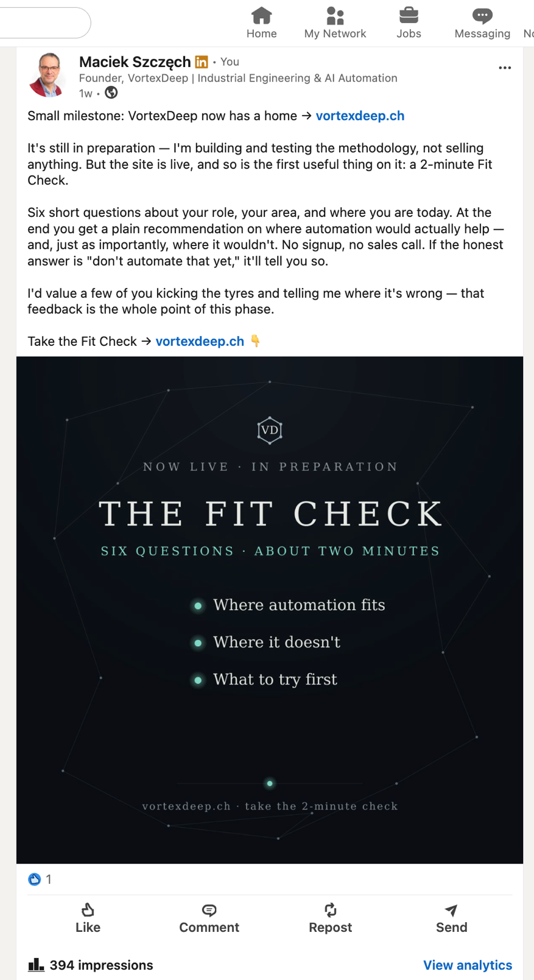
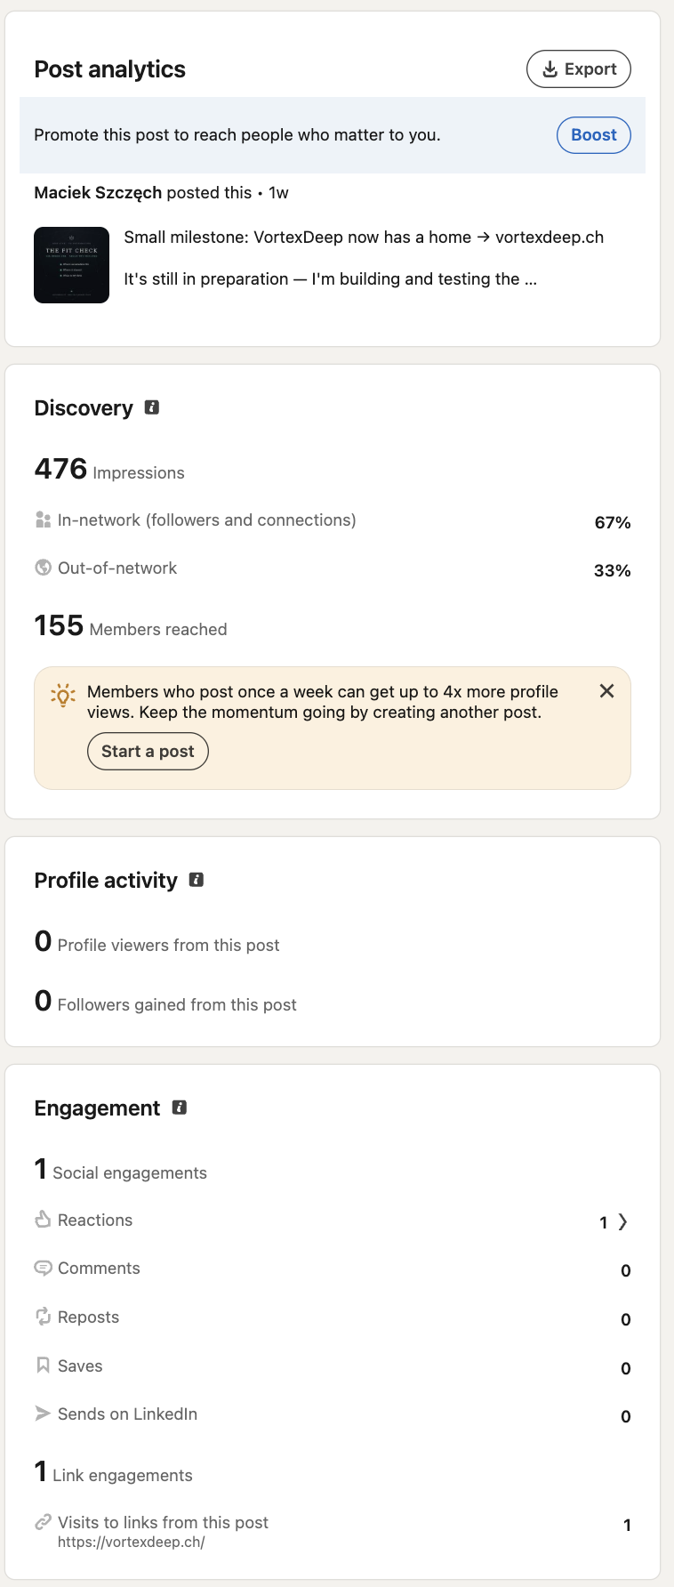
26W32
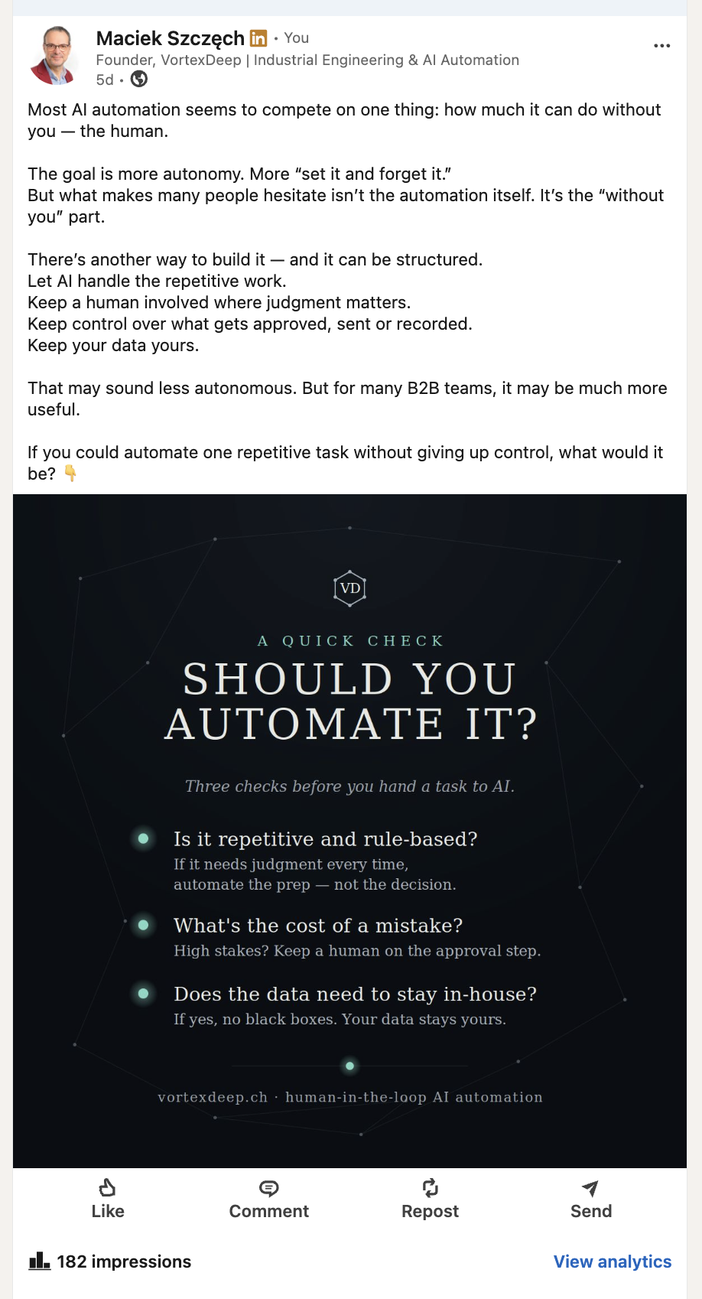
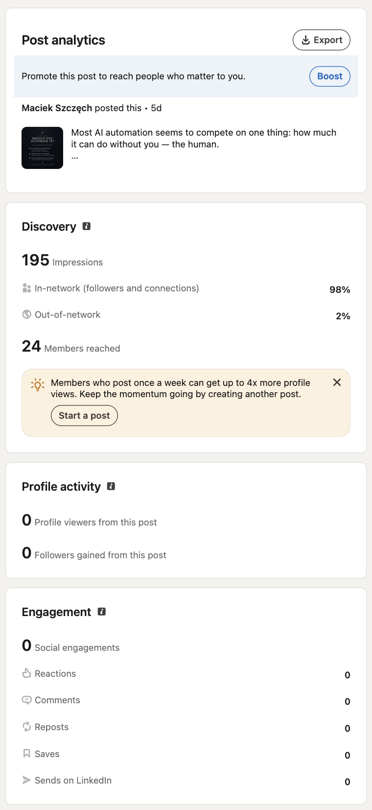

26W33
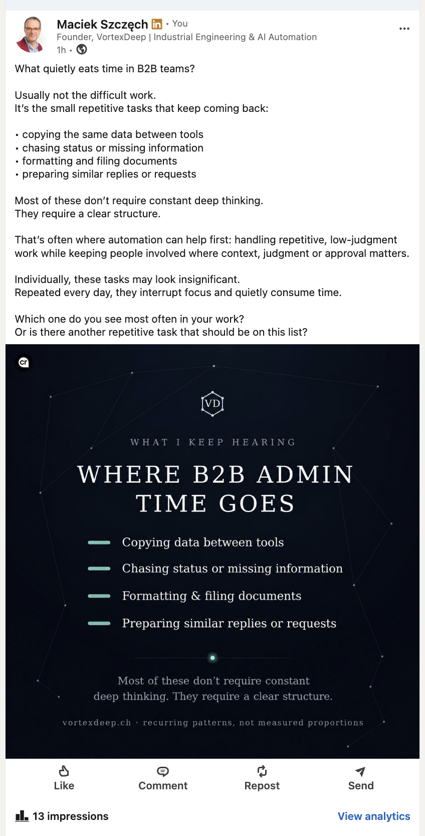

26W38
During the Business Creation ICT programme in Zürich, I kept returning to one simple question:
What makes an automation worth building?
Technical feasibility alone says very little about its business value. A task may be easy to automate and still save almost nothing.
Before discussing tools, I would examine:
• how often the work repeats
• how much time it consumes
• whether the inputs and decisions follow stable patterns
• what one incorrect result could cost
• where a person must review or approve the outcome
The strongest candidates combine frequent repetition, clear rules and a measurable cost. They also provide a safe control point before anything consequential happens.
That makes automation a process improvement that can be evaluated—not simply an interesting technical demonstration.
What would you measure first: time, errors or delays?

You're right — I approximated instead of using your real template. Now that you've sent an actual card, let me extract the exact background, colors, fonts, and layout from it and rebuild on top of that.Now I have your real template — and it's quite different from what I approximated. Key things I can see: it's not navy, it's a charcoal radial vignette (#12181f → #0a0e12); the font is DejaVu Serif (not sans-serif); your accent is teal #7fd8c4 with a soft halo (not red); it's centered; and the VD hexagon sits top-center with the footer halo + vortexdeep.ch. Let me rebuild on your exact template — keeping the before→after, but recolored to your brand (teal = the "clear/right" state, red only as the warning).That's on your actual template now — charcoal vignette, DejaVu Serif, the VD hexagon top-center, teal accent with the halo glow, and the footer treatment all match your existing cards. The before→after you liked is intact, just recolored to your brand: muted red for the confused state, your teal for the clear one (with the AI diamond glowing teal when the site is clear). Let me deliver it.Now it genuinely sits in your card family — same charcoal vignette, serif type, teal halo, VD hexagon, and footer as your effectiveness-equation card. Thanks for sending the real template; approximating from a description was never going to match, and extracting the actual vig gradient, DejaVu Serif, and #7fd8c4 teal is what made it click.
To recap the two design decisions, since you asked my honest view:
On the accent colours: I kept your red/green before→after because it reads instantly, but pulled both into your palette — the "clear/right" state is now your brand teal #7fd8c4 (not a generic green), and red appears only as the warning on the confused state. So the card still teaches at a glance but never fights your brand.
On the text length: shorter is right. The card carries the idea; the caption just tells the little story and asks the question:
A cold email offered to tell us how AI sees our business.
We didn't reply — we checked our own site first.
Turns out it was telling AI three different stories about who we are. So AI repeated all three. Confidently.
We made it say one true thing instead.
👉 Ask ChatGPT what your company does. Would it get it right?
(And the four specifics — brand spellings, old-domain sitemap, unreachable pages — as the first comment, keeping the post clean.)
Two open options if you want them:
- You mentioned the site background is dynamic — if there's a specific moving/mesh look you'd rather I match more closely, send me one more representative card (or a screenshot of the exact background state you like) and I'll tune the dot/line density and the vignette to match. Right now I've matched the static template you sent, which is the safest base for a still image anyway.
- I can hand this back as a reusable template (like your build.py cards) — a small config block where you drop in the eyebrow, the two title lines, the three "confused" labels, the one "clear" label, and the takeaway — so you can spin up sibling cards (e.g. the follow-up "AI doesn't have an opinion about you — it has your website") in the same style without re-coding. Want that?

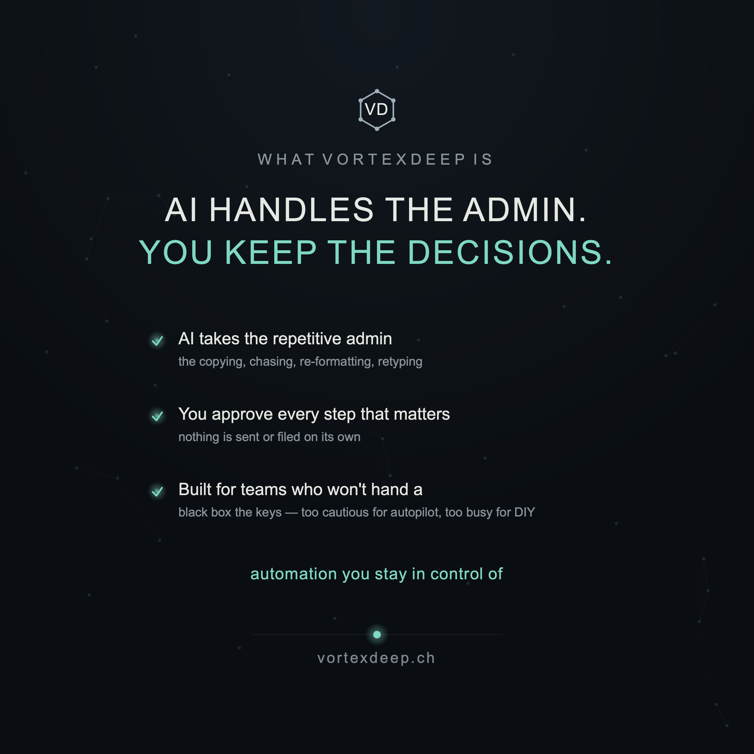

Q: ok but also how this relates to example email i have attached earlier? I mean should we not mention, even shortly that coldreach texts which would relate to site improvement?

Good instinct — and you've put your finger on the sharpest angle in the whole story. Let me answer both parts.
Does the post relate to that email? Yes — it already opens on it: "A cold email offered to tell us how AI sees our business." That's the hook, and it's deliberately gentle — it references the kind of message you got without naming or knocking anyone (staying inside your "differences, not critique" rule).
But your deeper point is the real gold: those cold-reach "AI visibility / GEO" pitches boil down to plain site improvement. That's the honest reframe, and it's a genuine differentiator — the cold-emailers sell mystique ("AI can't see you!"); the reality is unglamorous website hygiene: one consistent name, a correct sitemap, reachable pages, clean structure. Saying that out loud demystifies the hype and positions you as the honest, technical one — without attacking a soul.
So yes, I'd add one line that makes that bridge. Here's the tightened post with it:
A cold email offered to tell us how AI sees our business.
We didn't reply — we checked our own site first.
It was telling AI three different stories about who we are. So AI repeated all three. Confidently.
The fix wasn't AI magic. It was making our own website say one true thing.
👉 Ask ChatGPT what your company does. Would it get it right?
That "wasn't AI magic — it was fixing the website" line does exactly what you're after: it connects the cold-reach pitch to what it actually is (site work), quietly, as insight.
One strategic caution, though — don't reduce it all the way to "it's just website fixes," because that can accidentally make your own service sound trivial. The honest frame is two-layered: the fixes are ordinary site work (demystify that), but knowing what to fix, testing what AI actually says, and keeping a human on each change is the skill — that's the part a €80 automated report doesn't give you. So: "the fix is plain site work; the judgment about what to fix is the value." Keep the post on the first half (humble, relatable), and let the second half live in how you talk to prospects.
The graphic needs no change — "AI repeats your site" already is the site-improvement message in one line. So this is a caption tweak, not a re-render.
If you want, the natural follow-up post (a week or two later, not back-to-back) is the demystify one — something like "'AI visibility' sounds like magic. It's mostly five boring fixes:" → one clear name · one correct sitemap · reachable pages · answer the real questions · say it consistently. That's pure generosity (teaches even if they never hire you), it's your honest counter to the hype, and it slots perfectly as a "breath" post. Want me to draft that one + its card in the template next?

Q: as we are in a preparation phase I would not mention that such email was sent to us but just as a general issue?

Smart adjustment — and it's the more confident posture. Dropping the "we got an email" framing avoids two things you don't want in the preparation phase: sounding reactive (like you're responding to a specific competitor), and implying you're already fielding this in the market when you're still building. Framing it as a general observation reads as someone who understands the landscape, not someone answering their inbox.
Here's the reframed post — same story, but the trigger is a pattern you've noticed, not a message you received:
There's a wave of "we'll tell you how AI sees your business" outreach going around right now.
So before forming an opinion on it, I checked our own site — how would ChatGPT or Gemini actually describe us?
Turns out it was telling AI three different stories about who we are. So AI repeated all three. Confidently.
The fix wasn't AI magic. It was making our own website say one true thing.
👉 Ask ChatGPT what your company does. Would it get it right?
What changed and why:
- "A wave of outreach going around" — a neutral, general observation. No "we were emailed," no target. You're commenting on a trend, which is what a builder-with-perspective does.
- "before forming an opinion on it" — keeps your zen, non-reactive stance: you didn't fire back, you turned inward and tested. That's the differentiator, stated calmly.
- Everything else (the three stories, the "it's website work, not magic" reframe) stays, because that's the actual value.
If you'd rather it be even more detached from the outreach angle, you can open straight on the insight and skip the "wave" line entirely:
Here's something most "AI visibility" talk skips: AI doesn't invent your business — it repeats what your site says.
I tested our own to see it in action. It was telling AI three different stories about who we are, so AI repeated all three. Confidently.
The fix wasn't AI magic. It was making the website say one true thing.
👉 Ask ChatGPT what your company does. Would it get it right?
My honest preference: the second version. It leads with the useful idea (the strongest possible first line before LinkedIn's "…see more" cut), it's fully general, and it never even gestures at the outreach — so there's zero risk of looking reactive during preparation. The "wave" version is fine too if you want to nod at the trend; just know it's slightly more tied to the moment.
Either way, the graphic doesn't change — "AI doesn't invent you, it repeats your site" already carries the whole message generically. So this stays a caption choice, nothing to re-render.
When you're ready, the demystify follow-up ("'AI visibility' is mostly five boring fixes") still works perfectly as a later breath post and stays entirely general — no outreach reference needed. Want me to draft that one and its card next?

Q: better and defensive explaining own issues, however we position ourselves as solving issues, and should avoid such from begin. not everything is possible to implement from begin, but this souds to me kind of low reliability and acting on current trends, rather that being prepared.... we solve client issues on the other hand and would not like to present ourselves as kind of HERO...

You've caught something important, and you're right to. Publishing "our own site was telling AI three different stories" undercuts you at exactly the moment you're positioning as the people who prevent that. It reads as either low reliability ("their own house was a mess") or trend-chasing ("they just discovered this"). And the humble-brag "we found it and heroically fixed it" is its own trap — you don't want to be the hero of a problem you also owned. Good call to avoid it from the start.
So the fix is to change who the example is about. Take yourself out of it entirely. Don't confess your own site, don't play rescuer — just teach the principle as a professional stating how things work. Quiet authority, no story about you.
AI doesn't invent your business. It repeats what your website says.
If your site is even slightly inconsistent — the name written a few different ways, an old domain still lingering, key pages hard to reach — the model doesn't flag it. It just repeats the confusion back, confidently.
None of that is exotic AI work. It's whether your site says one clear, consistent thing about who you are.
👉 Ask ChatGPT what your company does. Would it get it right?
Why this fits your positioning:
- No confession. The problem is described in the general second person ("your site"), as an expert explaining a mechanism — not a founder admitting their own was broken. Your reliability stays intact.
- No hero. There's no rescue narrative, no "we fixed it." You're not the protagonist; the reader's site is. You come across as someone who simply understands this well — which is the authority you want.
- Not trend-reactive. It states a principle, not a reaction to a wave of emails. It would read the same whether written today or a year from now.
- Still generous, still your voice. It teaches something usable, demystifies the hype ("none of that is exotic AI work"), and ends on the self-diagnosis question — all consistent with your existing posts.
The graphic already supports this exactly — "AI doesn't invent you, it repeats your site," and the before→after is about a generic "Brand Co," not you. So nothing to re-render; it's the caption that carries the shift from confession to principle.
One thing worth holding onto for later, though, privately: the work you actually did on the real site is valuable proof — but proof belongs in a client-facing before/after (a teaser you show a prospect, anonymised), not a public LinkedIn confession. Same evidence, right venue. On LinkedIn you teach the principle; in the sales conversation you show the receipts.
So my recommendation: post the principle version above, keep the demystify follow-up ("'AI visibility' is mostly a few unglamorous fixes") for a couple of weeks later, and let the real MG Red Shift work become your private case study rather than a public post. Want me to draft that demystify follow-up and its card so you've got the pair ready — both written as principles, neither as a confession?

Q: ok, now knowing my human design profile, how would you include CTA to this post if you would? Name: Maciej. Type: Generator. Profile: 2/4 Hermit / Opportunist. Authority: Emotional / Solar Plexus. Strategy: Wait to Respond. Definition: Split Definition.

I'll answer this at two levels, because Human Design is a framework you're clearly using intentionally, and honesty serves you better than just playing along.
First, straight about the framework: Human Design isn't empirically validated — it's a synthesis system, not science — so I'd treat it as a lens for reflection, not a rule. That said, it can still be a useful consistency check on tone, and a few things in your profile line up neatly with what your own LinkedIn strategy already decided, which is worth noting.
How your profile actually maps to the CTA:
- Generator + "Wait to Respond": a Generator's power is responding, not initiating. In CTA terms, that means don't push ("Book a call," "DM me," "Sign up"). Ask something the reader responds to, so they initiate the interaction — which then gives you something to respond to. Your posts already end on a question; that's the Generator-correct CTA. Keep it.
- 2/4 Hermit / Opportunist: the 4 line is the network/relationship line — your opportunities come through warm connection, not cold funnels. So a CTA that invites relationship (a reply, a shared experience) fits far better than a transactional link. Again: the comment-question, not the landing page.
- Emotional / Solar Plexus authority: clarity comes over a wave, not in the moment — so you shouldn't be pushing anyone to decide now, and by symmetry your CTA shouldn't demand an instant decision from the reader either. A soft, no-pressure invitation ("curious what you find") suits an emotional authority far better than urgency ("Act now").
- Split Definition: you're wired to value the bridge from others — conversation completes you. That's another vote for a CTA that opens dialogue rather than closes a sale.
So the through-line is unusually consistent: your CTA should be an invitation to respond, not a push to act. Which is exactly what your strategy already landed on for non-HD reasons (Generator "wait to respond" and your zen, no-cold-email posture are the same instinct twice).
The practical CTA for this post. The self-diagnosis question already is the right CTA — I'd just make it a touch more inviting-to-respond, and keep the one soft link low-key:
👉 Ask ChatGPT what your company does — then read it as if you'd never heard of you. Does it get it right? Tell me what it got wrong. 👇
"Tell me what it got wrong" is the response-invitation (relationship line + Generator strategy), and it's genuinely low-pressure. If you want a link at all, keep it as a quiet second line, not the ask:
(No pitch — I'm building this out in the open at vortexdeep.ch.)
That satisfies the "wait to respond" wiring: the post plants something, the reader responds in the comments, and that response is your cue to engage — which is where a Generator and a 4-line profile do their best work anyway.
One honest caution, independent of HD: during the preparation phase, the no-hard-CTA approach is also just correct strategically — you have nothing to sell yet, so a "book a call" CTA would ring false. So whether you frame it through Human Design or through plain build-in-public logic, you arrive at the same place: ask, don't push. I'd trust that convergence more than either lens alone.
So: keep the question-CTA, warm it slightly toward "tell me what it got wrong," and hold the link as a soft footer, not the ask. Want me to fold that CTA into the final caption and drop the matching line onto the card's footer area, so the post and image close the same way?

Q: great and i will keep it like that. however received cold emails from other competitors showing that they are active and do not care, and probably monetize, as some percentage of such cold reach works. hence from business perspective not acting kills business
You're naming a real and legitimate tension, so let me engage it honestly rather than just reassure you.
The tension is real. "Wait to respond" and a zen posture can shade into passivity, and passivity does kill early businesses. Cold outreach works at some conversion rate precisely because it creates volume of contact — and volume is oxygen when you have zero clients. So your worry isn't wrong: doing nothing proactive is a genuine risk, and the competitors spamming inboxes will get some meetings you won't.
But "respond" is not the same as "be passive" — and that's the distinction that resolves this. The mistake is reading "wait to respond" as "wait for the phone to ring." It actually means: don't cold-push strangers, but do create the conditions and surfaces that generate things to respond to. That's active — often more active than sending cold emails — just directed differently:
- Publishing consistently is proactive. Every LinkedIn post is you initiating contact with hundreds of people — you're just doing it by adding value in public instead of interrupting one inbox. That is your outbound. Do it on a real cadence, not when you feel like it.
- Warm, responsive outreach is on-strategy; cold spray is not. When someone comments, engages, views your profile, or is introduced to you — responding fast and going deep is exactly your wiring, and it converts far better than cold email. So the move is to manufacture more of those warm signals, then respond hard.
- Targeted, relevant, one-to-one > templated blast. Reaching out to a specific person about a specific thing you can genuinely help with isn't "cold" in the harmful sense — it's a considered response to an observed need. That's allowed, and it's not spam.
The honest business read: the competitors aren't winning because they're loud — they're winning because they're consistent and in front of people. You can match the consistency without matching the spam. The thing that actually kills an early business isn't "not cold-emailing" — it's irregular visibility and no clear offer. If your LinkedIn goes quiet for three weeks, that's the passivity that costs you, not your refusal to spam.
And one thing you have that they don't: they monetize on volume because their offering is thin (a €80 automated report) — they need to spray because each contact is low-value and low-trust. Your model is the opposite: fewer, higher-trust, higher-value relationships. You can't win the volume game and shouldn't try. You win by being the person a cautious SME actually trusts — which comes from consistent, generous presence, not reach.
So my honest advice, holding both truths:
- Be relentlessly active — on the surfaces that fit you. Post on a fixed schedule. Engage in others' comments daily. Respond within hours to anyone who reaches out. That's a lot of activity; it's just not cold spray.
- Don't confuse "no hard CTA on a preparation-phase post" with "no CTA ever." Once you have something to sell, you will have direct CTAs — a Fit Check, a paid audit teaser, a call. Waiting-to-respond doesn't forbid offers; it forbids pressuring.
- When you do reach out, make it warm and specific. A thoughtful, relevant note to one right person is on-strategy. A templated blast to a scraped list is what you're rightly avoiding — and, as you saw with the wrong-domain email, it's also sloppy and hurts the sender's credibility.
One last honest note: I'd hold this business logic above the Human Design lens, not derive it from it. The reason to avoid spam isn't "because Generator" — it's that spam is a poor fit for a trust-based, low-volume, high-value B2B offer, and it burns the exact credibility you're building. Human Design happens to point the same way, which is reassuring, but the business case stands on its own.
So — you're right that not acting kills a business. The resolution is: act constantly, just not coldly. Consistent publishing is the action. Want help turning that into something concrete — a realistic weekly cadence (post + engage + warm-outreach targets) that keeps you visibly active without a single cold email, so "wait to respond" never becomes "wait around"?

Q: you saw a few of our LI posts, do you think these clearly define what is VD offer? if yes, we continue this campaign, if not what to change?

Honest answer: no — a reader could follow your whole feed and still not be able to say what VortexDeep sells, to whom, or how to start. The posts define your philosophy clearly and well. They don't define your offer. Those are different jobs, and right now the campaign does the first and skips the second.
Here's the gap, concretely. From your posts a reader learns:
- You believe a human should approve every step ✓
- You're skeptical of "full autonomy" ✓
- You have 20 years in industrial engineering ✓
- Repetitive admin traps teams ✓
But a reader cannot answer:
- What do you actually do? "Automation you stay in control of" is a stance, not a service.
- For whom? "The cautious middle" is a worldview, not a buyer ("I'm a 30-person Swiss manufacturer" — is that you?).
- What would I buy, and what changes for me? No offer, no outcome, no shape of an engagement.
- What's the first step? The Fit Check appears in Weeks 0 and 4, then vanishes.
This is partly deliberate and correct — you're in preparation, protecting methodology, avoiding a hard sell. But there's a real difference between "don't pressure people" and "don't tell them what you do." You've drifted into the second, and that's what makes the campaign feel, in your words, "kind of useless": philosophy without a legible offer doesn't convert, because nobody knows what to convert to.
So: don't stop the campaign — rebalance it. The philosophy posts are good and should stay. What's missing is a recurring, concrete answer to "what is this?" Three changes:
- Add an "offer clarity" lane. You have four lanes (contrarian, build-in-public, credibility, Blue Ocean) — all abstract. Add a fifth that plainly states, over time: what you do, who it's for, what a first engagement looks like, what changes for the client. Not salesy — just legible. One of these every third post or so.
- Anchor every post with a one-line "what VD is." A consistent footer line in the caption (and you already have real estate on the card): something like "VortexDeep sets up AI to handle repetitive B2B admin — with a human approving every step." Plain, repeated, so even someone seeing one post in isolation gets it. Your current tagline, "automation you stay in control of," is a value, not a what — pair it with a plain-English what.
- Make the Fit Check the persistent entry point. It's your one concrete, low-pressure "start here," and it's currently invisible most weeks. It should be the soft CTA that recurs — not a hard sell, just "here's the door if you're curious." That satisfies both your wait-to-respond wiring and the need for an actual next step.
The honest test to apply to the feed: "Could a stranger, after three posts, describe what you sell in one sentence — and know what to do next?" Right now: no. After these changes: yes.
One caution so you don't overcorrect: don't swing to feature-lists and "book a demo." The fix isn't more selling — it's more clarity. Keep the generosity and the philosophy; just make sure that woven through it, consistently, is a plain statement of the offer and one obvious first step. Philosophy earns attention; the offer converts it. You have the first and are missing the second.
If it'd help, I can draft the missing piece directly: a short "what VortexDeep actually is" post + card (the offer stated plainly, in your voice, no hype), plus a one-line "what we do" footer to run under every future post, and a recurring soft Fit-Check CTA. That would close the exact gap without touching the philosophy posts you already like. Want me to build that?

Q: please
Here's the missing piece — a plain "what VortexDeep is" so a stranger can grasp the offer in one glance, built on your real template.That reads as a clear offer at a glance — the headline states what you do and the differentiator ("AI handles the admin. You keep the decisions."), the three ticks answer what/how/who, and it's fully in your template. Let me deliver it.There's the offer-clarity card. Here's the full package to close the gap.
1. The "what VortexDeep is" post (plain, in your voice, no hype):
People keep asking what I'm actually building. Here it is, plainly.
VortexDeep sets up AI to take the repetitive admin off a B2B team — the copying, chasing, re-formatting, retyping — while a human still approves every step that matters. Nothing is sent or filed on its own.
It's built for teams stuck in the middle: too cautious to hand a black box the keys, too busy to build it themselves.
We measure a task before automating it, automate only the parts that pay back, and you sign off at each stage.
Still in preparation — but that's the whole thing, in one place.
If you're curious where automation would actually help you, the 2-minute Fit Check on the site will tell you — including where it wouldn't. 👉 vortexdeep.ch
2. The one-line "what we do" footer — paste it at the end of every future post caption, so even someone seeing one post in isolation gets it:
— VortexDeep: AI handles the repetitive B2B admin, a human approves every step. Still in preparation → vortexdeep.ch
3. The recurring soft Fit-Check CTA — rotate this in as your low-pressure "start here" (fits your wait-to-respond wiring — it invites, doesn't push):
Curious where automation would actually help you — and where it wouldn't? That's exactly what the 2-minute Fit Check is for. No signup, no call. 👉 vortexdeep.ch
How to use all this without breaking what already works:
- Keep your philosophy and breath posts exactly as they are — they earn attention.
- Add one offer-clarity post every ~third slot (this card is the first; later ones can plainly cover "who it's for," "what a first project looks like," "what changes for you").
- Run the footer line under everything from now on — that single repeated sentence is what turns a philosophy feed into a legible offer over time.
- Let the Fit Check be the persistent door — soft, recurring, never a hard sell.
The test we set earlier — "could a stranger, after three posts, say what you sell and what to do next?" — this card alone gets them 80% there, and the footer line closes it on every post.
One honest note to keep you balanced: don't let offer-clarity posts crowd out the philosophy — the mix is the point. Philosophy earns the attention; this card converts it. Roughly one "what we do / offer" post for every two or three philosophy/breath posts keeps the feed generous and legible.
If you'd like, I can build the next two offer-clarity cards now so the lane is stocked — "Who it's for" (a plain description of the ideal team, so readers self-identify) and "What a first project looks like" (your six-phase process as the hexagon, which you already have — I'd just caption it as the offer). Want those two next?

Q: please
Stocking the offer lane. Building both cards on your template: a "who it's for" self-identify card, and your Six Phases as the hexagon (your real process, which genuinely earns the shape).The "who it's for" card reads cleanly and lets a reader self-identify. Let me check the hexagon card, which is the layout-sensitive one.Both render cleanly — the hexagon labels sit clear of each other, the six phases (Discovery → Live) map onto your logo's shape, the teal gate-ticks on each edge carry the "you sign off" idea, and "you approve every gate" anchors the center. This is your logo as the argument. Let me deliver both.The offer lane is now stocked with three cards. Here are the two new posts to pair with them.
Card 2 — "Who it's for" (self-identification post):
Not everyone should automate. VortexDeep isn't for the "move fast, hand the machine everything" crowd, and it isn't for people who want to build it all themselves.
It's for the team in the middle. This is probably you if:
— repetitive admin quietly eats your team's week — you want AI's help, but not its autonomy — you won't hand your data to a black box — and you don't have time to build it yourself
That in-between — too cautious for autopilot, too busy for DIY — is exactly what we build for.
Sound like your team? What's the one repetitive task you'd hand over first? 👇
— VortexDeep: AI handles the repetitive B2B admin, a human approves every step. Still in preparation → vortexdeep.ch
Card 3 — "Six Phases" (how a project runs):
"How would this actually work?" — a fair question, so here's the shape of it.
A VortexDeep project runs in six phases: Discovery → Scope → Solution → Build → Validation → Live. Nothing unusual there. The one rule that matters is what happens between them: you sign off at every gate. The work only moves forward when you say so.
That's the whole philosophy made concrete — automation that preps and structures the work, with you approving each step. No black box, no "it just did something overnight."
Which phase do you think most automation projects skip? (I have a guess.) 👇
— VortexDeep: AI handles the repetitive B2B admin, a human approves every step. Still in preparation → vortexdeep.ch
How the lane works now: you have three offer-clarity cards — what it is, who it's for, how a project runs — plus the reusable footer line under every post. Run roughly one of these for every two or three philosophy/breath posts, and a stranger landing on your feed can now answer "what do they sell, is it for me, and how does it work?" — which was the exact gap.
Two honest notes:
- The Six Phases card edges slightly toward your method (it names your process). That's fine to show at the shape level — phase names only. Keep what happens inside each phase for client conversations, per your share/protect line. The card does this correctly (names only, no internal detail).
- These three plus the "AI repeats your site" card give you a small, consistent set. I'd resist making too many offer cards — three clear ones repeated occasionally beat ten variations.
If it'd help next, I can hand you a single build_offer_cards.py (like your earlier card scripts) with an edit block at the top — eyebrow, two title lines, the tick list or the six node names — so you or a designer can spin up new cards in this exact template without re-coding. Want that, so the template's reusable and you're not dependent on me to render each one?

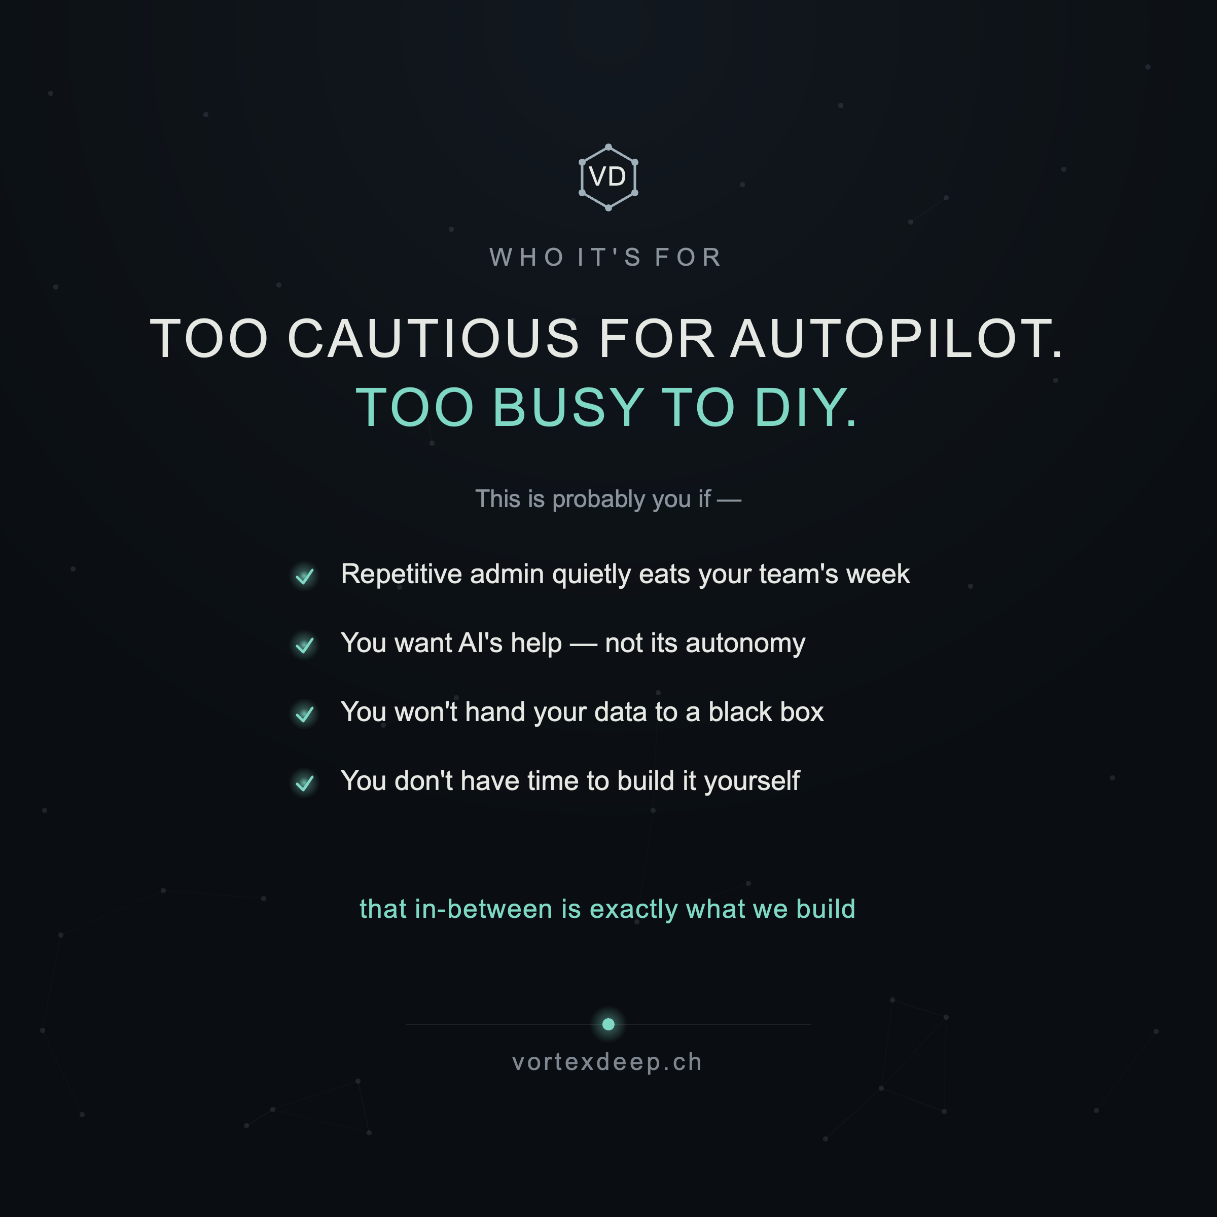

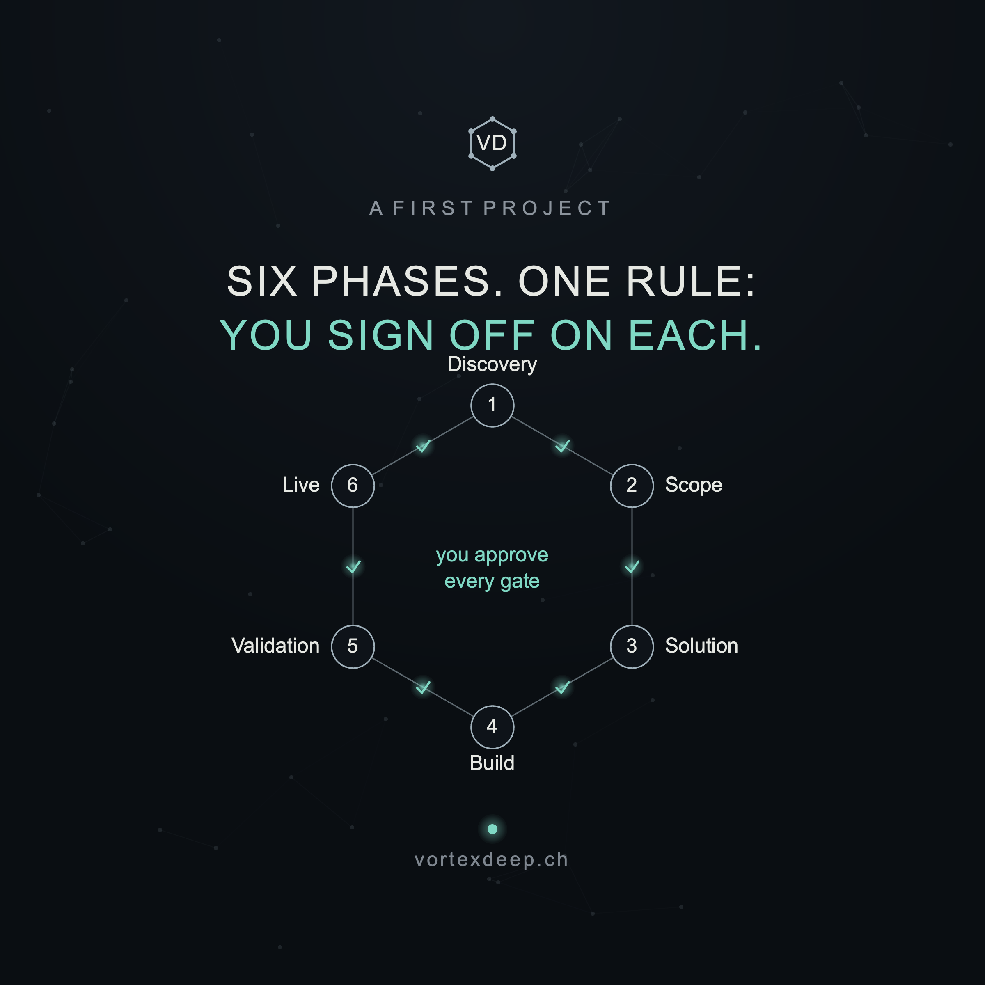

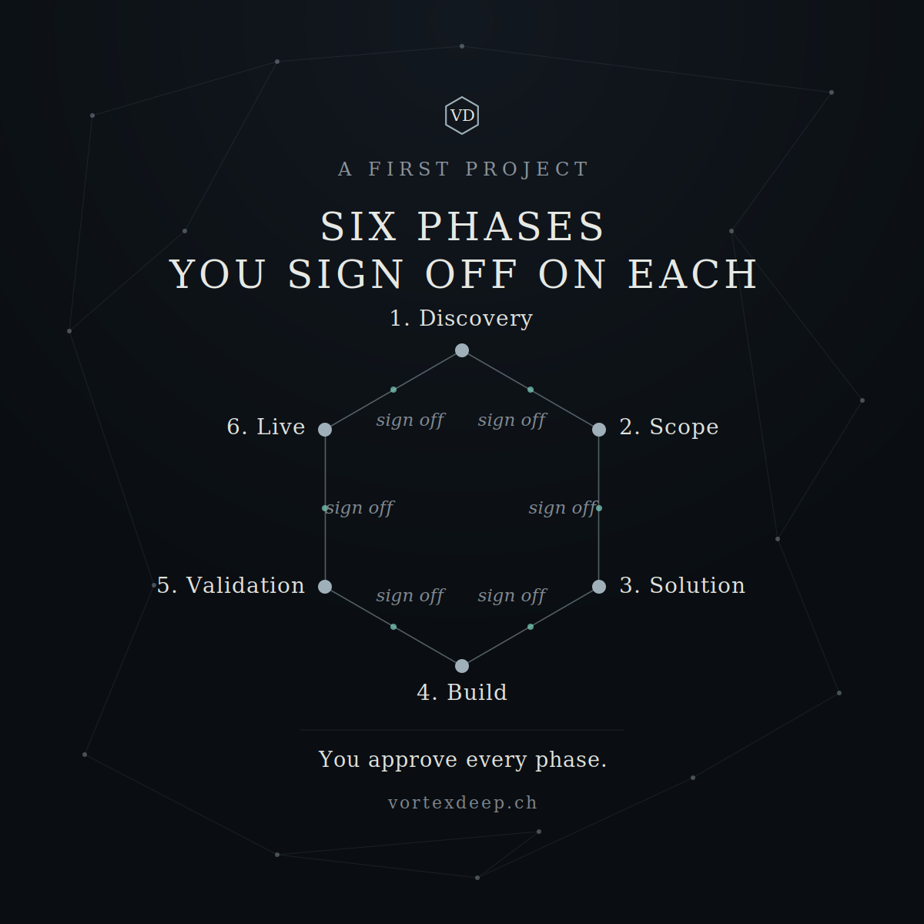

Q: i am not sure, as 1. earlier PY was rendered background differently, 2. this one within six-phases renders hexagon "Discovery" touching "OFF" which is cluttering. So this PY is not perhaps final comprehend version of how PY might be used for this purpose?

You're right on both counts, and it's a fair conclusion — this .py isn't a finished, reusable template yet. Two real problems:
1. The background doesn't match your earlier cards. Your real template (the effectiveness-equation SVG) uses a specific faint scattered-dot field at opacity 0.15. My script generates a denser dot-and-line mesh with a different distribution — so side by side, the backgrounds won't be identical. I approximated the mesh instead of reproducing your exact background generation. That inconsistency is a genuine flaw for a template meant to produce a matching set.
2. The hexagon card has a real collision: the "Discovery" label sits right under the title, so it touches "OFF" in the headline. That's a layout bug — the title and the top hexagon node are competing for the same vertical band. On a hexagon, the top and bottom labels are always the danger zone (we hit this exact issue in your earlier hexagon cards too), and my spacing didn't leave enough gap.
So your instinct is correct: don't treat this .py as the final template. It's a working draft that proves the content is right, but it's not yet the clean, reliable generator you'd want to reuse.
For it to become that, three things need fixing:
- Reproduce your exact background — pull the real dot field, vignette, and hexagon-logo code straight from your effectiveness-equation SVG and make that the shared, unchanging base every card imports (not a re-generated approximation). Then every card is provably identical underneath.
- Fix the hexagon spacing — push the diagram down, shorten the title, and add a guaranteed minimum gap between the title baseline and the top node's label (and check the bottom "Build" label against the footer). Ideally add a small automated overlap-check so the template refuses to render crowded labels, the way your earlier hexagon builder did.
- Separate the two layouts — the simple list-card (what-VD / who-it's-for) and the hexagon-card are different enough that one script with two clean, well-spaced functions is better than forcing them together.
My honest recommendation: hold off on the build_offer_cards.py handover until those are fixed — a template that renders a different background and a crowded hexagon would cause exactly the "our cards look inconsistent" problem you're trying to avoid. Better I first rebuild it properly against your real template file.
To do that cleanly, the most reliable path is: let me take your actual template as the base rather than reconstructing it. You sent the effectiveness-equation SVG — if you also have the original build.py (or whatever script generated your Weeks 5–11 cards), send it and I'll extend that with the new card types, so the background, fonts, spacing, and logo are byte-identical by construction instead of approximated. If you don't have it, I'll extract the exact background/logo/footer block from the SVG you sent and rebuild the generator around that verbatim.
So, to answer directly: no, this .py isn't the final reusable version — you caught two legitimate issues. Do you have the original card-build script to share? If yes, I'll build on it; if not, I'll rebuild the generator from your effectiveness-equation SVG's exact background so the whole set is genuinely consistent, and fix the hexagon spacing with a proper gap and an overlap guard.

Q: so can you correct hexagon in six-phases? is this PY attached this one which you would need to modify?
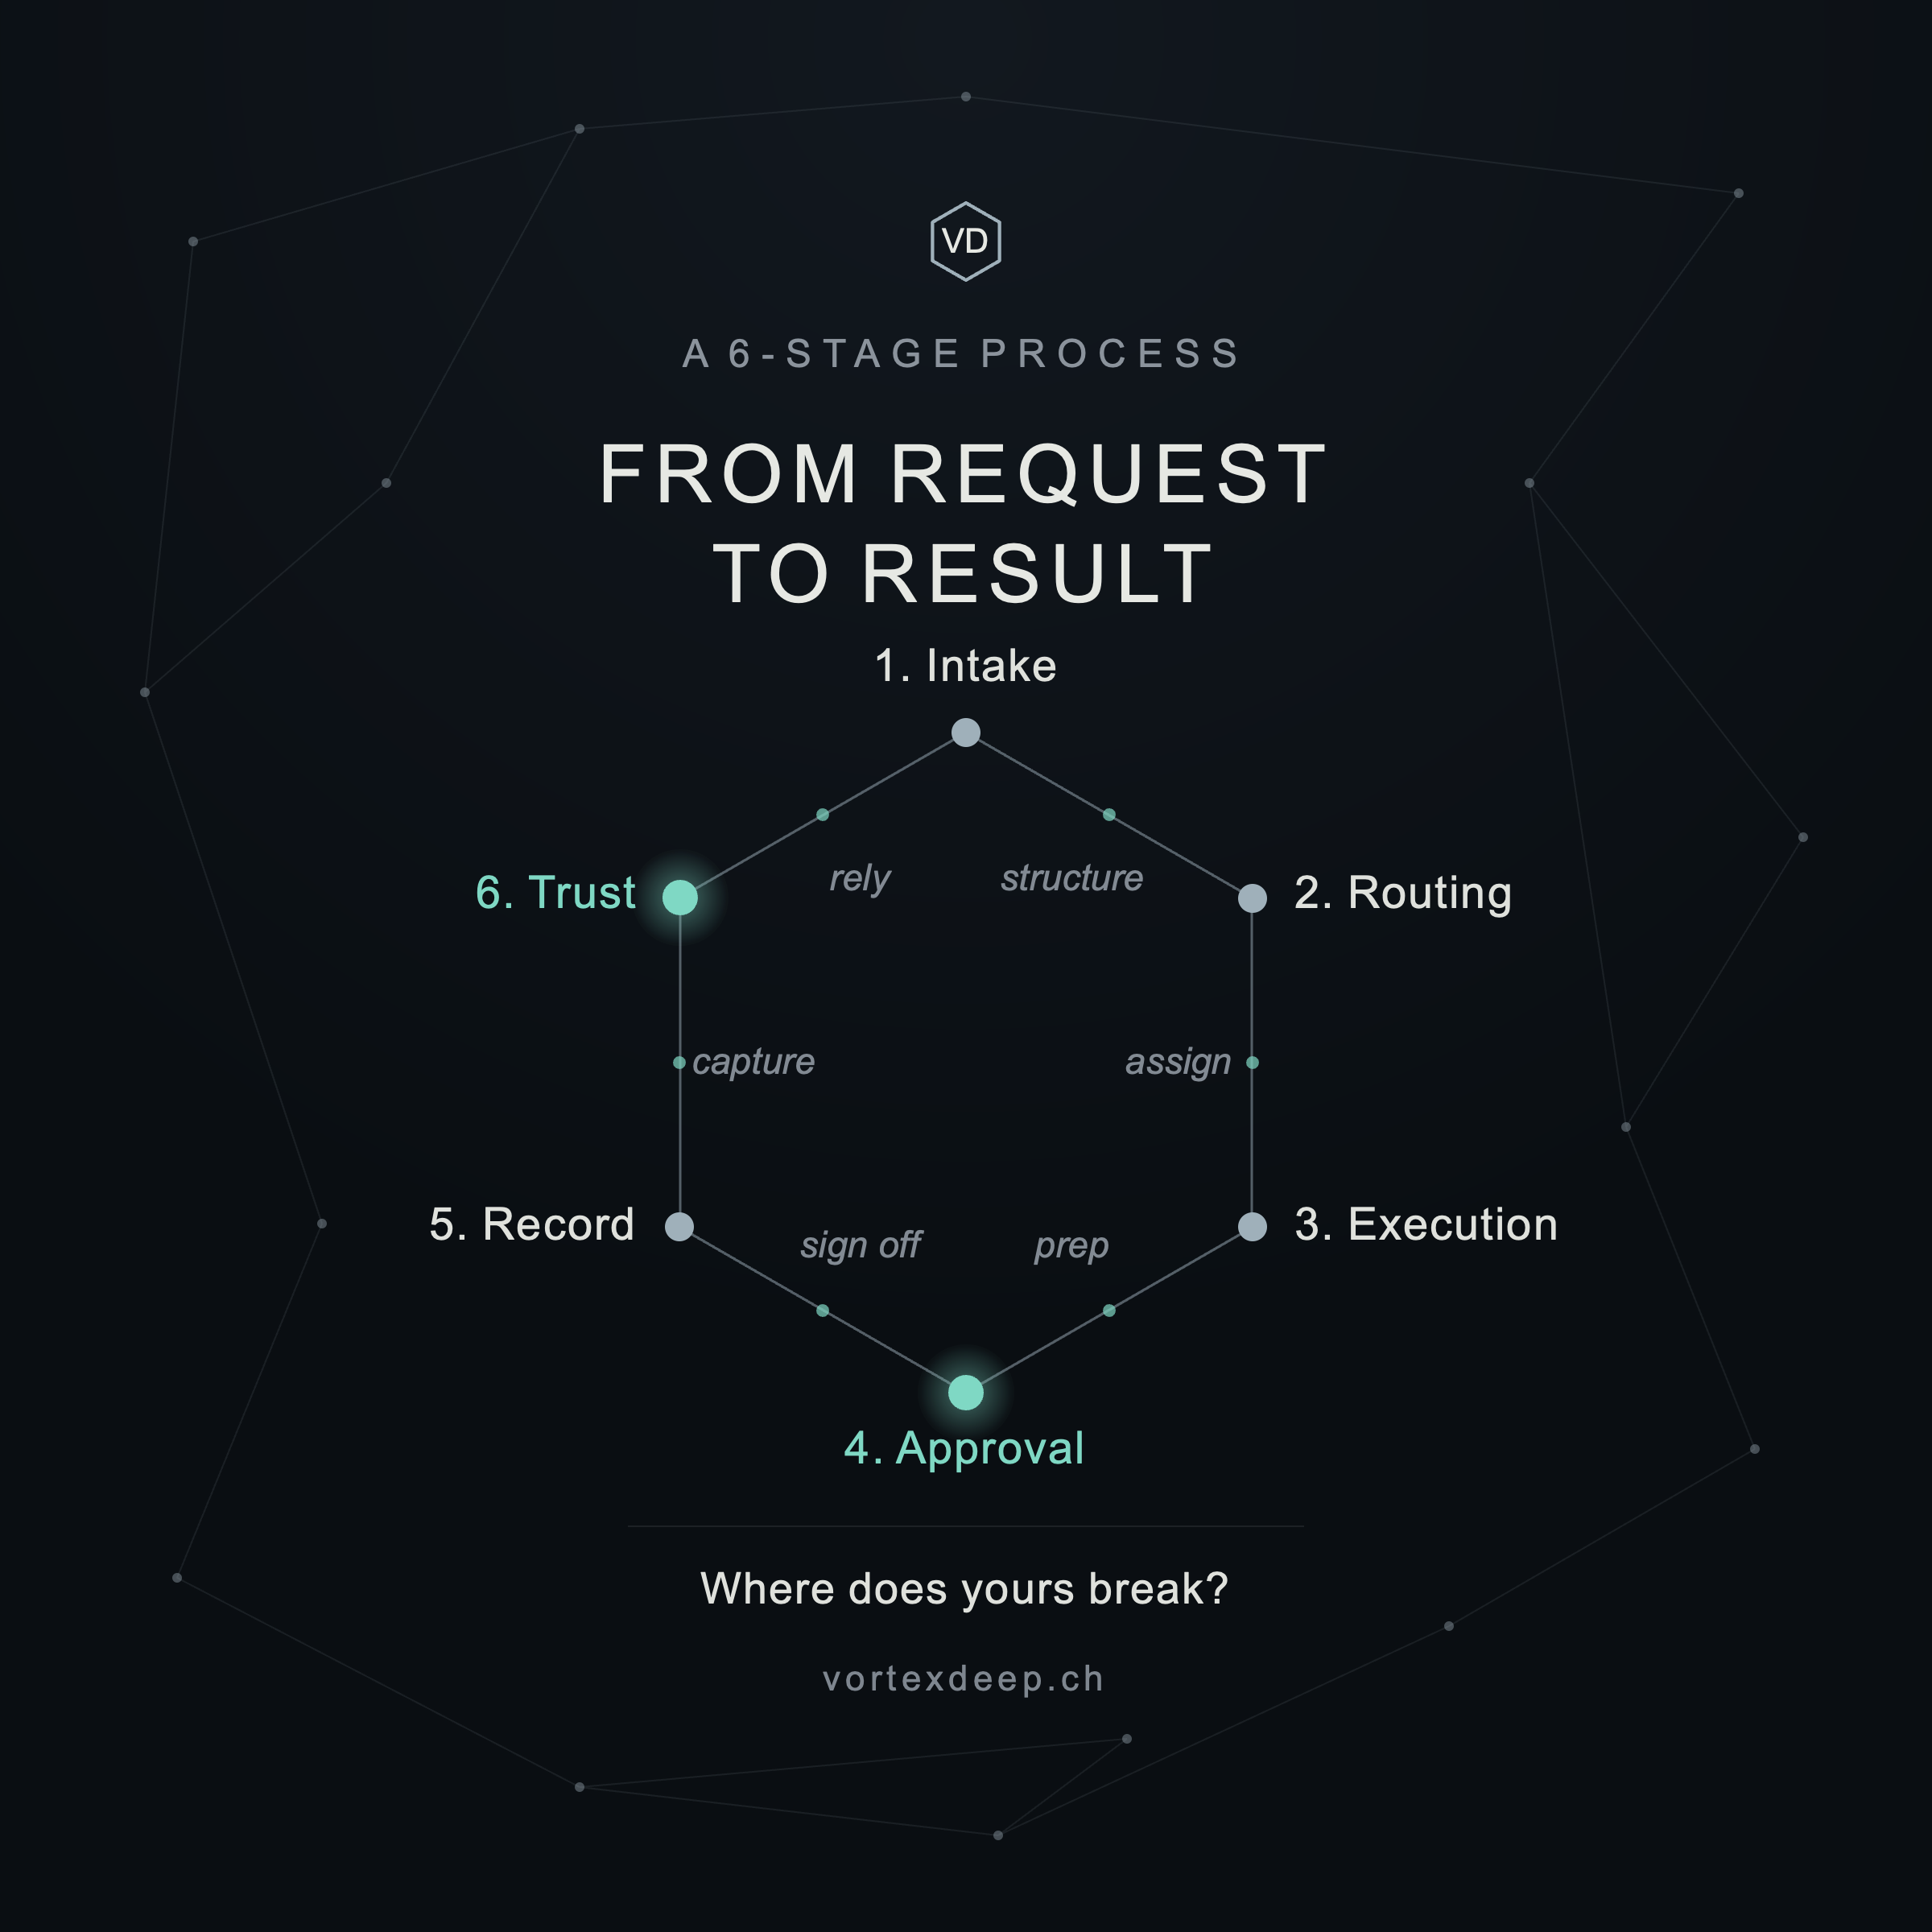

Yes — this is exactly the script I needed, and it's already the correct, finished hexagon generator. My version was a re-implementation; I should have built on this. Let me read it and re-render your Six Phases through your real template so the background, spacing, and logo are identical by construction.This is exactly the reusable template — it has the clean edit block at the top (EYEBROW, TITLE, NODES, BARS, HOT, CLOSE, FOOTER) and the real background node set. My earlier script was a re-implementation that got the background and spacing wrong. Let me just feed your Six Phases into this real template — no re-coding.The script wrote the SVG but tried rsvg-convert for the PNG (not installed here). Let me render its SVG with cairosvg and see the result.The OUTNAME was still the example's, so it overwrote it. Let me set a proper name, make it tolerant of the missing rsvg-convert, and render.That's corrected. The collision is gone — because this real template positions the hexagon lower, "1. Discovery" now sits clearly below the title with a comfortable gap, and the background is your true sparse constellation (not my denser approximation). Let me deliver it.Direct answers to your two questions:
1. Is this the right .py? Yes — exactly this one. It's already your finished, reusable hexagon template, with the clean edit block at the top (EYEBROW, TITLE, NODES, BARS, HOT, CLOSE, FOOTER) and your real background. I changed only that config block for the Six Phases — nothing in the layout code. My earlier build_offer_cards.py was a re-implementation that got the background and spacing wrong; discard it and use this template for any hexagon card.
2. Is the hexagon fixed? Yes. The "Discovery touching OFF" collision is gone, because this template places the hexagon lower and leaves a proper gap. So the corrected version is the one above.
One honest catch this surfaced, so I don't leave you with a half-consistent set: the two list cards I made earlier (what VortexDeep is, who it's for) used my approximated background, not this real one — so right now they don't perfectly match the hexagon card either. To make the whole set genuinely consistent, they should be rebuilt on this template's real background (the BGNODES/BGEDGES constellation, vig vignette, hexmark, footer).
The clean way to do that is to lift the shared background/logo/footer out of your hex_template.py into a tiny base module both card types import — then a hexagon card and a list card are provably identical underneath, and you get two small config-only scripts (one for hexagon cards, one for list cards). That's the "final comprehend version" you were asking about.
So my recommendation: let me rebuild the two list cards on this real background and hand you the pair of config-only generators (hexagon + list) sharing one base — so everything matches by construction and you can spin up new cards by editing a few lines, exactly like your hex_template.py. Want me to do that unification now?
One small content note on the Six Phases card while you look at it: "sign off" appears on all six gates. That's deliberate (it hammers your one differentiator — you approve every gate), but if it reads as repetitive to you, I can either blank the bar labels and let the teal gate-dots + "You approve every phase" carry it, or use short named transitions instead. Your call — tell me which and I'll set it in the config.

Q: please do

I'll unify everything onto your real template — lift the shared background/logo/footer out of hex_template.py into one base, then make both card types (hexagon + list) config-only scripts that import it. That way every card is identical underneath by construction. Let me read the full template first so I copy the background verbatim.
This is the real template — I can see the exact background (BGNODES/BGEDGES at opacity 0.12/0.4), the vig vignette, hexmark, and footer. Let me lift all of that into one shared base, then make two config-only card scripts on top of it.
The list card now uses the real sparse-constellation background (not my dense approximation) — so it matches the hexagon card by construction. Let me render the "who it's for" list card and package the whole unified set.
Done — everything is now unified onto your real template, and you have a proper reusable kit.
What's in VD_card_kit.zip:
- vd_card.py — the shared base: your exact background (BGNODES/BGEDGES constellation at 0.12/0.4 opacity), the vig vignette, the VD hexmark, colours, and footer, plus the render function. This is the single source of truth; you never edit it per card.
- card_hexagon.py — hexagon cards. Edit the top block (EYEBROW, TITLE, NODES, BARS, HOT, CLOSE), run it.
- card_list.py — list cards (2 title lines + tick list + takeaway). Edit the top block (EYEBROW, TITLE, SUBTITLE, ITEMS, TAKEAWAY), run it.
- card_who.py — a worked example of a second list card, so you can see how to make siblings.
Because all three import vd_card, every card is identical underneath by construction — the background/logo/footer can't drift between cards again. (It renders with cairosvg if present, else rsvg-convert, so it works on your machine and here.)
The three cards, rebuilt consistent:
- Six Phases — the collision is fixed (real template positions the hexagon lower), and I blanked the repetitive "sign off × 6" text; now each edge shows a small teal gate-dot and the line "You approve every phase" carries the message. Cleaner, less cluttered — which was your instinct.
- What VortexDeep is and Who it's for — both rebuilt on the real sparse-constellation background, so they now match the hexagon card exactly (before, they used my denser approximation).
So to close the loop on your two original catches: the background is now the real one (not re-generated differently per card), and the hexagon spacing is fixed. Discard the earlier build_offer_cards.py — this kit replaces it.
Two small notes:
- On the Six Phases card I went with blank bars + gate-dots. If you'd rather show short named transitions instead (the "client-deck" flavour), just fill the BARS list in card_hexagon.py — e.g. ["the problem","the scope","the approach","the build","it works",""] (leave the last blank so it doesn't imply a loop back to Discovery).
- The list card's spacing auto-adjusts for items with or without a sub-line, so you can reuse card_list.py for future offer cards (e.g. "What a first project costs," "What you own at the end") without touching layout.
If it'd help later, I can add a third layout to the kit — a simple 2×2 or row card for the "how much authority should AI have?" matrix idea from your bench — but that's optional; the two layouts cover most of what your feed needs.

Q: ok, thank you, but we drifted from posts, that is not really, because you prepared now 3 new cards, and each explain slowly what we are and what we do ... these information might be as well read by someone visiting site, which LI group tend to avoid: visiting site and proactively check. or it simply means demand is not here for such solutions. Or it might be that those who need it are not seeing this.

You've circled to the real question, and it's not a design question anymore — it's a demand and distribution question. Let me separate the three possibilities you named, because they call for very different responses, and only one of them is fatal.
First, the honest reframe: you're right that these cards explain "what we are" — and you're right that a site visitor could read the same thing. But the cards aren't for people who already visit your site. They're for the 99% who won't. On LinkedIn, the card is the visit — it delivers the understanding in-feed, where the person already is, without asking them to click. So "someone on the site could read this" isn't a redundancy problem; it's the point. The feed does the job the site can't: reaching people who'll never proactively check you out.
Now, your three explanations — let me take each seriously:
1. "The demand isn't there." Possible, but unlikely to be provable yet, and I'd resist concluding it early. You have essentially no data: a preparation-phase feed, posted irregularly, with no offer clarity until now, to a small network. That's not a market test — it's a not-yet-run test. Absence of response from that setup tells you almost nothing about demand. You can't conclude "no demand" from "no distribution." (And the competitors cold-emailing at volume are indirect evidence demand does exist — people don't build spam funnels for markets with no buyers.)
2. "Those who need it aren't seeing this." This is the most likely one, and the most fixable. LinkedIn reach for a new page with a small network is tiny — a post might reach a few dozen of the wrong people. The people drowning in repetitive admin exist, but they're not in your follower graph yet, and organic reach won't put you in front of them by itself. This isn't a demand problem; it's a distribution problem, and it's the normal condition of every new B2B account. The answer isn't better cards — it's getting the cards in front of the right eyes.
3. "People who need it don't proactively check." Also true, and it's actually an argument for what you're doing, not against. Precisely because your buyers won't go looking, you can't rely on a good site — you have to show up in their feed and, eventually, reach out warmly. Passive presence (a nice site, occasional posts) will not reach a passive buyer. That's the whole case for consistent publishing plus targeted outreach.
So my honest read: the problem is almost certainly distribution, not demand or content. You've now fixed the content (the offer is legible). The missing half is getting it seen. A perfect feed nobody sees converts exactly as badly as a confusing one.
What that means concretely — and this is where your earlier tension resolves:
- Publishing is necessary but not sufficient. Posting into a small network and waiting is the passive trap you were worried about. The cards are the raw material; they need distribution behind them.
- Distribution, done your way (warm, not spam): engage genuinely in the comment sections where your buyers already gather (Swiss SME, ops, manufacturing groups and voices); reply and add value on others' posts so their audiences discover you; ask the handful of people who do know you to react/comment so the feed's reach compounds; and yes — targeted, one-to-one, relevant outreach to specific people whose problem you can name. That last one isn't the spam you're avoiding; it's the opposite of it.
- Run one real test before concluding anything about demand. Pick a narrow segment (say, Swiss B2B firms of 10–50 people in one sector), post consistently for 6–8 weeks and actively distribute, and watch for signal: profile visits, Fit Check completions, DMs, comments that say "this is us." That's a demand test. What you have now isn't one yet.
One thing I want to be straight with you about, because you keep circling it and it matters: you cannot diagnose demand from a channel you haven't really run. The most common founder error here is to conclude "no demand" when the truth is "no distribution," kill a viable thing, and never find out. Before you let "maybe demand isn't there" take root, give the idea a fair test — consistent content plus active, warm distribution to a defined segment. If that produces nothing over a couple of months, then the demand question becomes real and worth taking seriously.
So the cards weren't a drift — they were the prerequisite (you can't distribute an unclear offer). The next piece is the one you've been sensing is missing: a distribution plan that gets these in front of the right people without becoming the cold-spray you don't want to be.
If it'd help, I can sketch that concretely: a narrow target segment to start with, a realistic weekly rhythm (what to post, where to engage, how many warm touches), and the two or three signals to watch that would tell you "demand is real / not real" — so you're testing the market deliberately instead of guessing from silence. Want me to draft that?

Q: i thought we already have a plan whith LI posts which we prepared, but it seems to me week. now what you said is i think thats a good step to take now, please sketch that concretely.

You're right — what you have is a content calendar, not a distribution plan, and those are different things. A content calendar answers "what do I post?" A distribution plan answers "how does the right person ever see it?" You've solved the first. Here's a concrete sketch of the second.
The core shift: you already have more content than you can use. Stop making posts the priority. Make getting seen the priority. For a new page with a small network, publishing into the void is the passive trap — the reach comes from where you spend attention, not from what you post.
1. Pick one beachhead segment (don't start broad).
Your instinct to serve "the cautious middle" is a worldview, not a target you can go find. Narrow it to a group you can literally make a list of and speak to precisely. Given your background, the natural beachhead is Swiss/Liechtenstein industrial & manufacturing SMEs, roughly 10–50 people — and the person is the owner, COO, or ops/office manager who personally feels the admin drag. Why this one: you have 20 years of credibility there, you can name their processes specifically, and it's a tight enough community that word travels. You expand later; you win a small pond first. Everything you post and everyone you engage should be chosen as if only this group matters.
2. A realistic weekly rhythm (≈3–5 hrs/week, sustainable solo).
Three activities, in priority order — note that publishing is the least of them:
- Engage (the real reach engine, ~20–30 min/day): comment thoughtfully on 3–5 posts a day from your target buyers and the voices they already follow (Swiss SME/industry figures, ops people). A substantive comment puts you in front of their audience — that's how strangers who need you discover you. This, not posting, is what actually distributes you.
- Publish (1–2 posts/week): draw from the library you already have. Consistency beats volume. Run the offer footer under each, rotate one offer-clarity card in every third slot.
- Warm outreach (3–5/week): a personal note to a specific person whose problem you can name — reacting to something they posted, or a genuine question. Not a pitch. This is the opposite of the cold spray you're avoiding: one relevant human message, not a templated blast.
- Respond fast: reply to every comment and DM within hours. This is your "wait to respond" strategy doing exactly what it's built for.
3. The signals that actually test demand (6–8 weeks).
Right now you have no demand data — not "no demand." Run a real test and watch three tiers:
- Leading (are the right people noticing?): profile views trending up, connection acceptances from the target segment, comments that say some version of "this is us."
- Middle (is there interest?): Fit Check completions, DMs with questions, someone tagging a colleague.
- Lagging (is there pull?): someone asking "could you help with X," "what would this cost," "can we try it."
The honest read after 8 weeks: if you've published consistently and actively engaged and sent ~30 warm touches, and there's still near-zero movement on the middle/lagging tiers — then the demand question is real and worth taking seriously. Even then, the likeliest culprit is the segment or the message being slightly off, not "no market." What you must not do is conclude "no demand" from the silence you have now, because you haven't run the test yet.
4. What preparation-phase success actually looks like (since you've nothing to sell yet): the goal isn't revenue, it's three things — validate the problem is real and painful, build an audience of the right people, and collect the exact words and tasks they describe. Those conversations become your sharper offer and your first (anonymised) case studies. So a good week is measured in conversations started, not posts published.
What to stop doing: making more cards (you have enough), posting more often (won't help reach), and — most importantly — treating "I posted and nothing happened" as market feedback. It isn't, yet.
One caution so this doesn't become its own trap: this plan is deliberately active — it's roughly an hour a day of engaging and reaching out, which is more work than posting-and-waiting, not less. That effort is the distribution. If the hour-a-day isn't realistic, cut the segment even narrower rather than diluting the effort across everyone.
If it'd help, I can turn this into a one-page weekly checklist you actually run against — Monday through Friday, what to do each day, with a simple tally for the three signal tiers so you can see at week 8 whether the needle moved. Want that as a doc you can keep beside you?

Q: please. note also that we do not aim exclusively CH/LI small or mid - businesses but are open to worldwide
Important correction, and it changes the framing in a good way: "open to worldwide" (who you'll happily serve) is different from where you concentrate your limited attention (your beachhead). You can be global-open and focused — the trick is to focus by who and what (persona + problem + industry), not by country. So the beachhead becomes a niche you can win, worldwide: B2B ops people in industrial/manufacturing/engineering-adjacent SMEs drowning in repetitive admin — English-first, anywhere. Your CH/LI network is just the warm start, not the boundary. Let me build the checklist around that.Now the one-pager. Let me build it as a clean Word doc you can keep beside you (or print), focused on the worldwide niche.It rendered to a single page. Let me verify it looks clean and fits.Clean, fits on one page, with the 8-week signal tracker ready to fill. Let me deliver it.There's your one-pager — VD-Weekly-Distribution-Plan.docx. It's built to be run against, not just read: a daily rhythm, a weekly tick-list, and an 8-week signal tracker you fill in as you go.
The key correction is baked in: the beachhead is defined by who and what, not where — B2B ops people in industrial/manufacturing/engineering-adjacent SMEs, English-first and open worldwide, with your CH/LI network as the warm start rather than the boundary. So you stay global-open while still being focused enough that an hour a day actually reaches someone.
How to use it:
- Daily: the engage + respond block. That's the reach engine.
- Weekly: tick the five boxes; they're the whole job for the week.
- Track: each week, jot a number in the three signal rows (W1–W8). Watching those three tiers move (or not) is how you replace guessing about demand with evidence.
- At week 8: read the tracker honestly against "The 8-week read." If Leading is moving but Middle/Lagging isn't, the message or segment needs tuning. If nothing moves after a genuinely-run 8 weeks, then the demand question is real.
The single most important line on the page, and the answer to the doubt you keep circling: "no response from a channel you haven't really run" is not "no demand." Right now you're at the start of the test, not the end of it. This plan is how you actually run it.
To connect it back to everything we built: the cards and the offer-clarity work were the prerequisite (you can't distribute an unclear offer) — this plan is the distribution. Content was never the missing piece; getting it in front of the right people is, and now you have a concrete way to do that without becoming the cold-spray you don't want to be.
If it'd help when you start, I can draft a small "engagement starter kit": 8–10 specific search terms / hashtags / the kinds of posts and people to comment on for your niche, plus three or four reusable (but genuine, non-templated) opening lines for warm outreach — so day one isn't a blank page. Want that?
_MSZ_VD-Weekly-Distribution-Plan_26W34-W42.docx
Q: please draft
Here's your engagement starter kit — a companion to the weekly plan, so day one isn't a blank page. Let me build it as a matching one-pager.Single page. Let me verify it reads cleanly.Clean, one page, and the outreach openers are set off in quote blocks so they're easy to find and adapt. Let me deliver it.There's the starter kit — a matched companion to the weekly plan. It answers the "where do I even begin on Monday?" question with five concrete parts:
- Where your people gather — 6–8 hashtags to follow, the exact problem-phrases to search each week (the words your buyers actually vent in), and the kinds of voices to follow.
- Posts worth your comment — which post types to engage (and which to skip), so your attention goes where it compounds.
- How to comment — the reach engine, with four ready comment shapes (reframe, principle, honest caution, genuine question) you can adapt in seconds.
- Warm outreach openers — four openers, each tied to a real trigger, written to sound human. Fill the brackets, never paste twice. Openers A and B are your bread-and-butter (they follow genuine engagement); D leans into exactly where you are (prep phase, "not selling anything yet"), which is disarming and honest.
- Rules that keep it warm, not spam — the guardrails that make this the opposite of the cold-spray you're avoiding.
The design principle behind all of it: every action puts you in front of the right people by adding value first — comments in their feed, messages tied to something real about them. That's how you get distribution without becoming what you don't want to be.
So you now have the full loop for launching the channel:
- The cards — a legible offer (what you are, who it's for, how a project runs).
- The weekly plan — the rhythm and the signal tracker.
- The starter kit — exactly where to show up and what to say.
The honest next move is simply to run it for a few weeks and let the signal tracker tell you something real. When you've got a couple of weeks of actual engagement logged — comments that landed, replies you got, any "this is us" moments — bring them back and I can help you read the signal and tune the segment or the message. That's the point where guessing about demand turns into evidence.

