STAT 200 Week 7 Homework Problems
10.1.2
Table #10.1.6 contains the value of the house and the amount of rental income in a year that the house brings in ("Capital and rental," 2013). Create a scatter plot and find a regression equation between house value and rental income. Then use the regression equation to find the rental income a house worth $230,000 and for a house worth $400,000. Which rental income that you calculated do you think is closer to the true rental income? Why?

Table #10.1.6: Data of House Value versus Rental
 | Rental | Value | Rental | Value | Rental | Value | Rental
81000 | 6656 | 77000 | 4576 | 75000 | 7280 | 67500 | 6864
95000 | 7904 | 94000 | 8736 | 90000 | 6240 | 85000 | 7072
121000 | 12064 | 115000 | 7904 | 110000 | 7072 | 104000 | 7904
135000 | 8320 | 130000 | 9776 | 126000 | 6240 | 125000 | 7904
145000 | 8320 | 140000 | 9568 | 140000 | 9152 | 135000 | 7488
165000 | 13312 | 165000 | 8528 | 155000 | 7488 | 148000 | 8320
178000 | 11856 | 174000 | 10400 | 170000 | 9568 | 170000 | 12688
200000 | 12272 | 200000 | 10608 | 194000 | 11232 | 190000 | 8320
214000 | 8528 | 208000 | 10400 | 200000 | 10400 | 200000 | 8320
240000 | 10192 | 240000 | 12064 | 240000 | 11648 | 225000 | 12480
289000 | 11648 | 270000 | 12896 | 262000 | 10192 | 244500 | 11232
325000 | 12480 | 310000 | 12480 | 303000 | 12272 | 300000 | 12480

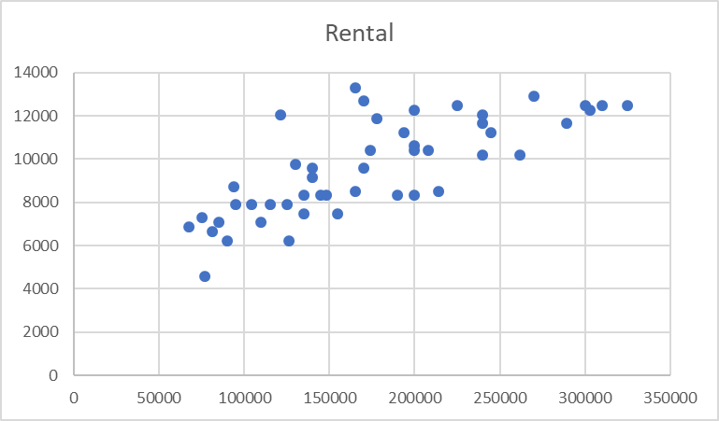

10.1.4
The World Bank collected data on the percentage of GDP that a country spends on health expenditures ("Health expenditure," 2013) and also the percentage of women receiving prenatal care ("Pregnant woman receiving," 2013). The data for the countries where this information are available for the year 2011 is in table #10.1.8. Create a scatter plot of the data and find a regression equation between percentage spent on health expenditure and the percentage of women receiving prenatal care. Then use the regression equation to find the percent of women receiving prenatal care for a country that spends 5.0% of GDP on health expenditure and for a country that spends 12.0% of GDP. Which prenatal care percentage that you calculated do you think is closer to the true percentage? Why?

Table #10.1.8: Data of Health Expenditure versus Prenatal Care
Health Expenditure (% of GDP) | Prenatal Care (%)
9.6 | 47.9
3.7 | 54.6
5.2 | 93.7
5.2 | 84.7
10.0 | 100.0
4.7 | 42.5
4.8 | 96.4
6.0 | 77.1
5.4 | 58.3
4.8 | 95.4
4.1 | 78.0
6.0 | 93.3
9.5 | 93.3
6.8 | 93.7
6.1 | 89.8

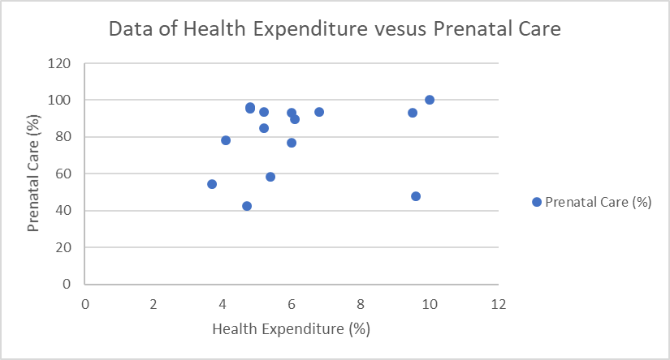

10.2.2
Table #10.1.6 contains the value of the house and the amount of rental income in a year that the house brings in ("Capital and rental," 2013). Find the correlation coefficient and coefficient of determination and then interpret both.

Table #10.1.6: Data of House Value versus Rental
Value | Rental | Value | Rental | Value | Rental | Value | Rental
81000 | 6656 | 77000 | 4576 | 75000 | 7280 | 67500 | 6864
95000 | 7904 | 94000 | 8736 | 90000 | 6240 | 85000 | 7072
121000 | 12064 | 115000 | 7904 | 110000 | 7072 | 104000 | 7904
135000 | 8320 | 130000 | 9776 | 126000 | 6240 | 125000 | 7904
145000 | 8320 | 140000 | 9568 | 140000 | 9152 | 135000 | 7488
165000 | 13312 | 165000 | 8528 | 155000 | 7488 | 148000 | 8320
178000 | 11856 | 174000 | 10400 | 170000 | 9568 | 170000 | 12688
200000 | 12272 | 200000 | 10608 | 194000 | 11232 | 190000 | 8320
214000 | 8528 | 208000 | 10400 | 200000 | 10400 | 200000 | 8320
240000 | 10192 | 240000 | 12064 | 240000 | 11648 | 225000 | 12480
289000 | 11648 | 270000 | 12896 | 262000 | 10192 | 244500 | 11232
325000 | 12480 | 310000 | 12480 | 303000 | 12272 | 300000 | 12480

10.2.4
The World Bank collected data on the percentage of GDP that a country spends on health expenditures ("Health expenditure," 2013) and also the percentage of women receiving prenatal care ("Pregnant woman receiving," 2013). The data for the countries where this information is available for the year 2011 are in table #10.1.8. Find the correlation coefficient and coefficient of determination and then interpret both.

Table #10.1.8: Data of Health Expenditure versus Prenatal Care
Health Expenditure (% of GDP) | Prenatal Care (%)
9.6 | 47.9
3.7 | 54.6
5.2 | 93.7
5.2 | 84.7
10.0 | 100.0
4.7 | 42.5
4.8 | 96.4
6.0 | 77.1
5.4 | 58.3
4.8 | 95.4
4.1 | 78.0
6.0 | 93.3
9.5 | 93.3
6.8 | 93.7
6.1 | 89.8

10.3.2
Table #10.1.6 contains the value of the house and the amount of rental income in a year that the house brings in ("Capital and rental," 2013).
Test at the 5% level for a positive correlation between house value and rental amount.

Table #10.1.6: Data of House Value versus Rental
Value | Rental | Value | Rental | Value | Rental | Value | Rental
81000 | 6656 | 77000 | 4576 | 75000 | 7280 | 67500 | 6864
95000 | 7904 | 94000 | 8736 | 90000 | 6240 | 85000 | 7072
121000 | 12064 | 115000 | 7904 | 110000 | 7072 | 104000 | 7904
135000 | 8320 | 130000 | 9776 | 126000 | 6240 | 125000 | 7904
145000 | 8320 | 140000 | 9568 | 140000 | 9152 | 135000 | 7488
165000 | 13312 | 165000 | 8528 | 155000 | 7488 | 148000 | 8320
178000 | 11856 | 174000 | 10400 | 170000 | 9568 | 170000 | 12688
200000 | 12272 | 200000 | 10608 | 194000 | 11232 | 190000 | 8320
214000 | 8528 | 208000 | 10400 | 200000 | 10400 | 200000 | 8320
240000 | 10192 | 240000 | 12064 | 240000 | 11648 | 225000 | 12480
289000 | 11648 | 270000 | 12896 | 262000 | 10192 | 244500 | 11232
325000 | 12480 | 310000 | 12480 | 303000 | 12272 | 300000 | 12480

10.3.4
The World Bank collected data on the percentage of GDP that a country spends on health expenditures ("Health expenditure," 2013) and also the percentage of women receiving prenatal care ("Pregnant woman receiving," 2013). The data for the countries where this information is available for the year 2011 are in table #10.1.8.
Test at the 5% level for a correlation between percentage spent on health expenditure and the percentage of women receiving prenatal care.

Table #10.1.8: Data of Health Expenditure versus Prenatal Care
Health Expenditure (% of GDP) | Prenatal Care (%)
9.6 | 47.9
3.7 | 54.6
5.2 | 93.7
5.2 | 84.7
10.0 | 100.0
4.7 | 42.5
4.8 | 96.4
6.0 | 77.1
5.4 | 58.3
4.8 | 95.4
4.1 | 78.0
6.0 | 93.3
9.5 | 93.3
6.8 | 93.7
6.1 | 89.8

11.1.2

Researchers watched groups of dolphins off the coast of Ireland in 1998 to determine what activities the dolphins partake in at certain times of the day ("Activities of dolphin," 2013). The numbers in table #11.1.6 represent the number of groups of dolphins that were partaking in an activity at certain times of days. Is there enough evidence to show that the activity and the time period are independent for dolphins? Test at the 1% level.

Table #11.1.6: Dolphin Activity
Activity | Period |  |  |  | Row  Total
Activity | Morning | Noon | Afternoon | Evening | Row  Total
Travel | 6 | 6 | 14 | 13 | 39
Feed | 28 | 4 | 0 | 56 | 88
Social | 38 | 5 | 9 | 10 | 62
Column Total | 72 | 15 | 23 | 79 | 189

11.1.4
A person’s educational attainment and age group was collected by the U.S. Census Bureau in 1984 to see if age group and educational attainment are related. The counts in thousands are in table #11.1.8 ("Education by age," 2013). Do the data show that educational attainment and age are independent? Test at the 5% level.
Table #11.1.8: Educational Attainment and Age Group
Education | Age Group |  |  |  |  | Row Total
Education | 25-34 | 35-44 | 45-54 | 55-64 | >64 | Row Total
Did not complete HS | 5416 | 5030 | 5777 | 7606 | 13746 | 37575
Competed HS | 16431 | 1855 | 9435 | 8795 | 7558 | 44074
College 1-3 years | 8555 | 5576 | 3124 | 2524 | 2503 | 22282
College 4 or more years | 9771 | 7596 | 3904 | 3109 | 2483 | 26863
Column Total | 40173 | 20057 | 22240 | 22034 | 26290 | 130794

11.2.4
In Africa in 2011, the number of deaths of a female from cardiovascular disease for different age groups are in table #11.2.6 ("Global health observatory," 2013). In addition, the proportion of deaths of females from all causes for the same age groups are also in table #11.2.6. Do the data show that the death from cardiovascular disease are in the same proportion as all deaths for the different age groups? Test at the 5% level.
Table #11.2.6: Deaths of Females for Different Age Groups
Age | 5-14 | 15-29 | 30-49 | 50-69 | Total
Cardiovascular Frequency | 8 | 16 | 56 | 433 | 513
All Cause Proportion | 0.10 | 0.12 | 0.26 | 0.52

11.2.6
A project conducted by the Australian Federal Office of Road Safety asked people many questions about their cars. One question was the reason that a person chooses a given car, and that data is in table #11.2.8 ("Car preferences," 2013).
Table #11.2.8: Reason for Choosing a Car
Safety | Reliability | Cost | Performance | Comfort | Looks
84 | 62 | 46 | 34 | 47 | 27
Do the data show that the frequencies observed substantiate the claim that the reasons for choosing a car are equally likely? Test at the 5% level.

